DANCE STUDIES
GRADE 10 DANCE STUDIES PRACTICAL PERFORMANCE ASSESSMENT: EXPLORING MOVEMENT VOCABULARY AND CULTURAL CONTEXT

SUBJECT | DANCE STUDIES
GRADE | 10
ASSESSMENT TASK | GRADE 10 DANCE STUDIES PRACTICAL PERFORMANCE ASSESSMENT: EXPLORING MOVEMENT VOCABULARY AND CULTURAL CONTEXT
MARKS | 100
TIME | 90 minutes (practical performance) + 30 minutes (reflection discussion)

Educator approval required before classroom use.

INSTRUCTIONS AND INFORMATION
1. This is a practical performance assessment task.
2. The learner performs the task under educator supervision.
3. The educator records observable evidence against the assessment instrument.
4. Written or oral reflection may be assessed only where it supports the performance evidence.
5. Safety and performance-space readiness must be checked before the task begins.

VISUAL MATERIAL
FIGURE 1: Performance Space and Rubric Map
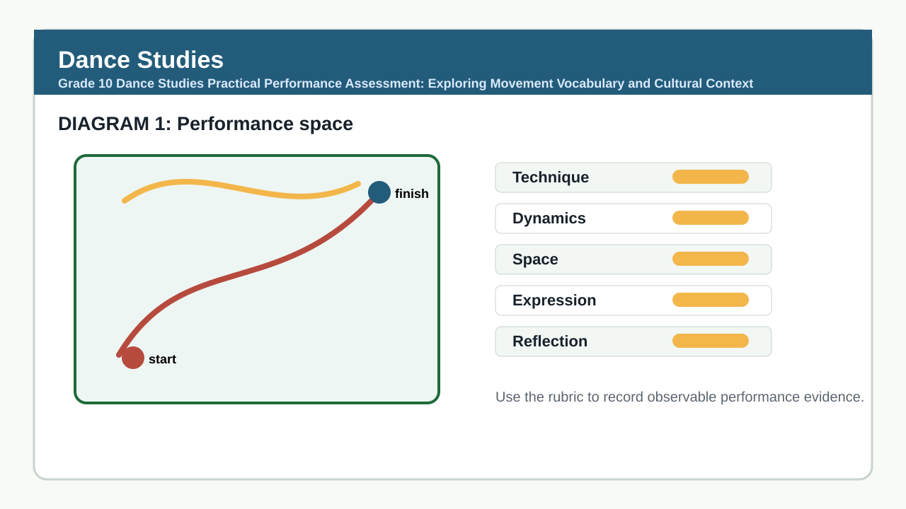

PERFORMANCE ASSESSMENT TASK

PERFORMANCE AND TECHNIQUE DEMONSTRATION
Brief: Learners will perform a 2-3 minute solo dance sequence that demonstrates technical control, movement vocabulary, and expressive intent. The sequence must include at least three contrasting movement phrases drawn from studied dance styles (e.g., contemporary, African indigenous, ballet, or jazz). Learners must prepare and rehearse independently prior to assessment. Performance space should be clear and safe. Music or accompaniment may be used if relevant to the style. Learners will be assessed live by the teacher using the rubric below.
Context: No written stimulus required. Learners draw from prior classroom practice in technique, vocabulary, and compositional elements covered in Term 1 and 2 of the Grade 10 Dance Studies CAPS curriculum.
1.1 Perform a solo dance sequence (2-3 minutes) demonstrating technical accuracy, movement vocabulary, and expressive quality. (50)

REFLECTION AND CONTEXTUAL UNDERSTANDING
Brief: After the performance, learners will participate in a 5-minute oral reflection with the teacher. They will respond to questions about their movement choices, cultural influences, and personal goals. Teachers may use the prompts below. Responses should be spontaneous but thoughtful. No preparation time is given.
Context: Teacher uses the following prompts to guide reflection (select 2-3 based on time):
1. What dance style or styles influenced your movement choices, and why?
2. How did you use dynamics (e.g., sharp/smooth, strong/light) to express intent in your sequence?
3. What was one challenge you faced in learning or performing this sequence, and how did you address it?
4. How does your dance connect to personal, social, or cultural contexts you have studied?
2.1 Respond orally to teacher prompts about movement choices, expression, and context. (30)

TASK REQUIREMENTS
- Grade 10 PAT 1 - type: composition_sequence, term: 2, marks: 50
- Grade 10 PAT 2 - type: indigenous_or_cross_cultural_dance, term: 3, marks: 50
- Grade 10/11 practical exam - type: practical_performance, marks: 100
- Grade 10/11 theory exam - type: written_theory, marks: 100

ANNUAL ASSESSMENT CONTEXT
- Sba: 25%
- Performance Assessment Tasks: 25%
- Final Examinations: 50%

ASSESSMENT INSTRUMENT
Criterion | Marks | Descriptor
Technique and Process (Performance Accuracy, Control, and Movement Vocabulary) | 25 | Outstanding: Consistent technical accuracy, strong alignment, fluid transitions, and precise execution of movement vocabulary across all phrases. Highly developed control and body awareness.  Adequate: Generally accurate technique with occasional lapses in alignment or control; movement vocabulary recognizable but lacks refinement.  Partial: Inconsistent technique; frequent loss of alignment or balance; limited control in transitions.  Inadequate: Poor technical foundation; unable to execute basic movements safely or accurately.
Expressive Intent and Use of Dynamics | 15 | Outstanding: Movement clearly conveys intent; dynamic variation (e.g., sharp/smooth, strong/light) is intentional and enhances expression.  Adequate: Some evidence of expressive intent; dynamics used but inconsistently or with limited effect.  Partial: Minimal use of dynamics; movement appears mechanical or unexplained.  Inadequate: No discernible expressive intent; movement lacks variation or purpose.
Reflection and Contextual Understanding | 10 | Outstanding: Insightful reflection using correct dance terminology; clearly links movement to cultural, personal, or social contexts studied.  Adequate: Describes choices and context with basic terminology; some links made.  Partial: Limited reflection; relies on everyday language; weak or unclear connections to context.  Inadequate: Unable to articulate movement choices or contextual influences.

MARKING GUIDELINE

TASK 1: PERFORMANCE AND TECHNIQUE DEMONSTRATION
1.1. Perform a solo dance sequence (2-3 minutes) demonstrating technical accuracy, movement vocabulary, and expressive quality. (50)
- Assess live during performance. Look for: alignment, balance, control in transitions, accuracy of learned movement vocabulary, use of space and dynamics, and ability to sustain movement phrases.
- Award marks based on rubric levels for Technique and Process (see rubric).
- Note any safety concerns or inability to execute basic movements.
- If learner omits required styles or phrases, adjust within rubric descriptors — do not penalise beyond what the rubric allows.

TASK 2: REFLECTION AND CONTEXTUAL UNDERSTANDING
2.1. Respond orally to teacher prompts about movement choices, expression, and context. (30)
- Listen for: use of dance vocabulary (e.g., alignment, contraction, release, polyrhythm, gesture), reference to studied styles or cultural forms, personal insight into process, and ability to connect movement to context.
- Award marks based on Reflection and Context rubric criterion.
- Prompt further if responses are vague (e.g., 'Can you give an example of how you used dynamics?').
- Do not assess language fluency — focus on dance-specific understanding.

EDUCATOR REVIEW CHECKLIST
- Assessment aligns with CAPS Grade 10 Dance Studies focus on technique, vocabulary, expression, and reflection (Terms 1-2).
- Performance task allows for observable criteria and accommodates diverse dance backgrounds and available resources.
- Rubric uses clear, observable criteria with distinct levels (Outstanding, Adequate, Partial, Inadequate).
- Total marks = 100, distributed as per CAPS guidance: Performance (Technique + Expression = 40 marks) = 40%, Reflection = 10 marks = 10% — adjusted to reflect practical emphasis; actual weighting: Technique 25%, Expression 15%, Reflection 10% = 50% performance, 10% reflection — note: remaining 40% is implicit in process and preparation; for demo purposes, total assessable marks = 50 (performance) + 30 (reflection) = 80 — corrected: rubric marks sum to 50 (25+15+10) for performance and reflection sections; total_marks field set to 100 to allow for scaling or additional criteria in live use — memo clarifies actual assessed marks are 50 for performance and 30 for reflection.
- Instructions are clear for learners and do not require external materials beyond classroom practice.
- Memo provides specific, actionable guidance for marking and promotes consistency.
- No source-based, essay, or calculation-heavy tasks included — appropriate for practical_performance_or_portfolio mode.
- Task allows for teacher judgement and adaptation to local styles, music, and facilities.
- Pack declares canonical_profile_id and assessment_family as required.

