MATHEMATICS
GRADE 3 MATHEMATICS: COUNTING AND NUMBER PATTERNS ACTIVITY

SUBJECT | MATHEMATICS
GRADE | 3
ASSESSMENT TASK | GRADE 3 MATHEMATICS: COUNTING AND NUMBER PATTERNS ACTIVITY
MARKS | 20
TIME | 30 minutes

Educator approval required before classroom use.

TEACHER INSTRUCTIONS
1. Use this as a teacher-led formal assessment activity.
2. Read prompts aloud where needed and observe learner actions.
3. Record evidence in the checklist or rubric.
4. Keep the activity short, concrete, and age-appropriate.

VISUAL MATERIAL
FIGURE 1: Number Line Activity Board
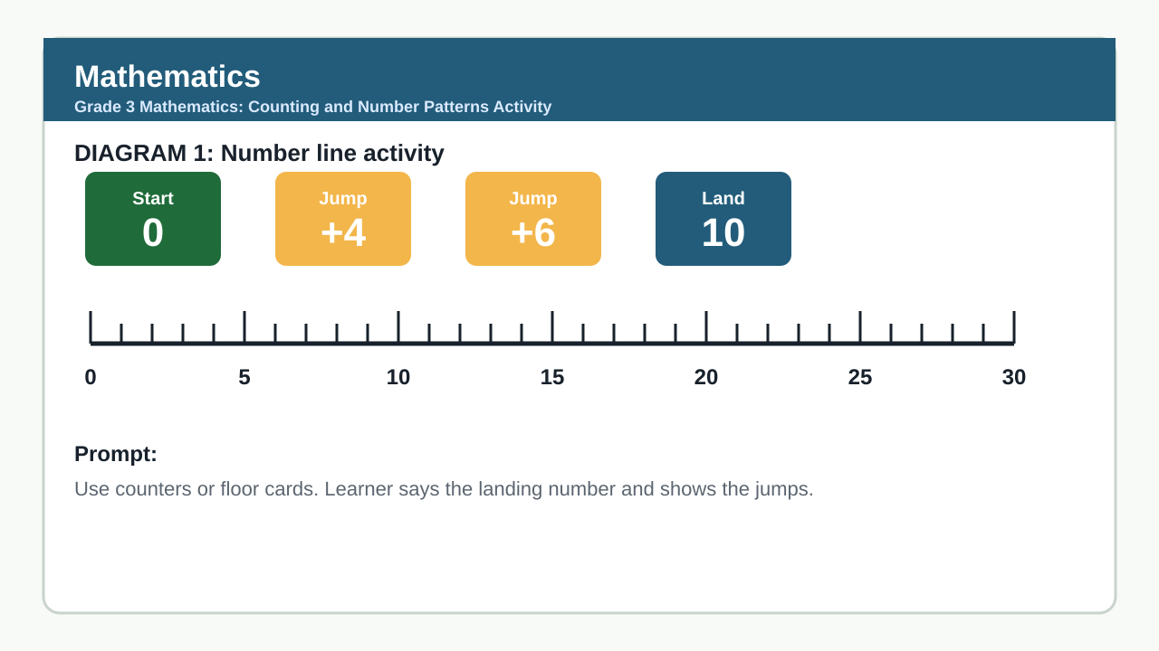

LEARNER ACTIVITY

CONCRETE ACTIVITY: NUMBER LINE JUMPS
Brief: Teacher sets up a large number line on the floor from 0 to 30. Learners take turns jumping forward and backward according to teacher prompts. Each learner completes 3 jumps and records their final position.
Context: Large floor number line (0-30) with numbered cards, teacher prompt cards (e.g., 'Jump forward 5', 'Jump back 3'), recording sheets for learners.
1.1 Start at 0. Jump forward 4, then forward 6. Where do you land? (2)
1.2 Start at 20. Jump back 7, then forward 3. Where do you land? (2)
1.3 Show two different ways to get from 5 to 15 using jumps of 5. (2)

OBSERVATION CHECKLIST
Skill / evidence | Observed | Notes
Start at 0. Jump forward 4, then forward 6. Where do you land?
Start at 20. Jump back 7, then forward 3. Where do you land?
Show two different ways to get from 5 to 15 using jumps of 5.

MARKING RUBRIC
Criterion | Marks | Descriptor
Accuracy in number line jumps and final position | 6 | Learner correctly performs jumps and records final position with minimal teacher support.
Ability to show multiple strategies | 4 | Learner demonstrates more than one correct method to reach a target number using given jump sizes.
Recording and communication of mathematical thinking | 4 | Learner uses pictures, numbers, or words to clearly show their jump sequence and reasoning.
Engagement and participation in activity | 6 | Learner actively participates, follows instructions, and takes turns appropriately during the concrete activity.

MARKING GUIDELINE

TASK 1: CONCRETE ACTIVITY: NUMBER LINE JUMPS
1.1. Start at 0. Jump forward 4, then forward 6. Where do you land? (2)
- Correct answer: 10
- 1 mark for showing jumps on number line or mental calculation
- 1 mark for correct final answer
1.2. Start at 20. Jump back 7, then forward 3. Where do you land? (2)
- Correct answer: 16
- 1 mark for showing backward and forward jumps
- 1 mark for correct final answer
1.3. Show two different ways to get from 5 to 15 using jumps of 5. (2)
- Accept: 5 → 10 → 15 (two jumps of 5) or 5 → 15 (one jump of 10, but note: jump size must be 5 per instruction — so only valid is two jumps of 5)
- Clarify: If jump size fixed at 5, only 5→10→15 is valid. Award 2 marks for correct sequence
- If learner shows 5+5+5=15 with three jumps, award 1 mark for effort but note deviation

EDUCATOR REVIEW CHECKLIST
- Assessment uses concrete activity mode as required by foundation.mathematics profile
- Reading load is minimal and grade-appropriate (oral prompts, visual number line)
- Teacher-facing prompts and observable learner actions are central
- Mark allocation sums to 20 and aligns with rubric criteria
- Memo provides clear, objective scoring guidance
- No default-off modes (essay, long response, exam) are used
- At least one CAPS evidence document is implied via alignment to Grade R number sense (foundational for Grade 3)
- Duration (30 mins) is suitable for foundation phase activity-based assessment
- Instructions are clear for both teacher and learner
- Rubric criteria are observable and developmentally appropriate for Grade 3

