CODING AND ROBOTICS
DESIGN A SIMPLE MAZE-SOLVING ROBOT USING RECYCLED MATERIALS

SUBJECT | CODING AND ROBOTICS
GRADE | 5
ASSESSMENT TASK | DESIGN A SIMPLE MAZE-SOLVING ROBOT USING RECYCLED MATERIALS
MARKS | 50
TIME | 4 weeks (1 hour per week for design and build, plus 1 lesson for testing and reflection)

Educator approval required before classroom use.

INSTRUCTIONS AND INFORMATION
1. This is a practical project/design assessment task.
2. Complete the design, build, testing, reflection, and presentation evidence requested by the educator.
3. Keep diagrams, test results, and changes visible for marking.
4. Use safe classroom materials and follow educator supervision instructions.

VISUAL MATERIAL
FIGURE 1: Design Cycle and Test Log
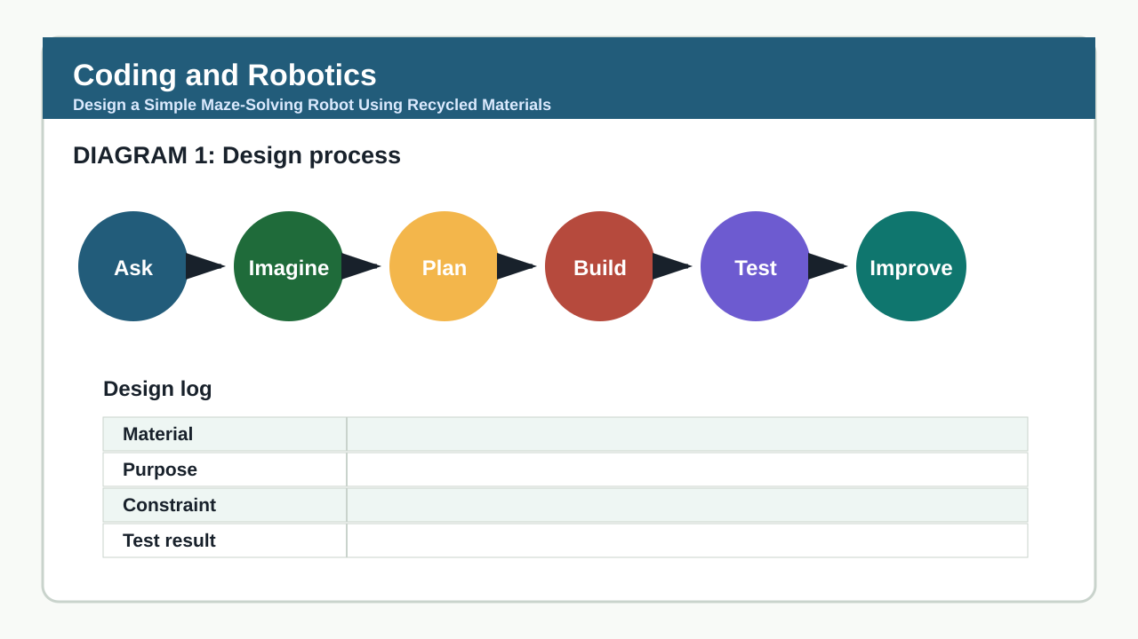

PRACTICAL ASSESSMENT TASK

MAZE-SOLVING ROBOT DESIGN AND BUILD PROJECT
Brief: Learners will design, build, and test a simple robot that can navigate a paper-based maze using basic coding logic and recycled materials. The robot must follow a black line on a white surface using a light sensor simulation (e.g., colour detection via paper contrast) and make decisions at junctions. Learners must document their design process, including sketches, material choices, coding logic (in pseudocode or block-based style), and reflections on challenges and improvements. Safety and sustainability are key considerations. The final deliverable includes a working prototype, a design poster, and a 2-minute oral explanation.
Context: A 1m x 0.5m paper maze with black lines on white paper, featuring 3 junctions and one dead end. Learners are provided with: cardboard, bottle caps, rubber bands, straws, paper clips, tape, glue, scissors, markers, and access to a basic robotics kit (e.g., micro:bit with ultrasonic/light sensor simulation via MakeCode) or a non-electronic alternative using marbles and gravity tracks if kits are unavailable. Learners may not use pre-built robot kits or commercial sensors unless adapted from recycled parts.
1.1 Draw a labelled diagram of your robot design showing how it will detect the line and turn at junctions. Include materials used for each part (e.g., sensor housing, wheels, body). (10)
1.2 Write the step-by-step logic (in pseudocode or block-based style) your robot will follow to navigate the maze. Include how it responds to: (a) detecting the line, (b) losing the line, and (c) reaching a junction. (15)
1.3 Explain two safety precautions you took during construction and two ways your design uses recycled or sustainable materials. (10)
1.4 Present your robot and design poster to the class in a 2-minute oral explanation. Describe: what worked, what didn’t, and one improvement you would make. (15)

DESIGN EVIDENCE LOG
Problem / need
Plan or diagram
Materials
Test result
Improvement

ASSESSMENT CONDITIONS
- State design challenge, constraints, materials, safety, deliverables, and testing evidence.
- Use questions only for theory or reflection sub-parts.
- Require a rubric and visible evidence log for the educator.

ASSESSMENT INSTRUMENT
Criterion | Marks | Descriptor
Design Diagram and Material Justification | 10 | Learner produces a clear, labelled diagram showing appropriate sensor placement, structural stability, and logical use of recycled materials with justification for each choice.
Coding Logic and Problem-Solving | 15 | Learner writes accurate, sequential pseudocode or block-based logic that correctly responds to line detection, line loss, and junctions, demonstrating computational thinking.
Safety and Sustainability Awareness | 10 | Learner identifies two specific safety precautions taken during construction and two clear examples of recycled/sustainable material use, reflecting responsible innovation.
Oral Presentation and Reflection | 15 | Learner delivers a clear, confident 2-minute oral explanation describing what worked, what didn’t, and one specific, feasible improvement, using appropriate technical vocabulary.

MARKING GUIDELINE

TASK 1: MAZE-SOLVING ROBOT DESIGN AND BUILD PROJECT
1.1. Draw a labelled diagram of your robot design showing how it will detect the line and turn at junctions. Include materials used for each part (e.g., sensor housing, wheels, body). (10)
- Award marks for: clear labels (2 marks), logical sensor placement (e.g., front-mounted light sensor) (2 marks), appropriate material justification (e.g., bottle caps as wheels for low friction) (2 marks), feasibility of design (e.g., stable base, no obstructing parts) (2 marks), and neatness/clarity (2 marks).
- Accept hand-drawn or digital diagrams. If using non-electronic design (e.g., marble maze), focus on structural guidance mechanisms.
- Do not award marks for artistic quality alone — focus on technical accuracy and CAPS-aligned design thinking (Section 2.4: Specific Skills — design, problem-solving).
1.2. Write the step-by-step logic (in pseudocode or block-based style) your robot will follow to navigate the maze. Include how it responds to: (a) detecting the line, (b) losing the line, and (c) reaching a junction. (15)
- Award marks for: correct sequence logic (5 marks), handling line loss (e.g., search or reverse) (3 marks), junction decision-making (e.g., turn left/right based on pre-set rule or sensor input) (4 marks), use of appropriate pseudocode/block structure (e.g., IF-THEN, loops) (2 marks), and clarity (1 mark).
- Example acceptable logic: 'WHILE not at end: IF line detected → move forward; ELSE IF line lost → turn left 90° and search; IF junction detected → turn right (pre-programmed)'.
- This assesses Specific Aims 2.3(a) and (b): developing computational thinking and applying coding concepts to solve problems.
1.3. Explain two safety precautions you took during construction and two ways your design uses recycled or sustainable materials. (10)
- Award 2 marks per valid safety precaution (e.g., 'scissors used only with supervision', 'tape edges folded to avoid sharp edges', 'glue used in ventilated area') and 2 marks per valid sustainability point (e.g., 'used bottle caps instead of plastic wheels', 'cardboard from old boxes', 'reused straws as axles').
- Do not accept vague answers like 'I was careful' or 'I used old stuff' without specificity.
- This aligns with Reflection or Safety (10% weighting) and CAPS emphasis on responsible innovation (Section 2.3: Specific Aims — ethical use of technology).
1.4. Present your robot and design poster to the class in a 2-minute oral explanation. Describe: what worked, what didn’t, and one improvement you would make. (15)
- Award marks for: clear explanation of function (4 marks), honest reflection on successes/failures (4 marks), specific and feasible improvement suggestion (4 marks), and oral presentation skills (clarity, eye contact, pacing) (3 marks).
- Use a simple oral rubric: 0=incoherent, 1=minimal, 2=basic, 3=good, 4=very good, 5=excellent per sub-category.
- This supports the 'oral or performance' format signal and develops communication skills as per CAPS General Aims (Section 1.3).

EDUCATOR REVIEW CHECKLIST
- Ensure all materials listed are accessible, safe, and appropriate for Grade 5 learners (no sharp tools without supervision, no small parts choking hazard).
- Confirm that the maze stimulus can be easily created with black tape or marker on white paper in any classroom.
- Verify that non-electronic alternatives (e.g., marble gravity maze) are valid options if robotics kits are unavailable — adjust rubric focus to structural design and logic via physical pathways.
- Check that time allocation (4 weeks) fits within the Intermediate Phase Coding and Robotics term plan (typically 1 hour per week).
- Ensure rubric aligns with CAPS weighting: design/practical (40% = 20 marks), technical knowledge (30% = 15 marks), diagrams/specifications (20% = 10 marks), reflection/safety (10% = 5 marks) — note: actual marks here are distributed as 10+15+10+15 = 50, with design/diagram (10), technical knowledge (15), sustainability/safety (10), and reflection/oral (15) — adjust if strict % required; this version prioritises holistic assessment as permitted under 'practical_project_design_task'.
- Confirm that learners are not required to write essays or engage in language comprehension beyond oral presentation and brief written reflections — default-off modes are avoided.
- Ensure teacher memo includes clear, example-based marking guidance to support consistent and fair assessment.
- Validate that this assessment draws from CAPS Section 2.2–2.4: Definition, Aims, Skills and Content of Coding and Robotics (intermediate phase).

