DANCE STUDIES
GRADE 10 DANCE STUDIES PERFORMANCE ASSESSMENT TASK: INDIGENOUS DANCE COMPOSITION

SUBJECT | DANCE STUDIES
GRADE | 10
ASSESSMENT TASK | GRADE 10 DANCE STUDIES PERFORMANCE ASSESSMENT TASK: INDIGENOUS DANCE COMPOSITION
MARKS | 100
TIME | 4 weeks preparation + 5-minute performance

Educator approval required before classroom use.

INSTRUCTIONS AND INFORMATION
1. This is a practical performance assessment task.
2. The learner performs the task under educator supervision.
3. The educator records observable evidence against the assessment instrument.
4. Written or oral reflection may be assessed only where it supports the performance evidence.
5. Safety and performance-space readiness must be checked before the task begins.

VISUAL MATERIAL
FIGURE 1: Performance Space and Rubric Map
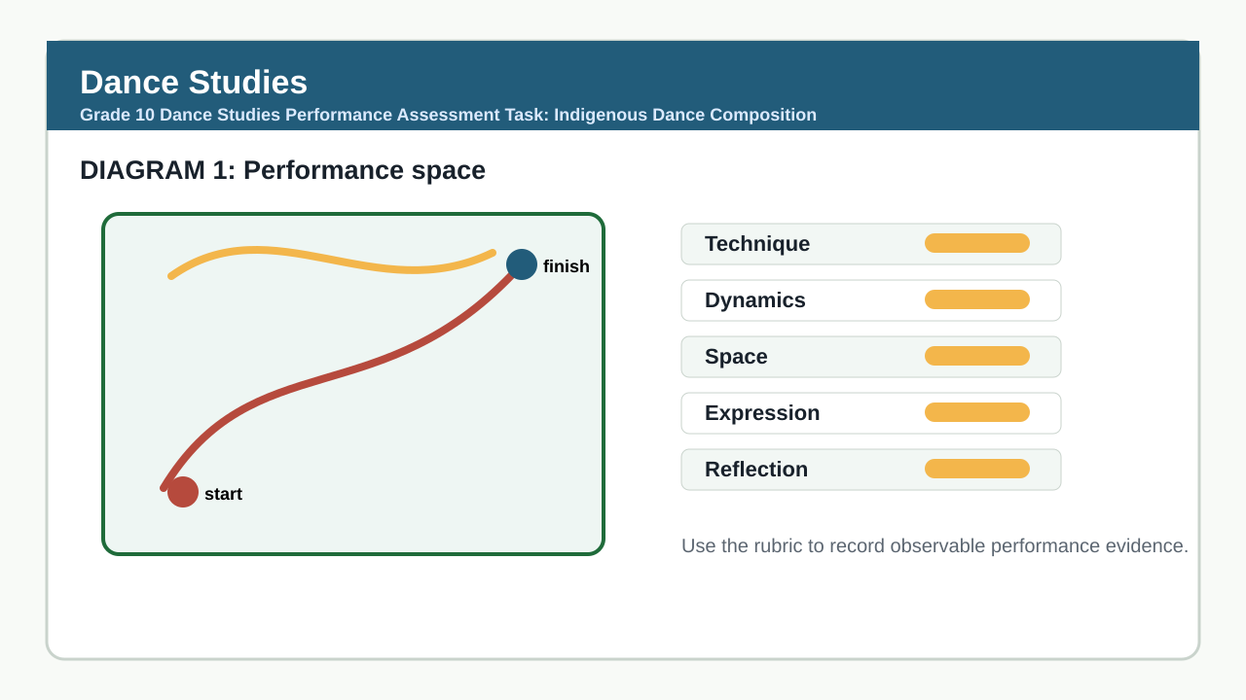

PERFORMANCE ASSESSMENT TASK

PERFORMANCE TASK: INDIGENOUS DANCE COMPOSITION
Brief: Learners must create and perform an original 3-5 minute dance composition inspired by South African indigenous dance forms. The work must demonstrate understanding of cultural context, movement vocabulary, and choreographic principles. Evidence of process (journal, sketches, music selection) must be submitted with final performance. Performance to be assessed live by teacher with optional recording for moderation.
Context: Scenario: Your community is hosting a Youth Cultural Heritage Festival. You have been invited to create a dance piece that celebrates and respectfully interprets one South African indigenous dance tradition (e.g., Indlamu, Isicathamiya, Reed Dance, Trance Dance, or another approved form). Your composition must reflect cultural authenticity while expressing a contemporary youth perspective on heritage and identity.
1 Create and perform an original dance composition (3-5 minutes) based on research into a South African indigenous dance form. Submit process evidence (journal, music choice, movement notes) alongside the final performance. (100)

TASK REQUIREMENTS
- Grade 10 PAT 1 - type: composition_sequence, term: 2, marks: 50
- Grade 10 PAT 2 - type: indigenous_or_cross_cultural_dance, term: 3, marks: 50
- Grade 10/11 practical exam - type: practical_performance, marks: 100
- Grade 10/11 theory exam - type: written_theory, marks: 100

ANNUAL ASSESSMENT CONTEXT
- Sba: 25%
- Performance Assessment Tasks: 25%
- Final Examinations: 50%

ASSESSMENT INSTRUMENT
Criterion | Marks | Descriptor
Content Accuracy: Cultural understanding and authentic use of indigenous dance elements (movement, rhythm, symbolism, context) | 25 | Outstanding: Demonstrates deep, respectful understanding of the chosen indigenous dance form; movement vocabulary is authentically adapted with clear cultural relevance. Satisfactory: Shows basic understanding with some authentic elements; may include superficial or generic use. Limited: Minimal cultural connection; movements are generic or misrepresentative. Not Evident: No identifiable link to indigenous dance form; inappropriate or stereotypical use.
Skill Demonstration: Technical control, movement quality, and physical execution | 30 | Outstanding: High level of technical precision, control, alignment, and dynamic range; movement is expressive and embodied. Satisfactory: Competent execution with occasional lapses in control or alignment; movement is mostly clear. Limited: Inconsistent technical control; movement lacks clarity or purpose. Not Evident: Poor technical foundation; movement is unsafe or uncontrolled.
Reasoning: Choreographic structure, use of space, dynamics, and relationship to music | 20 | Outstanding: Sophisticated choreographic structure with clear intent; innovative use of space, dynamics, and music; seamless transitions. Satisfactory: Clear structure with identifiable beginning, development, and end; adequate use of choreographic elements. Limited: Weak or unclear structure; minimal use of space/dynamics; disjointed sections. Not Evident: No discernible structure; random movement without intent or relation to stimulus.
Communication: Expression of intent, emotional engagement, and performance presence | 15 | Outstanding: Compelling performance presence; intent is powerfully communicated through facial expression, focus, and embodiment; connects with audience. Satisfactory: Clear intent with reasonable engagement; some expressiveness evident. Limited: Inconsistent expression; minimal connection to intent or audience. Not Evident: No expression or engagement; mechanical or absent performance quality.
CAPS Alignment: Evidence of process work, reflection, and adherence to task brief (indigenous/cross-cultural focus, duration, originality) | 10 | Outstanding: Comprehensive process evidence (journal, research, music choice) shows deep reflection and strict adherence to task; original work within time limit. Satisfactory: Adequate process evidence; mostly meets requirements with minor gaps. Limited: Incomplete process evidence; partial adherence to brief (e.g., wrong duration, lack of research). Not Evident: No process submitted; work does not resemble indigenous dance or violates task constraints.

MARKING GUIDELINE

TASK 1: PERFORMANCE TASK: INDIGENOUS DANCE COMPOSITION
1. Create and perform an original dance composition (3-5 minutes) based on research into a South African indigenous dance form. Submit process evidence (journal, music choice, movement notes) alongside the final performance. (100)
- Assessment is based entirely on the performance rubric below. No written answers are required for this practical task.
- All 100 marks are allocated through the rubric dimensions: content_accuracy (25), skill_demonstration (30), reasoning (20), communication (15), and caps_alignment (10).
- Evidence for moderation includes: live performance observation, learner journal, music selection rationale, and teacher observation notes.
- Learners must demonstrate respectful engagement with cultural sources; appropriation without understanding will be penalised under content_accuracy and caps_alignment.
- Performance must be the learner’s own work; group work is not permitted for this individual task.

EDUCATOR REVIEW CHECKLIST
- Total marks reconcile: 25 + 30 + 20 + 15 + 10 = 100.
- Learner-facing text contains no answer-line questions; assessment is purely performance-based with process evidence.
- All rubric criteria are observable in performance, process documentation, or teacher judgment.
- Task aligns with CAPS Grade 10 PAT 2: indigenous_or_cross_cultural_dance (50 marks) but scaled to 100 marks for this extended practical synthesis task as per opportunity and focus areas.
- Duration and submission requirements are feasible for school context.
- Cultural sensitivity and respectful engagement are explicitly addressed in rubric and instructions.
- Memo clearly separates learner instructions from educator guidance and ties every mark to observable evidence.

