DANCE STUDIES
GRADE 10 DANCE STUDIES: INDIGENOUS DANCE PERFORMANCE TASK – SECOND OPPORTUNITY

SUBJECT | DANCE STUDIES
GRADE | 10
ASSESSMENT TASK | GRADE 10 DANCE STUDIES: INDIGENOUS DANCE PERFORMANCE TASK – SECOND OPPORTUNITY
MARKS | 100
TIME | 45 minutes

Educator approval required before classroom use.

INSTRUCTIONS AND INFORMATION
1. This is a practical performance assessment task.
2. The learner performs the task under educator supervision.
3. The educator records observable evidence against the assessment instrument.
4. Written or oral reflection may be assessed only where it supports the performance evidence.
5. Safety and performance-space readiness must be checked before the task begins.

VISUAL MATERIAL
FIGURE 1: Performance Space and Rubric Map
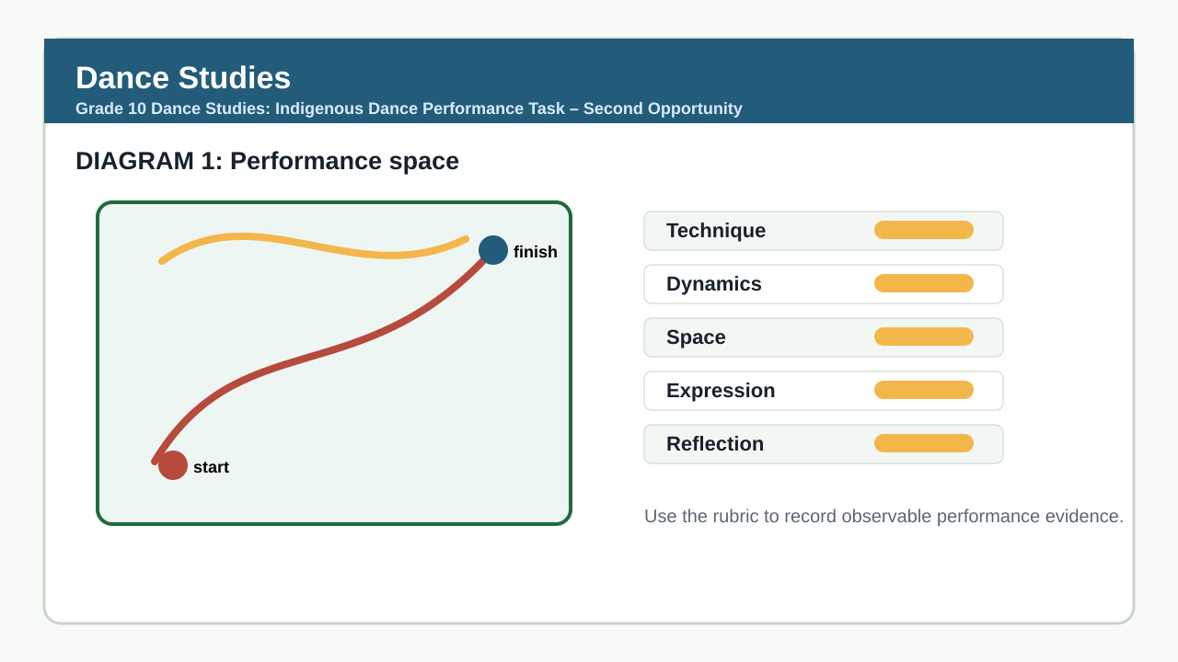

PERFORMANCE ASSESSMENT TASK

PERFORMANCE TASK: INDIGENOUS DANCE SEQUENCE
Brief: Learners will perform a 2–3 minute indigenous dance sequence inspired by South African cultural traditions. The sequence must demonstrate understanding of cultural context, movement vocabulary, spatial awareness, and expressive qualities. Learners are to choreograph and perform individually or in pairs, using only body percussion and vocal accompaniment (no props or recorded music). Evidence of the performance must be recorded for moderation purposes. Learners receive the task brief two weeks prior to performance to allow for rehearsal and refinement.
Context: Task Brief: Research and create an original dance sequence drawing from one of the following indigenous South African dance forms: Indlamu (Zulu), Mokgibo (Tswana), or Xhosa umtshotsho. Your sequence must include: (a) a clear cultural intention or narrative, (b) three distinct movement motifs rooted in the chosen tradition, (c) use of levels, directions, and floor patterns, (d) rhythmic accuracy through body percussion or vocalisation, and (e) expressive performance qualities. Avoid copying set works; focus on authentic interpretation and personal expression within the tradition.
1.1 Choreograph and perform an original indigenous dance sequence (2–3 minutes) that reflects cultural understanding and artistic intent. (100)

TASK REQUIREMENTS
- Grade 10 PAT 1 - type: composition_sequence, term: 2, marks: 50
- Grade 10 PAT 2 - type: indigenous_or_cross_cultural_dance, term: 3, marks: 50
- Grade 10/11 practical exam - type: practical_performance, marks: 100
- Grade 10/11 theory exam - type: written_theory, marks: 100

ANNUAL ASSESSMENT CONTEXT
- Sba: 25%
- Performance Assessment Tasks: 25%
- Final Examinations: 50%

ASSESSMENT INSTRUMENT
Criterion | Marks | Descriptor
Cultural Understanding and Contextual Awareness | 25 | Demonstrates clear understanding of the cultural significance, origin, and purpose of the chosen indigenous dance form. Movement choices reflect authentic intent (e.g., storytelling, rites of passage, communal celebration) rather than generic movement. Shows evidence of research through accurate use of gestures, posture, or rhythmic patterns associated with the tradition.
Movement Vocabulary and Technique | 25 | Uses three or more distinct movement motifs drawn from the selected indigenous tradition (e.g., stamping, jumping, torso undulations, arm swings, footwork patterns). Movements are executed with control, alignment, and appropriate energy. Transitions between motifs are purposeful and flow naturally. Avoids ballet, contemporary, or hip-hop vocabulary unless fused respectfully and with justification.
Use of Space, Time, and Rhythm | 20 | Effectively uses levels (high, medium, low), directions (forward, backward, sideways, turning), and floor patterns (circular, linear, zigzag) to enhance meaning. Maintains rhythmic accuracy through body percussion (clapping, stomping, slapping) or vocalisation (chants, calls, responses). Tempo is consistent and appropriate to the tradition. Phrasing is clear and musically sensitive.
Expressive Performance and Engagement | 15 | Performs with confidence, focus, and expressive commitment. Uses facial expression, gaze, and projection to engage an audience. Demonstrates emotional connection to the cultural intent. Maintains performance energy throughout. Shows presence and authenticity rather than mechanical execution.
Originality and Choreographic Intent | 15 | Sequence is original and not a copy of a set work or video. Demonstrates personal interpretation and creative arrangement of traditional elements. Shows evidence of improvisation, variation, or development of motifs. Avoids plagiarism; instead, innovates within cultural boundaries. Clear beginning, development, and ending are evident.

MARKING GUIDELINE

TASK 1: PERFORMANCE TASK: INDIGENOUS DANCE SEQUENCE
1.1. Choreograph and perform an original indigenous dance sequence (2–3 minutes) that reflects cultural understanding and artistic intent. (100)
- Award marks based on the rubric below. Assess observable evidence during performance.
- Look for: clear cultural intention (e.g., storytelling, ritual, celebration), use of authentic movement vocabulary from selected tradition, variation in levels and directions, rhythmic precision in accompaniment, and sustained expressive quality.
- Credit evidence of research and adaptation, not replication. Allow for individual interpretation within cultural frameworks.
- If performed in pairs, assess both individuals’ contribution and synchronization where relevant.
- Use video recording to verify timing, spatial use, and movement accuracy for moderation.

EDUCATOR REVIEW CHECKLIST
- Total marks in rubric sum to 100 (25+25+20+15+15).
- Learner-facing instructions are separate from memo and rubric guidance.
- Task requires performance, not written responses; no answer-line questions included.
- Stimulus provides clear cultural options and performance requirements without prescribing exact movements.
- Duration is appropriate for a 2–3 minute performance plus setup and transitions.
- Assessment aligns with CAPS Grade 10 Dance Studies practical performance task requirements.
- Evidence (video) can be retained for moderation as per CAPS guidelines.
- No copied content from first opportunity; context, wording, and dance form selection are different.
- All marks are tied to observable performance criteria.
- Rubric descriptors are grade-appropriate and distinguishable across achievement levels.

