DANCE STUDIES
GRADE 10 DANCE STUDIES FIRST OPPORTUNITY PERFORMANCE TASK: COMPOSITION SEQUENCE

SUBJECT | DANCE STUDIES
GRADE | 10
ASSESSMENT TASK | GRADE 10 DANCE STUDIES FIRST OPPORTUNITY PERFORMANCE TASK: COMPOSITION SEQUENCE
MARKS | 50
TIME | 4 weeks preparation + 5-minute performance

Educator approval required before classroom use.

INSTRUCTIONS AND INFORMATION
1. This is a practical performance assessment task.
2. The learner performs the task under educator supervision.
3. The educator records observable evidence against the assessment instrument.
4. Written or oral reflection may be assessed only where it supports the performance evidence.
5. Safety and performance-space readiness must be checked before the task begins.

VISUAL MATERIAL
FIGURE 1: Performance Floor Plan And Sequence Map
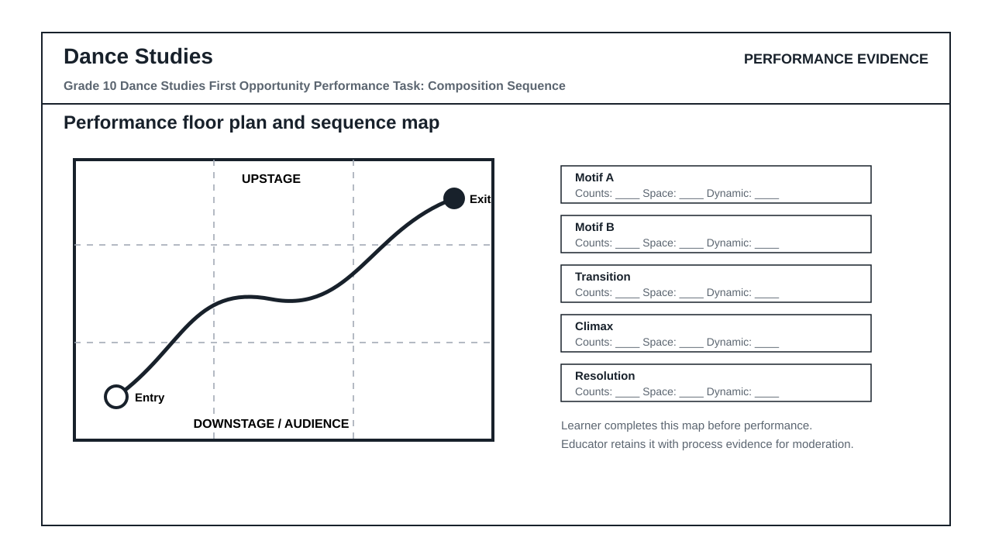
FIGURE 2: Teacher Observation Instrument
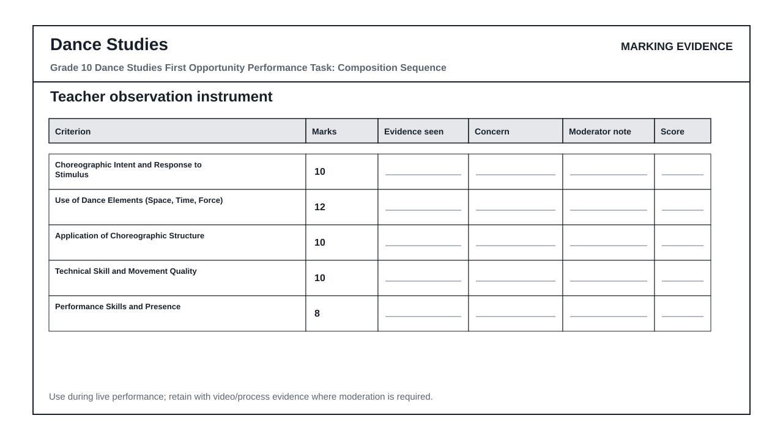

PERFORMANCE ASSESSMENT TASK

COMPOSITION SEQUENCE PERFORMANCE TASK
Brief: Learners must create and perform an original dance composition sequence based on a given stimulus. The sequence must demonstrate understanding of dance elements, choreographic structures, and safe dance practice. Learners will work individually to develop the sequence over four weeks and perform it for assessment. Evidence of process (journal, sketches, music selection) must be retained for moderation. Performance duration: 3–5 minutes.
Context: Stimulus: 'Journey' – interpreted as a physical, emotional, or spiritual progression through space and time. Learners may interpret this through narrative, abstract movement, or cultural motifs, but must justify their choice in the process journal.
1.1 Create and perform an original dance composition sequence (3–5 minutes) in response to the stimulus 'Journey'. The sequence must demonstrate clear choreographic intent, use of dance elements (space, time, force), and application of a choreographic structure (e.g., narrative, binary, ternary, rondo, or collage). (50)

TASK REQUIREMENTS
- Grade 10 PAT 1 - type: composition_sequence, term: 2, marks: 50
- Grade 10 PAT 2 - type: indigenous_or_cross_cultural_dance, term: 3, marks: 50
- Grade 10/11 practical exam - type: practical_performance, marks: 100
- Grade 10/11 theory exam - type: written_theory, marks: 100

ANNUAL ASSESSMENT CONTEXT
- Sba: 25%
- Performance Assessment Tasks: 25%
- Final Examinations: 50%

ASSESSMENT INSTRUMENT
Criterion | Marks | Descriptor
Choreographic Intent and Response to Stimulus | 10 | Outstanding: Clear, sophisticated interpretation of 'Journey' with deep personal/cultural insight; movement choices consistently reflect the stimulus. Meritorious: Clear interpretation with meaningful links to stimulus; minor lapses in consistency. Adequate: Basic interpretation evident; some movement choices lack clear connection. Elementary: Weak or unclear link to stimulus; movement appears random. Not Achieved: No discernible response to stimulus.
Use of Dance Elements (Space, Time, Force) | 12 | Outstanding: Sophisticated and varied use of all three elements; intentional contrasts and developments enhance meaning. Meritorious: Effective use of elements with clear purpose; minor inconsistencies. Adequate: Basic use of elements; limited variation or repetition. Elementary: Minimal or inappropriate use of elements; movement lacks dynamism. Not Achieved: No discernible application of dance elements.
Application of Choreographic Structure | 10 | Outstanding: Structure is innovative, coherent, and enhances the narrative/emotional arc; transitions are seamless and purposeful. Meritorious: Clear and appropriate structure (e.g., binary, ternary); transitions mostly effective. Adequate: Recognisable structure present but transitions are abrupt or unclear. Elementary: Structure is incoherent or absent; movement lacks organisational logic. Not Achieved: No evidence of choreographic structure.
Technical Skill and Movement Quality | 10 | Outstanding: High level of control, alignment, balance, and coordination; movement is expressive and artistically refined. Meritorious: Solid technical foundation; minor lapses in control do not distract from expression. Adequate: Basic technical competence; noticeable limitations in control or alignment affect quality. Elementary: Poor technical control; movement is unsafe or uncontrolled. Not Achieved: Movement poses risk of injury; lacks basic control or safety awareness.
Performance Skills and Presence | 8 | Outstanding: Commanding stage presence; strong focus, projection, and emotional engagement; connects authentically with audience. Meritorious: Clear focus and engagement; occasional lapses in projection. Adequate: Basic awareness of performance; inconsistent focus or energy. Elementary: Minimal engagement; appears distracted or disengaged. Not Achieved: No evidence of performance skills; learner appears unaware of audience or context.

