DANCE STUDIES
GRADE 10 DANCE STUDIES: SECOND OPPORTUNITY CAPS-ALIGNED ASSESSMENT

SUBJECT | DANCE STUDIES
GRADE | 10
ASSESSMENT TASK | GRADE 10 DANCE STUDIES: SECOND OPPORTUNITY CAPS-ALIGNED ASSESSMENT
MARKS | 50
TIME | 2 hours

Educator approval required before classroom use.

INSTRUCTIONS AND INFORMATION
1. This is a practical performance assessment task.
2. The learner performs the task under educator supervision.
3. The educator records observable evidence against the assessment instrument.
4. Written or oral reflection may be assessed only where it supports the performance evidence.
5. Safety and performance-space readiness must be checked before the task begins.

VISUAL MATERIAL
FIGURE 1: Performance Floor Plan And Sequence Map
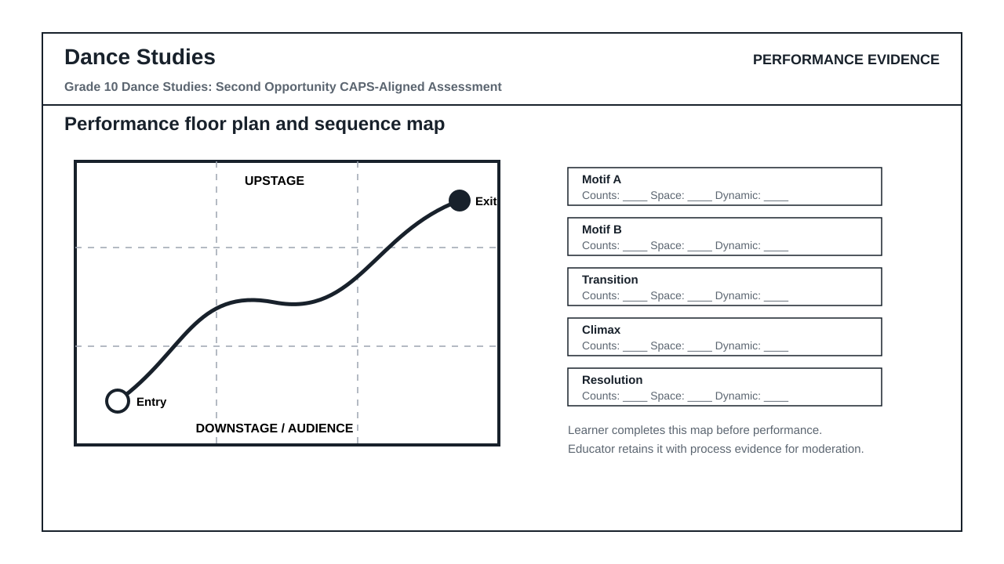
FIGURE 2: Teacher Observation Instrument
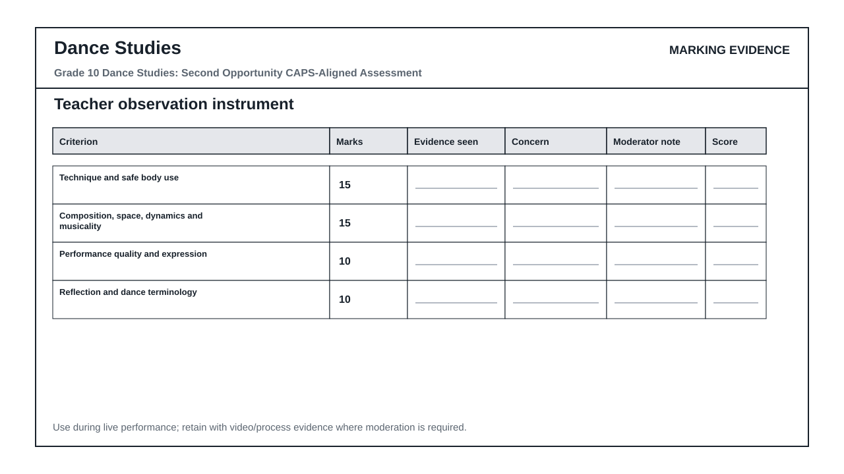

PERFORMANCE ASSESSMENT TASK
Brief: Prepare and perform the required sequence under educator supervision. The educator records observable performance evidence against the rubric.
Context: Use classroom-taught technique, movement vocabulary, composition principles, and safe dance practice.
1.1 Perform the prepared practical sequence according to the task brief and safety conditions. (30)
1.2 Present a short oral or written reflection on movement choices, style, and improvement. (20)

TASK REQUIREMENTS
- Grade 10 PAT 1 - type: composition_sequence, term: 2, marks: 50
- Grade 10 PAT 2 - type: indigenous_or_cross_cultural_dance, term: 3, marks: 50
- Grade 10/11 practical exam - type: practical_performance, marks: 100
- Grade 10/11 theory exam - type: written_theory, marks: 100

ANNUAL ASSESSMENT CONTEXT
- Sba: 25%
- Performance Assessment Tasks: 25%
- Final Examinations: 50%

ASSESSMENT INSTRUMENT
Criterion | Marks | Descriptor
Technique and safe body use | 15 | Accurate, controlled, safe execution of required movement vocabulary.
Composition, space, dynamics and musicality | 15 | Clear movement structure with effective use of space, timing, dynamics and transitions.
Performance quality and expression | 10 | Committed, focused performance with appropriate expressive intent.
Reflection and dance terminology | 10 | Clear reflection using relevant subject vocabulary and evidence from the performed work.

