Natural Sciences: Photosynthesis Learning Pack
  - classroom_bundle | Grade 7 learners and educators
Product | homs
Subject | Natural Sciences
Grade | 7
Curriculum focus | Term 1: Photosynthesis and plant nutrition
Language | English
Version | 1.0.0
CONTROLLED REVIEW ASSET. Human approval is required before external release.

Contents
Update this field in Word or LibreOffice to populate the table of contents.

Learning objective: Explain how green plants use light energy, carbon dioxide and water to produce glucose and oxygen.

1. Core concept
Photosynthesis is the process by which chlorophyll-containing plants convert light energy into stored chemical energy. The process takes place mainly in the leaves.
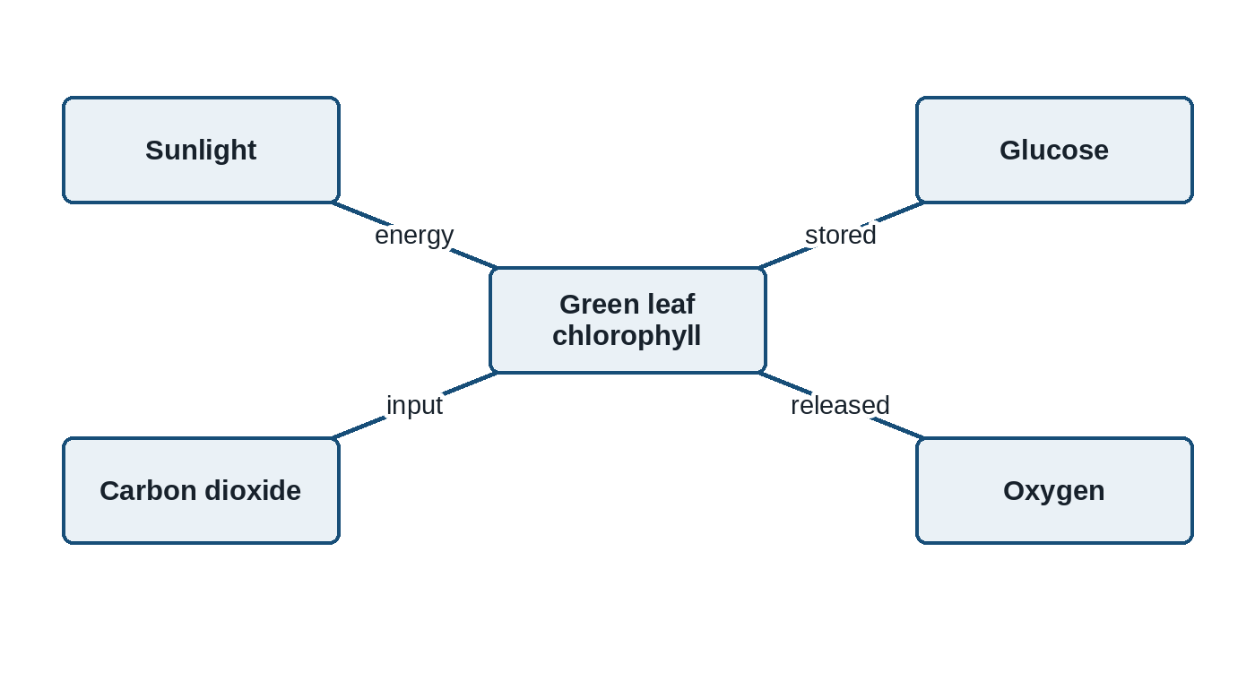
Figure 1: Inputs and products of photosynthesis
carbon dioxide + water -> glucose + oxygen (in the presence of light and chlorophyll)

2. Guided investigation
Teacher note: Prepare one destarched plant and demonstrate the iodine test using the school's approved laboratory safety procedure.

Learner instruction: Record the colour observed before and after iodine is added. Do not handle hot ethanol or an open flame.

Investigation observations
Leaf area | Light exposure | Colour after iodine | Starch present?
Covered section | No direct light | Yellow-brown | No
Exposed section | Direct light | Blue-black | Yes

2.1. Identify the independent variable in this investigation. | (1)

2.2. Use the observations to explain why light is necessary for starch production in the leaf. | (3)

3. Assessment rubric
Explanation rubric
Criterion | 2 marks | 1 mark | 0 marks
Evidence | Uses both observed colours accurately | Uses one relevant observation | No relevant observation
Reasoning | Links light to starch production | States a partial link | No valid scientific link

Annexure A: Educator memorandum
Expected response: 2.1 Light exposure. 2.2 Only the exposed area turned blue-black, showing that starch formed where light was available.

Plants do not absorb food from soil. They manufacture glucose through photosynthesis.

