ENGLISH LANGUAGE
ENGLISH LANGUAGE GRADE 12 SOURCE-EMBEDDED SMOKE TEST

SUBJECT | ENGLISH LANGUAGE
GRADE | 12
ASSESSMENT TASK | ENGLISH LANGUAGE GRADE 12 SOURCE-EMBEDDED SMOKE TEST
MARKS | 31
TIME | 45 minutes

Educator approval required before classroom use.

INSTRUCTIONS AND INFORMATION
1. Read each source text and question carefully.
2. Answer in the language of assessment unless instructed otherwise.
3. Use evidence from the supplied text or visual source where required.
4. Plan written responses before writing the final answer.
5. Write neatly and observe spelling, punctuation, grammar and register.

SOURCE MATERIAL
SOURCE 1: Official-paper exemplar: Text Extract
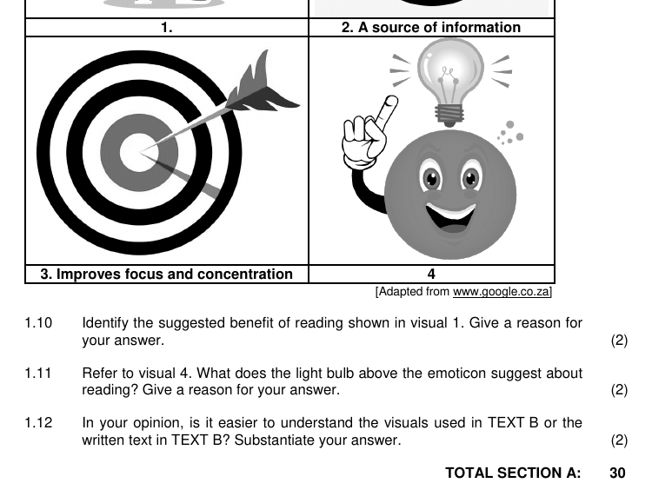
Paper: English First Additional Language P1 November 2024 | Page: 6 | Source Type: text_extract
SOURCE 2: Official-paper exemplar: Cartoon
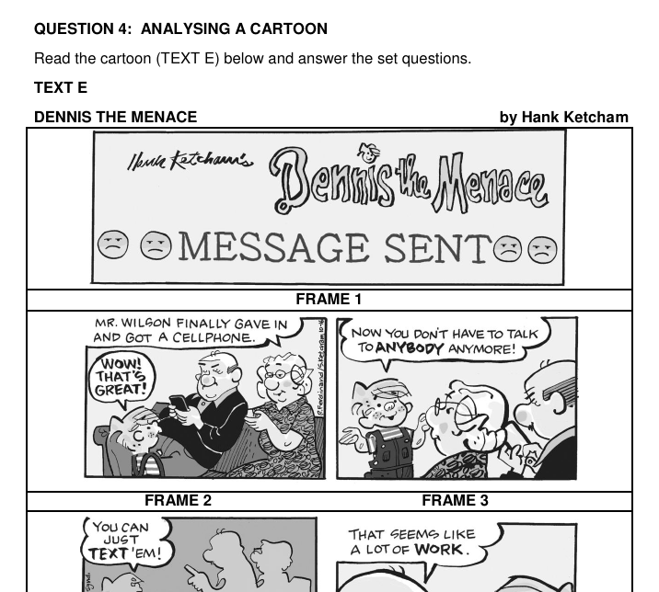
Paper: English First Additional Language P1 November 2024 | Page: 10 | Source Type: cartoon
SOURCE 3: Official-paper exemplar: Data Table

Paper: English First Additional Language P1 November 2024 | Page: 3 | Source Type: data_table
SOURCE 4: Official-paper exemplar: Photograph Or Image
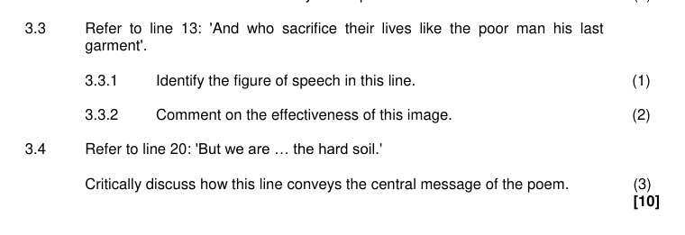
Paper: English Home Language P2 November 2024 | Page: 9 | Source Type: photograph_or_image

VISUAL MATERIAL
FIGURE 1: Text Response And Language Planner
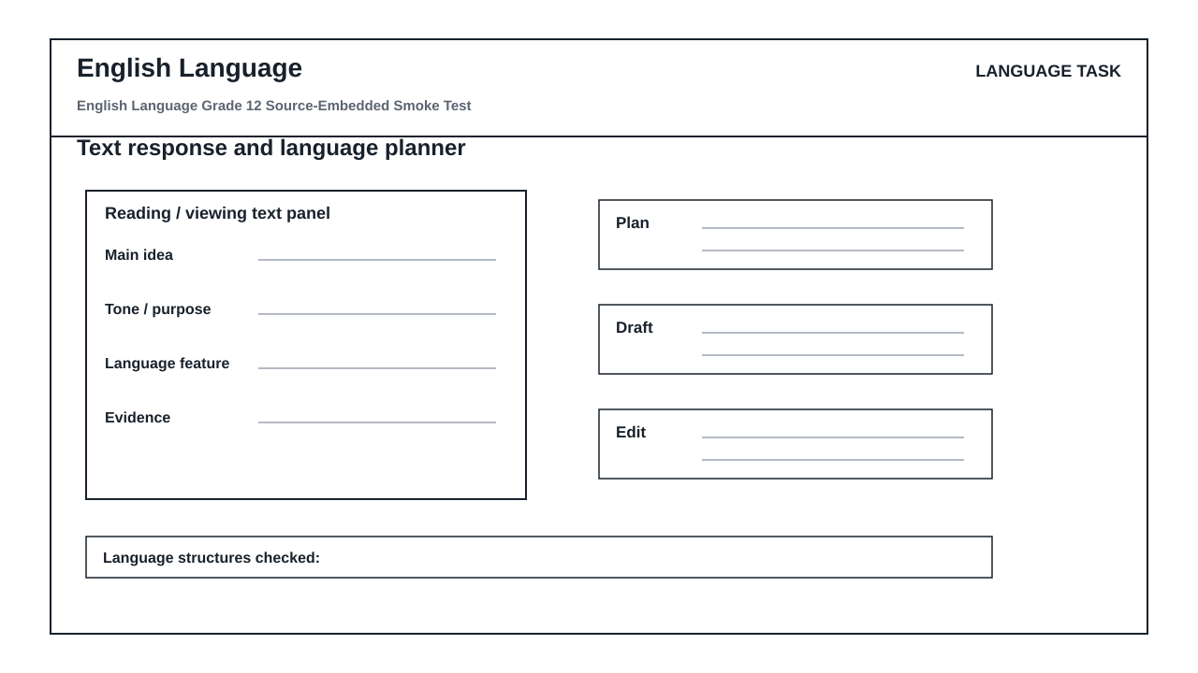

LANGUAGE ASSESSMENT TASK

SECTION 1: SOURCE INTERPRETATION
Instructions: Use the supplied source material. Answer from visible evidence and relevant subject knowledge.
1.1. Refer to SOURCE 1. Identify one important feature of the text extract and explain how it could be used as evidence in English Language. (4)

1.2. Refer to SOURCE 2. Identify one important feature of the cartoon and explain how it could be used as evidence in English Language. (4)

1.3. Refer to SOURCE 3. Identify one important feature of the data table and explain how it could be used as evidence in English Language. (4)

1.4. Refer to SOURCE 4. Identify one important feature of the photograph or image and explain how it could be used as evidence in English Language. (4)

1.5. Compare TWO of the supplied sources. Explain which one would produce the strongest assessment question and why. (5)

SECTION 2: METHOD AND REVIEW
Instructions: Evaluate whether this generated assessment pack is ready for a real learner group.
2.1. State TWO checks an educator must perform before releasing this assessment to learners. (4)

2.2. Explain why official-paper source exemplars are stronger than generic generated visuals for this route. (6)

LANGUAGE TASK CONDITIONS
- Use language-skills integration instead of a generic content subject exam.
- Scale text length, vocabulary, and writing load to the phase.

MARKING GUIDELINE

TASK 1: SOURCE INTERPRETATION
1.1. Refer to SOURCE 1. Identify one important feature of the text extract and explain how it could be used as evidence in English Language. (4)
- Relevant feature from SOURCE 1 is identified.
- Explanation is linked to the subject context.
- Answer uses visible evidence rather than unsupported recall.
1.2. Refer to SOURCE 2. Identify one important feature of the cartoon and explain how it could be used as evidence in English Language. (4)
- Relevant feature from SOURCE 2 is identified.
- Explanation is linked to the subject context.
- Answer uses visible evidence rather than unsupported recall.
1.3. Refer to SOURCE 3. Identify one important feature of the data table and explain how it could be used as evidence in English Language. (4)
- Relevant feature from SOURCE 3 is identified.
- Explanation is linked to the subject context.
- Answer uses visible evidence rather than unsupported recall.
1.4. Refer to SOURCE 4. Identify one important feature of the photograph or image and explain how it could be used as evidence in English Language. (4)
- Relevant feature from SOURCE 4 is identified.
- Explanation is linked to the subject context.
- Answer uses visible evidence rather than unsupported recall.
1.5. Compare TWO of the supplied sources. Explain which one would produce the strongest assessment question and why. (5)
- Two supplied sources are compared.
- A justified judgement is made.
- Reasoning mentions readability, data richness, visual clarity or subject fit.

TASK 2: METHOD AND REVIEW
2.1. State TWO checks an educator must perform before releasing this assessment to learners. (4)
- Check source readability and relevance.
- Check CAPS topic/grade alignment.
- Check mark allocation and memo correctness.
- Check copyright/reuse conditions for source material.
2.2. Explain why official-paper source exemplars are stronger than generic generated visuals for this route. (6)
- They reveal actual source types used in exams.
- They reduce invented visual nonsense.
- They still require adaptation and educator approval.

LANGUAGE RUBRIC
Criterion | Marks | Descriptor
Source evidence use | 10 | Answers use visible evidence from supplied sources.
Subject accuracy | 10 | Answers use correct subject concepts and terminology.
Review readiness | 10 | Risks and approval checks are identified clearly.

EDUCATOR REVIEW CHECKLIST
- Confirm each embedded source is readable after PDF export.
- Confirm source use/copyright status before client delivery.
- Confirm questions refer only to supplied or clearly stated evidence.
- Confirm memo and mark allocation match the subject route.

