GEOGRAPHY
GEOGRAPHY GRADE 12 SOURCE-EMBEDDED SMOKE TEST

SUBJECT | GEOGRAPHY
GRADE | 12
ASSESSMENT TASK | GEOGRAPHY GRADE 12 SOURCE-EMBEDDED SMOKE TEST
MARKS | 31
TIME | 45 minutes

Educator approval required before classroom use.

INSTRUCTIONS AND INFORMATION
1. Read all instructions carefully.
2. Answer all questions or complete all activities as instructed.
3. Show all working where calculations, planning, diagrams or explanations are required.
4. Use the space provided by the educator, answer booklet or learner task book.
5. Write neatly and clearly.

SOURCE MATERIAL
SOURCE 1: Official-paper exemplar: Map Extract
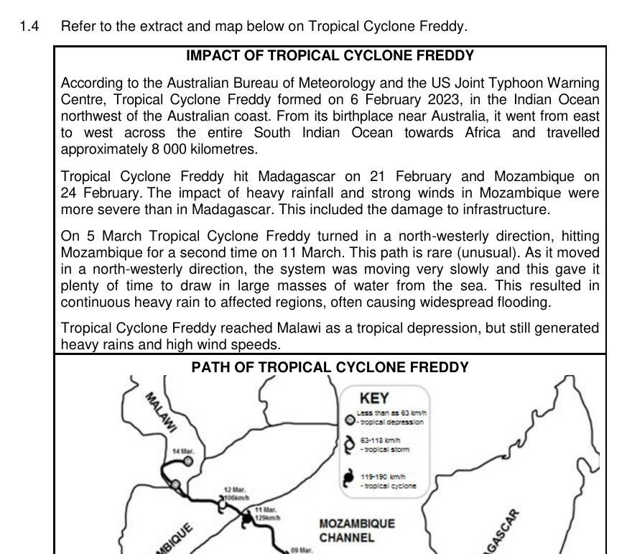
Paper: Geography P1 May June 2024 | Page: 7 | Source Type: map_extract
SOURCE 2: Official-paper exemplar: Synoptic Weather Map
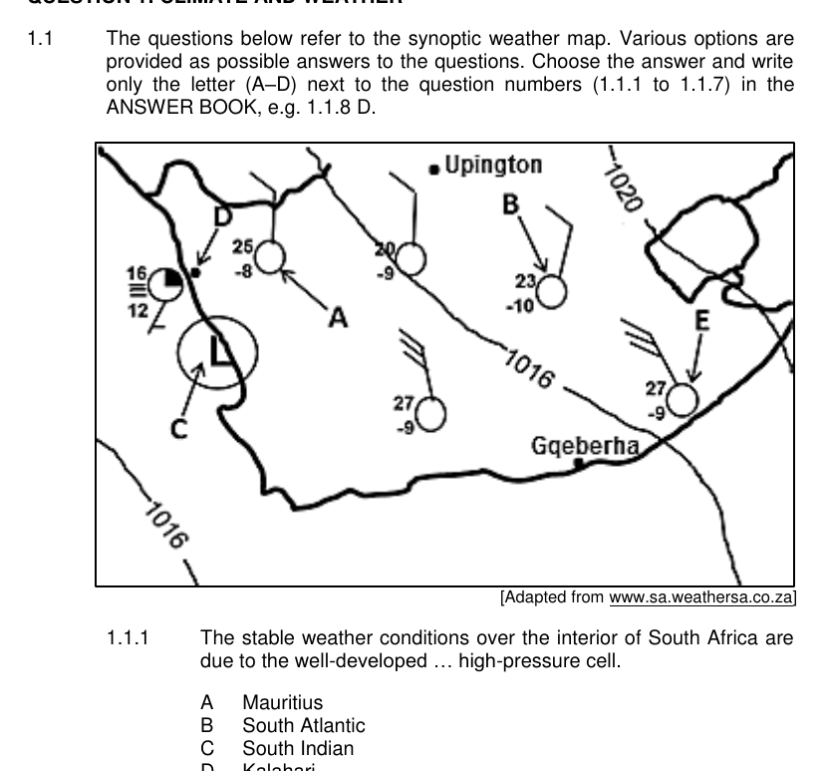
Paper: Geography P1 May June 2024 | Page: 3 | Source Type: synoptic_weather_map
SOURCE 3: Official-paper exemplar: Graph Or Chart
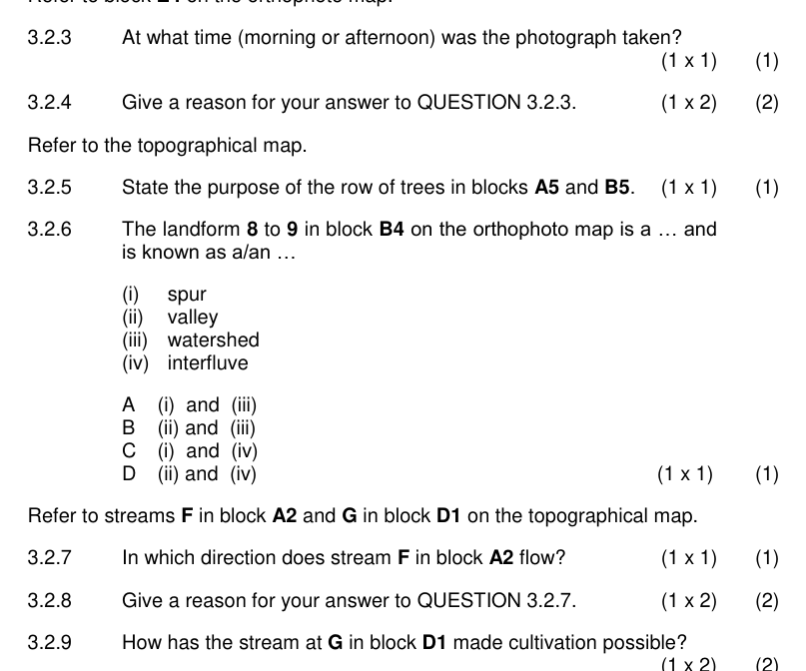
Paper: Geography P1 May June 2024 | Page: 18 | Source Type: graph_or_chart
SOURCE 4: Official-paper exemplar: Photograph Or Image
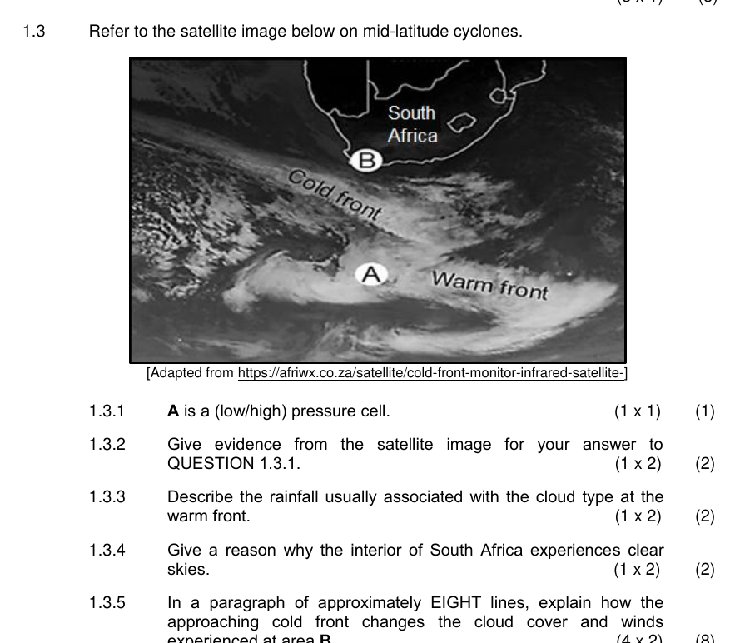
Paper: Geography P1 May June 2024 | Page: 6 | Source Type: photograph_or_image

VISUAL MATERIAL
FIGURE 1: Source Panel And Evidence Table
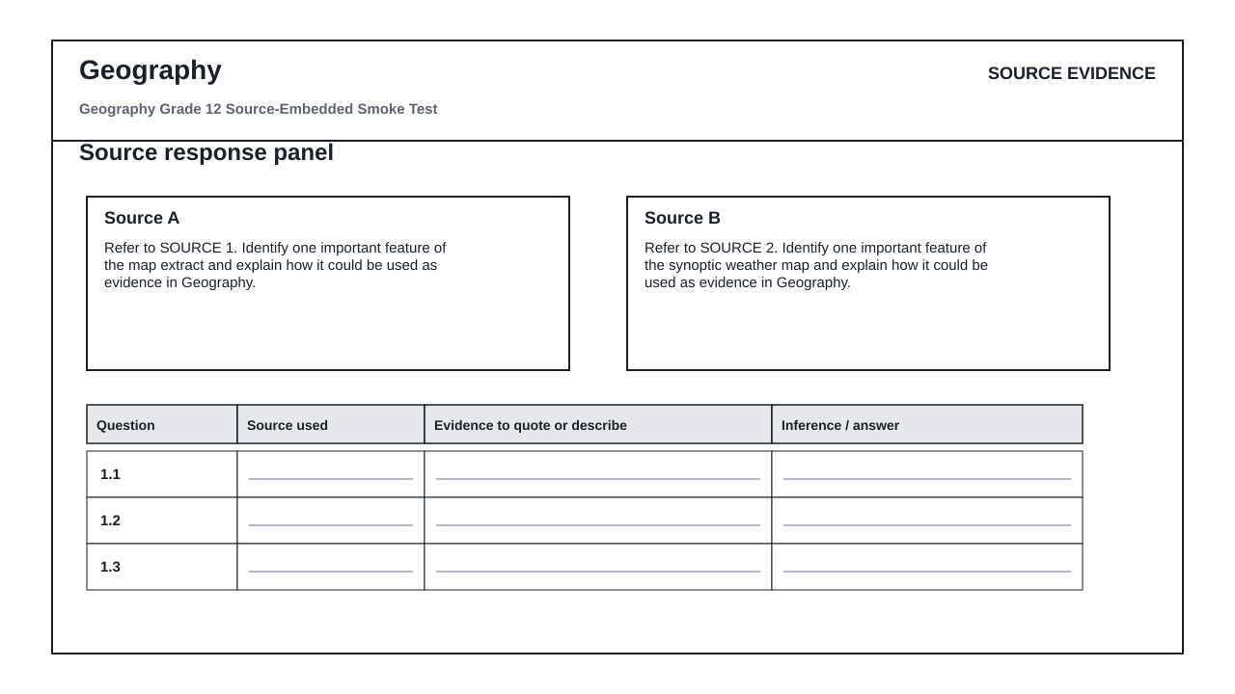

QUESTIONS

QUESTION 1: SOURCE INTERPRETATION
Instructions: Use the supplied source material. Answer from visible evidence and relevant subject knowledge.
1.1. Refer to SOURCE 1. Identify one important feature of the map extract and explain how it could be used as evidence in Geography. (4)

1.2. Refer to SOURCE 2. Identify one important feature of the synoptic weather map and explain how it could be used as evidence in Geography. (4)

1.3. Refer to SOURCE 3. Identify one important feature of the graph or chart and explain how it could be used as evidence in Geography. (4)

1.4. Refer to SOURCE 4. Identify one important feature of the photograph or image and explain how it could be used as evidence in Geography. (4)

1.5. Compare TWO of the supplied sources. Explain which one would produce the strongest assessment question and why. (5)

QUESTION 2: METHOD AND REVIEW
Instructions: Evaluate whether this generated assessment pack is ready for a real learner group.
2.1. State TWO checks an educator must perform before releasing this assessment to learners. (4)

2.2. Explain why official-paper source exemplars are stronger than generic generated visuals for this route. (6)

MARKING GUIDELINE

TASK 1: SOURCE INTERPRETATION
1.1. Refer to SOURCE 1. Identify one important feature of the map extract and explain how it could be used as evidence in Geography. (4)
- Relevant feature from SOURCE 1 is identified.
- Explanation is linked to the subject context.
- Answer uses visible evidence rather than unsupported recall.
1.2. Refer to SOURCE 2. Identify one important feature of the synoptic weather map and explain how it could be used as evidence in Geography. (4)
- Relevant feature from SOURCE 2 is identified.
- Explanation is linked to the subject context.
- Answer uses visible evidence rather than unsupported recall.
1.3. Refer to SOURCE 3. Identify one important feature of the graph or chart and explain how it could be used as evidence in Geography. (4)
- Relevant feature from SOURCE 3 is identified.
- Explanation is linked to the subject context.
- Answer uses visible evidence rather than unsupported recall.
1.4. Refer to SOURCE 4. Identify one important feature of the photograph or image and explain how it could be used as evidence in Geography. (4)
- Relevant feature from SOURCE 4 is identified.
- Explanation is linked to the subject context.
- Answer uses visible evidence rather than unsupported recall.
1.5. Compare TWO of the supplied sources. Explain which one would produce the strongest assessment question and why. (5)
- Two supplied sources are compared.
- A justified judgement is made.
- Reasoning mentions readability, data richness, visual clarity or subject fit.

TASK 2: METHOD AND REVIEW
2.1. State TWO checks an educator must perform before releasing this assessment to learners. (4)
- Check source readability and relevance.
- Check CAPS topic/grade alignment.
- Check mark allocation and memo correctness.
- Check copyright/reuse conditions for source material.
2.2. Explain why official-paper source exemplars are stronger than generic generated visuals for this route. (6)
- They reveal actual source types used in exams.
- They reduce invented visual nonsense.
- They still require adaptation and educator approval.

RUBRIC
Criterion | Marks | Descriptor
Source evidence use | 10 | Answers use visible evidence from supplied sources.
Subject accuracy | 10 | Answers use correct subject concepts and terminology.
Review readiness | 10 | Risks and approval checks are identified clearly.

EDUCATOR REVIEW CHECKLIST
- Confirm each embedded source is readable after PDF export.
- Confirm source use/copyright status before client delivery.
- Confirm questions refer only to supplied or clearly stated evidence.
- Confirm memo and mark allocation match the subject route.

