LIFE ORIENTATION
LIFE ORIENTATION GRADE 12 SOURCE-EMBEDDED SMOKE TEST

SUBJECT | LIFE ORIENTATION
GRADE | 12
ASSESSMENT TASK | LIFE ORIENTATION GRADE 12 SOURCE-EMBEDDED SMOKE TEST
MARKS | 23
TIME | 45 minutes

Educator approval required before classroom use.

INSTRUCTIONS AND INFORMATION
1. This is a practical performance assessment task.
2. The learner performs the task under educator supervision.
3. The educator records observable evidence against the assessment instrument.
4. Written or oral reflection may be assessed only where it supports the performance evidence.
5. Safety and performance-space readiness must be checked before the task begins.

SOURCE MATERIAL
SOURCE 1: Official-paper exemplar: Text Extract

Paper: Life Orientation Paper 1 Afrikaans September 2025 | Page: 6 | Source Type: text_extract
SOURCE 2: Official-paper exemplar: Data Table
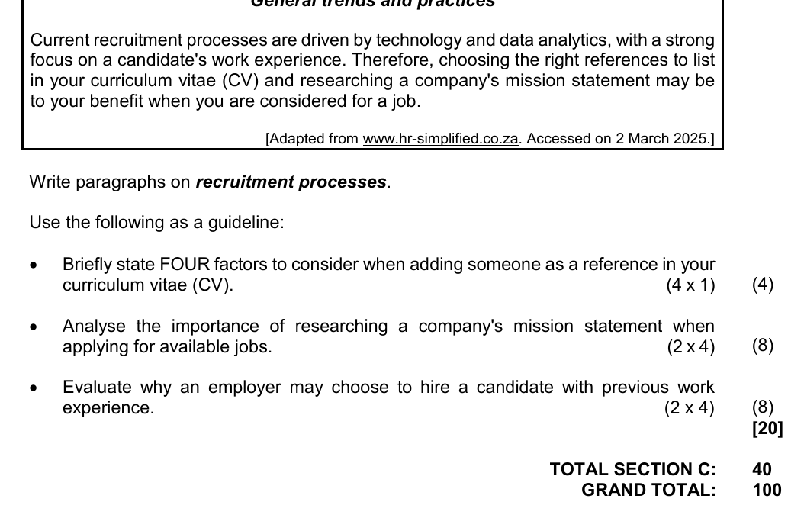
Paper: Life Orientation Paper 1 Afrikaans September 2025 | Page: 10 | Source Type: data_table

VISUAL MATERIAL
FIGURE 1: Performance Floor Plan And Sequence Map
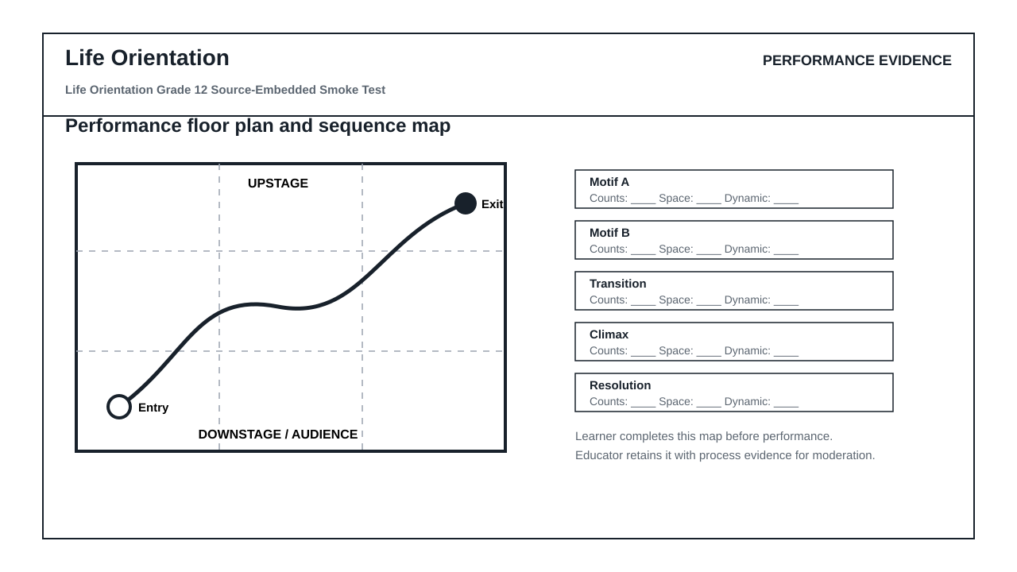
FIGURE 2: Teacher Observation Instrument
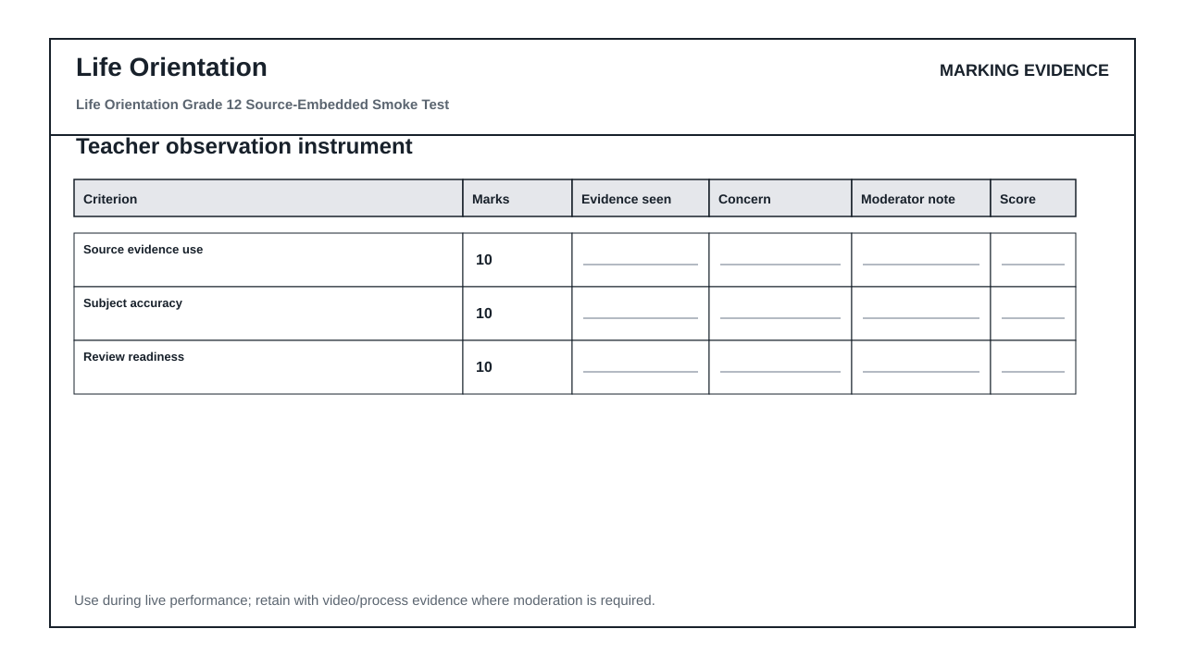

PERFORMANCE ASSESSMENT TASK

SOURCE INTERPRETATION
Brief: Use the supplied source material. Answer from visible evidence and relevant subject knowledge.
1.1 Refer to SOURCE 1. Identify one important feature of the text extract and explain how it could be used as evidence in Life Orientation. (4)
1.2 Refer to SOURCE 2. Identify one important feature of the data table and explain how it could be used as evidence in Life Orientation. (4)
1.3 Compare TWO of the supplied sources. Explain which one would produce the strongest assessment question and why. (5)

METHOD AND REVIEW
Brief: Evaluate whether this generated assessment pack is ready for a real learner group.
2.1 State TWO checks an educator must perform before releasing this assessment to learners. (4)
2.2 Explain why official-paper source exemplars are stronger than generic generated visuals for this route. (6)

ASSESSMENT INSTRUMENT
Criterion | Marks | Descriptor
Source evidence use | 10 | Answers use visible evidence from supplied sources.
Subject accuracy | 10 | Answers use correct subject concepts and terminology.
Review readiness | 10 | Risks and approval checks are identified clearly.

MARKING GUIDELINE

TASK 1: SOURCE INTERPRETATION
1.1. Refer to SOURCE 1. Identify one important feature of the text extract and explain how it could be used as evidence in Life Orientation. (4)
- Relevant feature from SOURCE 1 is identified.
- Explanation is linked to the subject context.
- Answer uses visible evidence rather than unsupported recall.
1.2. Refer to SOURCE 2. Identify one important feature of the data table and explain how it could be used as evidence in Life Orientation. (4)
- Relevant feature from SOURCE 2 is identified.
- Explanation is linked to the subject context.
- Answer uses visible evidence rather than unsupported recall.
1.3. Compare TWO of the supplied sources. Explain which one would produce the strongest assessment question and why. (5)
- Two supplied sources are compared.
- A justified judgement is made.
- Reasoning mentions readability, data richness, visual clarity or subject fit.

TASK 2: METHOD AND REVIEW
2.1. State TWO checks an educator must perform before releasing this assessment to learners. (4)
- Check source readability and relevance.
- Check CAPS topic/grade alignment.
- Check mark allocation and memo correctness.
- Check copyright/reuse conditions for source material.
2.2. Explain why official-paper source exemplars are stronger than generic generated visuals for this route. (6)
- They reveal actual source types used in exams.
- They reduce invented visual nonsense.
- They still require adaptation and educator approval.

EDUCATOR REVIEW CHECKLIST
- Confirm each embedded source is readable after PDF export.
- Confirm source use/copyright status before client delivery.
- Confirm questions refer only to supplied or clearly stated evidence.
- Confirm memo and mark allocation match the subject route.

