MATHEMATICS
MATHEMATICS GRADE 12 SOURCE-EMBEDDED SMOKE TEST

SUBJECT | MATHEMATICS
GRADE | 12
ASSESSMENT TASK | MATHEMATICS GRADE 12 SOURCE-EMBEDDED SMOKE TEST
MARKS | 27
TIME | 45 minutes

Educator approval required before classroom use.

INSTRUCTIONS AND INFORMATION
1. Read all instructions carefully.
2. Answer all questions or complete all activities as instructed.
3. Show all working where calculations, planning, diagrams or explanations are required.
4. Use the space provided by the educator, answer booklet or learner task book.
5. Write neatly and clearly.
6. Do not use a calculator unless the educator allows it.

SOURCE MATERIAL
SOURCE 1: Official-paper exemplar: Diagram Or Model
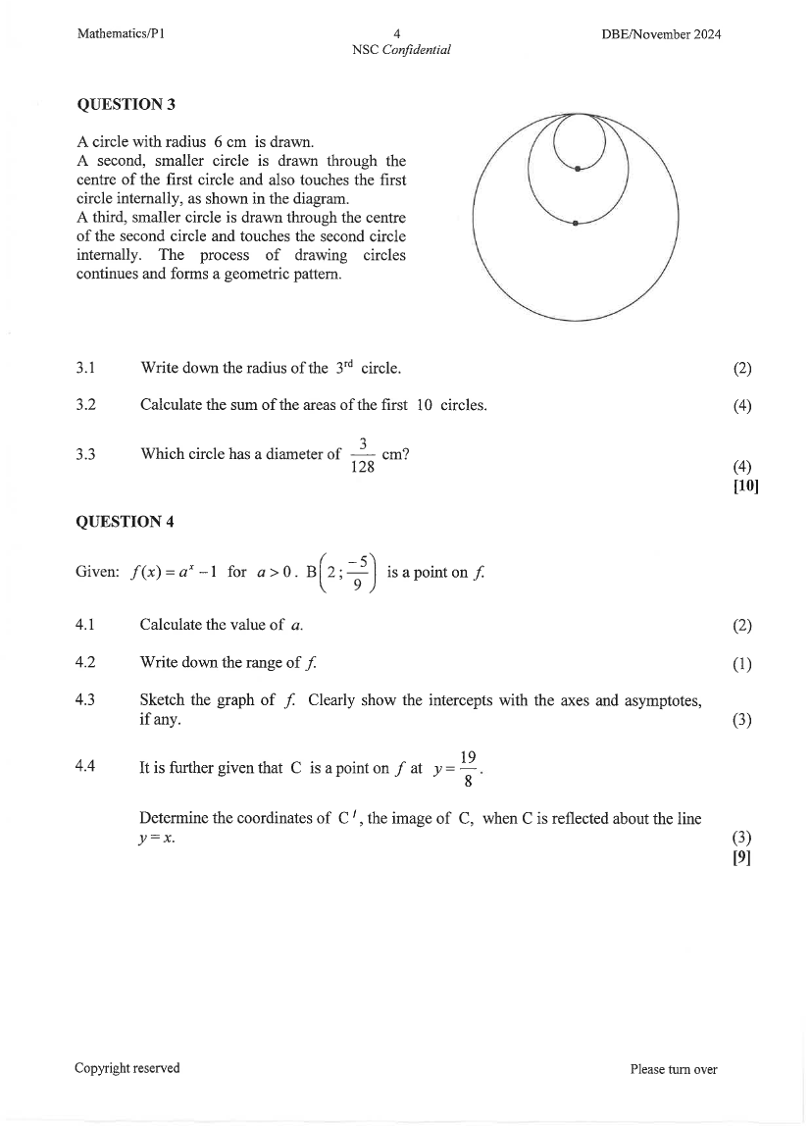
Paper: Mathematics P1 November 2024 | Page: 4 | Source Type: diagram_or_model
SOURCE 2: Official-paper exemplar: Graph Or Chart

Paper: Mathematics P1 November 2024 | Page: 4 | Source Type: graph_or_chart
SOURCE 3: Official-paper exemplar: Data Table
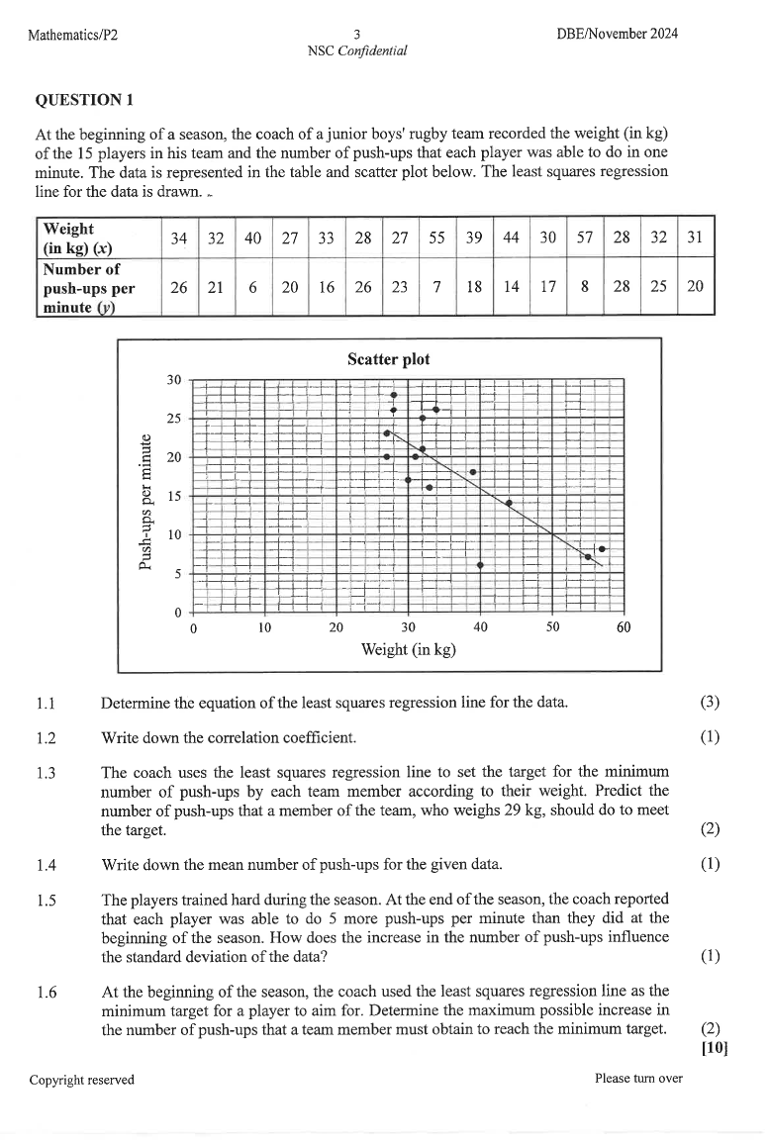
Paper: Mathematics P2 November 2024 | Page: 3 | Source Type: data_table

VISUAL MATERIAL
FIGURE 1: Working Grid And Method Marks
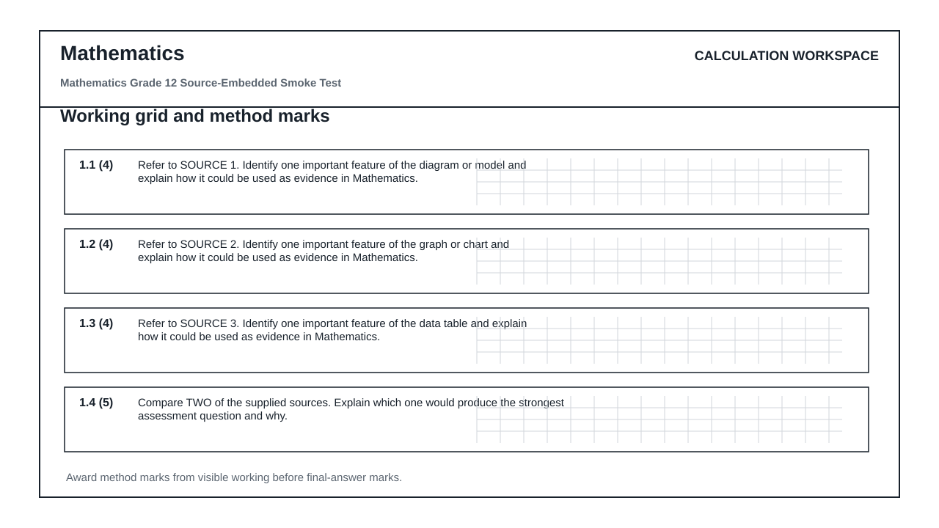

QUESTIONS

QUESTION 1: SOURCE INTERPRETATION
Instructions: Use the supplied source material. Answer from visible evidence and relevant subject knowledge.
1.1. Refer to SOURCE 1. Identify one important feature of the diagram or model and explain how it could be used as evidence in Mathematics. (4)

1.2. Refer to SOURCE 2. Identify one important feature of the graph or chart and explain how it could be used as evidence in Mathematics. (4)

1.3. Refer to SOURCE 3. Identify one important feature of the data table and explain how it could be used as evidence in Mathematics. (4)

1.4. Compare TWO of the supplied sources. Explain which one would produce the strongest assessment question and why. (5)

QUESTION 2: METHOD AND REVIEW
Instructions: Evaluate whether this generated assessment pack is ready for a real learner group.
2.1. State TWO checks an educator must perform before releasing this assessment to learners. (4)

2.2. Explain why official-paper source exemplars are stronger than generic generated visuals for this route. (6)

MARKING GUIDELINE

TASK 1: SOURCE INTERPRETATION
1.1. Refer to SOURCE 1. Identify one important feature of the diagram or model and explain how it could be used as evidence in Mathematics. (4)
- Relevant feature from SOURCE 1 is identified.
- Explanation is linked to the subject context.
- Answer uses visible evidence rather than unsupported recall.
1.2. Refer to SOURCE 2. Identify one important feature of the graph or chart and explain how it could be used as evidence in Mathematics. (4)
- Relevant feature from SOURCE 2 is identified.
- Explanation is linked to the subject context.
- Answer uses visible evidence rather than unsupported recall.
1.3. Refer to SOURCE 3. Identify one important feature of the data table and explain how it could be used as evidence in Mathematics. (4)
- Relevant feature from SOURCE 3 is identified.
- Explanation is linked to the subject context.
- Answer uses visible evidence rather than unsupported recall.
1.4. Compare TWO of the supplied sources. Explain which one would produce the strongest assessment question and why. (5)
- Two supplied sources are compared.
- A justified judgement is made.
- Reasoning mentions readability, data richness, visual clarity or subject fit.

TASK 2: METHOD AND REVIEW
2.1. State TWO checks an educator must perform before releasing this assessment to learners. (4)
- Check source readability and relevance.
- Check CAPS topic/grade alignment.
- Check mark allocation and memo correctness.
- Check copyright/reuse conditions for source material.
2.2. Explain why official-paper source exemplars are stronger than generic generated visuals for this route. (6)
- They reveal actual source types used in exams.
- They reduce invented visual nonsense.
- They still require adaptation and educator approval.

RUBRIC
Criterion | Marks | Descriptor
Source evidence use | 10 | Answers use visible evidence from supplied sources.
Subject accuracy | 10 | Answers use correct subject concepts and terminology.
Review readiness | 10 | Risks and approval checks are identified clearly.

EDUCATOR REVIEW CHECKLIST
- Confirm each embedded source is readable after PDF export.
- Confirm source use/copyright status before client delivery.
- Confirm questions refer only to supplied or clearly stated evidence.
- Confirm memo and mark allocation match the subject route.

