LIFE ORIENTATION
GRADE 12 LIFE ORIENTATION: EVIDENCE-FIRST CAPS ASSESSMENT

SUBJECT | LIFE ORIENTATION
GRADE | 12
ASSESSMENT TASK | GRADE 12 LIFE ORIENTATION: EVIDENCE-FIRST CAPS ASSESSMENT
MARKS | 50
TIME | 2 hours

Educator approval required before classroom use.

INSTRUCTIONS AND INFORMATION
1. This is a practical performance assessment task.
2. The learner performs the task under educator supervision.
3. The educator records observable evidence against the assessment instrument.
4. Written or oral reflection may be assessed only where it supports the performance evidence.
5. Safety and performance-space readiness must be checked before the task begins.

EVIDENCE / STIMULUS MATERIAL
Scenario A: Youth Leadership and Community Safety Initiative in a Rural Township
Type: constructed classroom evidence | Provenance: Constructed CAPS-aligned classroom stimulus for educator review | Date: Not applicable | Context: Grade 12 Life Orientation, FET phase, Term 2: Social and environmental responsibility; aligns with CAPS focus on youth participation in community development and applying decision-making skills to real-life scenarios.
In the rural township of Phola Park, Grade 12 learners from three local high schools have noticed a rise in petty crime and vandalism around the community centre and sports field after school hours. Interviews with elders reveal that youth feel disconnected from local governance, while a recent SAPS report indicates a 30% increase in minor offences linked to idle time and lack of recreational facilities. In response, a group of learners has proposed a Youth Safety Ambassadors programme, which would train 30 students in conflict mediation, basic first aid, and peer mentoring. The initiative requires approval from the School Governing Body (SGB), support from the local municipality for use of the community hall, and partnership with a local NGO that offers life skills training. Learners must present a proposal outlining goals, resource needs, risk management, and sustainability plans.
Decision Tool B: Ethical Decision-Making Framework for Community Projects
Type: constructed classroom evidence | Provenance: Constructed CAPS-aligned classroom stimulus for educator review | Date: Not applicable | Context: Grade 12 Life Orientation, FET phase, Term 2: Decision-making skills and ethical reasoning; supports CAPS requirement for learners to apply values-based decision-making in social and environmental contexts.
Before launching any community initiative, learners are encouraged to use this structured decision-making tool to assess proposals. The framework includes four filters: (1) Rights and Responsibilities – Does the action uphold constitutional rights (e.g., safety, participation) and respect duties to others? (2) Consequences – What are the short- and long-term effects on individuals, groups, and the environment? (3) Fairness and Justice – Does the initiative treat all stakeholders equitably, especially vulnerable groups? (4) Care and Integrity – Does it reflect empathy, honesty, and a commitment to the common good? Each filter is rated on a scale of 1 (poor) to 5 (excellent), with a total score of 16 or higher indicating strong ethical alignment. The tool also requires identification of at least two potential risks and corresponding mitigation strategies.

VISUAL MATERIAL
FIGURE 1: Case Facts And Decision Table
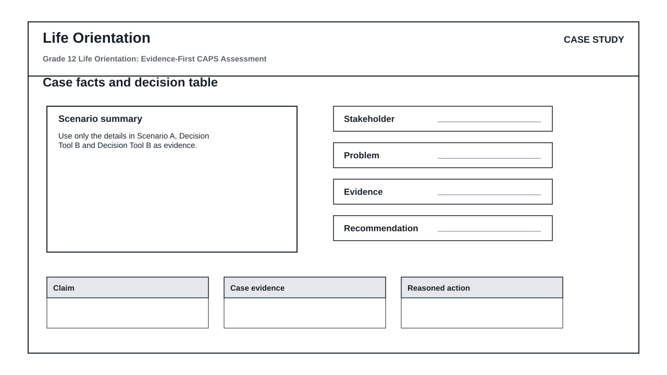

PERFORMANCE ASSESSMENT TASK

SECTION A: EVIDENCE-BASED RESPONSE
Brief: Read Scenario A and Decision Tool B carefully before answering.
Context: Use only the details in Scenario A, Decision Tool B and Decision Tool B as evidence.
1.1 Identify the main issue, idea or message in Scenario A and support your answer with one detail from the evidence. (25)
1.2 Explain how a detail in Decision Tool B affects the meaning, decision or viewpoint. (12)
1.3 Write a structured response that uses Scenario A and Decision Tool B to justify a conclusion or recommendation. (13)

ASSESSMENT INSTRUMENT
Criterion | Marks | Descriptor
Scenario comprehension and evidence use | 25 | Uses supplied evidence accurately.
Interpretation and explanation | 12 | Explains meaning, consequence or viewpoint clearly.
Structured response | 13 | Uses evidence to support a coherent conclusion or recommendation.

