LIFE ORIENTATION
GRADE 12 LIFE ORIENTATION: EVIDENCE-FIRST CAPS ASSESSMENT

SUBJECT | LIFE ORIENTATION
GRADE | 12
ASSESSMENT TASK | GRADE 12 LIFE ORIENTATION: EVIDENCE-FIRST CAPS ASSESSMENT
MARKS | 50
TIME | 2 hours

Educator approval required before classroom use.

INSTRUCTIONS AND INFORMATION
1. This is a practical performance assessment task.
2. The learner performs the task under educator supervision.
3. The educator records observable evidence against the assessment instrument.
4. Written or oral reflection may be assessed only where it supports the performance evidence.
5. Safety and performance-space readiness must be checked before the task begins.

EVIDENCE / STIMULUS MATERIAL
Scenario A: Community Health Campaign Dilemma
Type: constructed classroom evidence | Provenance: Constructed CAPS-aligned classroom stimulus for educator review | Date: Not applicable | Context: This scenario reflects real-world tensions in Life Orientation education between promoting comprehensive sexual health education and navigating cultural or religious community values, particularly in rural South African contexts. It aligns with CAPS Grade 12 Term 2 focus on 'Social and environmental responsibility' and 'Democracy and human rights'.
In a rural community in KwaZulu-Natal, a group of Grade 12 learners from Siyabonga Secondary School launched a health awareness campaign to address rising rates of teenage pregnancy and HIV/AIDS. The campaign, titled 'Know Your Status, Protect Your Future', included peer education workshops, distribution of informational pamphlets, and partnerships with the local clinic. However, after three months, the school governing body raised concerns that some parents felt the campaign promoted sexual activity among minors, despite the learners' emphasis on abstinence and safe sex education. The learners now face a decision: continue the campaign as is, modify it to focus solely on abstinence, or discontinue it due to community pushback.
Decision Tool B: Ethical Decision-Making Framework for Health Campaigns
Type: constructed classroom evidence | Provenance: Constructed CAPS-aligned classroom stimulus for educator review | Date: Not applicable | Context: This decision tool supports learners in applying constitutional values and ethical reasoning to community health dilemmas, directly supporting CAPS Grade 12 topics on 'Citizenship education', 'Human rights', and 'Social responsibility'. It provides a scaffold for analysing Scenario A.
When facing community opposition to health initiatives, learners should use this structured approach: (1) Identify the core values at stake (e.g., health, autonomy, cultural respect); (2) Gather accurate data from trusted sources (e.g., clinic statistics, national health policies); (3) Consult stakeholders respectfully (learners, parents, teachers, health workers); (4) Evaluate options against constitutional rights (Section 27: access to healthcare; Section 10: human dignity); (5) Choose an action that promotes health equity while minimizing harm; (6) Reflect on outcomes and be prepared to adapt. This tool is adapted from the Life Orientation CAPS emphasis on applying democratic values and human rights to real-life contexts.

VISUAL MATERIAL
FIGURE 1: Case Facts And Decision Table
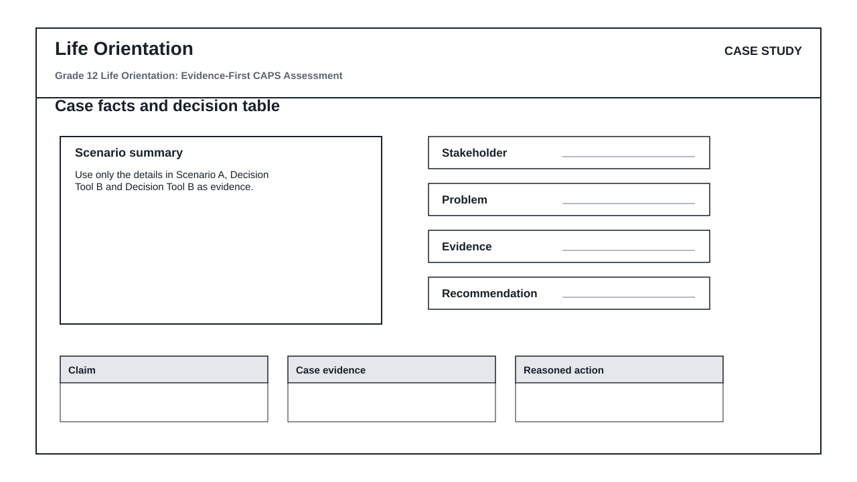

PERFORMANCE ASSESSMENT TASK

SECTION A: EVIDENCE-BASED RESPONSE
Brief: Read Scenario A and Decision Tool B carefully before answering.
Context: Use only the details in Scenario A, Decision Tool B and Decision Tool B as evidence.
1.1 Identify the main issue, idea or message in Scenario A and support your answer with one detail from the evidence. (25)
1.2 Explain how a detail in Decision Tool B affects the meaning, decision or viewpoint. (12)
1.3 Write a structured response that uses Scenario A and Decision Tool B to justify a conclusion or recommendation. (13)

ASSESSMENT INSTRUMENT
Criterion | Marks | Descriptor
Scenario comprehension and evidence use | 25 | Uses supplied evidence accurately.
Interpretation and explanation | 12 | Explains meaning, consequence or viewpoint clearly.
Structured response | 13 | Uses evidence to support a coherent conclusion or recommendation.

MARKING GUIDELINE

TASK 1: SECTION A: EVIDENCE-BASED RESPONSE
1.1. Identify the main issue, idea or message in Scenario A and support your answer with one detail from the evidence. (25)
- Credit a valid point supported by evidence from Scenario A.
1.2. Explain how a detail in Decision Tool B affects the meaning, decision or viewpoint. (12)
- Credit accurate interpretation of Decision Tool B and a clear explanation.
1.3. Write a structured response that uses Scenario A and Decision Tool B to justify a conclusion or recommendation. (13)
- Credit a coherent response that uses evidence from Scenario A and Decision Tool B.

EDUCATOR REVIEW CHECKLIST
- Confirm CAPS topic scope and grade level.
- Confirm the evidence/stimulus cards are suitable and school-safe.
- Confirm every evidence-dependent question cites a supplied label.
- Approve memo and mark allocation before classroom use.

