GEOGRAPHY
GEOGRAPHY GRADE 12 TERM 3 ECONOMIC GEOGRAPHY CONTROLLED TEST

SUBJECT | GEOGRAPHY
GRADE | 12
ASSESSMENT TASK | GEOGRAPHY GRADE 12 TERM 3 ECONOMIC GEOGRAPHY CONTROLLED TEST
MARKS | 50
TIME | 1.5 hours

Educator approval required before classroom use.

INSTRUCTIONS AND INFORMATION
1. Read all instructions carefully.
2. Answer all questions or complete all activities as instructed.
3. Show all working where calculations, planning, diagrams or explanations are required.
4. Use the space provided by the educator, answer booklet or learner task book.
5. Write neatly and clearly.

SOURCE MATERIAL
SOURCE 1: Mbali Economic Development Corridor map
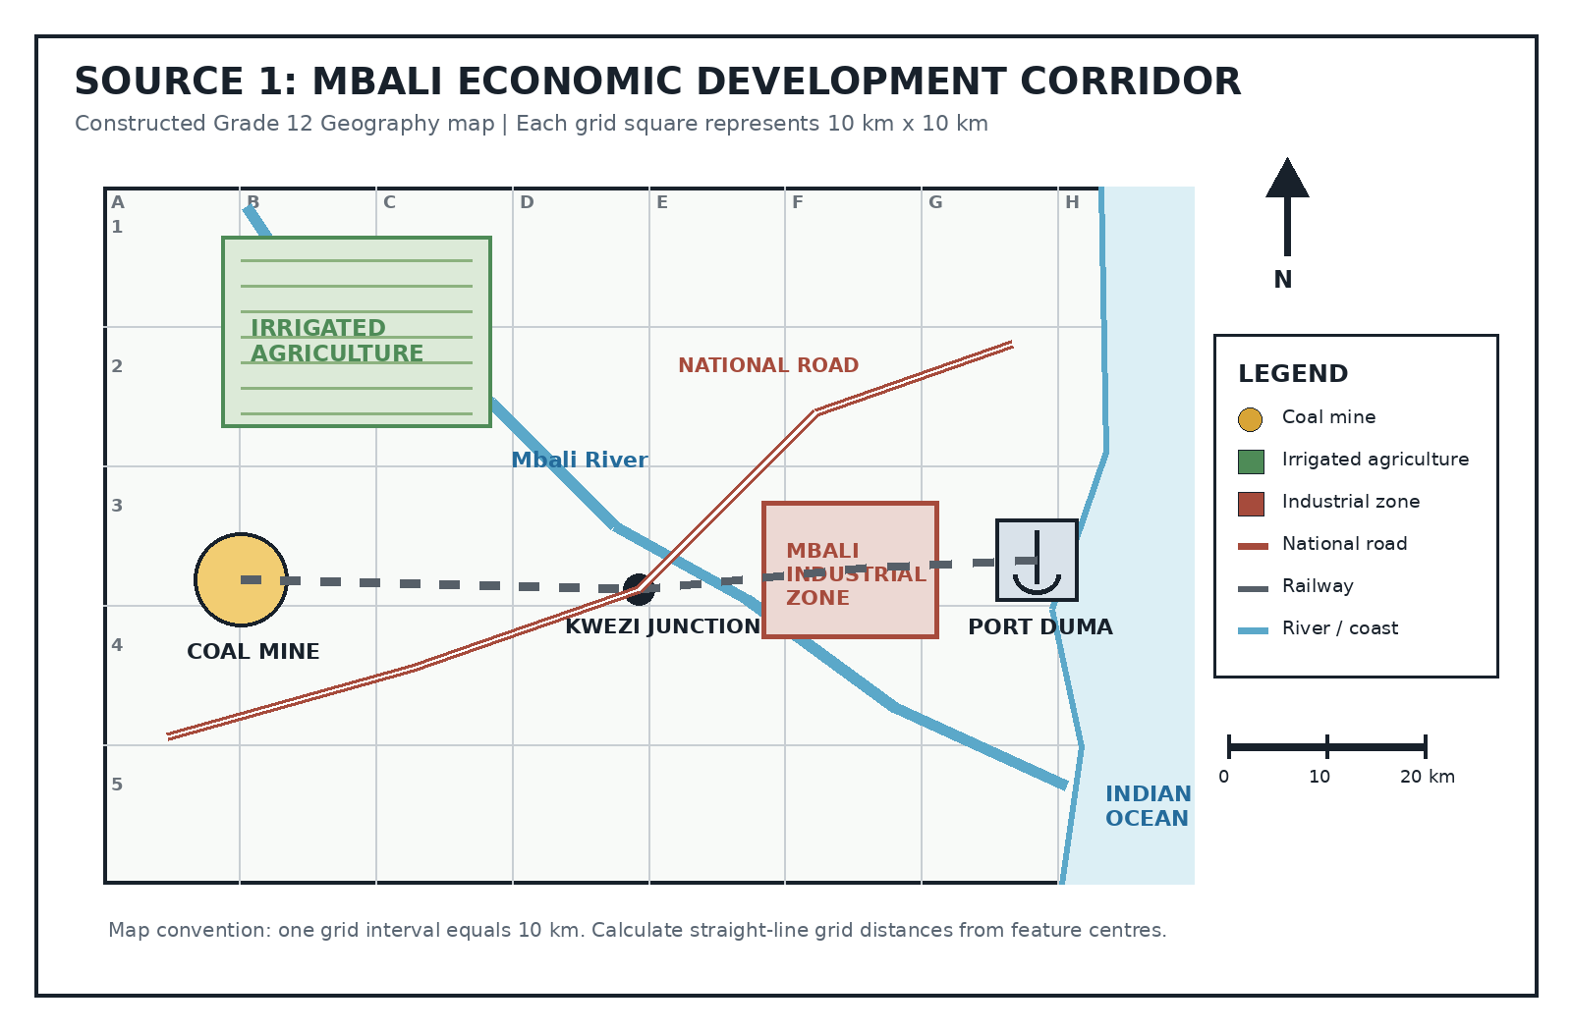
Source Type: Map Extract
SOURCE 2: Mbali Corridor economic data
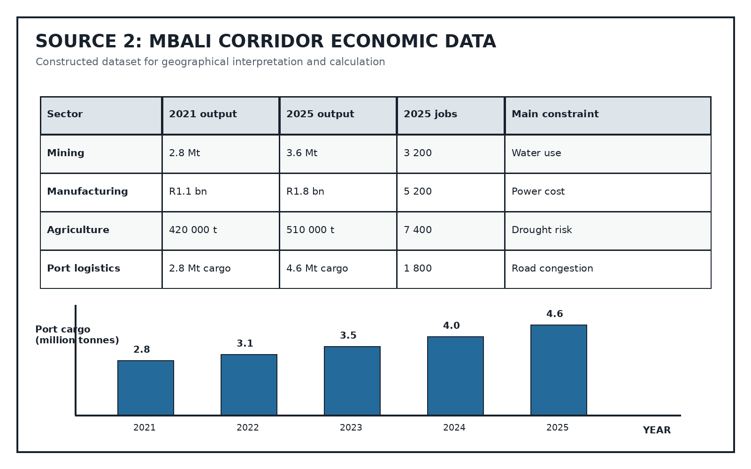
Source Type: Data Table

EVIDENCE / STIMULUS MATERIAL
SOURCE 3: Planning the Mbali Development Corridor
Type: constructed case-study extract | Provenance: Constructed CAPS-aligned economic-geography case study for educator review. | Date: Planning scenario | Context: A fictional regional planning case used with Sources 1 and 2.
The Mbali corridor authority plans to expand mineral processing near Kwezi Junction and move more freight by rail to Port Duma. Supporters argue that beneficiation will increase the value of raw coal before export, create manufacturing employment and stimulate local services. Farmers welcome improved transport but are concerned that industry and mining may compete with irrigation for water from the Mbali River. The port municipality expects higher revenue, yet road congestion and informal settlement growth are already placing pressure on housing, waste collection and public transport. The plan proposes solar generation for the industrial zone, a freight-rail upgrade, water recycling at processing plants and a protected buffer along the river. Critics question whether the new jobs will be accessible to local workers without a parallel skills programme.

QUESTIONS

QUESTION 1: MAP AND SPATIAL INTERPRETATION
Instructions: Use Source 1. Show calculations where required.
Stimulus: Refer to SOURCE 1.
1.1. State the general direction of Port Duma from the coal mine. (1)
1.2. Using the grid scale, calculate the approximate straight-line distance from the coal mine to the Mbali Industrial Zone. Show your calculation. (2)
1.3. Identify TWO location factors visible on the map that favour industry at the Mbali Industrial Zone. Explain the value of each factor. (4)
1.4. Explain how the transport network creates a development corridor between the coal mine, the industrial zone and Port Duma. (4)
1.5. Explain TWO economic linkages that could develop between irrigated agriculture and the industrial/port nodes. (4)
1.6. Assess ONE environmental risk shown by the location pattern and recommend a practical management response. (5)

QUESTION 2: ECONOMIC DATA INTERPRETATION
Instructions: Use Source 2 and show all calculations.
Stimulus: Refer to SOURCE 2.
2.1. Which sector provided the most jobs in 2025? (1)
2.2. Calculate the percentage increase in port cargo from 2021 to 2025. Use: change / original x 100. (3)
2.3. Compare the contribution of mining and manufacturing to the corridor economy using TWO data-based observations. (4)
2.4. Explain how growth in port cargo could produce a multiplier effect in the corridor. (3)
2.5. Evaluate TWO limitations of Source 2 when judging whether corridor development is socially and environmentally sustainable. (4)

QUESTION 3: INTEGRATED ECONOMIC-GEOGRAPHY RESPONSE
Instructions: Use Sources 1, 2 and 3 in your response.
Stimulus: Refer to SOURCE 1, SOURCE 2 and SOURCE 3.
3.1. Explain how beneficiation and improved freight rail could strengthen the Mbali corridor. Use at least TWO sources. (5)
3.2. Write a geographical paragraph evaluating whether the proposed corridor expansion is likely to be sustainable. Reach a supported judgement. (10)

