LIFE SCIENCES
LIFE SCIENCES GRADE 12 TERM 3 EVOLUTION CONTROLLED TEST

SUBJECT | LIFE SCIENCES
GRADE | 12
ASSESSMENT TASK | LIFE SCIENCES GRADE 12 TERM 3 EVOLUTION CONTROLLED TEST
MARKS | 50
TIME | 1.5 hours

Educator approval required before classroom use.

INSTRUCTIONS AND INFORMATION
1. Read all instructions carefully.
2. Answer all questions or complete all activities as instructed.
3. Show all working where calculations, planning, diagrams or explanations are required.
4. Use the space provided by the educator, answer booklet or learner task book.
5. Write neatly and clearly.

SOURCE MATERIAL
SOURCE 1: Finch beak depth and drought selection
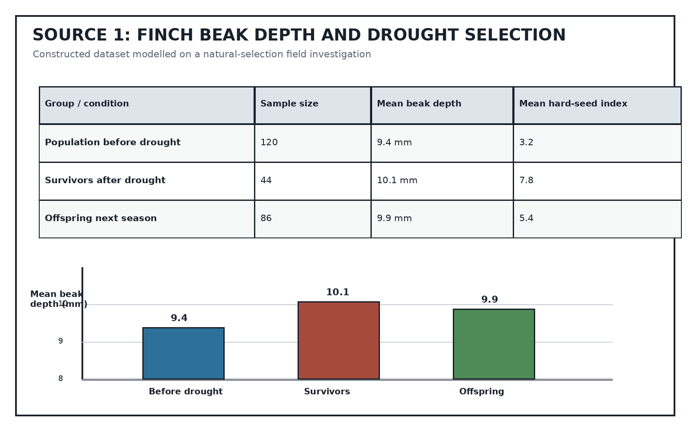
Source Type: Data Table And Graph
SOURCE 2: Hominin evidence table and timeline
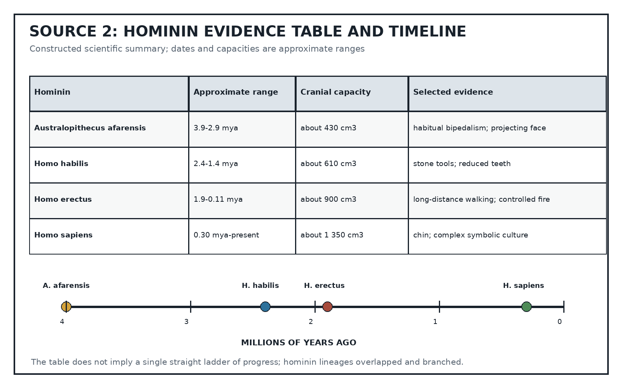
Source Type: Scientific Evidence Table
SOURCE 3: Insecticide-resistance investigation
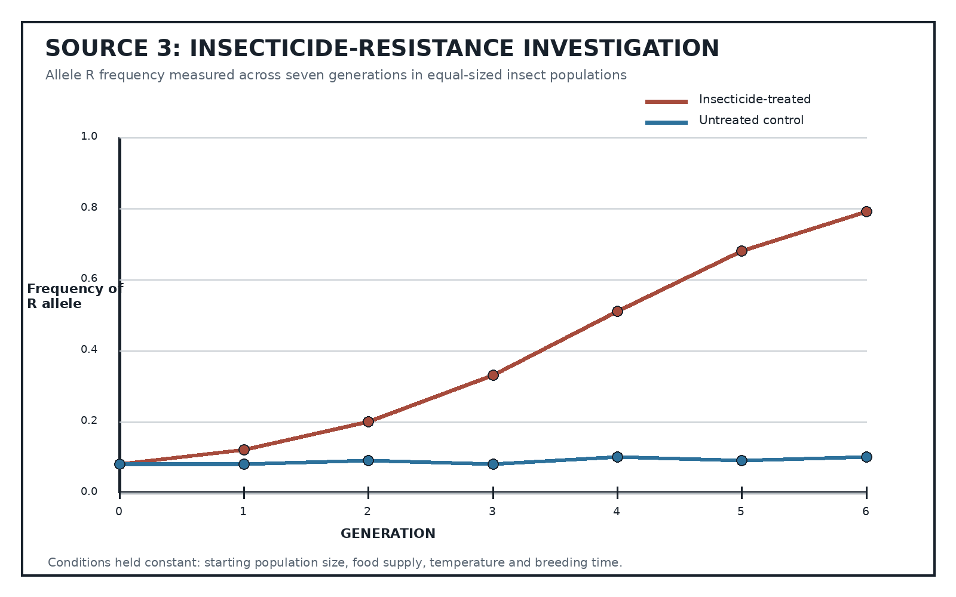
Source Type: Investigation Graph

QUESTIONS

QUESTION 1: EVOLUTION CORE CONCEPTS
Instructions: Answer the questions using correct biological terminology.
1.1. Define biological evolution. (2)
1.2. Distinguish between a scientific hypothesis and a scientific theory. (2)
1.3. Explain why genetic variation is necessary for natural selection to occur. (3)
1.4. State TWO sources of genetic variation in a sexually reproducing population. (2)
1.5. State the role of reproductive isolation in speciation. (1)

QUESTION 2: NATURAL SELECTION IN FINCHES
Instructions: Use Source 1. Show calculations where required.
Stimulus: Refer to SOURCE 1.
2.1. Calculate the increase in mean beak depth from the pre-drought population to the survivors. (2)
2.2. Describe TWO patterns shown by the table and graph. (3)
2.3. Explain why birds with deeper beaks were more likely to survive the drought. (3)
2.4. Use Source 1 to explain natural selection across the three groups. (4)
2.5. Suggest ONE additional measurement that would strengthen the investigation and explain why. (3)

QUESTION 3: EVIDENCE FOR HUMAN EVOLUTION
Instructions: Use Source 2. Treat the table as a summary of approximate scientific evidence.
Stimulus: Refer to SOURCE 2.
3.1. Compare Australopithecus afarensis and Homo erectus using THREE features from Source 2. (3)
3.2. Describe the general trend in cranial capacity shown in Source 2 and state ONE limitation of using cranial capacity alone to judge evolutionary relationships. (3)
3.3. Explain why the timeline should not be interpreted as a single straight 'ladder of progress'. (4)

QUESTION 4: INSECTICIDE RESISTANCE INVESTIGATION
Instructions: Use Source 3. Show calculations where required.
Stimulus: Refer to SOURCE 3.
4.1. Identify the independent variable in the investigation. (1)
4.2. Describe the trend in frequency of the R allele in the treated population. (2)
4.3. Calculate the change in R-allele frequency in the treated population from generation 0 to generation 6. (3)
4.4. Explain the change in R-allele frequency in terms of natural selection. Do not state that individual insects changed because they needed to. (5)
4.5. Evaluate the reliability of the investigation and recommend ONE improvement. (4)

