LIFE SCIENCES
LIFE SCIENCES GRADE 12 TERM 3 EVOLUTION CONTROLLED TEST

SUBJECT | LIFE SCIENCES
GRADE | 12
ASSESSMENT TASK | LIFE SCIENCES GRADE 12 TERM 3 EVOLUTION CONTROLLED TEST
MARKS | 50
TIME | 1.5 hours

Educator approval required before classroom use.

INSTRUCTIONS AND INFORMATION
1. Read all instructions carefully.
2. Answer all questions or complete all activities as instructed.
3. Show all working where calculations, planning, diagrams or explanations are required.
4. Use the space provided by the educator, answer booklet or learner task book.
5. Write neatly and clearly.

SOURCE MATERIAL
SOURCE 1: Finch beak depth and drought selection
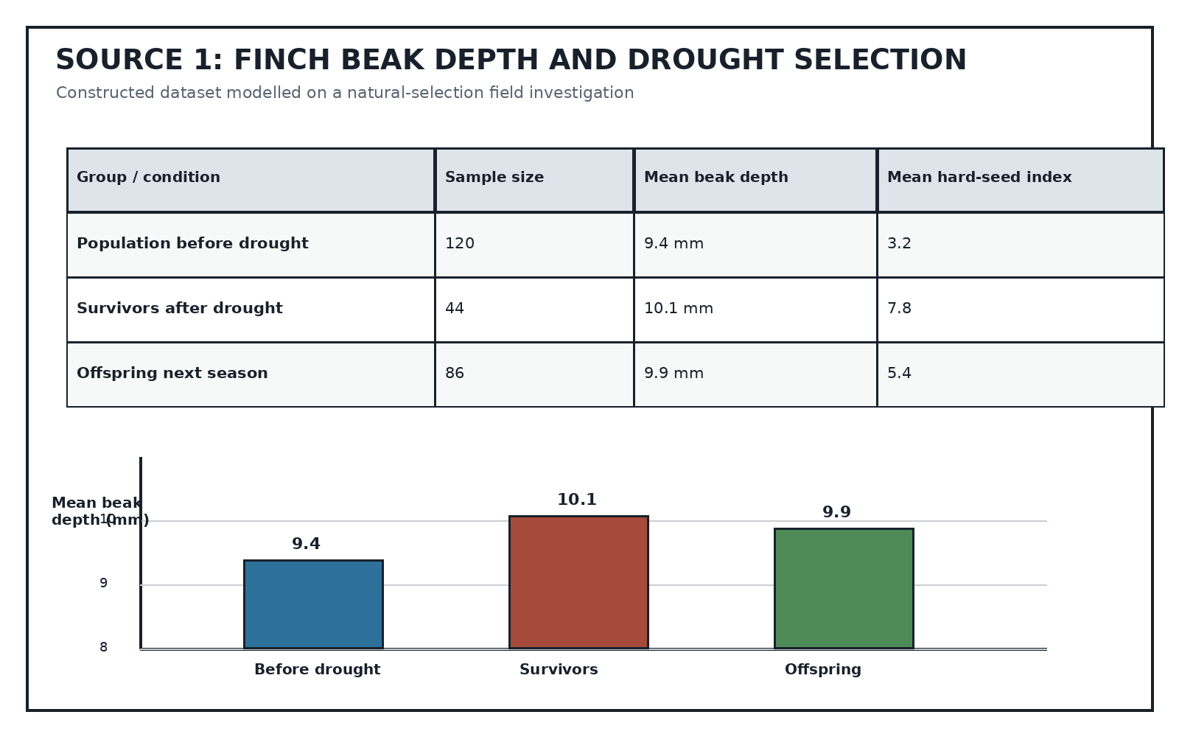
Source Type: Data Table And Graph
SOURCE 2: Hominin evidence table and timeline
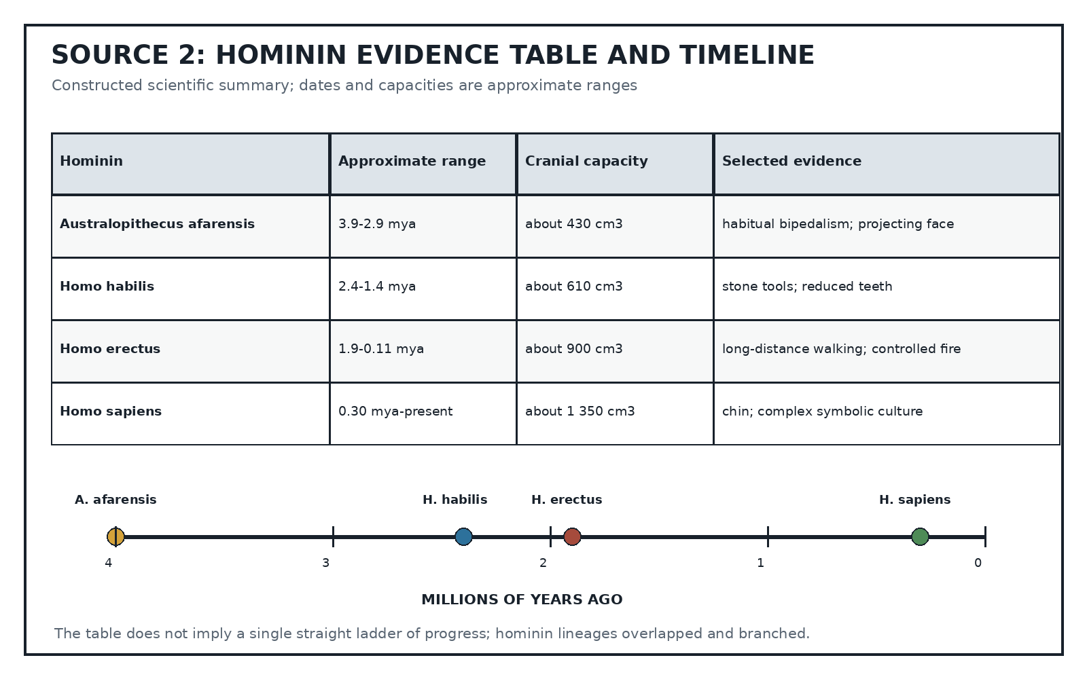
Source Type: Scientific Evidence Table
SOURCE 3: Insecticide-resistance investigation
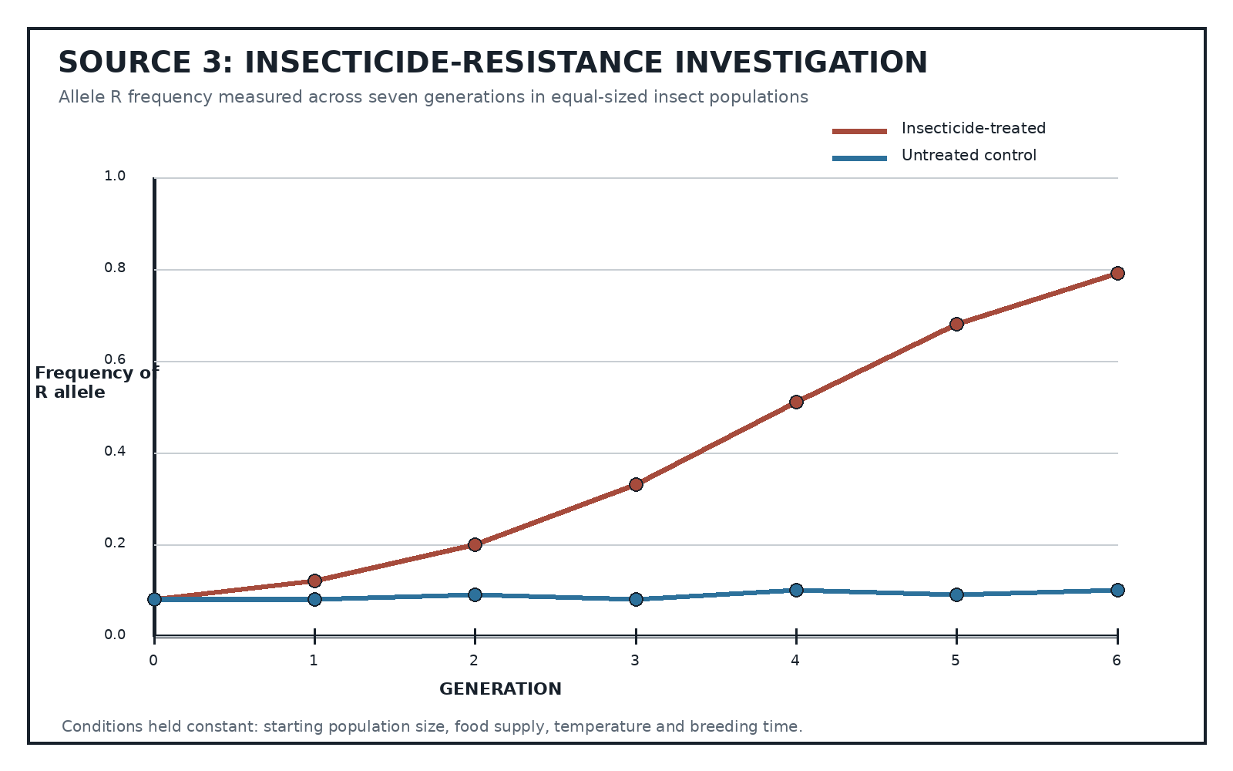
Source Type: Investigation Graph

QUESTIONS

QUESTION 1: EVOLUTION CORE CONCEPTS
Instructions: Answer the questions using correct biological terminology.
1.1. Define biological evolution. (2)
1.2. Distinguish between a scientific hypothesis and a scientific theory. (2)
1.3. Explain why genetic variation is necessary for natural selection to occur. (3)
1.4. State TWO sources of genetic variation in a sexually reproducing population. (2)
1.5. State the role of reproductive isolation in speciation. (1)

QUESTION 2: NATURAL SELECTION IN FINCHES
Instructions: Use Source 1. Show calculations where required.
Stimulus: Refer to SOURCE 1.
2.1. Calculate the increase in mean beak depth from the pre-drought population to the survivors. (2)
2.2. Describe TWO patterns shown by the table and graph. (3)
2.3. Explain why birds with deeper beaks were more likely to survive the drought. (3)
2.4. Use Source 1 to explain natural selection across the three groups. (4)
2.5. Suggest ONE additional measurement that would strengthen the investigation and explain why. (3)

QUESTION 3: EVIDENCE FOR HUMAN EVOLUTION
Instructions: Use Source 2. Treat the table as a summary of approximate scientific evidence.
Stimulus: Refer to SOURCE 2.
3.1. Compare Australopithecus afarensis and Homo erectus using THREE features from Source 2. (3)
3.2. Describe the general trend in cranial capacity shown in Source 2 and state ONE limitation of using cranial capacity alone to judge evolutionary relationships. (3)
3.3. Explain why the timeline should not be interpreted as a single straight 'ladder of progress'. (4)

QUESTION 4: INSECTICIDE RESISTANCE INVESTIGATION
Instructions: Use Source 3. Show calculations where required.
Stimulus: Refer to SOURCE 3.
4.1. Identify the independent variable in the investigation. (1)
4.2. Describe the trend in frequency of the R allele in the treated population. (2)
4.3. Calculate the change in R-allele frequency in the treated population from generation 0 to generation 6. (3)
4.4. Explain the change in R-allele frequency in terms of natural selection. Do not state that individual insects changed because they needed to. (5)
4.5. Evaluate the reliability of the investigation and recommend ONE improvement. (4)

MARKING GUIDELINE

TASK 1: QUESTION 1: EVOLUTION CORE CONCEPTS
1.1. Define biological evolution. (2)
- A change in the inherited characteristics/allele frequencies of a population over successive generations.
1.2. Distinguish between a scientific hypothesis and a scientific theory. (2)
- A hypothesis is a testable proposed explanation.
- A theory is a broad explanation supported by extensive evidence and repeated testing.
1.3. Explain why genetic variation is necessary for natural selection to occur. (3)
- Individuals must differ in inherited traits.
- Some variants improve survival/reproduction in a given environment.
- Those alleles are passed on more frequently.
1.4. State TWO sources of genetic variation in a sexually reproducing population. (2)
- Any two: mutation; crossing over; independent assortment; random fertilisation.
1.5. State the role of reproductive isolation in speciation. (1)
- It prevents gene flow, allowing populations to diverge into separate species.

TASK 2: QUESTION 2: NATURAL SELECTION IN FINCHES
2.1. Calculate the increase in mean beak depth from the pre-drought population to the survivors. (2)
- 10.1 - 9.4 = 0.7 mm.
2.2. Describe TWO patterns shown by the table and graph. (3)
- Survivors had the greatest mean beak depth.
- Offspring retained a greater mean than the pre-drought population.
- Hard-seed availability increased during the drought and then declined.
2.3. Explain why birds with deeper beaks were more likely to survive the drought. (3)
- Drought reduced softer seeds and increased the proportion of hard seeds.
- Deeper/stronger beaks could crack hard seeds more effectively.
- Those birds obtained more food and survived/reproduced.
2.4. Use Source 1 to explain natural selection across the three groups. (4)
- Variation in beak depth existed before the drought.
- The changed food environment created selection pressure.
- Deeper-beaked birds survived disproportionately.
- Their offspring inherited alleles associated with greater beak depth, shifting the population mean.
2.5. Suggest ONE additional measurement that would strengthen the investigation and explain why. (3)
- Examples: individual survival/reproductive success, seed-size distribution, parent-offspring beak measurements, repeated seasons.
- The explanation must show how the measurement tests inheritance, selection pressure or repeatability.

TASK 3: QUESTION 3: EVIDENCE FOR HUMAN EVOLUTION
3.1. Compare Australopithecus afarensis and Homo erectus using THREE features from Source 2. (3)
- H. erectus is more recent; has a larger cranial capacity; and shows evidence of long-distance walking/fire, while A. afarensis shows earlier bipedalism and a projecting face.
3.2. Describe the general trend in cranial capacity shown in Source 2 and state ONE limitation of using cranial capacity alone to judge evolutionary relationships. (3)
- General increase from about 430 cm3 to about 1 350 cm3.
- Capacity alone does not establish ancestry/intelligence and must be combined with age, anatomy, DNA and other evidence.
3.3. Explain why the timeline should not be interpreted as a single straight 'ladder of progress'. (4)
- Evolution branches rather than moving toward a predetermined goal.
- Different hominin species overlapped in time.
- A later species is not automatically a direct descendant of every earlier species.
- Relationships require multiple lines of evidence.

TASK 4: QUESTION 4: INSECTICIDE RESISTANCE INVESTIGATION
4.1. Identify the independent variable in the investigation. (1)
- Exposure to insecticide / treatment condition.
4.2. Describe the trend in frequency of the R allele in the treated population. (2)
- It increased each generation, from 0.08 to 0.79, with faster increase after generation 2.
4.3. Calculate the change in R-allele frequency in the treated population from generation 0 to generation 6. (3)
- 0.79 - 0.08 = 0.71, or 71 percentage points.
4.4. Explain the change in R-allele frequency in terms of natural selection. Do not state that individual insects changed because they needed to. (5)
- Resistance variation already existed in the starting population.
- Insecticide acted as a selection pressure.
- Susceptible insects died more frequently.
- Resistant insects survived and reproduced.
- The R allele was inherited more often, increasing its frequency over generations.
4.5. Evaluate the reliability of the investigation and recommend ONE improvement. (4)
- A control and constant conditions improve reliability.
- One population/run may not represent natural populations.
- Improve by repeating with multiple populations/larger samples and reporting variation/error bars.

RUBRIC
Criterion | Marks | Descriptor
Question 1: Core concepts | 10 | Credit accurate biological definitions and causal explanation.
Question 2: Finch selection | 15 | Credit calculation, data interpretation and natural-selection reasoning.
Question 3: Human-evolution evidence | 10 | Credit comparison, trend interpretation and evidence-aware reasoning.
Question 4: Resistance investigation | 15 | Credit variable identification, calculation, selection mechanism and reliability evaluation.

EDUCATOR REVIEW CHECKLIST
- Confirm Grade 12 Term 3 evolution scope and terminology.
- Verify all calculations and acceptable biological alternatives.
- Confirm that no diagram implies a linear ladder of human evolution.
- Approve the paper and memorandum before classroom use.

