MATHEMATICS
MATHEMATICS GRADE 12 TERM 3 CONTROLLED TEST

SUBJECT | MATHEMATICS
GRADE | 12
ASSESSMENT TASK | MATHEMATICS GRADE 12 TERM 3 CONTROLLED TEST
MARKS | 50
TIME | 1.5 hours

Educator approval required before classroom use.

INSTRUCTIONS AND INFORMATION
1. Read all instructions carefully.
2. Answer all questions or complete all activities as instructed.
3. Show all working where calculations, planning, diagrams or explanations are required.
4. Use the space provided by the educator, answer booklet or learner task book.
5. Write neatly and clearly.
6. Do not use a calculator unless the educator allows it.

SOURCE MATERIAL
SOURCE 1: Similar triangles
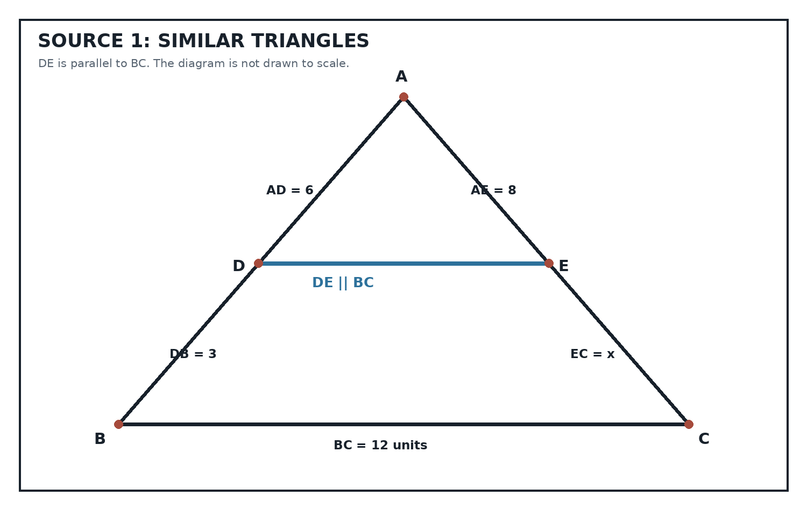
Source Type: Euclidean Geometry Diagram
SOURCE 2: Regression and correlation dataset
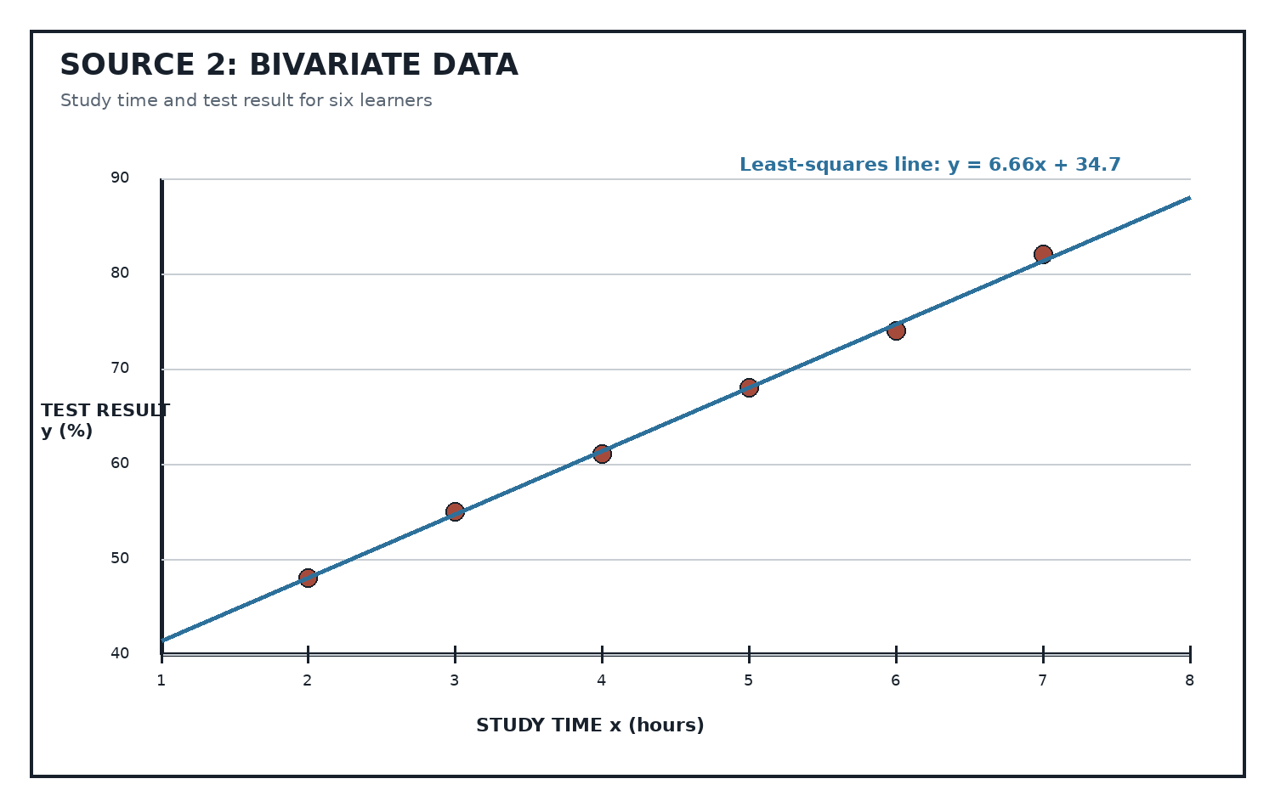
Source Type: Scatterplot And Regression Line
SOURCE 3: Quality-control probability tree
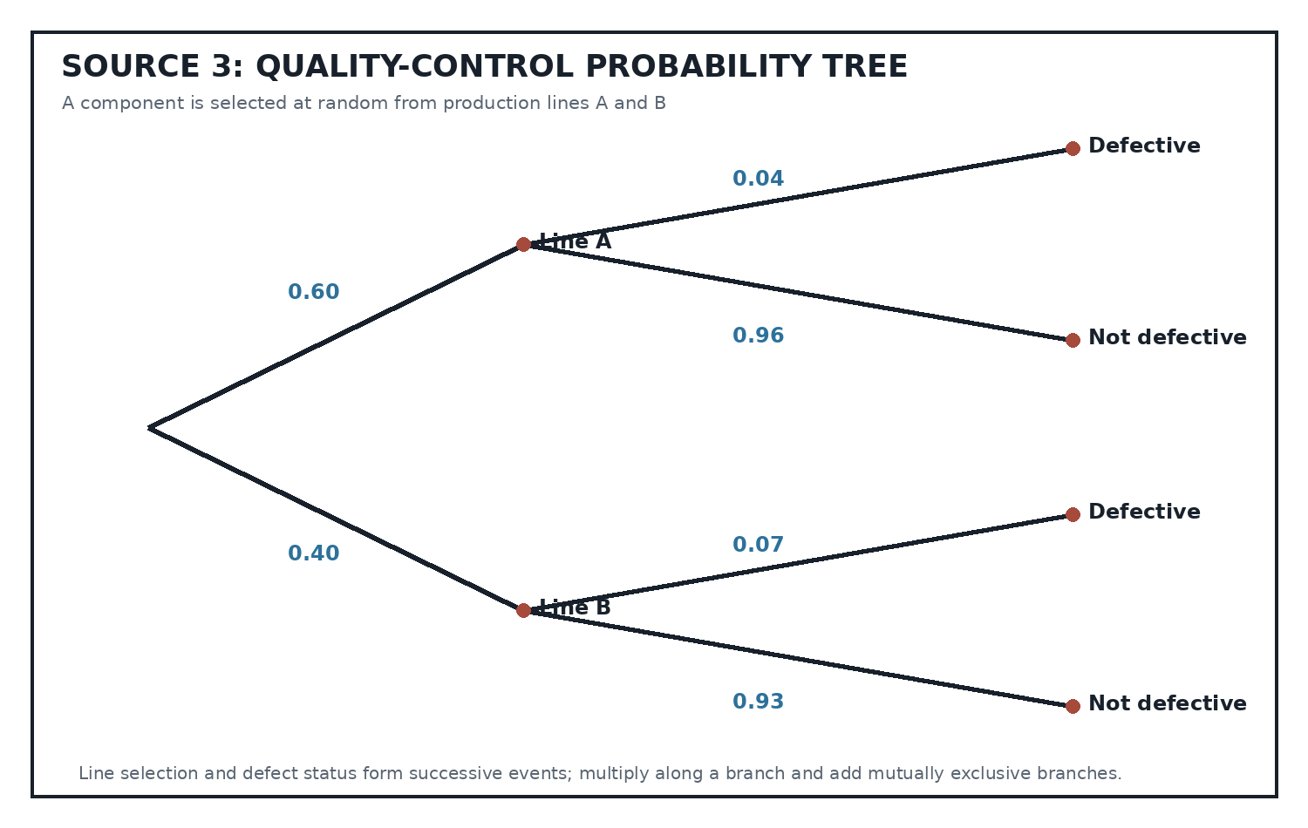
Source Type: Probability Tree

QUESTIONS

QUESTION 1: EUCLIDEAN GEOMETRY
Instructions: Use Source 1. Give reasons for all geometrical statements.
Stimulus: Refer to SOURCE 1.
1.1. Prove that triangle ADE is similar to triangle ABC. (4)
1.2. Hence prove that AD/DB = AE/EC. (5)
1.3. Calculate x, the length of EC. (3)
1.4. Calculate the length of DE. (3)
1.5. F is the midpoint of AB. A line through F parallel to BC meets AC at G. Prove that G is the midpoint of AC. (5)

QUESTION 2: REGRESSION AND CORRELATION
Instructions: Use Source 2. Round numerical answers to one decimal place where necessary.
Stimulus: Refer to SOURCE 2.
2.1. Identify the dependent variable. (1)
2.2. Describe the direction and strength of the correlation. (2)
2.3. Use the regression line to estimate the result for 6.5 hours of study. (2)
2.4. Is the estimate in Question 2.3 an interpolation or an extrapolation? Give a reason. (2)
2.5. Explain why the strong correlation does not by itself prove that extra study time causes higher marks. (3)

QUESTION 3: COUNTING AND PROBABILITY
Instructions: Use Source 3 where indicated. Show all probability calculations.
Stimulus: Refer to SOURCE 3 for Questions 3.1 to 3.4.
3.1. Verify that the probabilities on each pair of branches sum to 1. (2)
3.2. Calculate the probability that a randomly selected component is defective. (4)
3.3. Given that a component is defective, calculate the probability that it came from Line B. (4)
3.4. Determine whether the events 'Line B' and 'defective' are independent. Justify your answer. (3)
3.5. A batch code contains two different letters followed by three digits. Repetition of digits is allowed. How many different codes are possible? (4)
3.6. Three components are selected independently from a process with defect probability 0.052. Calculate the probability that at least one is defective. (3)

MARKING GUIDELINE

TASK 1: QUESTION 1: EUCLIDEAN GEOMETRY
1.1. Prove that triangle ADE is similar to triangle ABC. (4)
- Angle ADE = angle ABC and angle AED = angle ACB (corresponding angles, DE || BC).
- Angle A is common.
- Therefore triangle ADE is similar to triangle ABC (AAA).
1.2. Hence prove that AD/DB = AE/EC. (5)
- From similarity, AD/AB = AE/AC.
- AB = AD + DB and AC = AE + EC.
- AD/(AD+DB) = AE/(AE+EC).
- Cross-multiply and cancel AD.AE to obtain AD.EC = AE.DB.
- Therefore AD/DB = AE/EC.
1.3. Calculate x, the length of EC. (3)
- 6/3 = 8/x; 6x = 24; x = 4 units.
1.4. Calculate the length of DE. (3)
- DE/BC = AD/AB = 6/9 = 2/3.
- DE = (2/3)(12) = 8 units.
1.5. F is the midpoint of AB. A line through F parallel to BC meets AC at G. Prove that G is the midpoint of AC. (5)
- AF/FB = 1 because F is the midpoint.
- By the proportionality theorem, AF/FB = AG/GC.
- Therefore AG/GC = 1, so AG = GC and G is the midpoint of AC.

TASK 2: QUESTION 2: REGRESSION AND CORRELATION
2.1. Identify the dependent variable. (1)
- Test result y (%).
2.2. Describe the direction and strength of the correlation. (2)
- Strong positive correlation.
2.3. Use the regression line to estimate the result for 6.5 hours of study. (2)
- y = 6.66(6.5) + 34.7 = 78.0%.
2.4. Is the estimate in Question 2.3 an interpolation or an extrapolation? Give a reason. (2)
- Interpolation, because 6.5 lies within the observed range 2 to 7 hours.
2.5. Explain why the strong correlation does not by itself prove that extra study time causes higher marks. (3)
- Correlation does not prove causation.
- Other variables such as prior knowledge, teaching or sleep may influence both variables.
- A controlled design or further evidence is needed.

TASK 3: QUESTION 3: COUNTING AND PROBABILITY
3.1. Verify that the probabilities on each pair of branches sum to 1. (2)
- 0.60 + 0.40 = 1 and 0.04 + 0.96 = 1; 0.07 + 0.93 = 1.
3.2. Calculate the probability that a randomly selected component is defective. (4)
- P(D) = (0.60)(0.04) + (0.40)(0.07) = 0.024 + 0.028 = 0.052.
3.3. Given that a component is defective, calculate the probability that it came from Line B. (4)
- P(B|D) = P(B and D)/P(D) = 0.028/0.052 = 0.5385 (approximately).
3.4. Determine whether the events 'Line B' and 'defective' are independent. Justify your answer. (3)
- P(D|B) = 0.07 while P(D) = 0.052.
- They are not equal, so the events are not independent.
3.5. A batch code contains two different letters followed by three digits. Repetition of digits is allowed. How many different codes are possible? (4)
- 26 x 25 x 10 x 10 x 10 = 650 000 codes.
3.6. Three components are selected independently from a process with defect probability 0.052. Calculate the probability that at least one is defective. (3)
- 1 - P(none defective) = 1 - (0.948)^3 = 0.1480 (approximately).

RUBRIC
Criterion | Marks | Descriptor
Question 1: Euclidean geometry | 20 | Similarity proof, proportionality and geometric calculation.
Question 2: Statistics | 10 | Regression, interpolation and interpretation.
Question 3: Probability | 20 | Tree probability, conditional probability and counting.

EDUCATOR REVIEW CHECKLIST
- Verify all calculations and accepted equivalent proof sequences.
- Confirm the 20:10:20 Term 3 topic balance.
- Check diagrams and notation for legibility.
- Approve the paper and memorandum before classroom use.

