PHYSICAL SCIENCES
PHYSICAL SCIENCES GRADE 12 TERM 3 CONTROLLED TEST

SUBJECT | PHYSICAL SCIENCES
GRADE | 12
ASSESSMENT TASK | PHYSICAL SCIENCES GRADE 12 TERM 3 CONTROLLED TEST
MARKS | 50
TIME | 1.5 hours

Educator approval required before classroom use.

INSTRUCTIONS AND INFORMATION
1. Read all instructions carefully.
2. Answer all questions or complete all activities as instructed.
3. Show all working where calculations, planning, diagrams or explanations are required.
4. Use the space provided by the educator, answer booklet or learner task book.
5. Write neatly and clearly.

SOURCE MATERIAL
SOURCE 1: Internal resistance investigation
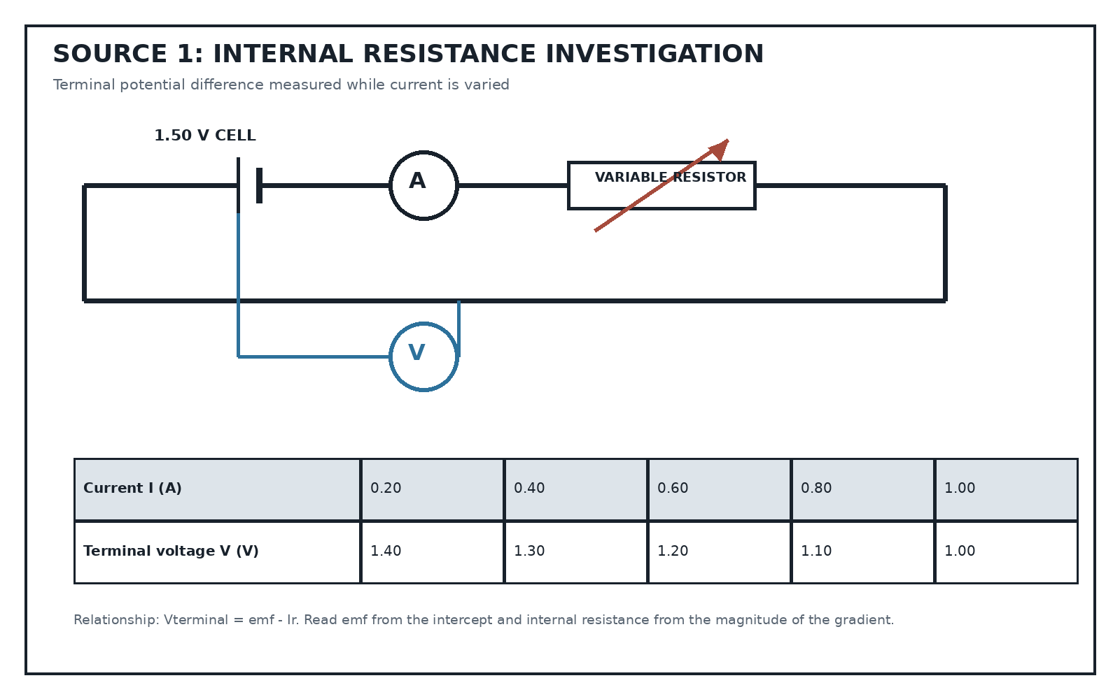
Source Type: Circuit Diagram And Data Table
SOURCE 2: Photoelectric-effect graph
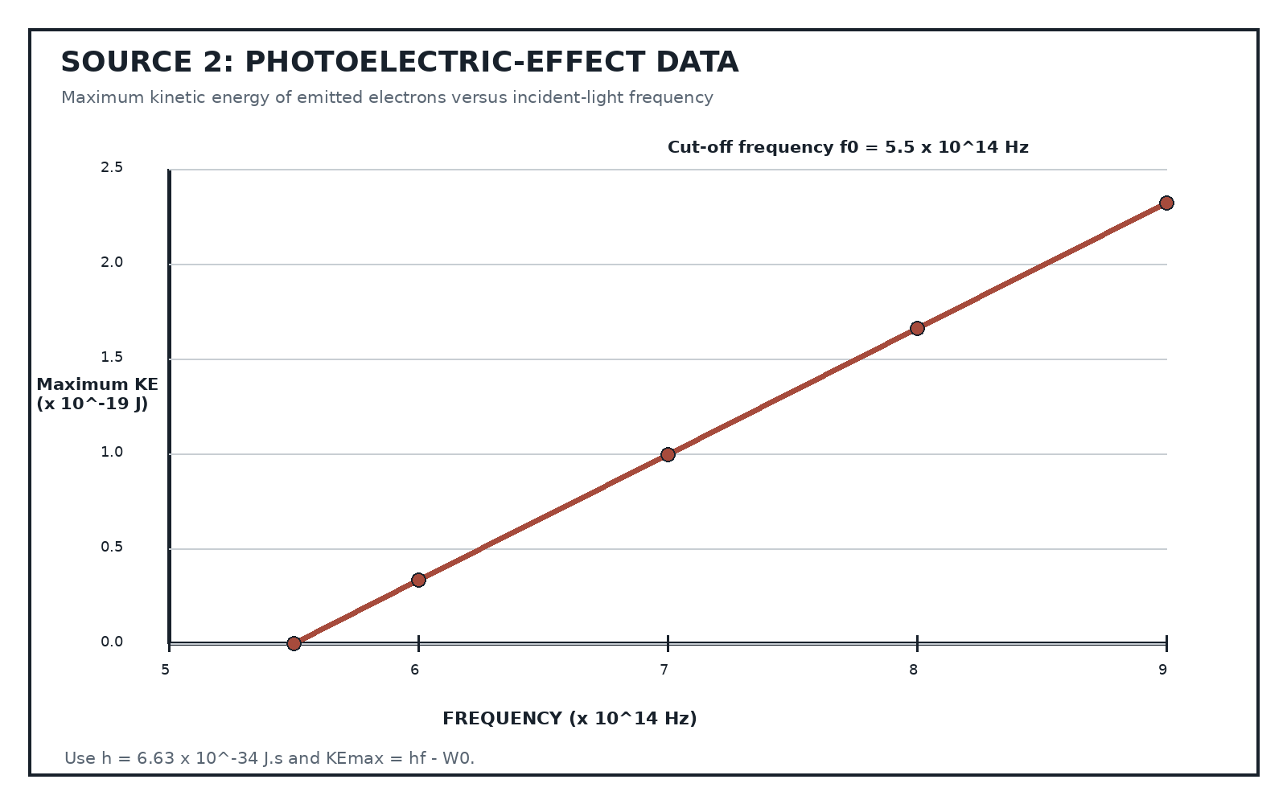
Source Type: Quantitative Graph
SOURCE 3: Zinc-copper galvanic cell
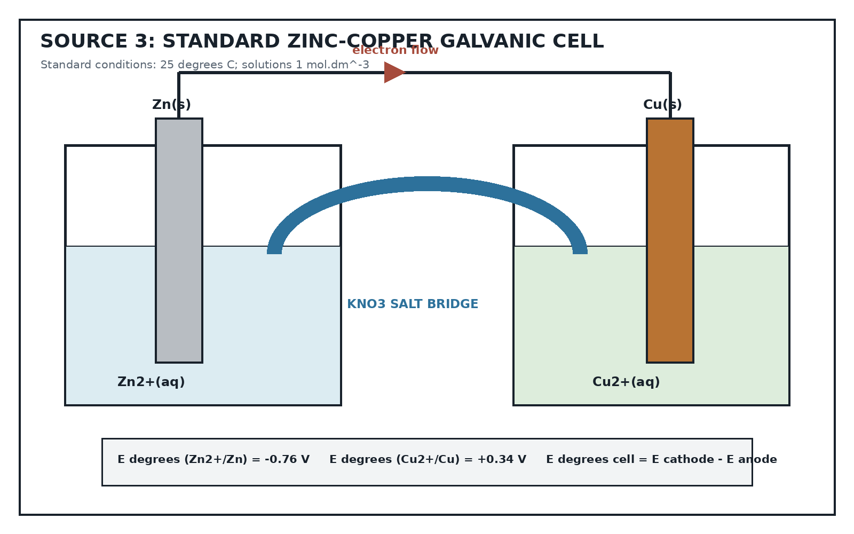
Source Type: Labelled Cell Diagram And Data

QUESTIONS

QUESTION 1: INTERNAL RESISTANCE
Instructions: Use Source 1. Show formulae, substitutions and units.
Stimulus: Refer to SOURCE 1.
1.1. Distinguish between the emf of a cell and its terminal potential difference. (2)
1.2. Identify the independent variable, the dependent variable and ONE controlled variable in this investigation. (3)
1.3. Describe the relationship between terminal voltage and current shown by the data. (2)
1.4. Use the data and V = emf - Ir to determine the emf and internal resistance of the cell. (5)
1.5. Calculate the terminal voltage and the potential difference across the internal resistance when the current is 0.70 A. (4)
1.6. Explain why the switch should be opened between readings. (2)

QUESTION 2: PHOTOELECTRIC EFFECT
Instructions: Use Source 2 and the supplied constant h = 6.63 x 10^-34 J.s.
Stimulus: Refer to SOURCE 2.
2.1. Define the work function of a metal. (2)
2.2. Calculate the work function of the metal. (4)
2.3. Calculate the maximum kinetic energy of emitted electrons when the frequency is 8.0 x 10^14 Hz. (4)
2.4. State the effect of increasing light intensity when the frequency is above f0, and explain what happens when the frequency is below f0. (3)
2.5. State why the photoelectric effect supports the particle model of light. (2)

QUESTION 3: GALVANIC CELLS
Instructions: Use Source 3. Standard conditions apply.
Stimulus: Refer to SOURCE 3.
3.1. Identify the anode and the cathode. (2)
3.2. State the direction of electron flow in the external circuit. (2)
3.3. Write the oxidation and reduction half-reactions. (4)
3.4. Write the overall cell reaction. (2)
3.5. Calculate the standard emf of the cell and state whether the reaction is spontaneous. (3)
3.6. Explain the function of the salt bridge. (2)
3.7. State how the cell potential changes as Zn2+ concentration increases and Cu2+ concentration decreases while the cell discharges. (2)

MARKING GUIDELINE

TASK 1: QUESTION 1: INTERNAL RESISTANCE
1.1. Distinguish between the emf of a cell and its terminal potential difference. (2)
- Emf is energy supplied per coulomb/open-circuit potential difference.
- Terminal potential difference is energy transferred per coulomb in the external circuit and decreases under load.
1.2. Identify the independent variable, the dependent variable and ONE controlled variable in this investigation. (3)
- Independent: current, varied with the variable resistor.
- Dependent: terminal voltage.
- Controlled: same cell/temperature/circuit components.
1.3. Describe the relationship between terminal voltage and current shown by the data. (2)
- Terminal voltage decreases linearly as current increases.
1.4. Use the data and V = emf - Ir to determine the emf and internal resistance of the cell. (5)
- Gradient = (1.00 - 1.40)/(1.00 - 0.20) = -0.50 V.A^-1.
- r = 0.50 ohm.
- Using any point, emf = V + Ir = 1.50 V.
1.5. Calculate the terminal voltage and the potential difference across the internal resistance when the current is 0.70 A. (4)
- V = 1.50 - (0.70)(0.50) = 1.15 V.
- Vinternal = Ir = 0.35 V.
1.6. Explain why the switch should be opened between readings. (2)
- To limit heating/discharge of the cell, which would change internal resistance/emf and reduce validity.

TASK 2: QUESTION 2: PHOTOELECTRIC EFFECT
2.1. Define the work function of a metal. (2)
- The minimum energy needed to remove an electron from the metal surface.
2.2. Calculate the work function of the metal. (4)
- W0 = hf0 = (6.63 x 10^-34)(5.5 x 10^14) = 3.65 x 10^-19 J.
2.3. Calculate the maximum kinetic energy of emitted electrons when the frequency is 8.0 x 10^14 Hz. (4)
- KEmax = h(f - f0) = (6.63 x 10^-34)(2.5 x 10^14) = 1.66 x 10^-19 J.
2.4. State the effect of increasing light intensity when the frequency is above f0, and explain what happens when the frequency is below f0. (3)
- Above f0, more electrons are emitted per second but KEmax is unchanged.
- Below f0, no electrons are emitted regardless of intensity.
2.5. State why the photoelectric effect supports the particle model of light. (2)
- Energy is transferred in discrete photons with energy hf; one photon transfers energy to one electron.

TASK 3: QUESTION 3: GALVANIC CELLS
3.1. Identify the anode and the cathode. (2)
- Anode: Zn; cathode: Cu.
3.2. State the direction of electron flow in the external circuit. (2)
- From the zinc electrode to the copper electrode.
3.3. Write the oxidation and reduction half-reactions. (4)
- Zn(s) -> Zn2+(aq) + 2e-.
- Cu2+(aq) + 2e- -> Cu(s).
3.4. Write the overall cell reaction. (2)
- Zn(s) + Cu2+(aq) -> Zn2+(aq) + Cu(s).
3.5. Calculate the standard emf of the cell and state whether the reaction is spontaneous. (3)
- Ecell = 0.34 - (-0.76) = +1.10 V.
- Positive Ecell means the reaction is spontaneous under standard conditions.
3.6. Explain the function of the salt bridge. (2)
- It permits ion movement, maintains electrical neutrality and completes the circuit without mixing the half-cell solutions directly.
3.7. State how the cell potential changes as Zn2+ concentration increases and Cu2+ concentration decreases while the cell discharges. (2)
- The cell potential decreases and approaches zero at equilibrium.

RUBRIC
Criterion | Marks | Descriptor
Question 1: Internal resistance | 18 | Concepts, variables, data relationship and circuit calculations.
Question 2: Photoelectric effect | 15 | Definitions, quantitative reasoning and photon model.
Question 3: Galvanic cells | 17 | Cell interpretation, redox equations, emf and ion movement.

EDUCATOR REVIEW CHECKLIST
- Verify all formulae, substitutions, signs and units.
- Confirm Grade 12 Term 3 CAPS scope.
- Check every diagram label and data value.
- Approve the paper and memorandum before classroom use.

