HOMS

Learner Concept Guide
Motion in One Dimension
Physical Sciences | Grade 10 | Term 3
Understand the motion story, then calculate it with confidence.

Learner name
Date

CAPS-aligned draft. Educator or subject-expert approval is required before classroom use.

How To Use This Guide
- Read the concept explanation before attempting the worked example.
- Choose a positive direction and keep signs consistent.
- Draw a small motion sketch before substituting into an equation.
- Complete the activity and worksheet before the mini-assessment.
- Use the memorandum only after making a serious attempt.

Learning Outcomes
- Describe motion relative to a reference frame.
- Distinguish distance from displacement and speed from velocity.
- Calculate average speed, average velocity and acceleration.
- Interpret position-time and velocity-time graphs.
- Apply the equations of uniformly accelerated motion.
- Evaluate whether an answer is physically sensible and correctly signed.

1. Reference Frames And Position
Motion is always described relative to a chosen reference frame. A reference frame has an origin and a positive direction. Once the direction is chosen, positions and vector quantities may be positive or negative.
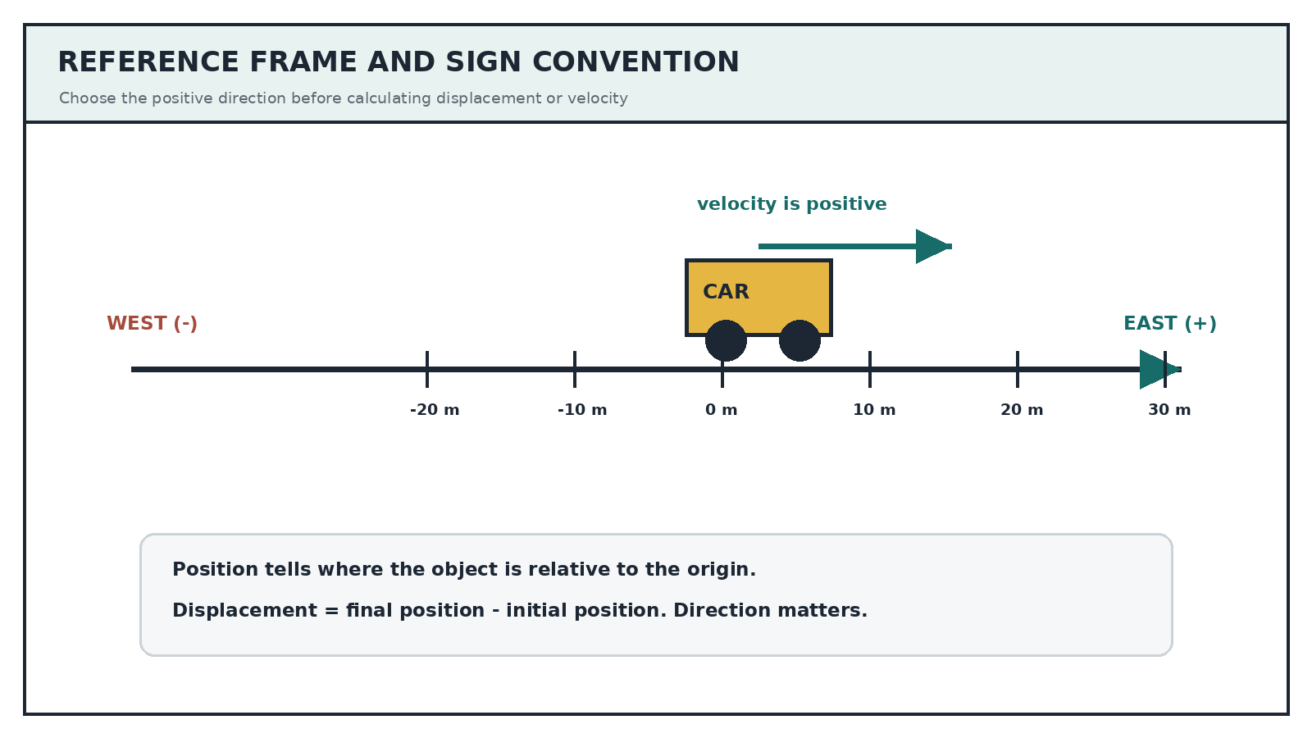
Sign discipline: A negative velocity does not mean that an object is slowing down. It means the object is moving in the chosen negative direction.

2. Distance And Displacement
Distance is the total path length travelled. It is a scalar and cannot be negative. Displacement is the change in position from the start to the finish. It is a vector and includes direction.

Worked Example 1
A learner walks 20 m east and then 5 m west in 10 s. Take east as positive.
Distance | 20 + 5 = 25 m
Displacement | +20 - 5 = +15 m (east)
Average speed | 25 / 10 = 2.5 m.s^-1
Average velocity | +15 / 10 = +1.5 m.s^-1 (east)

3. Velocity And Acceleration
Velocity describes how quickly position changes and in which direction. Acceleration describes how quickly velocity changes. An object can accelerate by speeding up, slowing down, or changing direction.
Quantity | Relationship | SI unit
Displacement | delta x = x final - x initial | m
Average speed | total distance / total time | m.s^-1
Average velocity | displacement / time interval | m.s^-1
Acceleration | a = delta v / delta t | m.s^-2
Uniform acceleration | v final = v initial + a delta t | m.s^-1
Uniform acceleration | delta x = v initial delta t + 0.5 a(delta t)^2 | m
Uniform acceleration | v final^2 = v initial^2 + 2a delta x | m^2.s^-2
Uniform acceleration | delta x = 0.5(v initial + v final)delta t | m

Worked Example 2
A trolley moves east at 2 m.s^-1 and accelerates uniformly east at 3 m.s^-2 for 4 s.
- Choose east as positive: v initial = +2 m.s^-1, a = +3 m.s^-2, delta t = 4 s.
- Final velocity: v final = 2 + (3)(4) = 14 m.s^-1 east.
- Displacement: delta x = (2)(4) + 0.5(3)(4^2) = 8 + 24 = 32 m east.
- Check: the trolley speeds up in the positive direction, so positive displacement is sensible.

4. Reading Motion Graphs
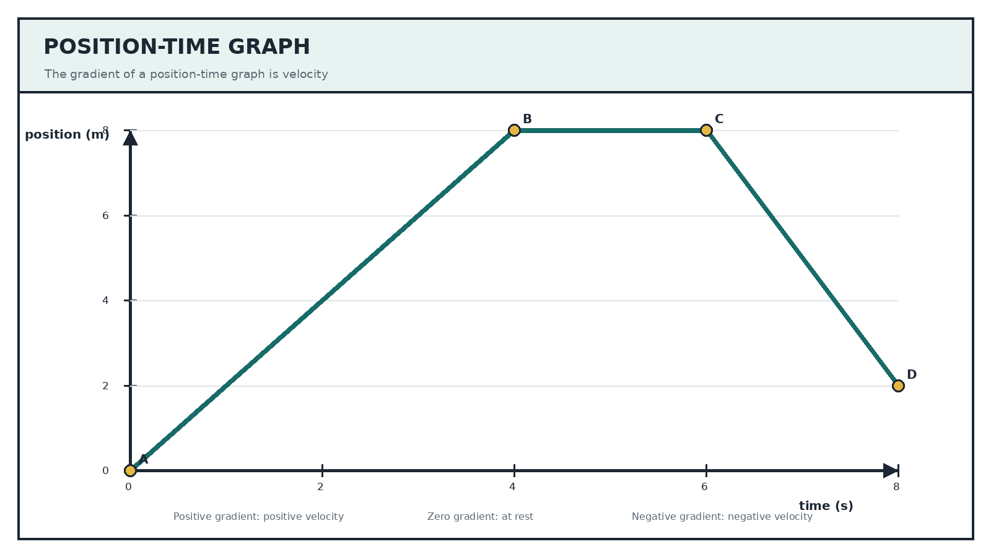
- A steeper position-time gradient means a greater speed.
- A horizontal position-time section means the object is at rest.
- A negative position-time gradient means motion in the negative direction.
- The gradient of a velocity-time graph is acceleration.
- The signed area between a velocity-time graph and the time axis is displacement.
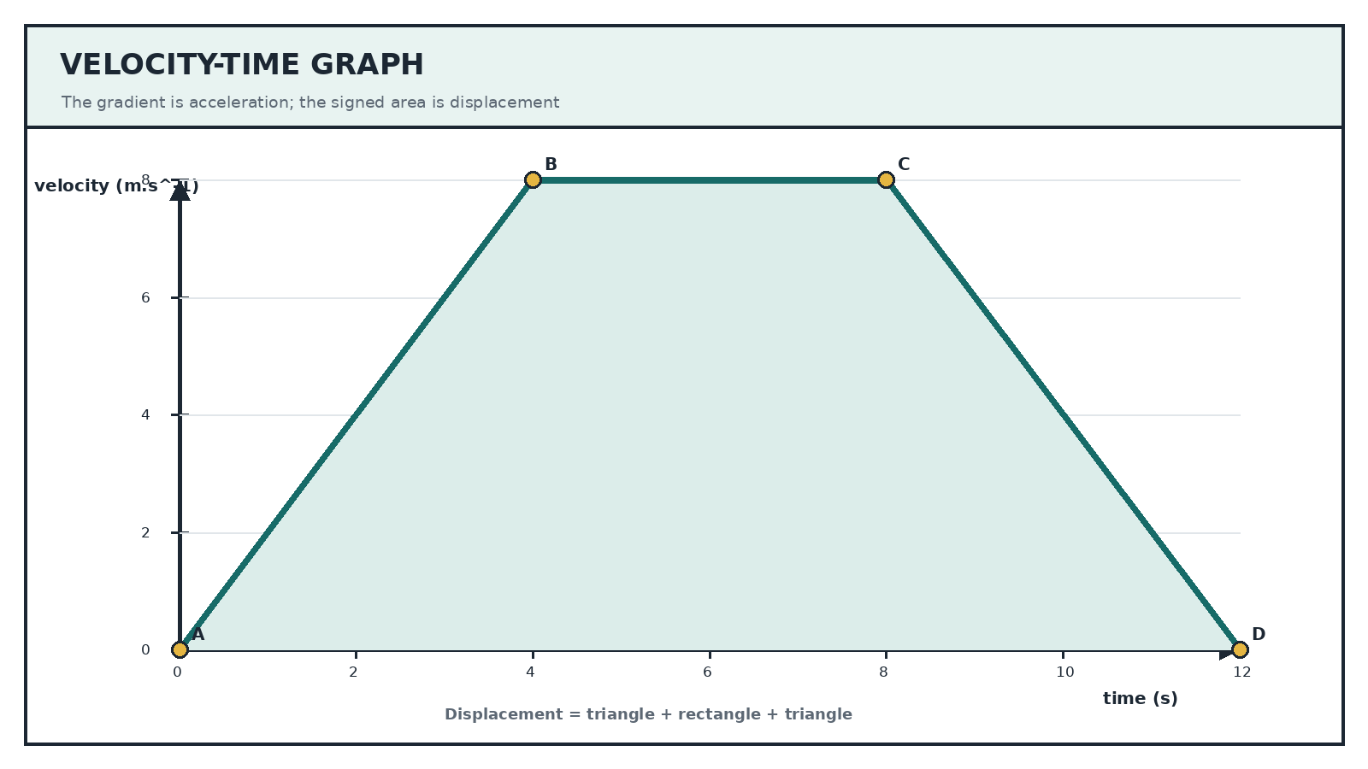

5. A Reliable Problem-Solving Routine
Step | Action | What to do
1 | Sketch | Draw the direction of motion and label the known values.
2 | Choose | State the positive direction before assigning signs.
3 | List | Write each known value with its unit.
4 | Select | Choose an equation containing the unknown and the available data.
5 | Substitute | Substitute with signs, then calculate.
6 | Interpret | Give the unit, direction and a physical reasonableness check.

Common Errors
- Using distance when average velocity requires displacement.
- Changing the positive direction halfway through a calculation.
- Treating a negative answer as automatically wrong.
- Using the area under a position-time graph instead of its gradient.
- Mixing kilometres per hour with metres per second without converting.
- Reporting a number without its unit and direction.

