HOMS

Mini-Assessment
Motion in One Dimension
Physical Sciences | Grade 10 | Term 3
Complete every question. Total: 30 marks.

Learner name
Date

CAPS-aligned draft. Educator or subject-expert approval is required before classroom use.

Instructions: Show formulae, substitutions, units and direction where required. Use the supplied graphs for graph questions.

Question 1: Concepts
1.1 Define average velocity. | (2)
________________________________________________________________________________________________________________
________________________________________________________________________________________________________________
1.2 Give one difference between a scalar and a vector quantity. | (2)
________________________________________________________________________________________________________________
________________________________________________________________________________________________________________
1.3 A learner says: 'An object with zero velocity must have zero acceleration.' Is this always correct? Briefly justify your answer. | (2)
________________________________________________________________________________________________________________
________________________________________________________________________________________________________________
________________________________________________________________________________________________________________
1.4 State what a horizontal section on a position-time graph means. | (2)
________________________________________________________________________________________________________________
________________________________________________________________________________________________________________

Question 2: Calculations
2.1 A taxi travels 120 m east and then 40 m west in 20 s. Calculate its average speed. | (3)
________________________________________________________________________________________________________________
________________________________________________________________________________________________________________
________________________________________________________________________________________________________________
2.2 Calculate the taxi's average velocity for the same journey. | (3)
________________________________________________________________________________________________________________
________________________________________________________________________________________________________________
________________________________________________________________________________________________________________
2.3 A train moving at 6 m.s^-1 accelerates uniformly at 1.5 m.s^-2 for 8 s. Calculate its final velocity. | (2)
________________________________________________________________________________________________________________
________________________________________________________________________________________________________________
________________________________________________________________________________________________________________
2.4 Calculate the train's displacement during the 8 s interval. | (4)
________________________________________________________________________________________________________________
________________________________________________________________________________________________________________
________________________________________________________________________________________________________________
________________________________________________________________________________________________________________

Question 3: Graph Interpretation
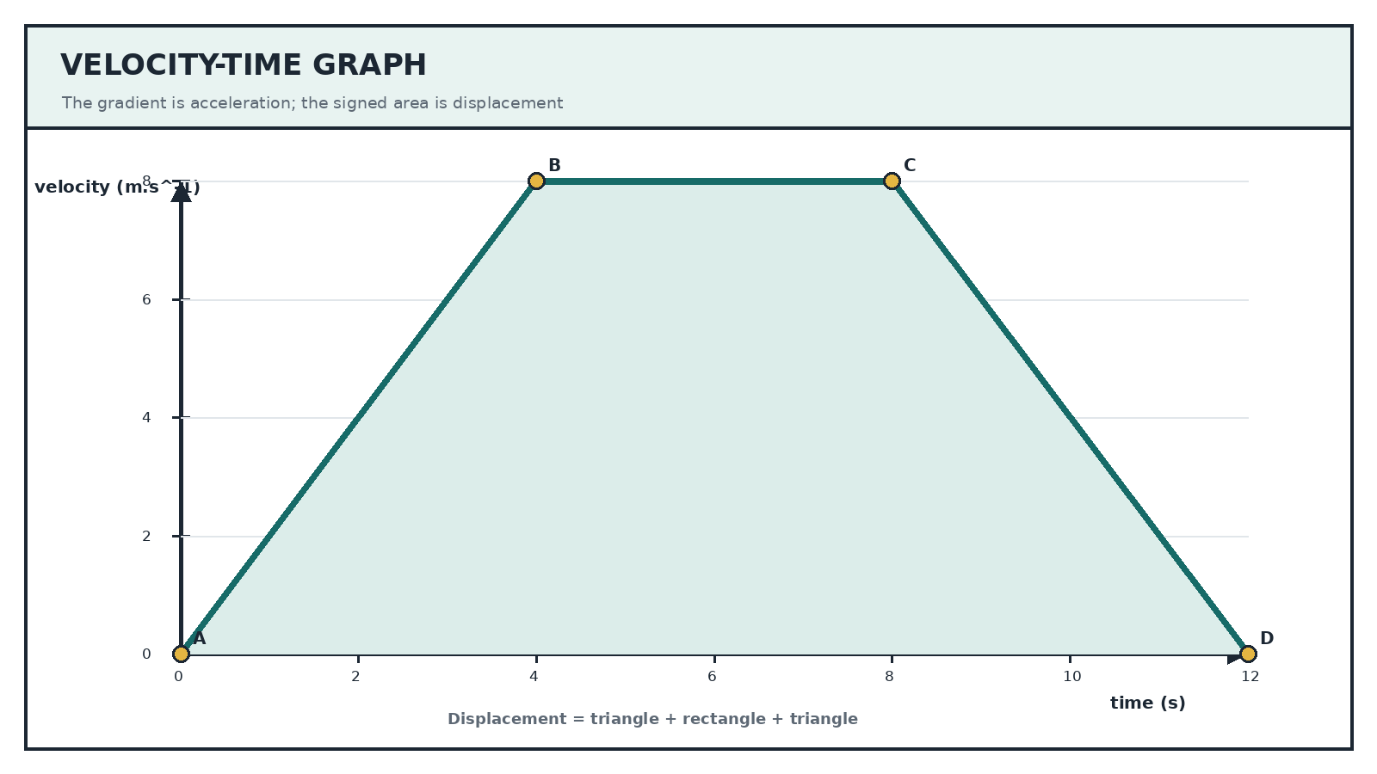
3.1 Refer to the velocity-time graph. Calculate the acceleration from A to B. | (2)
________________________________________________________________________________________________________________
________________________________________________________________________________________________________________
________________________________________________________________________________________________________________
3.2 Describe the motion from B to C. | (2)
________________________________________________________________________________________________________________
________________________________________________________________________________________________________________
3.3 Calculate the acceleration from C to D. | (2)
________________________________________________________________________________________________________________
________________________________________________________________________________________________________________
________________________________________________________________________________________________________________
3.4 Calculate the total displacement from 0 s to 12 s. | (4)
________________________________________________________________________________________________________________
________________________________________________________________________________________________________________
________________________________________________________________________________________________________________
________________________________________________________________________________________________________________
TOTAL: 30

