HOMS

Practical Activity
Motion in One Dimension
Physical Sciences | Grade 10 | Term 3
Measure a moving object's position and use a graph to determine velocity.

Learner name
Date

CAPS-aligned draft. Educator or subject-expert approval is required before classroom use.

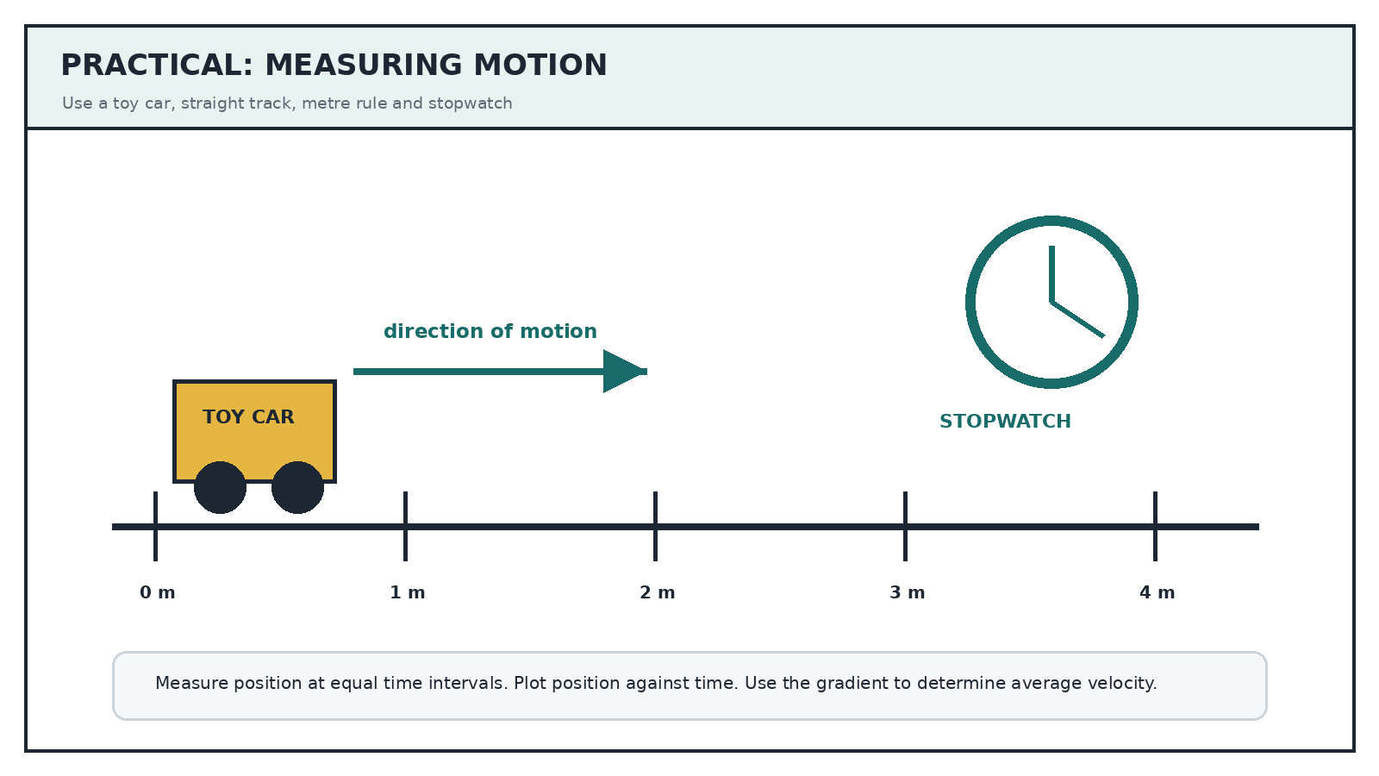

Investigation Question
How does the position of a toy car change with time as it moves along a straight track?

Materials
- Toy car or trolley
- Straight track or smooth floor
- Metre rule or measuring tape
- Masking tape or chalk markers
- Stopwatch or phone timer
- Graph paper

Variables
Independent variable | Time
Dependent variable | Position relative to the origin
Controlled variable | Same car, track and release method
Positive direction | From the origin toward the end of the track

Method
- Mark an origin and positions at 0.50 m intervals along a straight track.
- Place the car at the origin and practise releasing it without pushing.
- Release the car and record the time when its front reaches each position marker.
- Repeat the run three times. Use the average time for each position.
- Plot position on the vertical axis and average time on the horizontal axis.
- Draw a best-fit line or curve and calculate the gradient over a suitable interval.
Safety: Keep the track clear, do not place the car near stairs, and assign one learner to time while another observes position.

Results
Position (m) | Run 1 (s) | Run 2 (s) | Run 3 (s) | Average time (s) | Interval velocity (m.s^-1)
0.0
0.5
1.0
1.5
2.0
2.5
Plot your position-time graph on the grid below. Label both axes and show the points used for one gradient calculation.
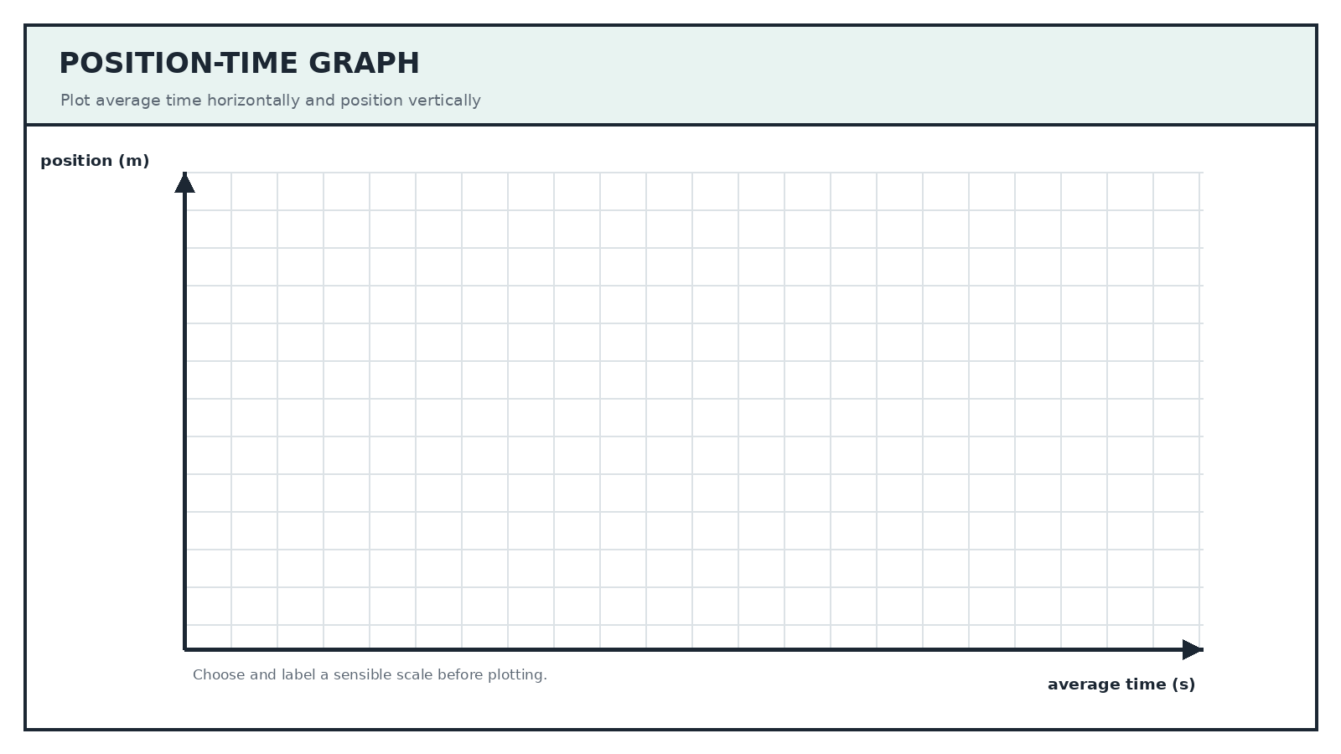

Analysis And Evaluation
1 State the relationship between position and time shown by your graph. | (2)
________________________________________________________________________________________________________________
________________________________________________________________________________________________________________
________________________________________________________________________________________________________________
2 Calculate the average velocity over one suitable interval. Show the points used. | (4)
________________________________________________________________________________________________________________
________________________________________________________________________________________________________________
________________________________________________________________________________________________________________
________________________________________________________________________________________________________________
3 Was the velocity constant? Use the graph as evidence. | (3)
________________________________________________________________________________________________________________
________________________________________________________________________________________________________________
________________________________________________________________________________________________________________
________________________________________________________________________________________________________________
4 Identify one source of random error and explain how repeating the run reduces its effect. | (3)
________________________________________________________________________________________________________________
________________________________________________________________________________________________________________
________________________________________________________________________________________________________________
________________________________________________________________________________________________________________
5 Suggest one improvement that would make the timing more reliable. | (2)
________________________________________________________________________________________________________________
________________________________________________________________________________________________________________
________________________________________________________________________________________________________________
6 Write a conclusion that answers the investigation question. | (3)
________________________________________________________________________________________________________________
________________________________________________________________________________________________________________
________________________________________________________________________________________________________________
________________________________________________________________________________________________________________
________________________________________________________________________________________________________________

