HOMS

Learner Worksheet
Motion in One Dimension
Physical Sciences | Grade 10 | Term 3
Complete every question. Total: 40 marks.

Learner name
Date

CAPS-aligned draft. Educator or subject-expert approval is required before classroom use.

Instructions: Show formulae, substitutions, units and direction where required. Use the supplied graphs for graph questions.

Question 1: Concepts
1.1 Define a frame of reference. | (2)
________________________________________________________________________________________________________________
________________________________________________________________________________________________________________
1.2 Distinguish between distance and displacement. | (2)
________________________________________________________________________________________________________________
________________________________________________________________________________________________________________
________________________________________________________________________________________________________________
1.3 Explain why a negative velocity does not necessarily mean that an object is slowing down. | (2)
________________________________________________________________________________________________________________
________________________________________________________________________________________________________________
________________________________________________________________________________________________________________
1.4 State the physical meaning of the gradient of a position-time graph. | (1)
________________________________________________________________________________________________________________
________________________________________________________________________________________________________________
1.5 State the physical meaning of the area under a velocity-time graph. | (1)
________________________________________________________________________________________________________________
________________________________________________________________________________________________________________

Question 2: Calculations
2.1 A learner walks 60 m east and then 25 m west. Calculate the distance and displacement. | (4)
________________________________________________________________________________________________________________
________________________________________________________________________________________________________________
________________________________________________________________________________________________________________
________________________________________________________________________________________________________________
2.2 The journey in Question 2.1 takes 50 s. Calculate average speed and average velocity. | (4)
________________________________________________________________________________________________________________
________________________________________________________________________________________________________________
________________________________________________________________________________________________________________
________________________________________________________________________________________________________________
2.3 A car changes velocity from +4 m.s^-1 to +16 m.s^-1 in 6 s. Calculate its acceleration. | (3)
________________________________________________________________________________________________________________
________________________________________________________________________________________________________________
________________________________________________________________________________________________________________
2.4 A bicycle moving at 10 m.s^-1 slows uniformly at 2 m.s^-2 for 3 s. Calculate its final velocity. | (3)
________________________________________________________________________________________________________________
________________________________________________________________________________________________________________
________________________________________________________________________________________________________________

Question 3: Graph Interpretation
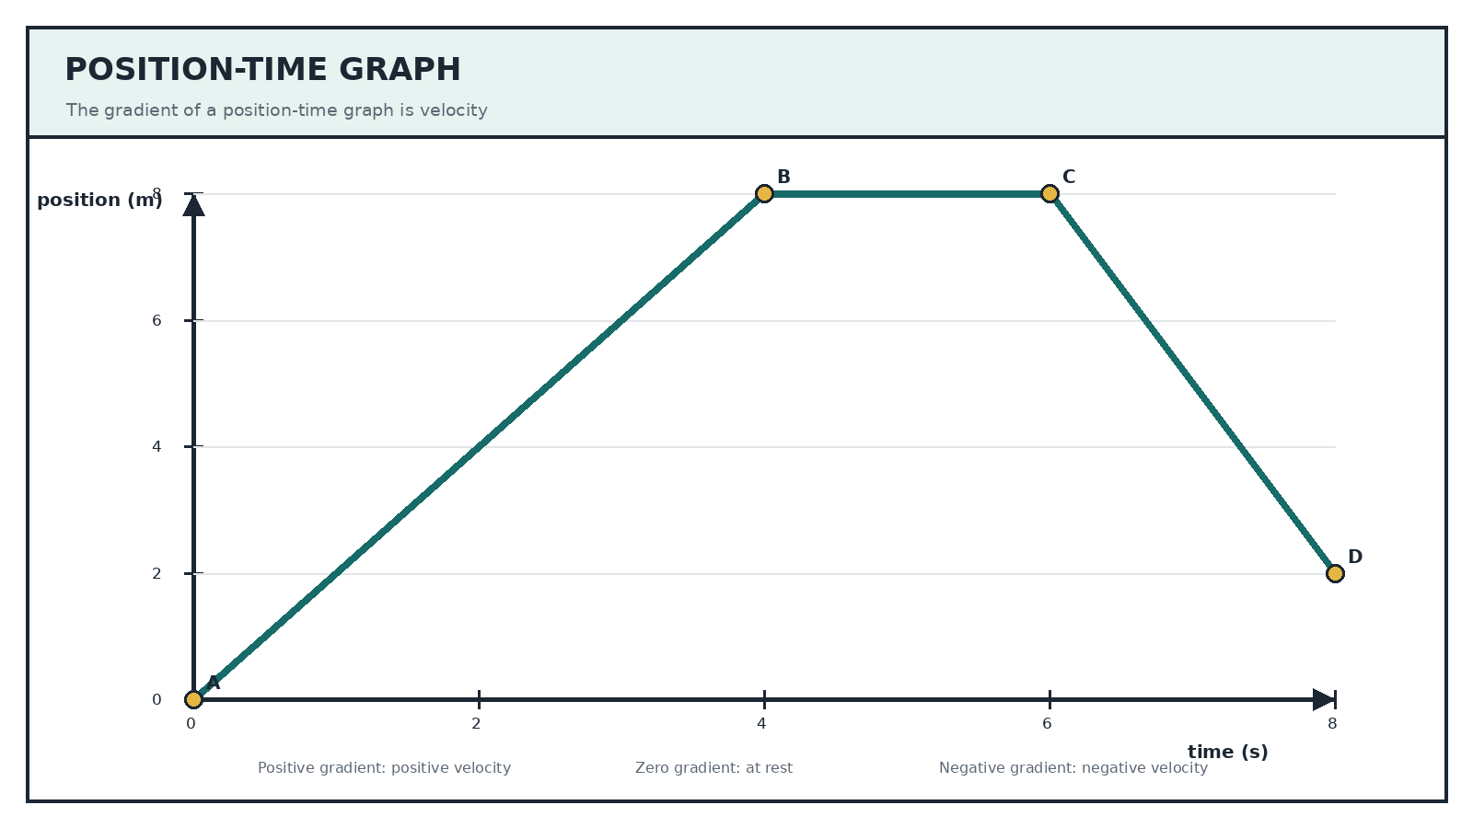
3.1 Refer to the position-time graph. Calculate the velocity from A to B. | (3)
________________________________________________________________________________________________________________
________________________________________________________________________________________________________________
________________________________________________________________________________________________________________
3.2 Describe the motion from B to C. | (2)
________________________________________________________________________________________________________________
________________________________________________________________________________________________________________
3.3 Calculate the velocity from C to D. | (3)
________________________________________________________________________________________________________________
________________________________________________________________________________________________________________
________________________________________________________________________________________________________________
3.4 Explain what the negative answer in Question 3.3 means. | (2)
________________________________________________________________________________________________________________
________________________________________________________________________________________________________________
________________________________________________________________________________________________________________

Question 4: Uniform Acceleration
4.1 A trolley starts at 3 m.s^-1 and accelerates uniformly at 2 m.s^-2 for 5 s. Calculate its final velocity. | (3)
________________________________________________________________________________________________________________
________________________________________________________________________________________________________________
4.2 Calculate the displacement of the trolley during the 5 s interval. | (5)
________________________________________________________________________________________________________________
________________________________________________________________________________________________________________
________________________________________________________________________________________________________________
TOTAL: 40

