LIFE SCIENCES
LIFE SCIENCES GRADE 12 TERM 3 EVOLUTION CONTROLLED TEST

SUBJECT | LIFE SCIENCES
GRADE | 12
ASSESSMENT TASK | LIFE SCIENCES GRADE 12 TERM 3 EVOLUTION CONTROLLED TEST
MARKS | 75
TIME | 1.5 hours

Educator approval required before classroom use.

INSTRUCTIONS AND INFORMATION
1. Read all instructions carefully.
2. Answer all questions or complete all activities as instructed.
3. Show all working where calculations, planning, diagrams or explanations are required.
4. Use the space provided by the educator, answer booklet or learner task book.
5. Write neatly and clearly.

VISUAL MATERIAL
FIGURE 1: Finch Beak Data Table And Graph
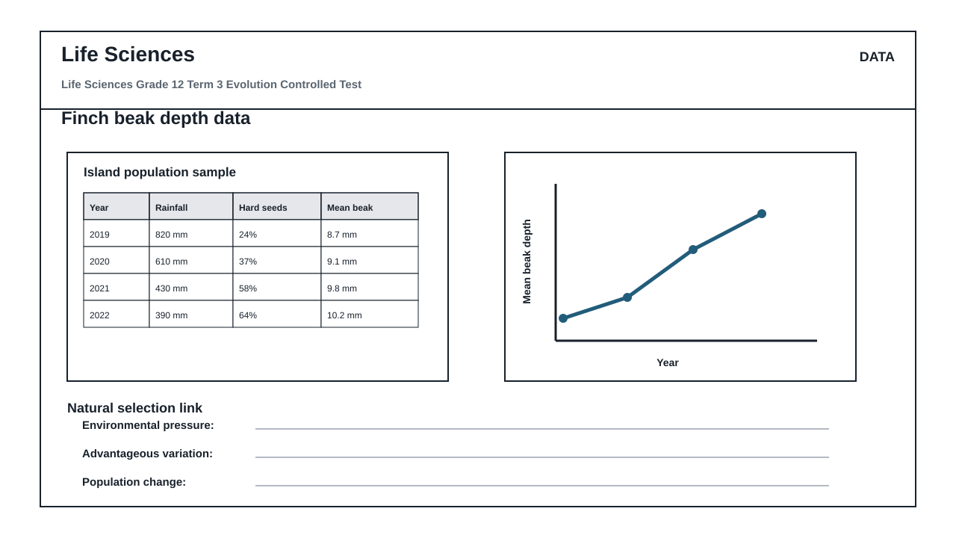
FIGURE 2: Investigation Data And Method Sheet
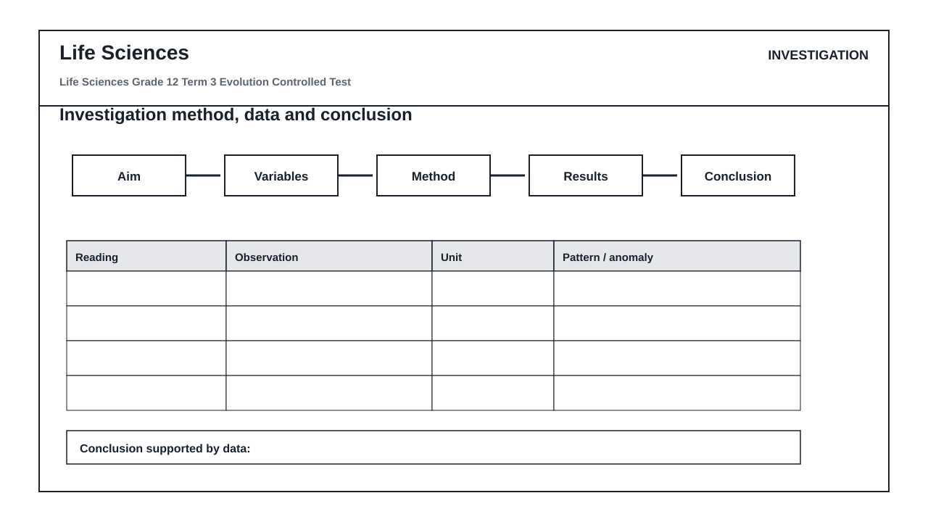
FIGURE 3: Life Sciences Hominin Skull Diagram
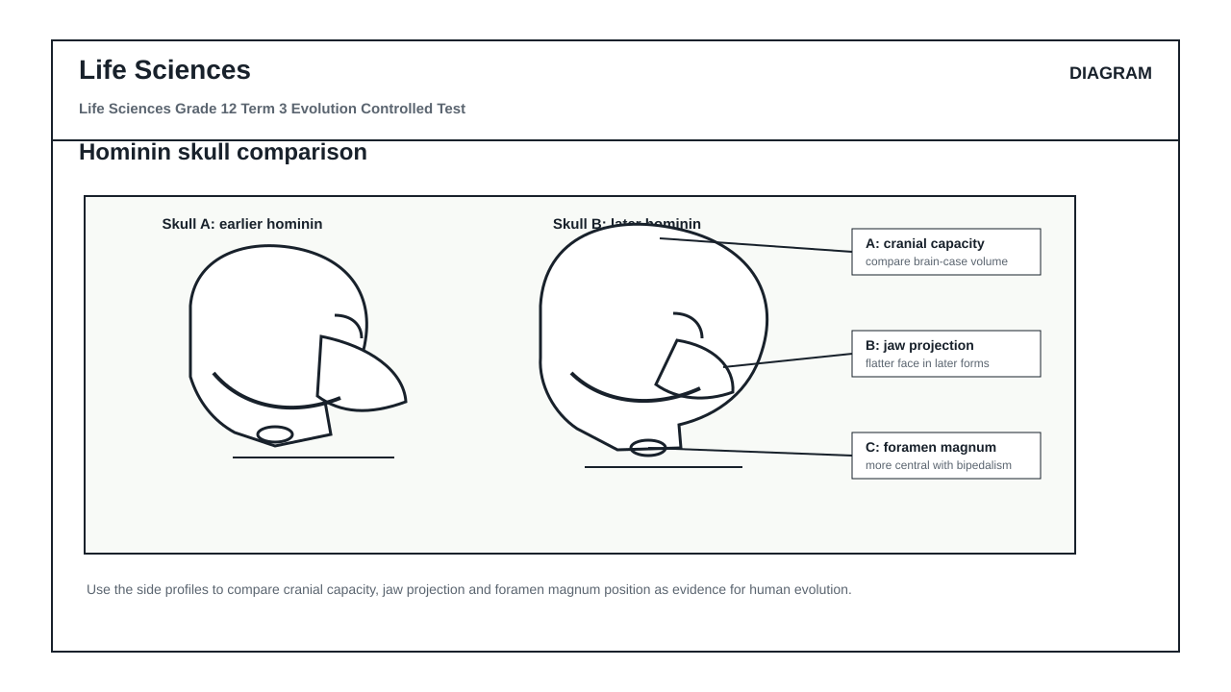

QUESTIONS

QUESTION 1: CORE CONCEPTS: EVOLUTION
Instructions: Answer each question in full sentences unless a term is requested.
Stimulus: CAPS Grade 12 Term 3 focus: Diversity, Change and Continuity; Darwinism, natural selection and human evolution.
1.1. Define biological evolution. (2)

1.2. Distinguish between a scientific hypothesis and a scientific theory. (2)

1.3. Explain why genetic variation is necessary for natural selection to occur. (3)

1.4. State TWO sources of genetic variation in a sexually reproducing population. (2)

1.5. Differentiate between homologous structures and analogous structures. (3)

1.6. Give THREE reasons why the fossil record is incomplete. (3)

QUESTION 2: DIAGRAM INTERPRETATION: HUMAN EVOLUTION
Instructions: Use Figure 3, the hominin skull comparison diagram.
Stimulus: Figure 3 shows two simplified skulls and three labelled features used as evidence in human evolution.
2.1. Identify the labelled feature A and explain why it is useful when comparing hominin skulls. (4)

2.2. Identify labelled feature B and state what a less projecting jaw suggests about diet or evolutionary trend. (4)

2.3. Identify labelled feature C and explain how its position is linked to bipedalism. (4)

2.4. Which skull, A or B, is more likely to represent the more recent hominin? Give TWO visible reasons from the diagram. (4)

2.5. Name TWO other forms of evidence, besides skull anatomy, that scientists use to study human evolution. (4)

QUESTION 3: DATA RESPONSE: NATURAL SELECTION
Instructions: Use Figure 1, the finch beak depth table and graph.
Stimulus: Figure 1 summarises changes in rainfall, hard seed availability and mean beak depth in an island finch population.
3.1. Identify the independent variable and the dependent variable shown in the graph in Figure 1. (4)

3.2. Describe the trend in mean beak depth from 2019 to 2022. (3)

3.3. Calculate the percentage increase in mean beak depth from 2019 to 2022. Show all working. (4)

3.4. Use the data to explain how natural selection could have caused the change in mean beak depth. (6)

3.5. Predict what may happen to mean beak depth after several wet years with more soft seeds. Justify your answer. (3)

QUESTION 4: INVESTIGATION DESIGN AND EVALUATION
Instructions: Use Figure 2, the investigation method and data sheet.
Stimulus: A learner investigates whether seed hardness affects feeding success in two finch-beak models.
4.1. Write a suitable aim for this investigation. (2)

4.2. Formulate a testable hypothesis for the investigation. (2)

4.3. Identify the independent variable, dependent variable and TWO controlled variables. (6)

4.4. Give TWO ways to improve the reliability or validity of the investigation. (4)

4.5. Write a conclusion that would be supported if the stronger beak model collected more hard seeds in every trial. (3)

4.6. Explain why a larger sample size would make the results more trustworthy. (3)

MARKING GUIDELINE

TASK 1: CORE CONCEPTS: EVOLUTION
1.1. Define biological evolution. (2)
- Change in the inherited characteristics/genetic composition of populations over successive generations. Award 2 for population-level change over time.
1.2. Distinguish between a scientific hypothesis and a scientific theory. (2)
- Hypothesis: testable proposed explanation. Theory: well-supported explanation built from repeated evidence and testing.
1.3. Explain why genetic variation is necessary for natural selection to occur. (3)
- Individuals must differ in inherited traits; some variants give survival/reproductive advantage; advantageous alleles become more common.
1.4. State TWO sources of genetic variation in a sexually reproducing population. (2)
- Accept: mutation, crossing over, random arrangement/segregation of chromosomes, random fertilisation. Any two.
1.5. Differentiate between homologous structures and analogous structures. (3)
- Homologous: same basic structure/common ancestry but may have different functions. Analogous: similar function but different evolutionary origin/basic structure.
1.6. Give THREE reasons why the fossil record is incomplete. (3)
- Accept: not all organisms fossilise; soft parts decay; geological processes destroy fossils; fossils remain undiscovered; conditions for fossilisation are rare. Any three.

TASK 2: DIAGRAM INTERPRETATION: HUMAN EVOLUTION
2.1. Identify the labelled feature A and explain why it is useful when comparing hominin skulls. (4)
- A is cranial capacity/brain case size; larger cranial capacity is associated with increased brain size in later hominins.
2.2. Identify labelled feature B and state what a less projecting jaw suggests about diet or evolutionary trend. (4)
- B is jaw projection/prognathism; reduced jaw projection suggests a flatter face and is generally associated with later hominins/changed diet and dentition.
2.3. Identify labelled feature C and explain how its position is linked to bipedalism. (4)
- C is foramen magnum; a more central/forward position under the skull indicates the skull balances on an upright vertebral column, supporting bipedalism.
2.4. Which skull, A or B, is more likely to represent the more recent hominin? Give TWO visible reasons from the diagram. (4)
- Skull B; accept larger cranial capacity/rounder cranium, flatter face/less projecting jaw, more central foramen magnum. Any two visible reasons.
2.5. Name TWO other forms of evidence, besides skull anatomy, that scientists use to study human evolution. (4)
- Accept: fossils of other bones, stone tools/artefacts, DNA/molecular evidence, comparative anatomy, dating methods, cultural evidence. Any two with explanation for full marks.

TASK 3: DATA RESPONSE: NATURAL SELECTION
3.1. Identify the independent variable and the dependent variable shown in the graph in Figure 1. (4)
- Independent variable: year/time. Dependent variable: mean beak depth. Award credit for identifying rainfall/hard-seed availability as environmental variables in the table.
3.2. Describe the trend in mean beak depth from 2019 to 2022. (3)
- Mean beak depth increased steadily from 8.7 mm to 10.2 mm over the period. Must mention direction and data values/range.
3.3. Calculate the percentage increase in mean beak depth from 2019 to 2022. Show all working. (4)
- Increase = 10.2 - 8.7 = 1.5 mm; percentage increase = 1.5/8.7 x 100 = 17.24% or 17.2%. Award method marks.
3.4. Use the data to explain how natural selection could have caused the change in mean beak depth. (6)
- Drier years had lower rainfall and more hard seeds; birds varied in beak depth; deeper beaks cracked hard seeds more effectively; those birds survived/reproduced more; alleles for deeper beaks increased; population mean shifted.
3.5. Predict what may happen to mean beak depth after several wet years with more soft seeds. Justify your answer. (3)
- Mean beak depth may decrease or selection pressure may weaken; smaller/shallower beaks may no longer be disadvantaged when soft seeds are abundant. Accept well-reasoned alternatives.

TASK 4: INVESTIGATION DESIGN AND EVALUATION
4.1. Write a suitable aim for this investigation. (2)
- To determine the effect of seed hardness on feeding success/number of seeds collected by different beak models.
4.2. Formulate a testable hypothesis for the investigation. (2)
- Example: If seed hardness increases, then the model with the deeper/stronger beak will collect more seeds than the smaller beak model. Must link variables.
4.3. Identify the independent variable, dependent variable and TWO controlled variables. (6)
- Independent: seed hardness/type. Dependent: number/mass of seeds collected or feeding success. Controlled variables: time allowed, number of seeds, same surface/container, same model users, same number of trials.
4.4. Give TWO ways to improve the reliability or validity of the investigation. (4)
- Repeat trials/calculate averages; use same time for each trial; use equal seed numbers/masses; control technique; use larger sample; test one variable at a time.
4.5. Write a conclusion that would be supported if the stronger beak model collected more hard seeds in every trial. (3)
- The stronger/deeper beak model is better adapted to hard seeds; seed hardness affects feeding success; this supports selection for deeper beaks under hard-seed conditions.
4.6. Explain why a larger sample size would make the results more trustworthy. (3)
- A larger sample reduces the effect of chance/anomalies, gives more representative data, and increases confidence in the pattern/conclusion.

RUBRIC
Criterion | Marks | Descriptor
Core evolution concepts and terminology | 15 | Accurate definitions and explanations using accepted Life Sciences terminology.
Diagram interpretation and human evolution evidence | 20 | Uses visible skull features to infer evolutionary trends and supports claims with evidence.
Data handling and natural selection reasoning | 20 | Reads table/graph values, calculates correctly, describes trends, and links data to natural selection.
Investigation design and evaluation | 20 | Identifies variables, controls, reliability/validity improvements, and evidence-based conclusions.

EDUCATOR REVIEW CHECKLIST
- Confirm Grade 12 Term 3 evolution scope against the local ATP/CAPS pacing plan.
- Check Figure 1 values and Figure 3 labels before classroom use.
- Confirm mark allocation totals 75.
- Confirm memo accepts scientifically equivalent wording.

