LIFE SCIENCES
LIFE SCIENCES GRADE 12 TERM 3 EVOLUTION CONTROLLED TEST

SUBJECT | LIFE SCIENCES
GRADE | 12
ASSESSMENT TASK | LIFE SCIENCES GRADE 12 TERM 3 EVOLUTION CONTROLLED TEST
MARKS | 75
TIME | 1.5 hours

Educator approval required before classroom use.

INSTRUCTIONS AND INFORMATION
1. Read all instructions carefully.
2. Answer all questions or complete all activities as instructed.
3. Show all working where calculations, planning, diagrams or explanations are required.
4. Use the space provided by the educator, answer booklet or learner task book.
5. Write neatly and clearly.

VISUAL MATERIAL
FIGURE 1: Finch Beak Data Table And Graph
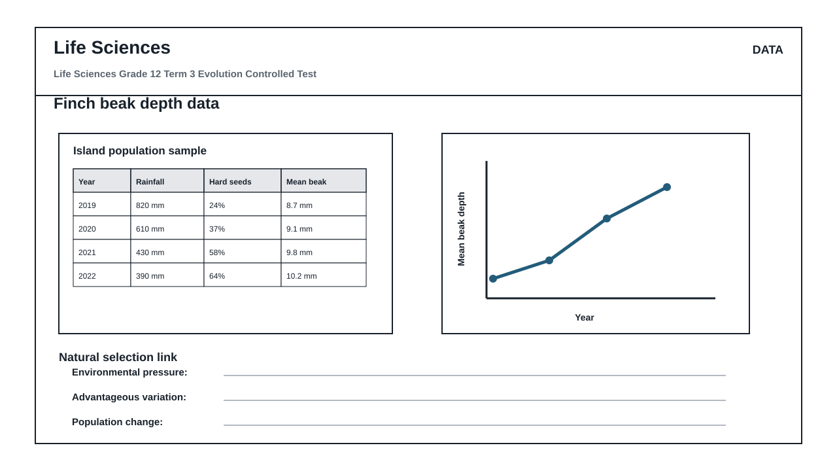
FIGURE 2: Investigation Data And Method Sheet
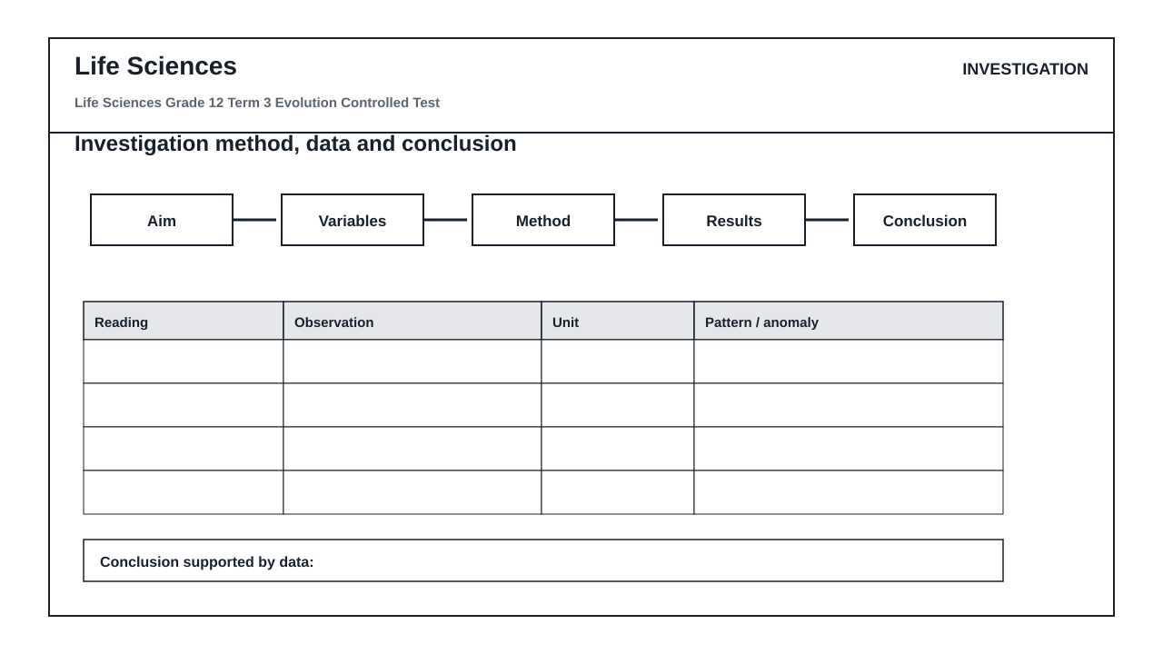
FIGURE 3: Life Sciences Hominin Skull Diagram
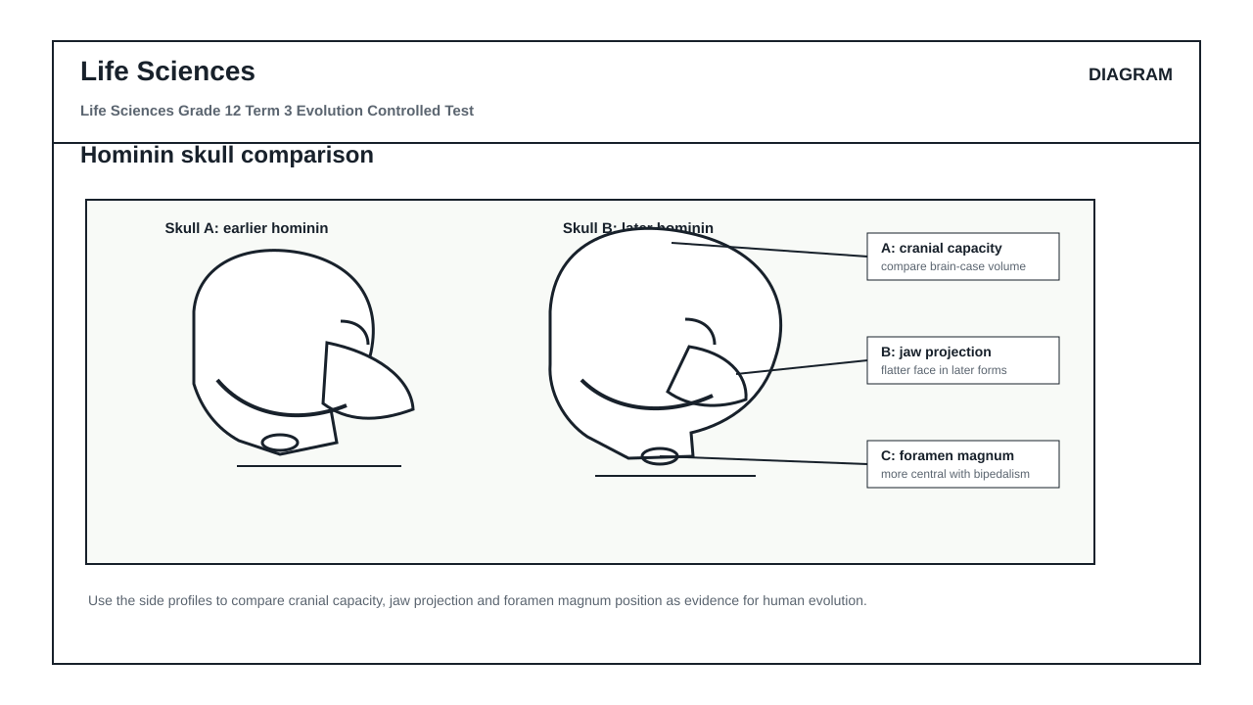

QUESTIONS

QUESTION 1: CORE CONCEPTS: EVOLUTION
Instructions: Answer each question in full sentences unless a term is requested.
Stimulus: CAPS Grade 12 Term 3 focus: Diversity, Change and Continuity; Darwinism, natural selection and human evolution.
1.1. Define biological evolution. (2)

1.2. Distinguish between a scientific hypothesis and a scientific theory. (2)

1.3. Explain why genetic variation is necessary for natural selection to occur. (3)

1.4. State TWO sources of genetic variation in a sexually reproducing population. (2)

1.5. Differentiate between homologous structures and analogous structures. (3)

1.6. Give THREE reasons why the fossil record is incomplete. (3)

QUESTION 2: DIAGRAM INTERPRETATION: HUMAN EVOLUTION
Instructions: Use Figure 3, the hominin skull comparison diagram.
Stimulus: Figure 3 shows two simplified skulls and three labelled features used as evidence in human evolution.
2.1. Identify the labelled feature A and explain why it is useful when comparing hominin skulls. (4)

2.2. Identify labelled feature B and state what a less projecting jaw suggests about diet or evolutionary trend. (4)

2.3. Identify labelled feature C and explain how its position is linked to bipedalism. (4)

2.4. Which skull, A or B, is more likely to represent the more recent hominin? Give TWO visible reasons from the diagram. (4)

2.5. Name TWO other forms of evidence, besides skull anatomy, that scientists use to study human evolution. (4)

QUESTION 3: DATA RESPONSE: NATURAL SELECTION
Instructions: Use Figure 1, the finch beak depth table and graph.
Stimulus: Figure 1 summarises changes in rainfall, hard seed availability and mean beak depth in an island finch population.
3.1. Identify the independent variable and the dependent variable shown in the graph in Figure 1. (4)

3.2. Describe the trend in mean beak depth from 2019 to 2022. (3)

3.3. Calculate the percentage increase in mean beak depth from 2019 to 2022. Show all working. (4)

3.4. Use the data to explain how natural selection could have caused the change in mean beak depth. (6)

3.5. Predict what may happen to mean beak depth after several wet years with more soft seeds. Justify your answer. (3)

QUESTION 4: INVESTIGATION DESIGN AND EVALUATION
Instructions: Use Figure 2, the investigation method and data sheet.
Stimulus: A learner investigates whether seed hardness affects feeding success in two finch-beak models.
4.1. Write a suitable aim for this investigation. (2)

4.2. Formulate a testable hypothesis for the investigation. (2)

4.3. Identify the independent variable, dependent variable and TWO controlled variables. (6)

4.4. Give TWO ways to improve the reliability or validity of the investigation. (4)

4.5. Write a conclusion that would be supported if the stronger beak model collected more hard seeds in every trial. (3)

4.6. Explain why a larger sample size would make the results more trustworthy. (3)

