LIFE SCIENCES
GRADE 12 LIFE SCIENCES: SECOND OPPORTUNITY CAPS-ALIGNED ASSESSMENT

SUBJECT | LIFE SCIENCES
GRADE | 12
ASSESSMENT TASK | GRADE 12 LIFE SCIENCES: SECOND OPPORTUNITY CAPS-ALIGNED ASSESSMENT
MARKS | 75
TIME | 1 hours

Educator approval required before classroom use.

INSTRUCTIONS AND INFORMATION
1. Read all instructions carefully.
2. Answer all questions or complete all activities as instructed.
3. Show all working where calculations, planning, diagrams or explanations are required.
4. Use the space provided by the educator, answer booklet or learner task book.
5. Write neatly and clearly.

VISUAL MATERIAL
FIGURE 1: Science Data Table And Graph Stimulus
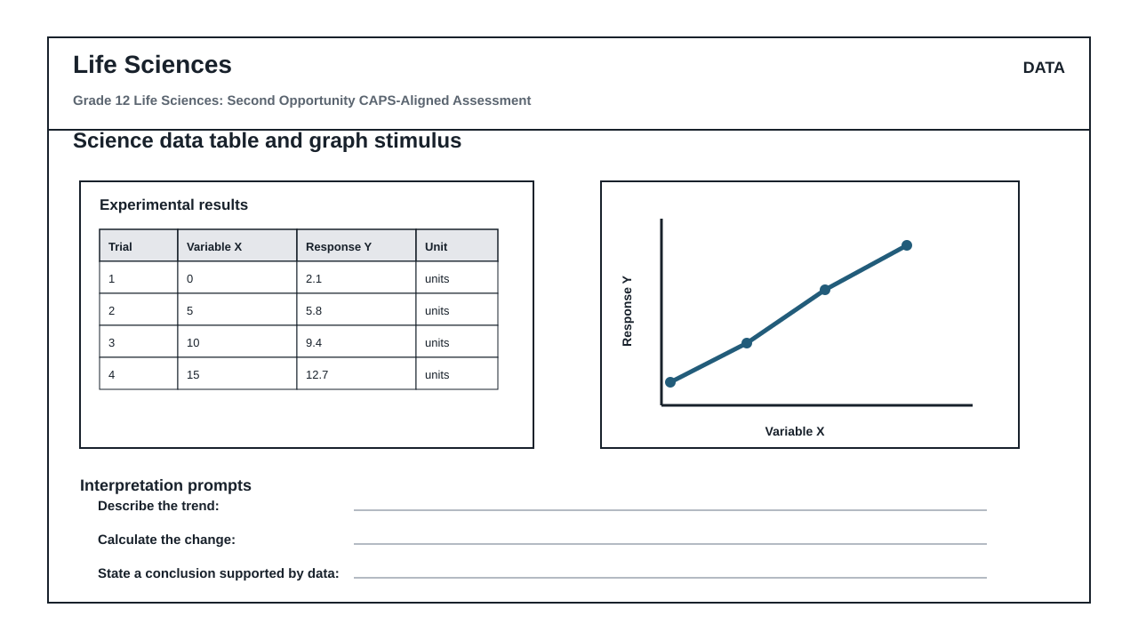
FIGURE 2: Investigation Data And Method Sheet
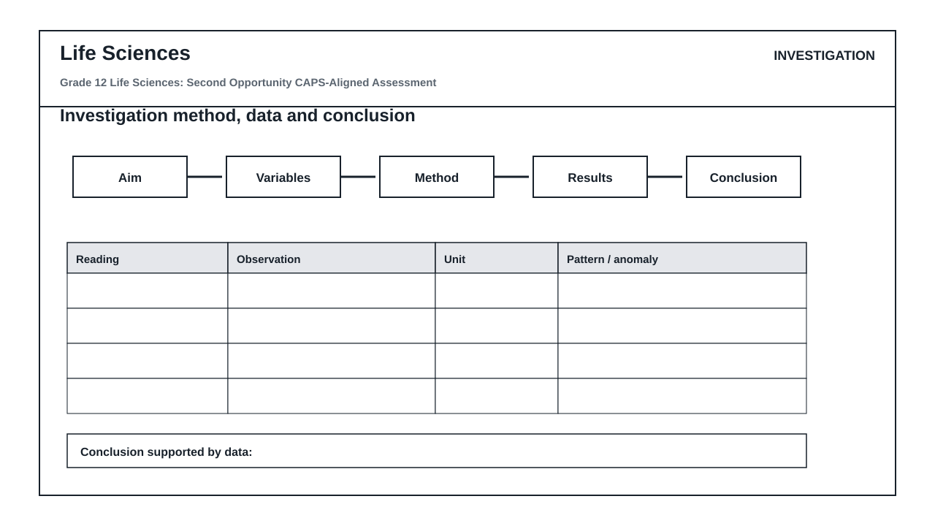
FIGURE 3: Life Sciences Labelled Diagram Stimulus
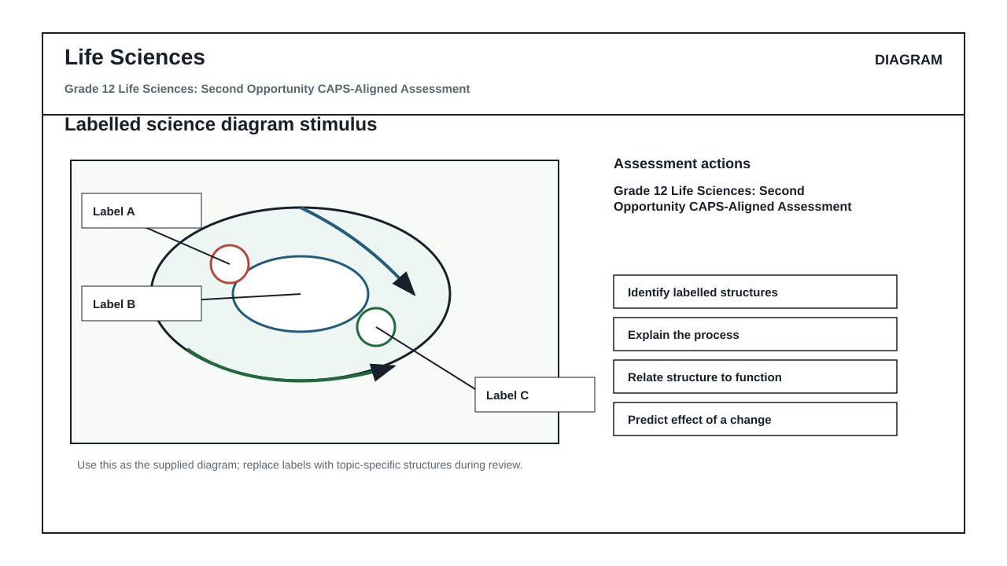

QUESTIONS

QUESTION 1: STRUCTURED ASSESSMENT TASK
Instructions: Answer all questions. Use the provided stimulus and show working or reasoning where required.
Stimulus: CAPS-aligned controlled classroom stimulus supplied by the educator.
1.1. Answer the first Life Sciences structured task using the stimulus. (37)
__________________________________________________________________________________
__________________________________________________________________________________
__________________________________________________________________________________
__________________________________________________________________________________
1.2. Complete the applied Life Sciences task with justified reasoning. (38)
__________________________________________________________________________________
__________________________________________________________________________________
__________________________________________________________________________________
__________________________________________________________________________________

MARKING GUIDELINE

TASK 1: STRUCTURED ASSESSMENT TASK
1.1. Answer the first Life Sciences structured task using the stimulus. (37)
- Credit accurate subject knowledge and evidence-based reasoning.
1.2. Complete the applied Life Sciences task with justified reasoning. (38)
- Credit application, explanation, and grade-appropriate communication.

RUBRIC
Criterion | Marks | Descriptor
Subject knowledge | 37 | Accurate CAPS-aligned knowledge.
Application and reasoning | 38 | Clear application and justified response.

EDUCATOR REVIEW CHECKLIST
- Confirm CAPS topic scope and phase appropriateness.
- Confirm all marks reconcile before use.
- Confirm the assessment form matches the subject and phase.
- Approve learner-facing wording and memo before classroom use.

