LIFE SCIENCES
GRADE 12 LIFE SCIENCES PAPER 2: EVOLUTION AND SPECIATION ASSESSMENT

SUBJECT | LIFE SCIENCES
GRADE | 12
ASSESSMENT TASK | GRADE 12 LIFE SCIENCES PAPER 2: EVOLUTION AND SPECIATION ASSESSMENT
MARKS | 75
TIME | 1.5 hours

Educator approval required before classroom use.

INSTRUCTIONS AND INFORMATION
1. Read all instructions carefully.
2. Answer all questions or complete all activities as instructed.
3. Show all working where calculations, planning, diagrams or explanations are required.
4. Use the space provided by the educator, answer booklet or learner task book.
5. Write neatly and clearly.

VISUAL MATERIAL
FIGURE 1: Finch Beak Data Table And Graph
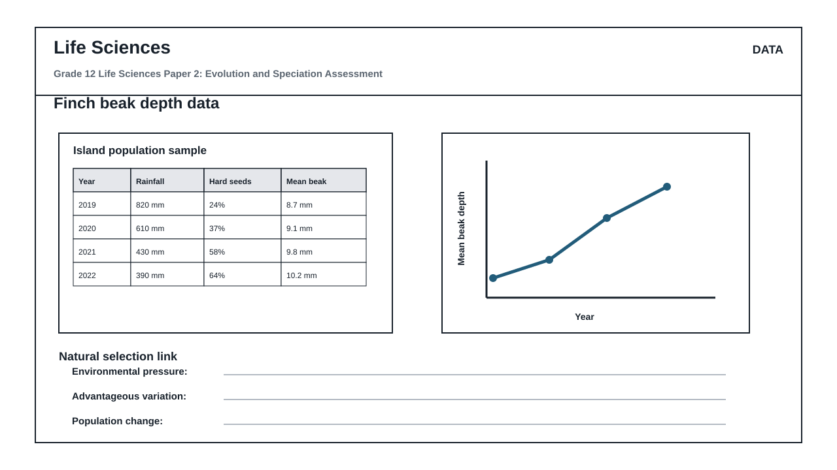
FIGURE 2: Investigation Data And Method Sheet
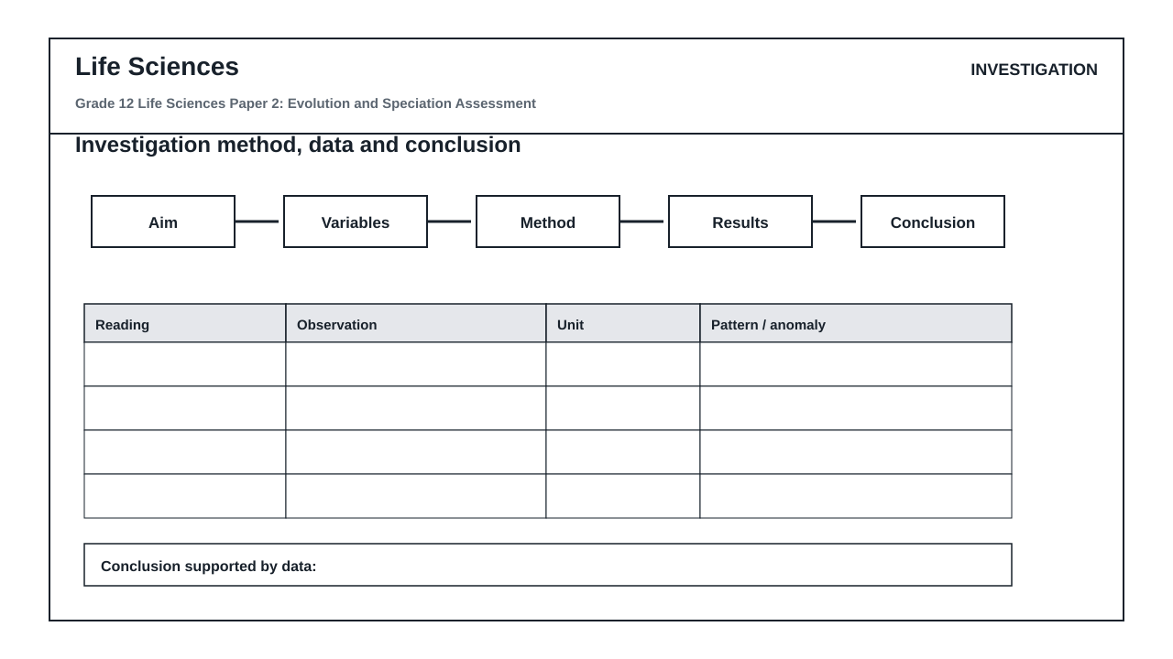
FIGURE 3: Life Sciences Hominin Skull Diagram
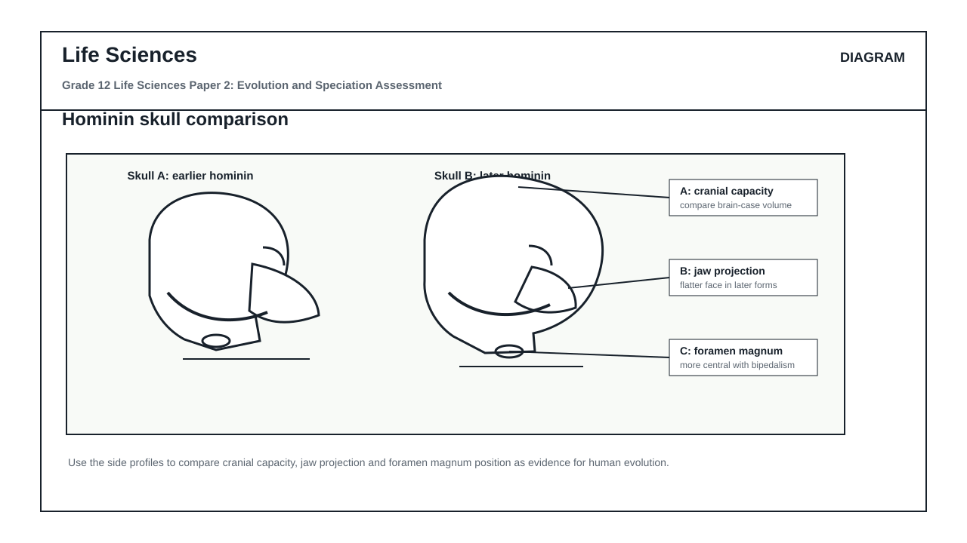

QUESTIONS

QUESTION 1: SECTION A: EVOLUTION BY NATURAL SELECTION AND SPECIATION
Instructions: Answer all questions. Refer to the provided stimuli where indicated.
Stimulus: Figure 1 shows the geographic isolation of a beetle population (Platynus montanus) due to the formation of a canyon over geological time, resulting in two distinct populations, A and B. Table 1 shows the percentage of dark-shelled and light-shelled beetles in Population A (west of the canyon) and Population B (east of the canyon) observed over a 50-year period.
Table 1: Percentage of beetle phenotypes in Populations A and B
Year | Population A (West) % Dark | Population A (West) % Light | Population B (East) % Dark | Population B (East) % Light
1975 | 50% | 50% | 50% | 50%
1995 | 72% | 28% | 31% | 69%
2015 | 88% | 12% | 15% | 85%
2025 | 95% | 5% | 8% | 92%
1.1. Define the term 'speciation' as understood in evolutionary biology. (2)

1.2. Using Figure 1 and the principles of geographic speciation, explain how the ancestral population of Platynus montanus split into two distinct species. (6)

1.3. Refer to Table 1. Calculate the percentage change in the dark-shelled phenotype of Population A from 1975 to 2025. Show all working. (4)

1.4. Explain the role of natural selection in the changing phenotypic frequencies of Population A (West) as shown in Table 1. (5)

1.5. Describe a biological test or observation that scientists could perform to confirm whether Population A and Population B have indeed become separate species. (4)

1.6. State two differences between Lamarckism and Darwinism regarding how phenotypic variation arises and is passed on to offspring. (4)

QUESTION 2: SECTION B: SCIENTIFIC INVESTIGATION DESIGN FOR NATURAL SELECTION
Instructions: Read the experimental description below and answer the questions that follow.
Stimulus: Investigation Sheet 1: A group of Grade 12 learners investigated the development of antibiotic resistance in Escherichia coli bacteria. They prepared nutrient agar plates containing different concentrations of the antibiotic Streptomycin: 0 mcg/mL (Control), 5 mcg/mL, 10 mcg/mL, and 20 mcg/mL. They inoculated each plate with a sample of E. coli from a wild-type culture and incubated them at 37°C for 24 hours. They then counted the number of surviving bacterial colonies on each plate. The experiment was repeated three times to ensure reliability.
Table 2: Number of surviving E. coli colonies at different Streptomycin concentrations
Streptomycin Concentration (mcg/mL) | Trial 1 (Colonies) | Trial 2 (Colonies) | Trial 3 (Colonies) | Average Number of Colonies
0 (Control) | 450 | 462 | 444 | 452
5 | 120 | 115 | 125 | 120
10 | 35 | 38 | 32 | 35
20 | 4 | 6 | 5 | 5
2.1. Formulate a suitable hypothesis for this investigation. (2)

2.2. Identify the independent and dependent variables in this investigation. (2)

2.3. State three variables that must be kept constant (controlled variables) during this investigation to ensure validity. (3)

2.4. Explain why the learners repeated the experiment three times and calculated an average. (2)

2.5. Plot a line graph to represent the average number of surviving E. coli colonies against the concentration of Streptomycin. (6)

2.6. Explain how the survival of a few bacterial colonies at 20 mcg/mL Streptomycin supports Darwin's theory of evolution by natural selection. (6)

2.7. State one safety precaution that must be taken when handling bacterial cultures in a school laboratory. (1)

2.8. Identify a limitation of this investigation design and suggest how it could be improved. (3)

QUESTION 3: SECTION C: HUMAN EVOLUTION EVIDENCE AND INTERPRETATION
Instructions: Answer all questions. Refer to Figure 2, which shows comparative anatomical diagrams of the skulls and pelvises of Homo sapiens, Australopithecus africanus, and Pan troglodytes (Chimpanzee).
Stimulus: Figure 2: Comparative anatomical structures of hominids.
Diagram A: Ventral view of the skull showing the position of the foramen magnum.
Diagram B: Lateral view of the skull showing the jaw, brow ridge, and cranial capacity.
Diagram C: Anterior view of the pelvis.
3.1. Identify two anatomical features visible in Diagram A (ventral view of the skull) that indicate adaptation to bipedalism. (2)

3.2. Tabulate three structural differences between the skulls of Homo sapiens and Pan troglodytes as visible in Diagram B. (7)

3.3. Explain the significance of the change in the shape of the pelvis from Pan troglodytes to Homo sapiens as shown in Diagram C. (4)

3.4. Discuss the 'Out of Africa' hypothesis, citing both genetic and fossil evidence that supports this model of human origins. (8)

3.5. Explain how the discovery of transitional fossils like Australopithecus sediba in South Africa contributes to our understanding of human evolution. (4)

