LIFE SCIENCES
GRADE 12 LIFE SCIENCES: EVOLUTION AND HUMAN ORIGINS ASSESSMENT

SUBJECT | LIFE SCIENCES
GRADE | 12
ASSESSMENT TASK | GRADE 12 LIFE SCIENCES: EVOLUTION AND HUMAN ORIGINS ASSESSMENT
MARKS | 75
TIME | 1.5 hours

Educator approval required before classroom use.

INSTRUCTIONS AND INFORMATION
1. Read all instructions carefully.
2. Answer all questions or complete all activities as instructed.
3. Show all working where calculations, planning, diagrams or explanations are required.
4. Use the space provided by the educator, answer booklet or learner task book.
5. Write neatly and clearly.

VISUAL MATERIAL
FIGURE 1: Finch Beak Data Table And Graph
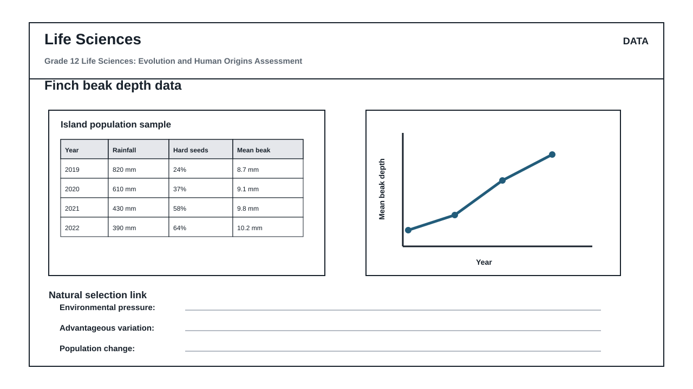
FIGURE 2: Life Sciences Hominin Skull Diagram
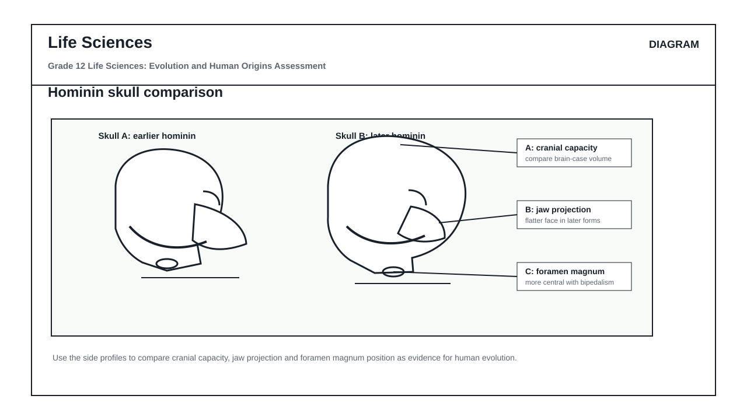

QUESTIONS

QUESTION 1: SECTION A: EVOLUTION BY NATURAL SELECTION AND SPECIATION
Instructions: Answer all questions. Refer to Figure 1 and the provided data to answer Questions 1.1 to 1.6.
Stimulus: Figure 1 shows the distribution of beak depth in a population of medium ground finches (Geospiza fortis) on an island before and after a severe drought. The drought resulted in a drastic reduction in rainfall (from 130 mm to 24 mm). Consequently, small, soft seeds became scarce, leaving mostly large, hard-shelled seeds available as a food source.
1.1. Define the term 'natural selection' as understood in evolutionary biology. (2)

1.2. Using the information in Figure 1, describe the relationship between rainfall, seed availability, and the survival of finches with different beak depths during the drought. (4)

1.3. Explain how natural selection led to the change in the average beak depth of the finch population after the drought. (6)

1.4. Describe how geographic isolation could lead to the speciation of these finches if a sub-population was carried to a neighboring island with different environmental conditions. (8)

1.5. Identify the independent and dependent variables in the investigation represented by Figure 1. (2)

1.6. State three ways in which researchers could increase the reliability of the data collected in this finch study. (3)

QUESTION 2: SECTION B: SCIENTIFIC INVESTIGATION DESIGN FOR NATURAL SELECTION
Instructions: Answer all questions based on the experimental design described below.
Stimulus: A group of Grade 12 learners designed an investigation to simulate how natural selection affects a population of birds with different beak shapes. They used three different tools to represent beak phenotypes: forceps (thin beak), a spoon (scoop beak), and pliers (heavy beak).
They placed 100 small, soft seeds and 100 large, hard seeds on a tray. Three learners, each using one of the tools, were given 30 seconds to collect as many seeds as possible. The investigation was repeated 5 times.
2.1. Formulate a suitable hypothesis for this investigation. (2)

2.2. Identify two variables that must be kept constant (controlled) to ensure the validity of this investigation. (2)

2.3. The table below shows the average number of seeds collected over the 5 trials:
- Forceps: 45 small seeds, 2 hard seeds
- Spoon: 38 small seeds, 5 hard seeds
- Pliers: 12 small seeds, 58 hard seeds
Calculate the percentage of the total available hard seeds (100) collected by the learner using pliers. Show all working. (4)

2.4. Draw a bar graph to compare the average number of small seeds and hard seeds collected by each of the three tools. (6)

2.5. Explain why variation in beak shape is essential for the long-term survival of a bird species if the island's vegetation changes permanently. (6)

QUESTION 3: SECTION C: HUMAN EVOLUTION EVIDENCE AND INTERPRETATION
Instructions: Answer all questions. Refer to Figure 2 and Figure 3 to answer Questions 3.1 to 3.6.
Stimulus: Figure 2 illustrates the lateral and ventral views of the skulls, and the anterior views of the pelvises of Homo sapiens, Australopithecus africanus, and Pan troglodytes (chimpanzee). Figure 3 provides data on the average cranial capacity of these species.
3.1. Tabulate three anatomical differences between the skulls of Homo sapiens and Pan troglodytes that are visible in Figure 2. (7)

3.2. Explain the significance of the position of the foramen magnum in Homo sapiens compared to Pan troglodytes. (4)

3.3. Describe how the shape of the pelvis in Australopithecus africanus supports the transition to bipedalism when compared to Pan troglodytes. (4)

3.4. Define the term 'hominin'. (2)

3.5. Explain how genetic evidence, specifically mitochondrial DNA (mtDNA), supports the 'Out of Africa' hypothesis of human origins. (6)

3.6. Analyze the cranial capacity data in Figure 3. Explain the evolutionary trend in brain size from Australopithecus to Homo sapiens, and suggest how this trend correlates with changes in diet and tool use. (7)

