LIFE SCIENCES
GRADE 12 LIFE SCIENCES CONTROLLED TEST: EVOLUTION AND SPECIATION

SUBJECT | LIFE SCIENCES
GRADE | 12
ASSESSMENT TASK | GRADE 12 LIFE SCIENCES CONTROLLED TEST: EVOLUTION AND SPECIATION
MARKS | 75
TIME | 1.5 hours

Educator approval required before classroom use.

INSTRUCTIONS AND INFORMATION
1. Read all instructions carefully.
2. Answer all questions or complete all activities as instructed.
3. Show all working where calculations, planning, diagrams or explanations are required.
4. Use the space provided by the educator, answer booklet or learner task book.
5. Write neatly and clearly.

VISUAL MATERIAL
FIGURE 1: Finch Beak Data Table And Graph
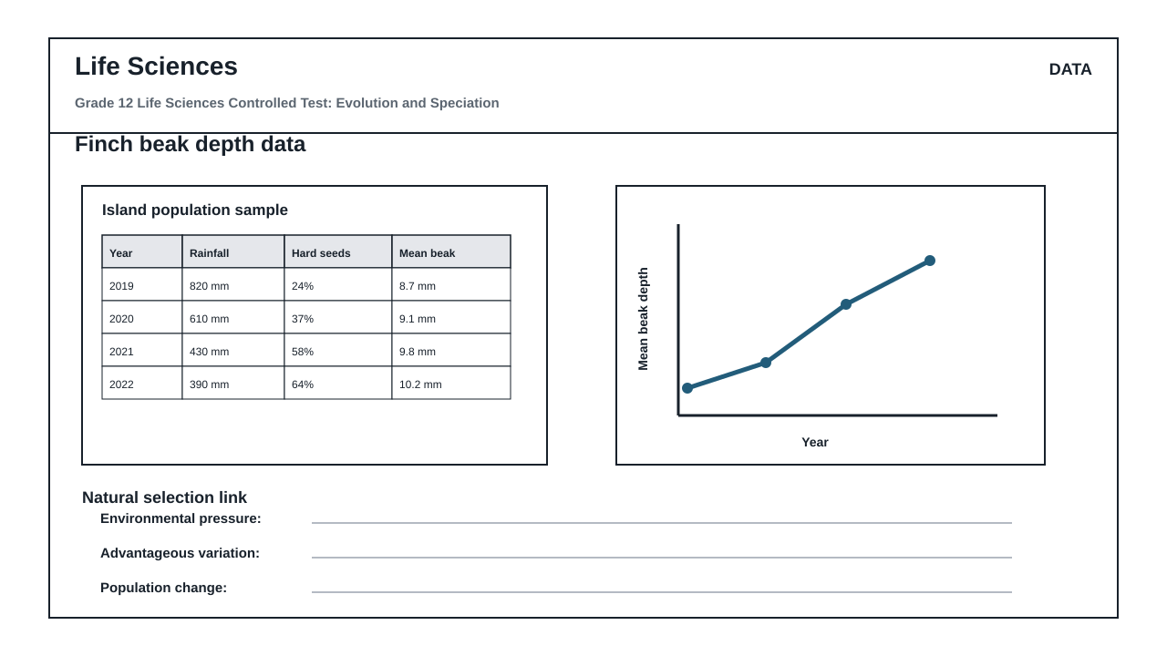
FIGURE 2: Investigation Data And Method Sheet
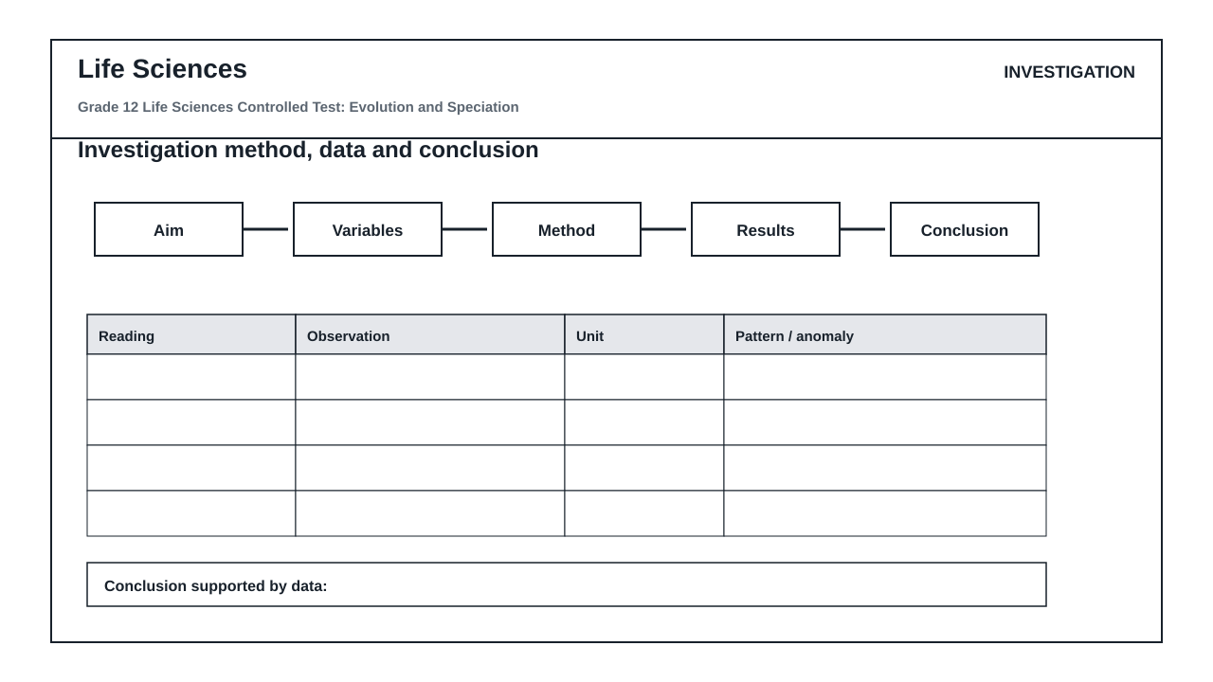
FIGURE 3: Life Sciences Hominin Skull Diagram
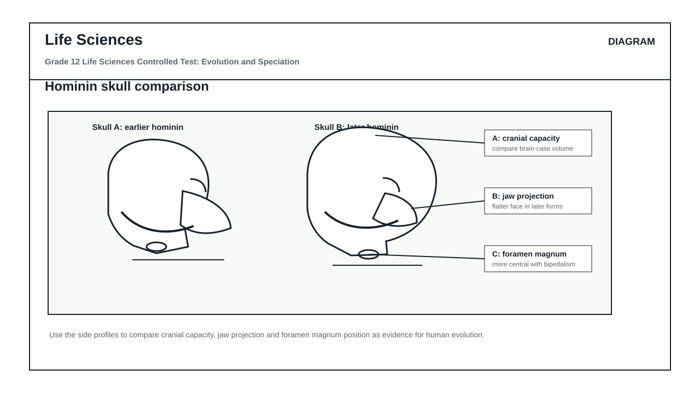

QUESTIONS

QUESTION 1: SECTION A: NATURAL SELECTION AND SPECIATION (DATA RESPONSE)
Instructions: Answer all questions. Refer to Figure 1 (Finch beak depth data table and graph) to answer Questions 1.1 to 1.6.
Stimulus: Figure 1: Finch beak depth data table and graph.
Table 1: Environmental conditions and mean beak depth of Geospiza fortis over four years:
- 2019: Rainfall 820 mm, Hard seeds 24%, Mean beak depth 8.7 mm
- 2020: Rainfall 610 mm, Hard seeds 37%, Mean beak depth 9.1 mm
- 2021: Rainfall 430 mm, Hard seeds 58%, Mean beak depth 9.8 mm
- 2022: Rainfall 390 mm, Hard seeds 64%, Mean beak depth 10.2 mm
1.1. State the relationship between annual rainfall and the percentage of hard seeds available in the environment as shown in Figure 1. (2)

1.2. Describe the trend in mean beak depth from 2019 to 2022 in relation to the changing environmental conditions. (3)

1.3. Calculate the percentage change in mean beak depth from 2019 to 2022. Show all working in the workspace provided. (4)

1.4. Explain how the decrease in rainfall acts as a selection pressure on this population of finches. (6)

1.5. Using Darwin's theory of evolution by natural selection, explain why a larger beak depth became more common in this population over time. (8)

1.6. Define the term 'speciation'. (2)

QUESTION 2: SECTION B: SCIENTIFIC INVESTIGATION DESIGN (PRACTICAL CRITIQUE)
Instructions: Refer to Figure 2 (Investigation method and data sheet) to answer Questions 2.1 to 2.8. Critique the design, variables, and quality of the method described.
Stimulus: Figure 2: Investigation method and data sheet.
Context: Learners simulated natural selection by using three different tools (tweezers, forceps, and clothes pegs) to pick up hard seeds of varying sizes from a flat surface over a 30-second period. They recorded the number of seeds successfully collected in a single trial.
Recorded Observations:
- Tweezers: 5 hard seeds collected
- Forceps: 12 hard seeds collected
- Clothes pegs: 28 hard seeds collected
2.1. Formulate a suitable aim for this investigation. (2)

2.2. Identify the independent and dependent variables in this investigation. (2)

2.3. State TWO variables that must be controlled (kept constant) to ensure a fair test. (2)

2.4. Explain the difference between the reliability and the validity of this scientific investigation. (4)

2.5. Critique the method quality: Suggest TWO ways the learners could improve the reliability of their results. (4)

2.6. Suggest ONE way the learners could improve the validity of this investigation. (2)

2.7. Based on the recorded observations in Figure 2, draw a suitable conclusion for this investigation. (3)

2.8. Explain how this simulation models the process of natural selection in a changing environment where only hard seeds are available. (6)

QUESTION 3: SECTION C: HUMAN EVOLUTION EVIDENCE (DIAGRAM INTERPRETATION)
Instructions: Refer to Figure 3 (Hominin skull comparison diagram) to answer Questions 3.1 to 3.6.
Stimulus: Figure 3: Hominin skull comparison diagram.
- Skull A represents an earlier hominin profile.
- Skull B represents a later hominin profile.
- Label A indicates cranial capacity.
- Label B indicates jaw projection (prognathism).
- Label C indicates the position of the foramen magnum.
3.1. Identify the anatomical features indicated by Labels A, B, and C in Figure 3. (3)

3.2. Draw a table to compare Skull A (earlier hominin) and Skull B (later hominin) with respect to the features indicated by Labels A, B, and C. (7)

3.3. Explain how the change in the position of the foramen magnum (Label C) from Skull A to Skull B supports the transition to bipedalism. (4)

3.4. State TWO anatomical advantages of bipedalism for early hominins living in open savannah environments. (2)

3.5. Discuss how the change in cranial capacity (Label A) is linked to cognitive development and tool use in human evolution. (5)

3.6. Name TWO types of evidence, other than fossilized anatomical structures, that scientists use to support the theory of common ancestry between humans and other hominids. (4)

