LIFE SCIENCES
GRADE 12 LIFE SCIENCES CONTROLLED TEST: EVOLUTION AND SPECIATION

SUBJECT | LIFE SCIENCES
GRADE | 12
ASSESSMENT TASK | GRADE 12 LIFE SCIENCES CONTROLLED TEST: EVOLUTION AND SPECIATION
MARKS | 75
TIME | 1.5 hours

Educator approval required before classroom use.

INSTRUCTIONS AND INFORMATION
1. Read all instructions carefully.
2. Answer all questions or complete all activities as instructed.
3. Show all working where calculations, planning, diagrams or explanations are required.
4. Use the space provided by the educator, answer booklet or learner task book.
5. Write neatly and clearly.

VISUAL MATERIAL
FIGURE 1: Finch Beak Data Table And Graph
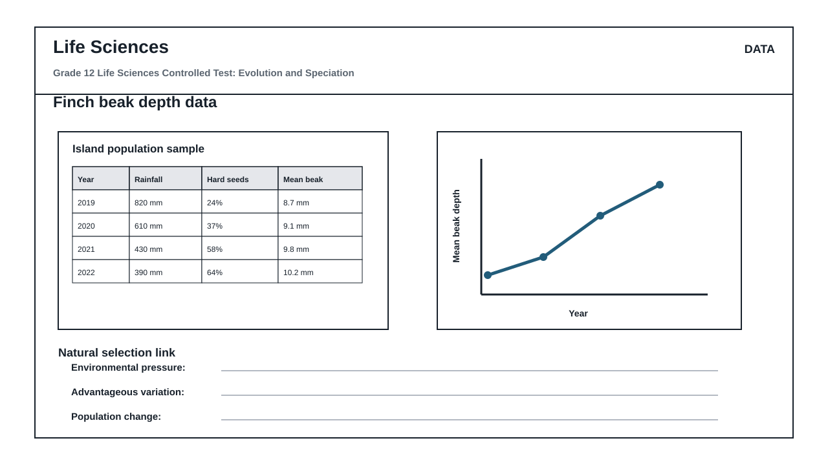
FIGURE 2: Investigation Data And Method Sheet
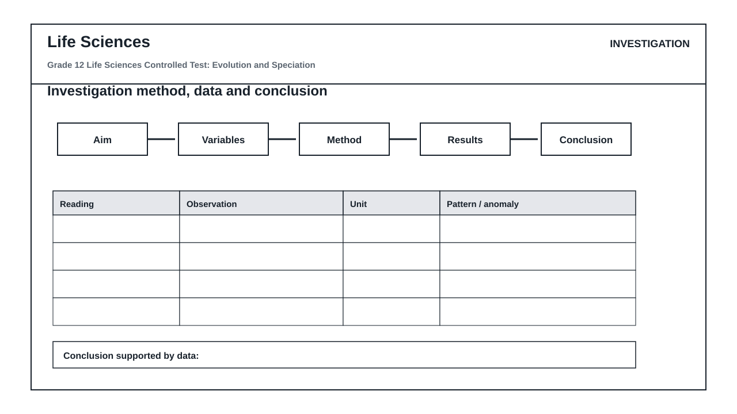
FIGURE 3: Life Sciences Hominin Skull Diagram
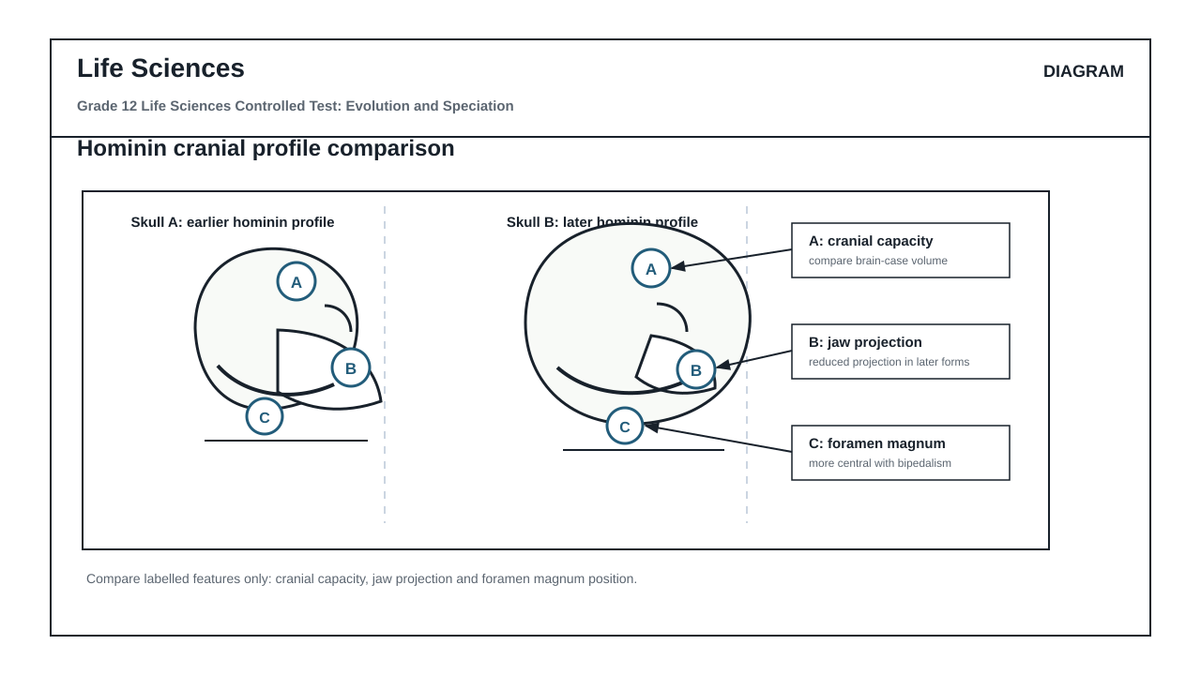

QUESTIONS

QUESTION 1: SECTION A: NATURAL SELECTION AND SPECIATION (DATA RESPONSE)
Instructions: Answer all questions. Refer to Figure 1 (Finch beak depth data table and graph) to answer Questions 1.1 to 1.6.
Stimulus: Figure 1: Finch beak depth data table and graph.
Table 1: Environmental conditions and mean beak depth of Geospiza fortis over four years:
- 2019: Rainfall 820 mm, Hard seeds 24%, Mean beak depth 8.7 mm
- 2020: Rainfall 610 mm, Hard seeds 37%, Mean beak depth 9.1 mm
- 2021: Rainfall 430 mm, Hard seeds 58%, Mean beak depth 9.8 mm
- 2022: Rainfall 390 mm, Hard seeds 64%, Mean beak depth 10.2 mm
1.1. State the relationship between annual rainfall and the percentage of hard seeds available in the environment as shown in Figure 1. (2)

1.2. Describe the trend in mean beak depth from 2019 to 2022 in relation to the changing environmental conditions. (3)

1.3. Calculate the percentage change in mean beak depth from 2019 to 2022. Show all working in the workspace provided. (4)

1.4. Explain how the decrease in rainfall acts as a selection pressure on this population of finches. (6)

1.5. Using Darwin's theory of evolution by natural selection, explain why a larger beak depth became more common in this population over time. (8)

1.6. Define the term 'speciation'. (2)

QUESTION 2: SECTION B: SCIENTIFIC INVESTIGATION DESIGN (PRACTICAL CRITIQUE)
Instructions: Refer to Figure 2 (Investigation method and data sheet) to answer Questions 2.1 to 2.8. Critique the design, variables, and quality of the method described.
Stimulus: Figure 2: Investigation method and data sheet.
Context: Learners simulated natural selection by using three different tools (tweezers, forceps, and clothes pegs) to pick up hard seeds of varying sizes from a flat surface over a 30-second period. They recorded the number of seeds successfully collected in a single trial.
Recorded Observations:
- Tweezers: 5 hard seeds collected
- Forceps: 12 hard seeds collected
- Clothes pegs: 28 hard seeds collected
2.1. Formulate a suitable aim for this investigation. (2)

2.2. Identify the independent and dependent variables in this investigation. (2)

2.3. State TWO variables that must be controlled (kept constant) to ensure a fair test. (2)

2.4. Explain the difference between the reliability and the validity of this scientific investigation. (4)

2.5. Critique the method quality: Suggest TWO ways the learners could improve the reliability of their results. (4)

2.6. Suggest ONE way the learners could improve the validity of this investigation. (2)

2.7. Based on the recorded observations in Figure 2, draw a suitable conclusion for this investigation. (3)

2.8. Explain how this simulation models the process of natural selection in a changing environment where only hard seeds are available. (6)

QUESTION 3: SECTION C: HUMAN EVOLUTION EVIDENCE (DIAGRAM INTERPRETATION)
Instructions: Refer to Figure 3 (Hominin skull comparison diagram) to answer Questions 3.1 to 3.6.
Stimulus: Figure 3: Hominin skull comparison diagram.
- Skull A represents an earlier hominin profile.
- Skull B represents a later hominin profile.
- Label A indicates cranial capacity.
- Label B indicates jaw projection (prognathism).
- Label C indicates the position of the foramen magnum.
3.1. Identify the anatomical features indicated by Labels A, B, and C in Figure 3. (3)

3.2. Draw a table to compare Skull A (earlier hominin) and Skull B (later hominin) with respect to the features indicated by Labels A, B, and C. (7)

3.3. Explain how the change in the position of the foramen magnum (Label C) from Skull A to Skull B supports the transition to bipedalism. (4)

3.4. State TWO anatomical advantages of bipedalism for early hominins living in open savannah environments. (2)

3.5. Discuss how the change in cranial capacity (Label A) is linked to cognitive development and tool use in human evolution. (5)

3.6. Name TWO types of evidence, other than fossilized anatomical structures, that scientists use to support the theory of common ancestry between humans and other hominids. (4)

MARKING GUIDELINE

TASK 1: SECTION A: NATURAL SELECTION AND SPECIATION (DATA RESPONSE)
1.1. State the relationship between annual rainfall and the percentage of hard seeds available in the environment as shown in Figure 1. (2)
- As the annual rainfall decreases, the percentage of hard seeds available increases. (2)
- OR
- There is an inverse relationship between annual rainfall and the percentage of hard seeds. (2)
1.2. Describe the trend in mean beak depth from 2019 to 2022 in relation to the changing environmental conditions. (3)
- The mean beak depth increased steadily from 8.7 mm in 2019 to 10.2 mm in 2022. (1)
- This increase corresponds with a decrease in rainfall (from 820 mm to 390 mm). (1)
- And an increase in the availability of hard seeds (from 24% to 64%). (1)
1.3. Calculate the percentage change in mean beak depth from 2019 to 2022. Show all working in the workspace provided. (4)
- Formula: Percentage Change = ((Value in 2022 - Value in 2019) / Value in 2019) x 100 (1)
- Calculation: ((10.2 mm - 8.7 mm) / 8.7 mm) x 100 (1)
- = (1.5 / 8.7) x 100 (1)
- = 17.24% (Accept 17.2% or 17%) (1)
1.4. Explain how the decrease in rainfall acts as a selection pressure on this population of finches. (6)
- Decreased rainfall leads to a shortage of soft, easy-to-crack seeds. (1)
- Only plants producing hard, drought-resistant seeds survive and reproduce. (1)
- This changes the primary food source to hard seeds. (1)
- Finches with smaller, shallower beaks cannot crack the hard seeds and face starvation/reduced survival. (1)
- Finches with larger, deeper beaks are able to crack the hard seeds and survive. (1)
- Thus, the dry environment selects for individuals with larger beak depths (differential survival). (1)
1.5. Using Darwin's theory of evolution by natural selection, explain why a larger beak depth became more common in this population over time. (8)
- There is variation in beak depth within the original population of finches (some have shallow beaks, some have deep beaks). (1)
- This variation is heritable (passed from parents to offspring). (1)
- When drought occurred (environmental change), competition for food (soft seeds) increased. (1)
- Finches with larger/deeper beaks had a favorable adaptation/were better suited to crack the abundant hard seeds. (1)
- These individuals had a higher chance of survival (survival of the fittest). (1)
- The surviving finches reproduced. (1)
- They passed the alleles/genes for larger beak depth to their offspring. (1)
- Over generations, the frequency of the allele for larger beak depth increased, making it more common in the population. (1)
1.6. Define the term 'speciation'. (2)
- The evolutionary process by which new, distinct species arise from existing species. (2)

TASK 2: SECTION B: SCIENTIFIC INVESTIGATION DESIGN (PRACTICAL CRITIQUE)
2.1. Formulate a suitable aim for this investigation. (2)
- To determine which tool (tweezers, forceps, or clothes pegs) is most effective at collecting hard seeds. (2)
- OR
- To investigate the effect of tool type on the number of hard seeds collected. (2)
2.2. Identify the independent and dependent variables in this investigation. (2)
- Independent variable: Type of tool used (tweezers, forceps, clothes pegs) (1)
- Dependent variable: Number of hard seeds collected (1)
2.3. State TWO variables that must be controlled (kept constant) to ensure a fair test. (2)
- Any two of:
- - The time allowed for collecting seeds (30 seconds). (1)
- - The size/type of the hard seeds used. (1)
- - The surface from which the seeds are collected. (1)
- - The person operating the tools (if comparing tool efficiency directly). (1)
2.4. Explain the difference between the reliability and the validity of this scientific investigation. (4)
- Reliability refers to the consistency of the results when the experiment is repeated. (2)
- Validity refers to whether the experiment actually measures what it set out to measure (i.e., all variables are controlled except the independent variable). (2)
2.5. Critique the method quality: Suggest TWO ways the learners could improve the reliability of their results. (4)
- Repeat the investigation multiple times (at least 3 trials) for each tool and calculate an average. (2)
- Increase the sample size of learners performing the test simultaneously and average the results. (2)
2.6. Suggest ONE way the learners could improve the validity of this investigation. (2)
- Ensure that the same person operates all three tools to eliminate differences in individual reaction time or manual dexterity. (2)
2.7. Based on the recorded observations in Figure 2, draw a suitable conclusion for this investigation. (3)
- Clothes pegs are the most effective tool for collecting hard seeds, followed by forceps, while tweezers are the least effective. (3)
2.8. Explain how this simulation models the process of natural selection in a changing environment where only hard seeds are available. (6)
- The different tools represent variations in beak morphology (shapes/sizes) within a bird population. (1)
- The hard seeds represent the limited food resource available in the environment. (1)
- The 30-second collection period represents the struggle for survival/competition for resources. (1)
- The clothes peg (representing a large, strong beak) was highly successful, simulating high survival fitness. (1)
- The tweezers (representing a small, delicate beak) were unsuccessful, simulating low survival fitness. (1)
- Over time, individuals with 'clothes peg' phenotypes would survive, reproduce, and dominate the population. (1)

TASK 3: SECTION C: HUMAN EVOLUTION EVIDENCE (DIAGRAM INTERPRETATION)
3.1. Identify the anatomical features indicated by Labels A, B, and C in Figure 3. (3)
- Label A: Cranial capacity / Brain size (1)
- Label B: Jaw projection / Prognathism (1)
- Label C: Position of the foramen magnum (1)
3.2. Draw a table to compare Skull A (earlier hominin) and Skull B (later hominin) with respect to the features indicated by Labels A, B, and C. (7)
- Marking rubric for table:
- - Table structure: Columns labeled Skull A and Skull B, rows labeled for features A, B, and C. (1)
- - Feature A (Cranial capacity): Skull A has a smaller cranial capacity; Skull B has a larger cranial capacity. (2)
- - Feature B (Jaw projection): Skull A is highly prognathous (protruding jaw); Skull B is flat-faced/non-prognathous (receding jaw). (2)
- - Feature C (Foramen magnum): Skull A has the foramen magnum positioned more towards the back of the skull; Skull B has the foramen magnum positioned centrally/forward under the skull. (2)
3.3. Explain how the change in the position of the foramen magnum (Label C) from Skull A to Skull B supports the transition to bipedalism. (4)
- In Skull A, the backward position of the foramen magnum indicates a quadrupedal posture where the head is held forward. (1)
- In Skull B, the central position of the foramen magnum allows the skull to balance vertically on top of the vertebral column. (1)
- This vertical alignment reduces the need for large neck muscles to hold the head upright. (1)
- It directly supports an upright, bipedal posture and locomotion. (1)
3.4. State TWO anatomical advantages of bipedalism for early hominins living in open savannah environments. (2)
- Any two of:
- - Frees the hands for carrying food, tools, or offspring. (1)
- - Raises the eyes higher to spot predators or food over tall grass. (1)
- - Exposes less body surface area to direct sunlight, aiding in thermoregulation. (1)
- - More energy-efficient locomotion over long distances. (1)
3.5. Discuss how the change in cranial capacity (Label A) is linked to cognitive development and tool use in human evolution. (5)
- An increase in cranial capacity indicates an increase in brain size. (1)
- This larger brain size correlates with increased cognitive ability, intelligence, and complex processing. (1)
- It allowed hominins to plan, communicate, and solve complex environmental problems. (1)
- This cognitive development enabled the transition from using simple, unmodified stones to manufacturing complex, specialized tools (e.g., Acheulean hand axes). (1)
- Better tools improved hunting efficiency and food processing, which in turn provided high-energy nutrition to support further brain growth. (1)
3.6. Name TWO types of evidence, other than fossilized anatomical structures, that scientists use to support the theory of common ancestry between humans and other hominids. (4)
- Any two of:
- - Genetic/DNA evidence (comparing sequence similarities in nuclear or mitochondrial DNA). (2)
- - Cultural evidence (fossilized tools, evidence of fire use, art, burial sites). (2)
- - Chromosomal evidence (comparing karyotypes and chromosome fusion, e.g., Chromosome 2 in humans). (2)

RUBRIC
Criterion | Marks | Descriptor
Section A: Natural Selection and Speciation | 25 | Accurate interpretation of finch beak depth data, correct calculation of percentage change, and clear, curriculum-aligned explanations of natural selection and speciation.
Section B: Scientific Investigation Design | 25 | Formulation of a clear aim, correct identification of variables, clear distinction between reliability and validity, constructive critique of the method, and drawing a valid conclusion based on observations.
Section C: Human Evolution Evidence | 25 | Correct identification of hominin skull features, accurate comparative tabulation, clear explanation of bipedalism and cognitive evolution, and correct identification of alternative evolutionary evidence.

EDUCATOR REVIEW CHECKLIST
- Verify that the total marks sum to exactly 75.
- Confirm that the duration of 1.5 hours is appropriate for the reading and writing load of Grade 12 learners.
- Check that all three figures (Figure 1, Figure 2, and Figure 3) are explicitly referenced and integrated into the questions.
- Ensure the marking guidelines accept scientifically equivalent wording and credit correct units.

