PHYSICAL SCIENCES
PHYSICAL SCIENCES GRADE 12 SOURCE-EMBEDDED CONTROLLED TEST PROOF

SUBJECT | PHYSICAL SCIENCES
GRADE | 12
ASSESSMENT TASK | PHYSICAL SCIENCES GRADE 12 SOURCE-EMBEDDED CONTROLLED TEST PROOF
MARKS | 35
TIME | 45 minutes

Educator approval required before classroom use.

INSTRUCTIONS AND INFORMATION
1. Read all instructions carefully.
2. Answer all questions or complete all activities as instructed.
3. Show all working where calculations, planning, diagrams or explanations are required.
4. Use the space provided by the educator, answer booklet or learner task book.
5. Write neatly and clearly.

SOURCE MATERIAL
SOURCE 1: Official-paper exemplar: Data Table
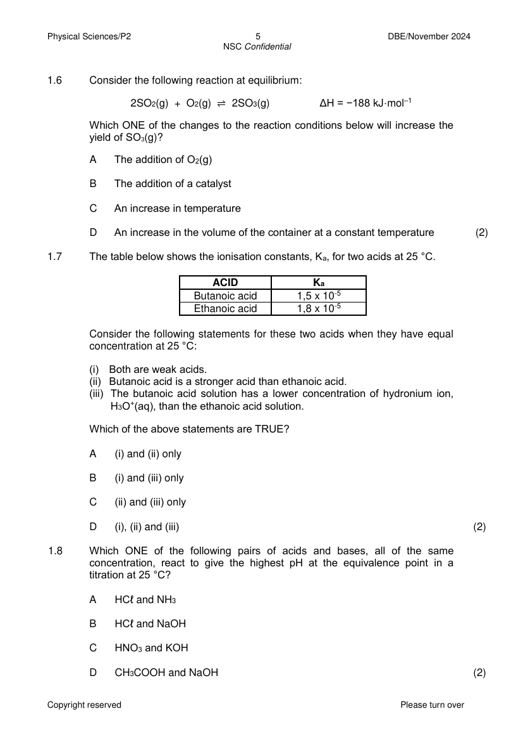
Paper: Physical Sciences Chemistry P2 November 2024 | Page: 5 | Source Type: data_table
SOURCE 2: Official-paper exemplar: Diagram Or Model
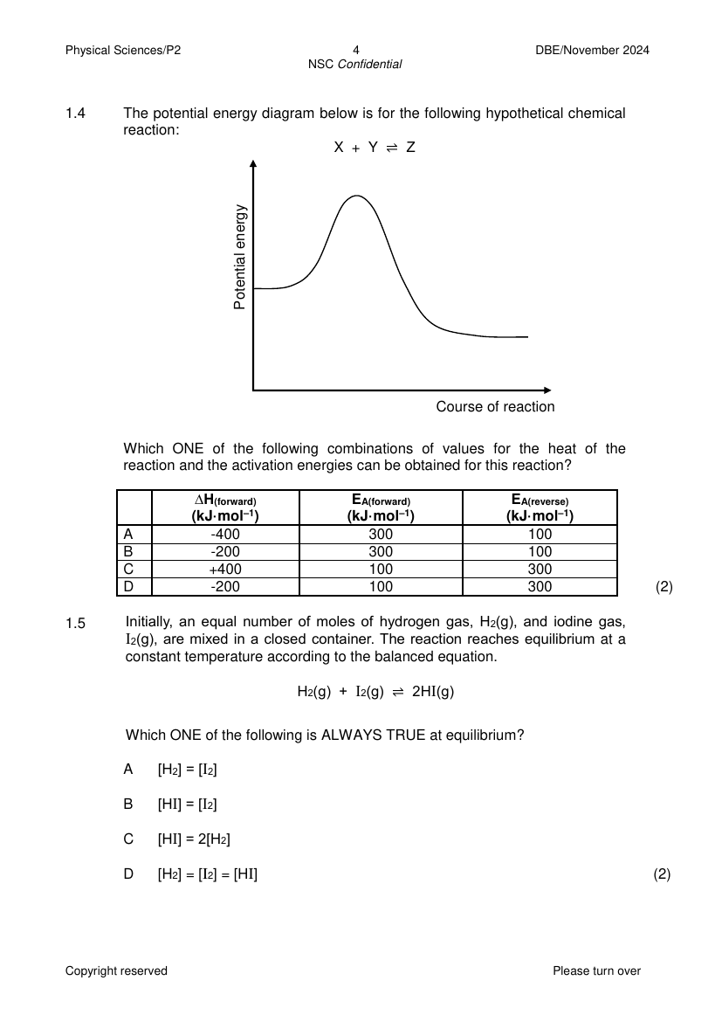
Paper: Physical Sciences Chemistry P2 November 2024 | Page: 4 | Source Type: diagram_or_model
SOURCE 3: Official-paper exemplar: Graph Or Chart
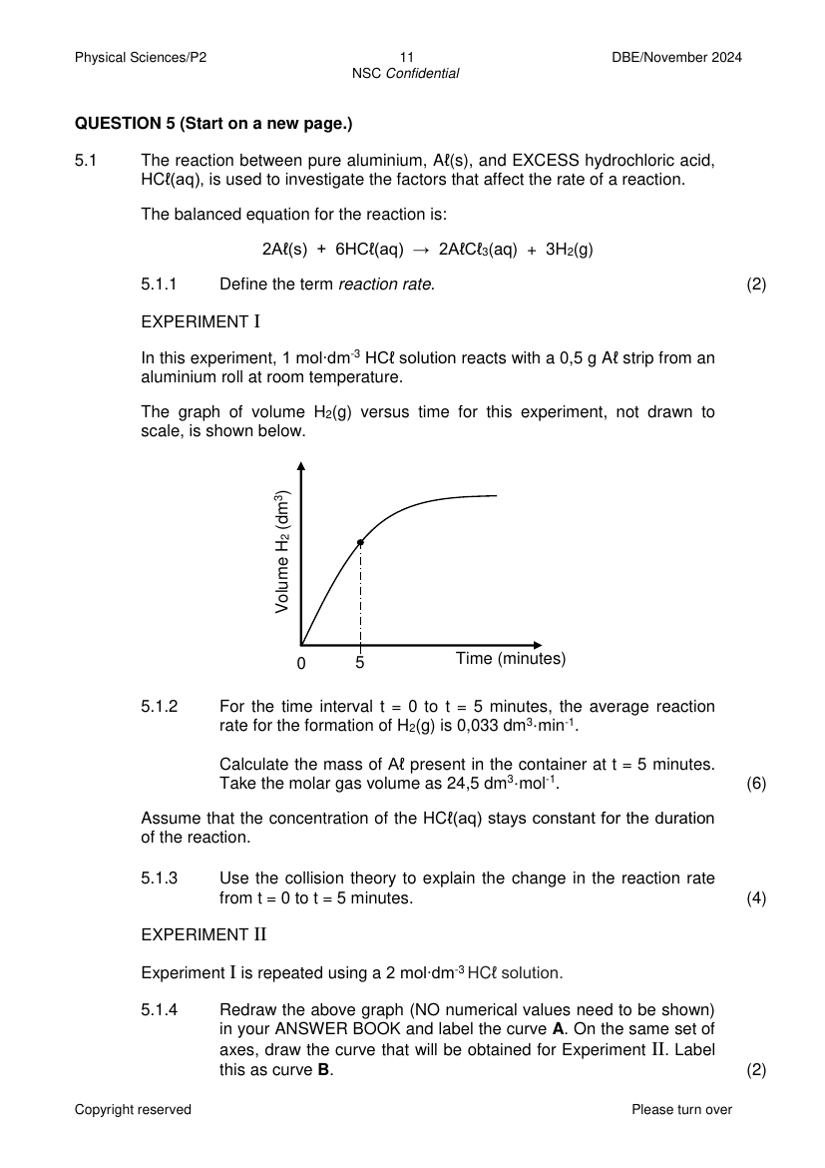
Paper: Physical Sciences Chemistry P2 November 2024 | Page: 11 | Source Type: graph_or_chart

VISUAL MATERIAL
FIGURE 1: Investigation Data And Method Sheet
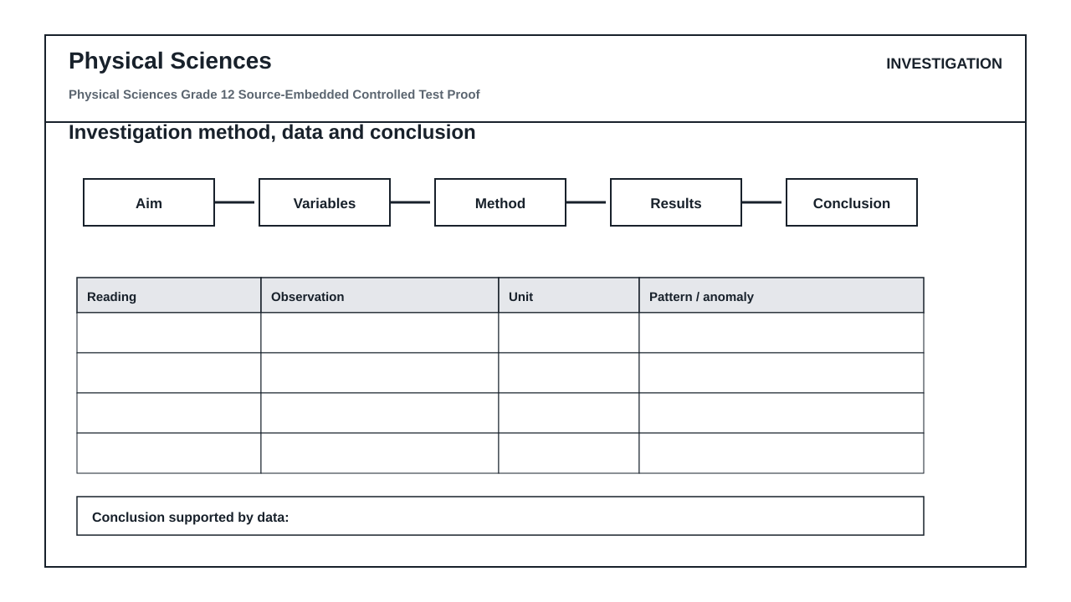

QUESTIONS

QUESTION 1: SOURCE-BASED SCIENTIFIC INTERPRETATION
Instructions: Use the embedded official-paper exemplars as source material. Answer from the visible data, labels and trends; do not rely only on recall.
1.1. Refer to SOURCE 1. Identify the independent variable shown or implied in the data and state the unit used where visible. (3)

1.2. Refer to SOURCE 2. Name one labelled component or represented quantity and explain its role in the physical or chemical system shown. (4)

1.3. Refer to SOURCE 3. Describe the trend shown by the graph and give one possible scientific reason for that trend. (5)

1.4. Explain why source-based questions are useful for testing scientific reasoning rather than memorised definitions only. (3)

QUESTION 2: CALCULATION AND METHOD REASONING
Instructions: Show formula selection, substitution and units where a calculation is required.
2.1. Write the general formula you would use to calculate a rate, gradient or change from a table or graph. (3)

2.2. State TWO checks an educator should perform before accepting a generated scientific diagram in a formal test. (4)

2.3. A learner gives a correct final value but no substitution or unit. Explain how the memo should award marks. (4)

2.4. Evaluate whether this paper is ready for classroom use. Give TWO strengths and TWO issues requiring educator approval. (9)

MARKING GUIDELINE

TASK 1: SOURCE-BASED SCIENTIFIC INTERPRETATION
1.1. Refer to SOURCE 1. Identify the independent variable shown or implied in the data and state the unit used where visible. (3)
- Independent variable correctly identified from the source.
- Unit stated if visible.
- Answer is linked to Source 1 evidence.
1.2. Refer to SOURCE 2. Name one labelled component or represented quantity and explain its role in the physical or chemical system shown. (4)
- Correct labelled feature or quantity named.
- Role explained using correct Physical Sciences terminology.
- Explanation is consistent with the source.
1.3. Refer to SOURCE 3. Describe the trend shown by the graph and give one possible scientific reason for that trend. (5)
- Trend described accurately.
- Reason is scientifically plausible.
- Answer refers to Source 3.
1.4. Explain why source-based questions are useful for testing scientific reasoning rather than memorised definitions only. (3)
- Mentions interpretation of evidence.
- Mentions use of data/labels/trends.
- Contrasts reasoning with isolated recall.

TASK 2: CALCULATION AND METHOD REASONING
2.1. Write the general formula you would use to calculate a rate, gradient or change from a table or graph. (3)
- Suitable formula or expression supplied.
- Change in dependent variable over change in independent variable accepted.
- Units considered.
2.2. State TWO checks an educator should perform before accepting a generated scientific diagram in a formal test. (4)
- Labels are visible/correct.
- Scale or relationships are coherent where applicable.
- Question refers only to visible features.
- Educator/source verification noted.
2.3. A learner gives a correct final value but no substitution or unit. Explain how the memo should award marks. (4)
- Formula/substitution/unit/final answer marks should be separated.
- Final answer alone should not receive all marks.
- Credit may be given for correct reasoning shown.
2.4. Evaluate whether this paper is ready for classroom use. Give TWO strengths and TWO issues requiring educator approval. (9)
- Strengths linked to source-based evidence and structured questions.
- Issues include source readability/copyright/curriculum fit/scientific accuracy.
- Clear judgement supplied.

RUBRIC
Criterion | Marks | Descriptor
Source evidence use | 10 | Answers cite visible details from the supplied source material.
Scientific accuracy | 10 | Concepts, units and relationships are correct.
Calculation reasoning | 8 | Formula, substitution, units and final answer logic are separated.
Educator review readiness | 7 | Known risks are identified before classroom release.

EDUCATOR REVIEW CHECKLIST
- Confirm every source image is readable after DOCX/PDF export.
- Confirm source copyright/reuse policy before client delivery.
- Confirm all questions are answerable from the supplied sources.
- Confirm all scientific labels, values and units are correct.

