ENGLISH LANGUAGE
GRADE 12 ENGLISH LANGUAGE TERM 1 CONTROLLED ASSESSMENT

SUBJECT | ENGLISH LANGUAGE
GRADE | 12
ASSESSMENT TASK | GRADE 12 ENGLISH LANGUAGE TERM 1 CONTROLLED ASSESSMENT
MARKS | 70
TIME | 2 hours

Educator approval required before classroom use.

INSTRUCTIONS AND INFORMATION
1. Read each source text and question carefully.
2. Answer in the language of assessment unless instructed otherwise.
3. Use evidence from the supplied text or visual source where required.
4. Plan written responses before writing the final answer.
5. Write neatly and observe spelling, punctuation, grammar and register.

VISUAL MATERIAL
FIGURE 1: Text Response And Language Planner
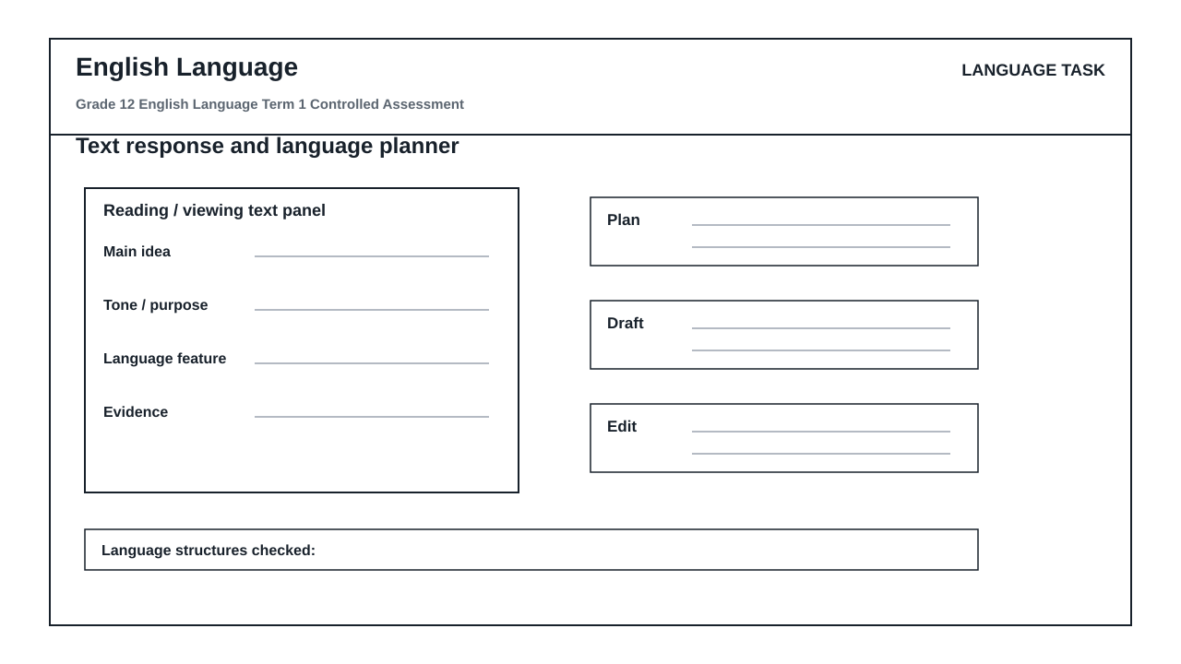

LANGUAGE ASSESSMENT TASK

SECTION 1: SECTION A: COMPREHENSION AND LANGUAGE IN CONTEXT
Instructions: Read the passage below and answer the questions that follow. Ensure your answers are grammatically correct and directly reference the text.
Source: TEXT A: THE SHALLOWS OF THE SCREEN
Paragraph 1
Our reading habits have undergone a silent, seismic shift. The transition from physical paper to digital screens has not merely changed the medium through which we consume words; it has fundamentally altered how our brains process information. When we read online, we do not engage in the slow, meditative process of deep reading. Instead, we skim, scanning the page for keywords, darting from one hyperlink to another. This ephemeral engagement means we rarely absorb the nuance of complex arguments. We have become information gatherers rather than critical thinkers.
Paragraph 2
Cognitive scientists warn that this shift has long-term consequences. The human brain is highly plastic, adapting continuously to its environment. If we train it to expect rapid, bite-sized updates, it loses the capacity for sustained attention. The deep, linear narrative of a novel requires a cognitive patience that digital platforms actively discourage. Neither the tablet nor the smartphone is designed for quiet contemplation; they are engineered to distract, pulling our attention away with notifications and algorithmic temptations.
Paragraph 3
To counter this cognitive crisis, we must consciously cultivate spaces for deep reading. It is not a matter of rejecting technology, but of establishing boundaries. Educators and writers must advocate for structured reading environments where sustained focus is prioritized. If we do not protect our deep reading habits before they disappear, we risk raising a generation capable of decoding words but entirely unable to comprehend their deeper significance.
1.1. State the primary shift in reading habits described by the author in Paragraph 1. (2)

1.2. Explain the contrast the author establishes in Paragraph 1 between 'information gatherers' and 'critical thinkers'. (3)

1.3. Identify the author's tone in Paragraph 2 and explain how it is suited to an academic audience. (3)

1.4. What is the primary purpose of Paragraph 3? Support your answer with a direct reference to the text. (3)

1.5. Identify a word in Paragraph 1 that means 'temporary' or 'lasting for a very short time'. (1)

1.6. Rewrite the following sentence from Paragraph 2 in the passive voice: 'Digital platforms actively discourage cognitive patience.' (2)

1.7. Correct the grammatical error in the following sentence from Paragraph 2: 'Neither the tablet nor the smartphone are designed for quiet contemplation.' (2)

1.8. Explain how the use of the colon in the title 'TEXT A: THE SHALLOWS OF THE SCREEN' serves a stylistic purpose. (2)

1.9. Rewrite the following sentence in indirect speech: The researcher stated, 'We must protect our deep reading habits before they disappear.' (2)

1.10. Critically evaluate the author's argument in Text A. In your response, refer to the use of persuasive techniques, evidence, and target audience. Write a cohesive paragraph of approximately 80-100 words. (10)

SECTION 2: SECTION B: SUMMARY PLANNING AND VISUAL LITERACY
Instructions: Use the 'language_response_planner' workspace provided in your answer booklet to plan and write your response. Pay close attention to the labels: 'text panel', 'main idea', 'evidence', 'plan', 'draft', and 'edit'.
Source: Refer to TEXT A ('The Shallows of the Screen') and the 'language_response_planner' visual workspace.
2.1. Using the 'text panel', 'main idea', and 'evidence' sections of your language_response_planner, plan a summary of TEXT A. Identify FOUR distinct negative impacts of digital reading on the human brain and reading habits. Write down your four points in clear, point-form planning format. (5)

2.2. Now, use the 'draft' and 'edit' sections of your language_response_planner to write a fluent, cohesive summary of the negative impacts of digital reading. Your final summary must be written in a single paragraph, must not exceed 80 words, and must reflect precise language editing (indicate your word count at the end). (5)

2.3. Analyze the visual layout of the 'language_response_planner' workspace. How does the sequential arrangement from the 'text panel' through to the 'edit' panel visually reinforce the cognitive process of writing an academic response? Refer to at least two specific labels in your answer. (4)

2.4. Explain how the inclusion of a dedicated 'edit' panel at the end of the workspace serves a functional purpose for a Grade 12 learner under exam conditions. (3)

2.5. Contrast the visual and functional roles of the 'main idea' panel and the 'evidence' panel in helping a writer avoid making unsubstantiated claims. (3)

SECTION 3: SECTION C: TRANSACTIONAL WRITING
Instructions: Write a formal response to the prompt below. Use the 'plan', 'draft', and 'edit' sections of your language_response_planner to prepare your writing. Your final response must be between 120 and 150 words.
Source: PROMPT: The school governing body (SGB) of your school is considering a policy to introduce a daily 'screen-free hour' to encourage deep reading and focused study among Grade 12 learners. Write a formal letter to the Chairperson of the SGB expressing your views on this proposal.
3.1. Write a formal letter to the Chairperson of the SGB in which you argue either in favor of or against the proposed 'screen-free hour'. Ensure you maintain a highly formal register, use appropriate letter format (addresses, salutation, subject line, signing-off), and control your audience tone to persuade the SGB. (20)

LANGUAGE TASK CONDITIONS
- Use language-skills integration instead of a generic content subject exam.
- Scale text length, vocabulary, and writing load to the phase.

