ENGLISH LANGUAGE
GRADE 12 ENGLISH LANGUAGE TERM 1 CONTROLLED ASSESSMENT

SUBJECT | ENGLISH LANGUAGE
GRADE | 12
ASSESSMENT TASK | GRADE 12 ENGLISH LANGUAGE TERM 1 CONTROLLED ASSESSMENT
MARKS | 70
TIME | 2 hours

Educator approval required before classroom use.

INSTRUCTIONS AND INFORMATION
1. Read each source text and question carefully.
2. Answer in the language of assessment unless instructed otherwise.
3. Use evidence from the supplied text or visual source where required.
4. Plan written responses before writing the final answer.
5. Write neatly and observe spelling, punctuation, grammar and register.

VISUAL MATERIAL
FIGURE 1: Text Response And Language Planner
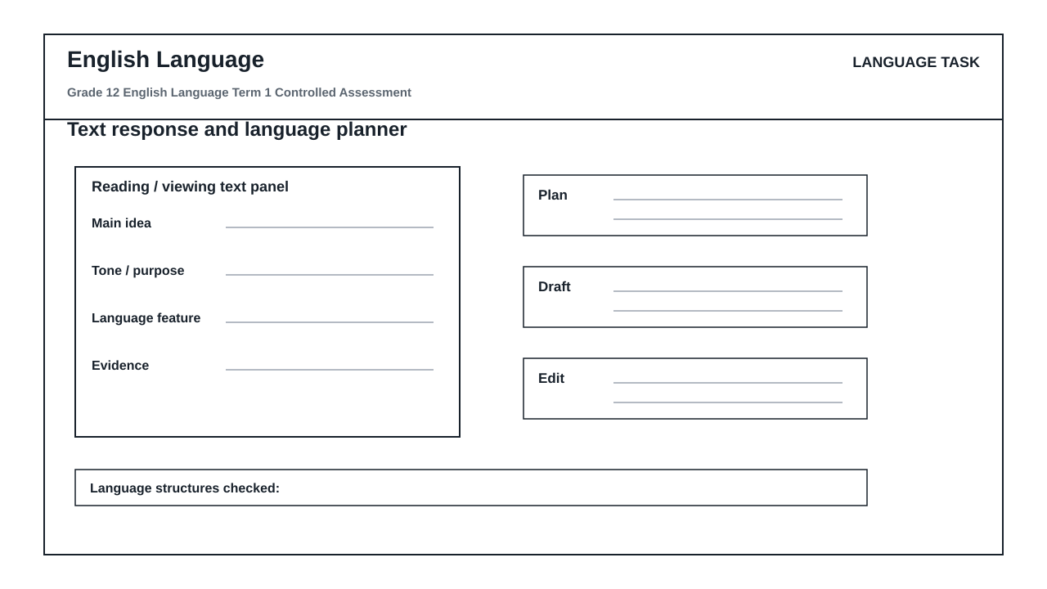

LANGUAGE ASSESSMENT TASK

SECTION 1: SECTION A: COMPREHENSION AND LANGUAGE IN CONTEXT
Instructions: Read the passage below and answer the questions that follow. Ensure your answers are grammatically correct and directly reference the text.
Source: TEXT A: THE SHALLOWS OF THE SCREEN
Paragraph 1
Our reading habits have undergone a silent, seismic shift. The transition from physical paper to digital screens has not merely changed the medium through which we consume words; it has fundamentally altered how our brains process information. When we read online, we do not engage in the slow, meditative process of deep reading. Instead, we skim, scanning the page for keywords, darting from one hyperlink to another. This ephemeral engagement means we rarely absorb the nuance of complex arguments. We have become information gatherers rather than critical thinkers.
Paragraph 2
Cognitive scientists warn that this shift has long-term consequences. The human brain is highly plastic, adapting continuously to its environment. If we train it to expect rapid, bite-sized updates, it loses the capacity for sustained attention. The deep, linear narrative of a novel requires a cognitive patience that digital platforms actively discourage. Neither the tablet nor the smartphone is designed for quiet contemplation; they are engineered to distract, pulling our attention away with notifications and algorithmic temptations.
Paragraph 3
To counter this cognitive crisis, we must consciously cultivate spaces for deep reading. It is not a matter of rejecting technology, but of establishing boundaries. Educators and writers must advocate for structured reading environments where sustained focus is prioritized. If we do not protect our deep reading habits before they disappear, we risk raising a generation capable of decoding words but entirely unable to comprehend their deeper significance.
1.1. State the primary shift in reading habits described by the author in Paragraph 1. (2)

1.2. Explain the contrast the author establishes in Paragraph 1 between 'information gatherers' and 'critical thinkers'. (3)

1.3. Identify the author's tone in Paragraph 2 and explain how it is suited to an academic audience. (3)

1.4. What is the primary purpose of Paragraph 3? Support your answer with a direct reference to the text. (3)

1.5. Identify a word in Paragraph 1 that means 'temporary' or 'lasting for a very short time'. (1)

1.6. Rewrite the following sentence from Paragraph 2 in the passive voice: 'Digital platforms actively discourage cognitive patience.' (2)

1.7. Correct the grammatical error in the following sentence from Paragraph 2: 'Neither the tablet nor the smartphone are designed for quiet contemplation.' (2)

1.8. Explain how the use of the colon in the title 'TEXT A: THE SHALLOWS OF THE SCREEN' serves a stylistic purpose. (2)

1.9. Rewrite the following sentence in indirect speech: The researcher stated, 'We must protect our deep reading habits before they disappear.' (2)

1.10. Critically evaluate the author's argument in Text A. In your response, refer to the use of persuasive techniques, evidence, and target audience. Write a cohesive paragraph of approximately 80-100 words. (10)

SECTION 2: SECTION B: SUMMARY PLANNING AND VISUAL LITERACY
Instructions: Use the 'language_response_planner' workspace provided in your answer booklet to plan and write your response. Pay close attention to the labels: 'text panel', 'main idea', 'evidence', 'plan', 'draft', and 'edit'.
Source: Refer to TEXT A ('The Shallows of the Screen') and the 'language_response_planner' visual workspace.
2.1. Using the 'text panel', 'main idea', and 'evidence' sections of your language_response_planner, plan a summary of TEXT A. Identify FOUR distinct negative impacts of digital reading on the human brain and reading habits. Write down your four points in clear, point-form planning format. (5)

2.2. Now, use the 'draft' and 'edit' sections of your language_response_planner to write a fluent, cohesive summary of the negative impacts of digital reading. Your final summary must be written in a single paragraph, must not exceed 80 words, and must reflect precise language editing (indicate your word count at the end). (5)

2.3. Analyze the visual layout of the 'language_response_planner' workspace. How does the sequential arrangement from the 'text panel' through to the 'edit' panel visually reinforce the cognitive process of writing an academic response? Refer to at least two specific labels in your answer. (4)

2.4. Explain how the inclusion of a dedicated 'edit' panel at the end of the workspace serves a functional purpose for a Grade 12 learner under exam conditions. (3)

2.5. Contrast the visual and functional roles of the 'main idea' panel and the 'evidence' panel in helping a writer avoid making unsubstantiated claims. (3)

SECTION 3: SECTION C: TRANSACTIONAL WRITING
Instructions: Write a formal response to the prompt below. Use the 'plan', 'draft', and 'edit' sections of your language_response_planner to prepare your writing. Your final response must be between 120 and 150 words.
Source: PROMPT: The school governing body (SGB) of your school is considering a policy to introduce a daily 'screen-free hour' to encourage deep reading and focused study among Grade 12 learners. Write a formal letter to the Chairperson of the SGB expressing your views on this proposal.
3.1. Write a formal letter to the Chairperson of the SGB in which you argue either in favor of or against the proposed 'screen-free hour'. Ensure you maintain a highly formal register, use appropriate letter format (addresses, salutation, subject line, signing-off), and control your audience tone to persuade the SGB. (20)

LANGUAGE TASK CONDITIONS
- Use language-skills integration instead of a generic content subject exam.
- Scale text length, vocabulary, and writing load to the phase.

MARKING GUIDELINE

TASK 1: SECTION A: COMPREHENSION AND LANGUAGE IN CONTEXT
1.1. State the primary shift in reading habits described by the author in Paragraph 1. (2)
- The shift is from physical paper reading to digital screen reading.
- This shift has changed reading from a slow, deep, meditative process to rapid skimming and scanning for keywords.
1.2. Explain the contrast the author establishes in Paragraph 1 between 'information gatherers' and 'critical thinkers'. (3)
- Information gatherers simply scan for quick facts, keywords, and surface-level data without deep engagement.
- Critical thinkers engage in slow, meditative reading, analyzing nuance and complex arguments.
- The contrast highlights how digital reading reduces our cognitive depth from active analysis to passive collection.
1.3. Identify the author's tone in Paragraph 2 and explain how it is suited to an academic audience. (3)
- The tone is urgent, cautionary, or analytical.
- It is suited to an academic audience because it uses formal language ('highly plastic', 'cognitive patience', 'algorithmic temptations') and references scientific observations ('cognitive scientists warn') to build a logical, credible argument.
1.4. What is the primary purpose of Paragraph 3? Support your answer with a direct reference to the text. (3)
- The purpose is to call to action / propose a solution to the cognitive crisis caused by digital reading.
- Evidence: The author states we must 'consciously cultivate spaces for deep reading' and 'establish boundaries' rather than completely rejecting technology.
1.5. Identify a word in Paragraph 1 that means 'temporary' or 'lasting for a very short time'. (1)
- ephemeral
1.6. Rewrite the following sentence from Paragraph 2 in the passive voice: 'Digital platforms actively discourage cognitive patience.' (2)
- Cognitive patience is actively discouraged by digital platforms.
1.7. Correct the grammatical error in the following sentence from Paragraph 2: 'Neither the tablet nor the smartphone are designed for quiet contemplation.' (2)
- Neither the tablet nor the smartphone IS designed for quiet contemplation.
- Award 1 mark for identifying 'are' and 1 mark for correcting it to 'is' (concord rule with 'neither/nor' singular subjects).
1.8. Explain how the use of the colon in the title 'TEXT A: THE SHALLOWS OF THE SCREEN' serves a stylistic purpose. (2)
- The colon introduces an explanation or elaboration of the main title.
- It links the concept of 'the shallows' directly to the medium of 'the screen', signaling that screens cause shallow thinking.
1.9. Rewrite the following sentence in indirect speech: The researcher stated, 'We must protect our deep reading habits before they disappear.' (2)
- The researcher stated that they had to protect their deep reading habits before they disappeared.
- Accept: The researcher stated that we must protect our deep reading habits before they disappear (if representing a general truth, but standard backshifting is preferred: 'they had to/must' and 'their/our').
1.10. Critically evaluate the author's argument in Text A. In your response, refer to the use of persuasive techniques, evidence, and target audience. Write a cohesive paragraph of approximately 80-100 words. (10)
- The learner must evaluate the argument's validity, noting that it is highly persuasive but relies heavily on generalized assertions of cognitive science rather than specific statistical data.
- Persuasive techniques: Use of strong emotive metaphors ('silent, seismic shift', 'algorithmic temptations') and authoritative appeals ('cognitive scientists warn').
- Audience: Targeted at educators, parents, and literate adults who value deep literacy.
- Marking guide: 3 marks for evaluation of argument validity; 3 marks for analysis of persuasive techniques/evidence; 2 marks for audience connection; 2 marks for language structure and cohesion.

TASK 2: SECTION B: SUMMARY PLANNING AND VISUAL LITERACY
2.1. Using the 'text panel', 'main idea', and 'evidence' sections of your language_response_planner, plan a summary of TEXT A. Identify FOUR distinct negative impacts of digital reading on the human brain and reading habits. Write down your four points in clear, point-form planning format. (5)
- Point 1: Digital reading causes skimming and scanning instead of deep, meditative reading.
- Point 2: It prevents the absorption of nuance in complex arguments.
- Point 3: It trains the brain to expect rapid, bite-sized updates, reducing sustained attention span.
- Point 4: It discourages the cognitive patience required for long, linear narratives.
- Award 4 marks for the four correct points and 1 mark for demonstrating clear planning structure within the planner's framework.
2.2. Now, use the 'draft' and 'edit' sections of your language_response_planner to write a fluent, cohesive summary of the negative impacts of digital reading. Your final summary must be written in a single paragraph, must not exceed 80 words, and must reflect precise language editing (indicate your word count at the end). (5)
- The summary must be a single, cohesive paragraph.
- It must capture the core negative impacts: skimming, loss of nuance, reduced attention span, and loss of cognitive patience.
- Mark allocation: 3 marks for content synthesis; 2 marks for language, punctuation, and adherence to the word limit (70-80 words).
2.3. Analyze the visual layout of the 'language_response_planner' workspace. How does the sequential arrangement from the 'text panel' through to the 'edit' panel visually reinforce the cognitive process of writing an academic response? Refer to at least two specific labels in your answer. (4)
- The sequential layout visually models a systematic, step-by-step writing methodology.
- Starting with the 'text panel' and 'main idea' ensures the learner anchors their response in comprehension first.
- Moving through 'evidence' and 'plan' forces the learner to organize structural support before writing.
- Ending with 'draft' and 'edit' visually reinforces that writing is an iterative process requiring refinement and error correction before final submission.
2.4. Explain how the inclusion of a dedicated 'edit' panel at the end of the workspace serves a functional purpose for a Grade 12 learner under exam conditions. (3)
- Under exam conditions, learners often rush and omit the proofreading stage.
- The dedicated 'edit' panel acts as a visual prompt/reminder that editing is a mandatory, distinct phase of writing.
- It provides a physical space to check for concord, spelling, and punctuation errors, directly improving language accuracy marks.
2.5. Contrast the visual and functional roles of the 'main idea' panel and the 'evidence' panel in helping a writer avoid making unsubstantiated claims. (3)
- The 'main idea' panel is functional for stating the central thesis or claim clearly.
- The 'evidence' panel is visually distinct to force the writer to pair every claim with direct textual proof or data.
- Together, they prevent unsubstantiated claims by visually separating what is asserted from what can be proven.

TASK 3: SECTION C: TRANSACTIONAL WRITING
3.1. Write a formal letter to the Chairperson of the SGB in which you argue either in favor of or against the proposed 'screen-free hour'. Ensure you maintain a highly formal register, use appropriate letter format (addresses, salutation, subject line, signing-off), and control your audience tone to persuade the SGB. (20)
- Format: Formal letter structure is essential (sender's address, date, recipient's designation and address, salutation, subject line, body paragraphs, formal sign-off: 'Yours faithfully' + signature + print name).
- Register: Formal, respectful, persuasive, and objective.
- Content: Must address the 'screen-free hour' proposal, linking it to themes of deep reading, focus, or the practicalities of digital learning.
- Mark breakdown: Content, planning, and format = 12 marks; Language, style, and editing = 8 marks.

LANGUAGE RUBRIC
Criterion | Marks | Descriptor
Section A: Comprehension and Language in Context | 30 | Assesses literal comprehension, inference, tone analysis, purpose, vocabulary, and language editing skills (active/passive, concord, indirect speech, punctuation).
Section B: Summary Planning and Visual Literacy | 20 | Assesses summary planning and synthesis using the language_response_planner workspace (10 marks) and visual literacy analysis of the workspace's structure and cognitive function (10 marks).
Section C: Transactional Writing (Content, Planning, and Format) | 12 | Assesses the application of formal letter format, logical structuring of arguments, adherence to the prompt, and evidence of planning/editing using the workspace.
Section C: Transactional Writing (Language, Style, and Editing) | 8 | Assesses register control, formal tone, grammatical accuracy, precise vocabulary, concord, and sentence construction appropriate for a Grade 12 level.

EDUCATOR REVIEW CHECKLIST
- Verify that the total marks sum to exactly 70.
- Confirm that the duration is set to 2 hours.
- Ensure the language_response_planner visual workspace is printed and provided in the learner answer booklet.
- Check that the memo allows for equivalent, plausible interpretations in the comprehension section.
- Verify that the transactional writing rubric matches the CAPS assessment guidelines for Grade 12.

