ENGLISH LANGUAGE
GRADE 12 ENGLISH HOME LANGUAGE TERM 2 CONTROLLED ASSESSMENT

SUBJECT | ENGLISH LANGUAGE
GRADE | 12
ASSESSMENT TASK | GRADE 12 ENGLISH HOME LANGUAGE TERM 2 CONTROLLED ASSESSMENT
MARKS | 70
TIME | 2 hours

Educator approval required before classroom use.

INSTRUCTIONS AND INFORMATION
1. Read each source text and question carefully.
2. Answer in the language of assessment unless instructed otherwise.
3. Use evidence from the supplied text or visual source where required.
4. Plan written responses before writing the final answer.
5. Write neatly and observe spelling, punctuation, grammar and register.

VISUAL MATERIAL
FIGURE 1: Text Response And Language Planner
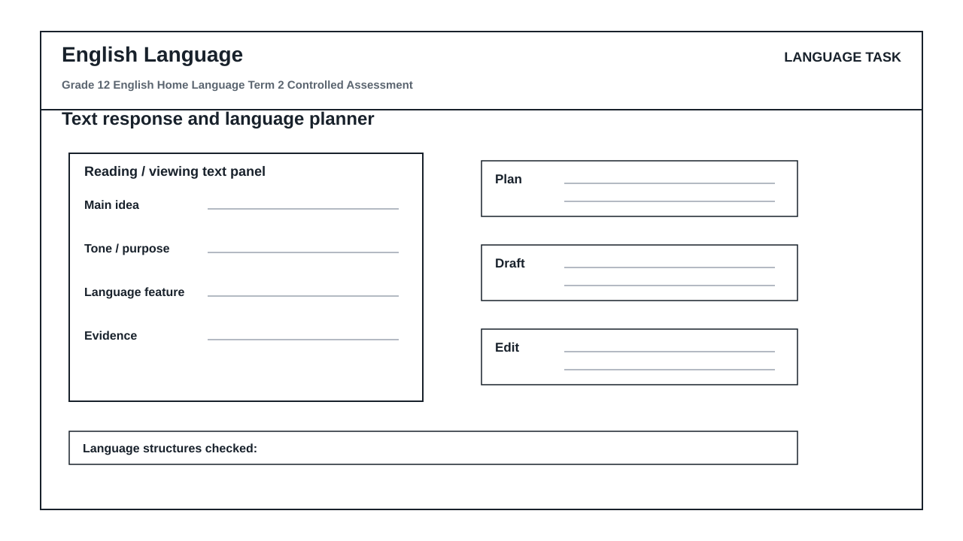

LANGUAGE ASSESSMENT TASK

SECTION 1: SECTION A: LITERARY EXTRACT, CHARACTER, THEME AND LANGUAGE ANALYSIS
Instructions: Read the following extract from 'The Winds of Change' by S. Ndlovu and answer the questions that follow.
Source: Mr. Khumalo adjusted his spectacles, his eyes scanning the dusty floorboards of the community hall before settling on Thabo. 'You speak of progress, boy, as if it is a crop you can harvest tomorrow. This soil has been dry for decades. You cannot simply pour new ideas into cracked earth and expect a forest.'
Thabo stood taller, his hands clenched at his sides. 'With respect, Baba, if we do not plant now, the wind will carry away what little soil we have left. The youth are not waiting for a forest; we are asking for a single seed of opportunity. Your caution is no longer a shield; it has become our cage.'
Mr. Khumalo sighed, the heavy sound echoing in the quiet room. He turned his back to the window, blocking the afternoon light, casting a long shadow that stretched across the table between them.
1.1. Analyze the contrast between Mr. Khumalo's and Thabo's perspectives on change, referencing their specific dialogue in the extract. (4)

1.2. Explain how the metaphors of 'cracked earth' and 'seed of opportunity' reflect the central theme of generational conflict in this extract. (4)

1.3. Discuss the dramatic impact of the action where Mr. Khumalo 'turned his back to the window, blocking the afternoon light'. How does this action reinforce his characterization? (4)

1.4. Write a cohesive paragraph of 50-60 words that integrates the quote 'Your caution is no longer a shield; it has become our cage' to argue that Thabo views traditional authority as restrictive. (5)

1.5. Identify the tone in Thabo's response ('With respect, Baba...') and evaluate whether his register remains appropriate for addressing an elder in this context. (4)

1.6. Rewrite the following sentence from the extract, correcting the grammatical error in concord: 'The youth is not waiting for a forest; they are asking for a single seed.' (4)

SECTION 2: SECTION B: VISUAL LITERACY AND MEDIA MESSAGE INTERPRETATION
Instructions: Refer to the 'language_response_planner' (Text response and language planner) workspace layout, which contains the following designated sections: 'text panel', 'main idea', 'evidence', 'plan', 'draft', and 'edit'. Use this structural framework to answer the questions below.
Source: The 'language_response_planner' is a visual workspace designed to help learners systematically deconstruct media messages and plan their written responses.
2.1. Explain how a reader should utilize the 'text panel' section of the planner to isolate key visual elements when analyzing a high-impact media advertisement. (3)

2.2. Describe the relationship between the 'main idea' and 'evidence' blocks in the planner when formulating an analysis of a target audience's emotional response. (4)

2.3. Analyze how the transition from the 'plan' block to the 'draft' block ensures that a paragraph maintains a logical, coherent development of an argument. (4)

2.4. Explain how the 'edit' block can be systematically used to identify and correct stylistic flaws, such as passive voice or ambiguous pronoun reference, in a written analysis. (4)

SECTION 3: SECTION C: DISCURSIVE OR ARGUMENTATIVE WRITING
Instructions: Write an argumentative or discursive essay on ONE of the following topics. Your essay must be 350–400 words in length. Ensure that you use the 'language_response_planner' structure to organize your thoughts before writing.
Source: Topic 1: 'The digital age has brought us closer together, yet left us more isolated than ever.'
OR
Topic 2: 'True leadership lies not in asserting authority, but in fostering collaboration across generations.'
3.1. Write a well-structured discursive or argumentative essay based on your chosen topic. Your response will be assessed on coherent development, effective paragraphing, and language accuracy. (30)

LANGUAGE TASK CONDITIONS
- Use language-skills integration instead of a generic content subject exam.
- Scale text length, vocabulary, and writing load to the phase.

