ENGLISH LANGUAGE
GRADE 12 ENGLISH LANGUAGE TERM 3 CONTROLLED ASSESSMENT

SUBJECT | ENGLISH LANGUAGE
GRADE | 12
ASSESSMENT TASK | GRADE 12 ENGLISH LANGUAGE TERM 3 CONTROLLED ASSESSMENT
MARKS | 70
TIME | 2 hours

Educator approval required before classroom use.

INSTRUCTIONS AND INFORMATION
1. Read each source text and question carefully.
2. Answer in the language of assessment unless instructed otherwise.
3. Use evidence from the supplied text or visual source where required.
4. Plan written responses before writing the final answer.
5. Write neatly and observe spelling, punctuation, grammar and register.

VISUAL MATERIAL
FIGURE 1: Text Response And Language Planner
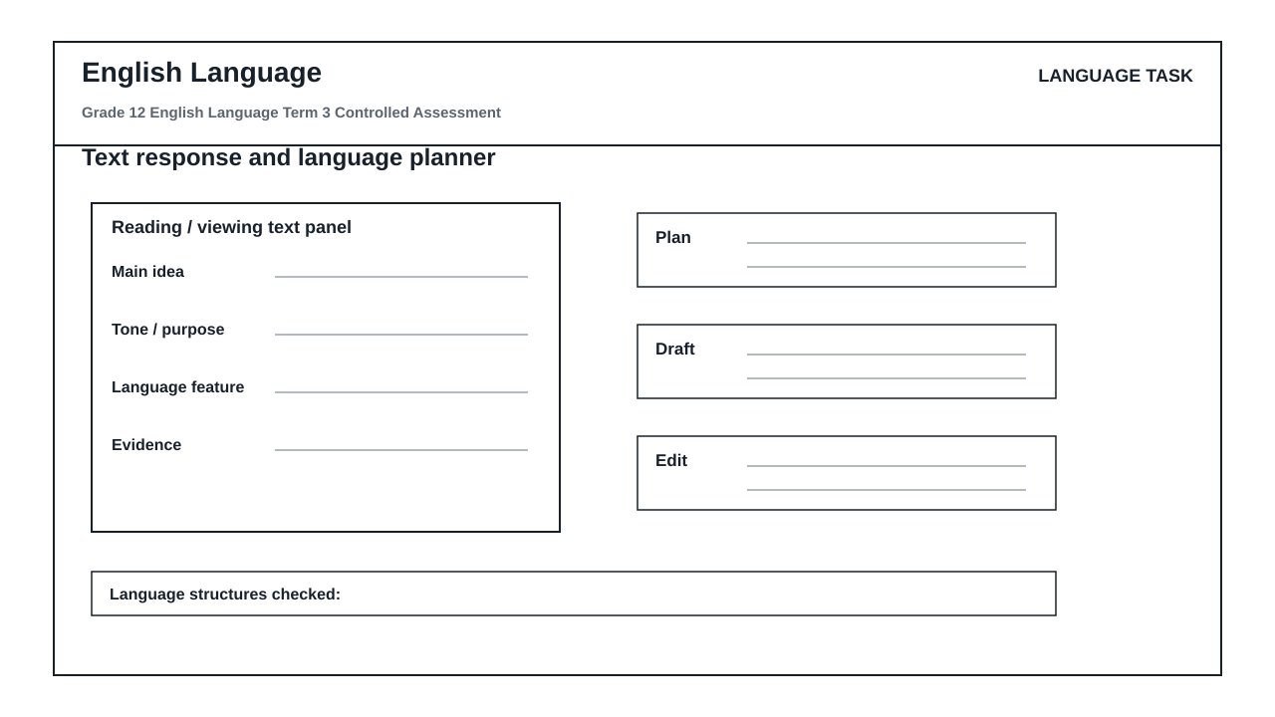

LANGUAGE ASSESSMENT TASK

SECTION 1: SECTION A: INTEGRATED COMPREHENSION AND SUMMARY
Instructions: Read Text A and Text B carefully before answering the questions that follow.
Source: TEXT A: THE DIGITAL SHIFT IN PROFESSIONAL COMMUNICATION
[Paragraph 1] The landscape of modern professional communication has undergone a seismic shift. Traditional corporate correspondence, once dominated by highly structured, formal emails and physical memoranda, has largely been supplanted by instant messaging platforms such as Slack, Microsoft Teams, and WhatsApp. While these platforms facilitate rapid decision-making and break down rigid corporate hierarchies, they have also introduced a level of linguistic informality that threatens the clarity and precision of professional discourse.
[Paragraph 2] This shift has resulted in what linguists call 'linguistic hybridity'—a blend of written and spoken language characteristics. In these digital workspaces, employees frequently employ sentence fragments, omit punctuation, and rely heavily on abbreviations. The boundary between personal, casual speech and professional, written communication has become increasingly blurred, leading to potential misunderstandings and a perceived decline in professional decorum.
[Paragraph 3] Furthermore, the integration of emojis into professional platforms has sparked intense debate. Proponents argue that emojis inject necessary emotional context into otherwise sterile text, preventing misinterpretation. Detractors, however, view the emoji invasion as a regression to pictographic communication, arguing that it diminishes the writer's vocabulary and undermines the authority of the message.
[Paragraph 4] Despite these concerns, some organizational theorists claim that informal communication channels actually increase workplace productivity. By reducing the time spent drafting elaborate emails, employees can resolve issues in real-time. However, this efficiency often comes at the cost of grammatical accuracy and depth of thought, raising questions about the long-term impact on cognitive writing skills.
[Paragraph 5] The rapid evolution of language in digital spaces is a double-edged sword. It reflects a dynamic, adaptable workforce, yet it demands a new form of linguistic literacy. Professionals must now navigate multiple registers, seamlessly transitioning from highly formal client proposals to highly informal internal chats without compromising their professional credibility.
TEXT B: THE VALUE OF MAINTAINING FORMAL REGISTER
Maintaining a formal register in professional environments remains a cornerstone of effective business operations. Firstly, a formal register establishes clear boundaries, ensuring that professional relationships remain objective and focused on organizational goals. Secondly, it projects an image of competence and reliability to external stakeholders, which is vital for building brand trust. Thirdly, formal language minimizes ambiguity, as it adheres to standardized grammatical rules that leave little room for misinterpretation. Fourthly, it fosters an inclusive environment by avoiding colloquialisms or slang that may exclude non-native speakers or older generations. Fifthly, formal documentation provides a legally robust record of business transactions and agreements. Sixthly, practicing formal writing sharpens critical thinking and analytical skills, as it requires the writer to structure complex arguments logically. Finally, a commitment to formal language preserves the rich heritage of linguistic precision in an increasingly fragmented digital age.
1.1. State the primary reason the author gives in Paragraph 1 for the decline of formal email etiquette in modern workplaces. (2)

1.2. Explain the concept of 'linguistic hybridity' as described in Paragraph 2, referencing specific linguistic features mentioned in the text. (3)

1.3. Analyze the author's tone in Paragraph 3 when discussing 'the emoji invasion'. Support your answer with reference to the diction used in the paragraph. (3)

1.4. Evaluate the validity of the claim in Paragraph 4 that informal communication channels increase workplace productivity. Refer to the counter-arguments presented in the same paragraph. (3)

1.5. Identify the metaphor used in Paragraph 5 and explain its effectiveness in conveying the nature of language evolution in digital spaces. (3)

1.6. Explain how the final sentence of Text A serves as an effective conclusion to the author's argument. (3)

2.1. Read Text B ('The Value of Maintaining Formal Register'). Summarise the seven key benefits of maintaining a formal register in professional environments. Write your summary in a single, coherent paragraph of 70-90 words. You must use your own words as far as possible and provide an accurate word count at the end of your summary. (10)

SECTION 2: SECTION B: VISUAL LITERACY AND LANGUAGE STRUCTURES
Instructions: Answer all questions in this section. Refer to the 'language_response_planner' visual workspace and the provided editing passage.
Source: VISUAL STIMULUS: The 'language_response_planner' is a structured workspace containing six distinct blocks: 'text panel', 'main idea', 'evidence', 'plan', 'draft', and 'edit'.
TEXT C: EDITING PASSAGE
[1] The committee have decided to postpone the meeting. [2] Its clear that nobody wants to take responsibility for the project's failure. [3] The manager spoke very good, but he did not convince the staff. [4] We must implement these changes immediately.
3.1. Locate the 'text panel' and 'main idea' blocks in the 'language_response_planner'. Explain how isolating the 'main idea' from the raw 'text panel' prevents a writer from misinterpreting a complex text. (3)

3.2. Examine the transition from the 'evidence' block to the 'plan' block in the 'language_response_planner'. Why is it linguistically vital to organize evidence before drafting a response? (3)

3.3. Contrast the 'draft' and 'edit' blocks in the 'language_response_planner'. Explain why the 'edit' phase requires a shift from creative expression to critical grammatical analysis. (4)

4.1. Identify and correct the concord error in Sentence 1 of Text C. (1)

4.2. Correct the homophone/punctuation error in Sentence 2 of Text C. (1)

4.3. Rewrite Sentence 3 of Text C ('The manager spoke very good...') to correct the error in adverb usage. (2)

4.4. Rewrite Sentence 4 of Text C ('We must implement these changes immediately') in the passive voice. (2)

4.5. Rewrite the following colloquial sentence in a formal, professional register suitable for an executive report: 'The boss was totally stressed out because the team messed up the presentation.' (4)

SECTION 3: SECTION C: FORMAL TRANSACTIONAL WRITING AND CONTROLLED RESPONSE PLANNING
Instructions: Complete both Part A and Part B of this section. Use the 'language_response_planner' workspace to plan your response before writing the final draft.
Source: SCENARIO: The School Governing Body (SGB) at your school has proposed a new language policy that restricts learners from speaking their home languages during informal school breaks, mandating that only the school's official medium of instruction may be spoken on school grounds at all times. As the chairperson of the Representative Council of Learners (RCL), you must write a formal letter of complaint to the SGB expressing the student body's concerns regarding this policy.
5.1. PART A: Controlled Response Planning
Using the 'language_response_planner' workspace, complete the planning phase for your formal letter. You must explicitly write out your plan under the following headings corresponding to the planner's blocks:
1. Main Idea (The core thesis of your complaint)
2. Evidence (Two specific arguments or constitutional/linguistic rights you will cite)
3. Plan (The structural outline of your letter's paragraphs) (6)

5.2. PART B: Formal Transactional Writing
Write the formal letter of complaint to the School Governing Body based on your planning in Question 5.1. Your letter must be between 120 and 150 words in length. Pay close attention to the formal letter format, appropriate register, persuasive diction, and accurate grammar. (14)

LANGUAGE TASK CONDITIONS
- Use language-skills integration instead of a generic content subject exam.
- Scale text length, vocabulary, and writing load to the phase.

