ENGLISH LANGUAGE
GRADE 12 ENGLISH LANGUAGE TERM 4 CONTROLLED ASSESSMENT

SUBJECT | ENGLISH LANGUAGE
GRADE | 12
ASSESSMENT TASK | GRADE 12 ENGLISH LANGUAGE TERM 4 CONTROLLED ASSESSMENT
MARKS | 70
TIME | 2 hours

Educator approval required before classroom use.

INSTRUCTIONS AND INFORMATION
1. Read each source text and question carefully.
2. Answer in the language of assessment unless instructed otherwise.
3. Use evidence from the supplied text or visual source where required.
4. Plan written responses before writing the final answer.
5. Write neatly and observe spelling, punctuation, grammar and register.

VISUAL MATERIAL
FIGURE 1: Text Response And Language Planner
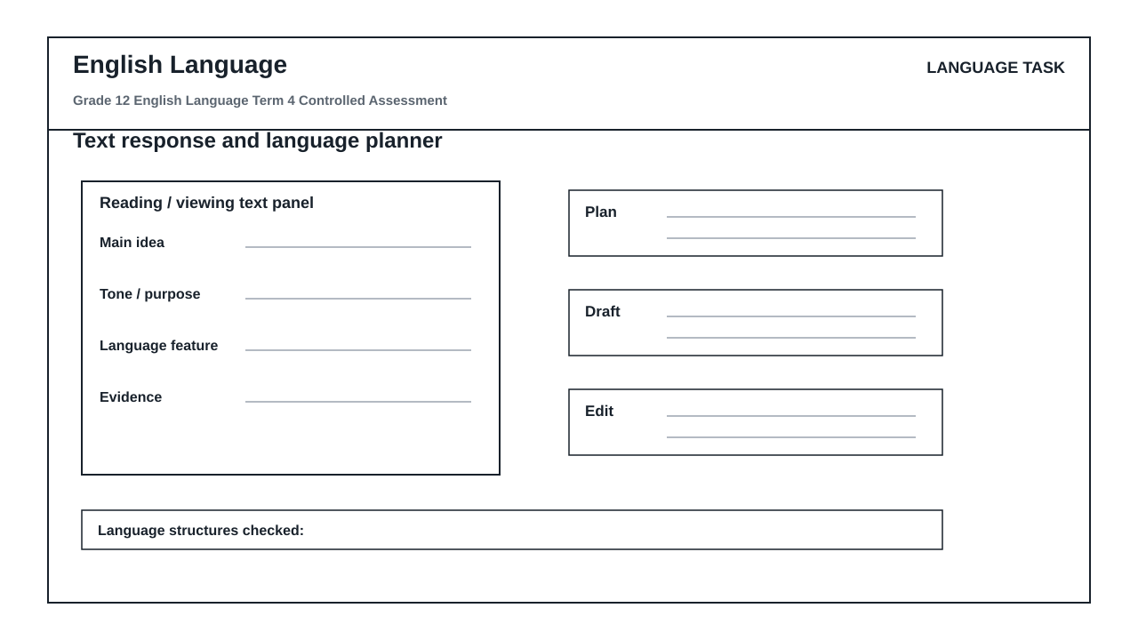

LANGUAGE ASSESSMENT TASK

SECTION 1: SECTION A: COMPREHENSION AND VISUAL LITERACY SYNTHESIS
Instructions: Read Text A below and study the 'Text response and language planner' visual layout in your workspace before answering the questions. Ensure your answers are contextualized and supported by direct reference to the texts.
Source: TEXT A: THE ATTENTION ECONOMY AND THE DEATH OF DEEP READING
Paragraph 1
Our cognitive bandwidth is under siege. In the modern digital landscape, algorithms are engineered specifically to capture and monetize human focus. We no longer read; we skim, leaping from one hyperlinked island to another in a restless quest for novelty. This constant cognitive fragmentation has eroded our capacity for sustained, deep reading—the very foundation of critical, analytical thought.
Paragraph 2
This erosion carries a heavy psychological toll. When we switch tasks every few seconds, we incur a 'cognitive switching cost'. The brain must expend energy to refocus, leaving less mental energy for synthesis, evaluation, and retention. We become passive consumers of fragmented data rather than active creators of structured knowledge. The antidote to this digital drift is not simply logging off, but actively practicing structured, deliberate cognitive processing.
Paragraph 3
To reclaim our minds, we must treat reading and writing as deliberate, multi-stage architectures. True comprehension requires us to isolate core arguments, interrogate supporting evidence, and systematically draft and refine our thoughts. Without these structured boundaries, our writing becomes as fragmented as the digital feeds that feed our distractions.
1.1. Identify the term used by the writer in Paragraph 1 to describe the modern digital environment's aggressive capture of human focus. (2)

1.2. Explain what the writer means by the phrase 'cognitive switching cost' in Paragraph 2. (3)

1.3. Analyze the shift in tone from Paragraph 2 to Paragraph 3. Support your answer with reference to specific words or phrases from both paragraphs. (3)

1.4. Evaluate the effectiveness of the metaphor 'hyperlinked island' in Paragraph 1 in illustrating modern reading habits. (4)

1.5. Refer to the 'Text response and language planner' visual workspace. Identify the two specific labels in the planner that correspond directly to the writer's demand in Paragraph 3 to 'isolate core arguments' and 'interrogate supporting evidence'. (3)

1.6. Examine the structural progression of the 'Text response and language planner' from 'plan' to 'draft' to 'edit'. How does this visual progression offer a practical solution to the 'cognitive fragmentation' described in Paragraph 1? (3)

1.7. Contrast the passive reading habits criticized in Paragraph 1 with the active reading process facilitated by the 'text panel' and 'main idea' sections of the visual planner. (4)

1.8. Synthesize the core message of Text A with the design philosophy of the 'Text response and language planner'. In an extended paragraph of 80-100 words, evaluate how the planner serves as a cognitive defense mechanism against the attention economy. (8)

SECTION 2: SECTION B: SUMMARY
Instructions: Read Text A again. Write a summary of the steps a modern reader must take to reclaim cognitive control and practice deep reading and writing. Write your summary in point form, using a maximum of 90 words. State your word count at the end of the summary.
Source: Refer to TEXT A: THE ATTENTION ECONOMY AND THE DEATH OF DEEP READING.
2.1. Summarize the steps required to reclaim cognitive control and practice deep reading and writing, based on Text A. (10)

SECTION 3: SECTION C: LANGUAGE STRUCTURES AND EDITING
Instructions: Read the passage below, which contains several deliberate language and grammatical errors, and answer the questions that follow.
Source: TEXT C: THE LITERACY CRISIS
(1) The digital age has revolutionized how we communicate. (2) However, many a student struggles to maintain their focus when writing essays. (3) If one does not plan, they will fail to produce coherent arguments. (4) The affect of constant notifications is highly detrimental to deep thought. (5) The educator said, 'We must teach learners how to edit their drafts.' (6) It is critical that we do not allow technology to completely disintegrate our intellectual standards.
3.1. Identify and correct the pronoun agreement error in sentence 2. (1)

3.2. Correct the pronoun inconsistency in sentence 3 to ensure formal grammatical concord. (1)

3.3. Identify and correct the homophone/word-choice error in sentence 4. (1)

3.4. Rewrite sentence 1 in the passive voice. (2)

3.5. Rewrite sentence 5 in reported (indirect) speech. (2)

3.6. Identify the part of speech of the word 'detrimental' in sentence 4. (1)

3.7. Identify the split infinitive in sentence 6 and rewrite the clause to correct it. (2)

SECTION 4: SECTION D: EXTENDED WRITING WITH ARGUMENT AND STYLE CONTROL
Instructions: Write an argumentative essay of 200-250 words on the topic below. You must use the structure of the 'Text response and language planner' to organize your response. Your final essay must demonstrate a clear 'main idea', structured 'evidence', a logical 'plan', and a polished, error-free final 'draft' that shows evidence of the 'edit' phase.
Source: TOPIC: 'The digital attention economy is producing a generation of shallow thinkers.'
Write an argumentative essay in which you either support or oppose this statement. Ensure your register is formal, your style is persuasive, and your argument is logically coherent.
4.1. Write an argumentative essay of 200-250 words on the impact of the digital attention economy on youth critical thinking, demonstrating rigorous planning and editing. (20)

LANGUAGE TASK CONDITIONS
- Use language-skills integration instead of a generic content subject exam.
- Scale text length, vocabulary, and writing load to the phase.

