ENGLISH LANGUAGE
TERM 3 ENGLISH LANGUAGE ASSESSMENT

SUBJECT | ENGLISH LANGUAGE
GRADE | 12
ASSESSMENT TASK | TERM 3 ENGLISH LANGUAGE ASSESSMENT
MARKS | 70
TIME | 2 hours

Educator approval required before classroom use.

INSTRUCTIONS AND INFORMATION
1. Read each source text and question carefully.
2. Answer in the language of assessment unless instructed otherwise.
3. Use evidence from the supplied text or visual source where required.
4. Plan written responses before writing the final answer.
5. Write neatly and observe spelling, punctuation, grammar and register.

VISUAL MATERIAL
FIGURE 1: Text Response And Language Planner
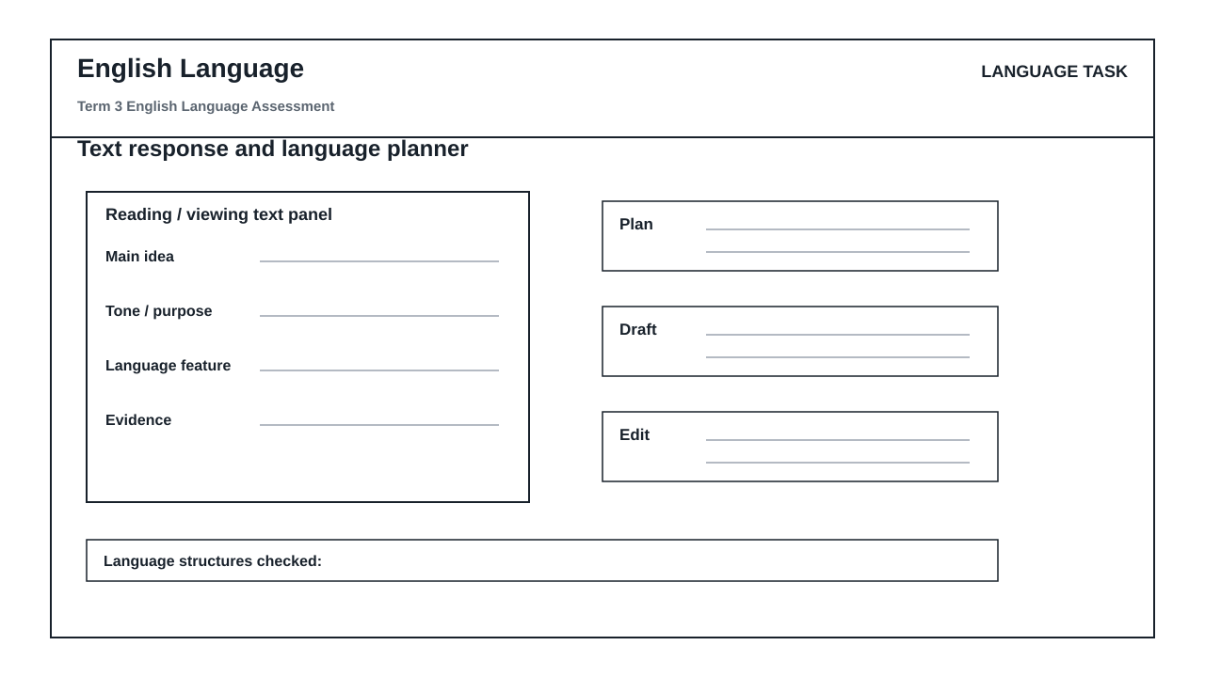

LANGUAGE ASSESSMENT TASK

SECTION 1: SECTION A: INTEGRATED COMPREHENSION AND SUMMARY
Instructions: Read the following text and answer the questions that follow.
Source: The advertisement for a new smartphone features a cartoon of a person using the phone to take a selfie. The caption reads, 'Capture life's moments with our new smartphone!'
1.1. What is the main idea of the advertisement? (5)

1.2. What is the tone of the advertisement? (5)

SECTION 2: SECTION B: CARTOON, ADVERTISEMENT, OR INFOGRAPHIC ANALYSIS
Instructions: Analyze the following infographic and answer the questions that follow.
Source: The infographic shows the number of people who use social media platforms. The data is presented in a bar chart.
2.1. What is the main finding of the infographic? (10)

2.2. What is the implication of the data presented in the infographic? (10)

SECTION 3: SECTION C: EDITING FOR GRAMMAR, DICTION, REGISTER, AND PUNCTUATION
Instructions: Edit the following text to ensure that it is free of grammatical errors and is written in the correct register.
Source: The text reads, 'The new smartphone is a great device for taking selfies. It has a good camera and a long battery life.'
3.1. What is the subject of the sentence? (2)

3.2. What is the verb of the sentence? (2)

SECTION 4: SECTION D: FORMAL TRANSACTIONAL WRITING AND CONTROLLED RESPONSE PLANNING
Instructions: Write a formal letter to the editor of a newspaper in response to the following article.
Source: The article reads, 'The new smartphone is a game-changer for the tech industry.'
4.1. What is the main idea of the article? (10)

4.2. What is the tone of the article? (10)

LANGUAGE TASK CONDITIONS
- Use language-skills integration instead of a generic content subject exam.
- Scale text length, vocabulary, and writing load to the phase.

