ENGLISH LANGUAGE
TERM 3 CONTROLLED ASSESSMENT: INTEGRATED LANGUAGE AND VISUAL LITERACY

SUBJECT | ENGLISH LANGUAGE
GRADE | 12
ASSESSMENT TASK | TERM 3 CONTROLLED ASSESSMENT: INTEGRATED LANGUAGE AND VISUAL LITERACY
MARKS | 70
TIME | 2 hours

Educator approval required before classroom use.

INSTRUCTIONS AND INFORMATION
1. Read each source text and question carefully.
2. Answer in the language of assessment unless instructed otherwise.
3. Use evidence from the supplied text or visual source where required.
4. Plan written responses before writing the final answer.
5. Write neatly and observe spelling, punctuation, grammar and register.

VISUAL MATERIAL
FIGURE 1: Text Response And Language Planner
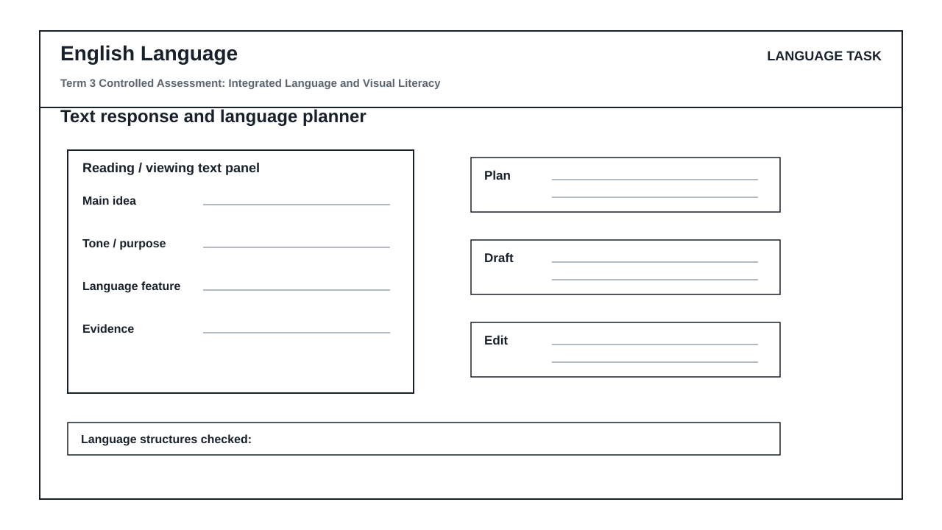

LANGUAGE ASSESSMENT TASK

SECTION 1: SECTION A: COMPREHENSION AND SUMMARY
Instructions: Read the passage below and answer the questions that follow. Use your own words where instructed.
Source: Passage: The Rise of Urban Rooftop Farming
Urban rooftop farming has transformed unused city spaces into productive green areas. In Johannesburg, several buildings now host vegetable gardens that supply fresh produce to local markets. These gardens reduce the distance food travels, cutting carbon emissions and providing jobs. However, challenges include high setup costs and the need for regular maintenance. Despite these obstacles, community support has been strong, with volunteers helping to sustain the gardens. Experts believe that rooftop farming can improve food security in densely populated areas.
1.1. What is the main idea of the passage? (2)

1.2. List TWO benefits of rooftop farming mentioned in the passage. (2)

1.3. What challenges are mentioned? Provide one. (1)

1.4. In your own words, explain why community support is important for the success of rooftop gardens. (2)

1.5. Summarise the passage in no more than 40 words. List SEVEN points. (7)

SECTION 2: SECTION B: VISUAL LITERACY – CARTOON AND ADVERTISEMENT
Instructions: Study the cartoon and advertisement provided. Answer the questions based on the visual details.
Source: Cartoon: A single-panel cartoon shows a character standing on a rooftop garden holding a watering can. The character says, 'Who knew the city could be this green?' The background shows skyscrapers and a clear sky. Advertisement: A print advertisement for a local farmers' market shows a basket of fresh vegetables with the slogan 'Fresh from the city's rooftops.' The ad includes a logo and a website URL.
2.1. What is the character's attitude in the cartoon? Provide a reason for your answer. (2)

2.2. How does the advertisement use colour to attract attention? Refer to specific details. (2)

2.3. What is the intended effect of the slogan 'Fresh from the city's rooftops'? (2)

2.4. Compare the cartoon and the advertisement. How do both convey the message of urban farming? (3)

SECTION 3: SECTION C: LANGUAGE STRUCTURES AND EDITING
Instructions: Answer the following questions on language structures and editing.
Source: Text: 'The gardens, which are located on rooftops, provide fresh produce to the community. They also create jobs for local residents. However, the cost of setting up a garden is high.'
3.1. Identify the relative clause in the sentence: 'The gardens, which are located on rooftops, provide fresh produce to the community.' (1)

3.2. Rewrite the following sentence in the passive voice: 'The community supports the gardens.' (2)

3.3. Correct the punctuation error in the following sentence: 'The gardens provide fresh produce, they also create jobs.' (1)

3.4. Choose the correct word: 'The cost of setting up a garden is (high/highly).' (1)

3.5. Provide a synonym for 'provide' as used in the text. (1)

SECTION 4: SECTION D: TRANSACTIONAL WRITING AND PLANNING
Instructions: Choose ONE of the following topics and write a response. Use the language_response_planner to plan your response before writing.
Source: Topic 1: Write a letter to the editor of a local newspaper arguing for the expansion of rooftop farming in your city. Topic 2: Write a speech to be delivered at a community meeting encouraging residents to start rooftop gardens.
4.1. Plan your response using the language_response_planner. Complete the 'main idea', 'evidence', and 'plan' sections. (5)

4.2. Write your response (letter or speech) in 180–200 words. Ensure appropriate register and format. (20)

LANGUAGE TASK CONDITIONS
- Use language-skills integration instead of a generic content subject exam.
- Scale text length, vocabulary, and writing load to the phase.

