ENGLISH LANGUAGE
TERM 3 CONTROLLED ASSESSMENT: INTEGRATED LANGUAGE AND VISUAL LITERACY

SUBJECT | ENGLISH LANGUAGE
GRADE | 12
ASSESSMENT TASK | TERM 3 CONTROLLED ASSESSMENT: INTEGRATED LANGUAGE AND VISUAL LITERACY
MARKS | 70
TIME | 2 hours

Educator approval required before classroom use.

INSTRUCTIONS AND INFORMATION
1. Read each source text and question carefully.
2. Answer in the language of assessment unless instructed otherwise.
3. Use evidence from the supplied text or visual source where required.
4. Plan written responses before writing the final answer.
5. Write neatly and observe spelling, punctuation, grammar and register.

VISUAL MATERIAL
FIGURE 1: Text Response And Language Planner
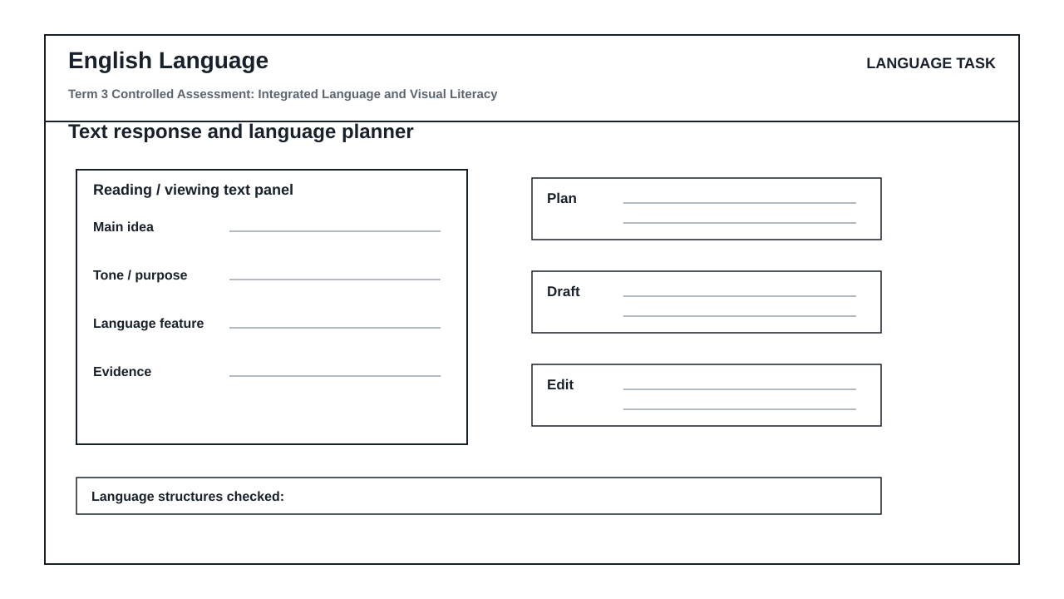

LANGUAGE ASSESSMENT TASK

SECTION 1: SECTION A: COMPREHENSION AND SUMMARY
Instructions: Read the passage below and answer the questions that follow. Use your own words where instructed.
Source: Passage: The Rise of Urban Rooftop Farming
Urban rooftop farming has transformed unused city spaces into productive green areas. In Johannesburg, several buildings now host vegetable gardens that supply fresh produce to local markets. These gardens reduce the distance food travels, cutting carbon emissions and providing jobs. However, challenges include high setup costs and the need for regular maintenance. Despite these obstacles, community support has been strong, with volunteers helping to sustain the gardens. Experts believe that rooftop farming can improve food security in densely populated areas.
1.1. What is the main idea of the passage? (2)

1.2. List TWO benefits of rooftop farming mentioned in the passage. (2)

1.3. What challenges are mentioned? Provide one. (1)

1.4. In your own words, explain why community support is important for the success of rooftop gardens. (2)

1.5. Summarise the passage in no more than 40 words. List SEVEN points. (7)

SECTION 2: SECTION B: VISUAL LITERACY – CARTOON AND ADVERTISEMENT
Instructions: Study the cartoon and advertisement provided. Answer the questions based on the visual details.
Source: Cartoon: A single-panel cartoon shows a character standing on a rooftop garden holding a watering can. The character says, 'Who knew the city could be this green?' The background shows skyscrapers and a clear sky. Advertisement: A print advertisement for a local farmers' market shows a basket of fresh vegetables with the slogan 'Fresh from the city's rooftops.' The ad includes a logo and a website URL.
2.1. What is the character's attitude in the cartoon? Provide a reason for your answer. (2)

2.2. How does the advertisement use colour to attract attention? Refer to specific details. (2)

2.3. What is the intended effect of the slogan 'Fresh from the city's rooftops'? (2)

2.4. Compare the cartoon and the advertisement. How do both convey the message of urban farming? (3)

SECTION 3: SECTION C: LANGUAGE STRUCTURES AND EDITING
Instructions: Answer the following questions on language structures and editing.
Source: Text: 'The gardens, which are located on rooftops, provide fresh produce to the community. They also create jobs for local residents. However, the cost of setting up a garden is high.'
3.1. Identify the relative clause in the sentence: 'The gardens, which are located on rooftops, provide fresh produce to the community.' (1)

3.2. Rewrite the following sentence in the passive voice: 'The community supports the gardens.' (2)

3.3. Correct the punctuation error in the following sentence: 'The gardens provide fresh produce, they also create jobs.' (1)

3.4. Choose the correct word: 'The cost of setting up a garden is (high/highly).' (1)

3.5. Provide a synonym for 'provide' as used in the text. (1)

SECTION 4: SECTION D: TRANSACTIONAL WRITING AND PLANNING
Instructions: Choose ONE of the following topics and write a response. Use the language_response_planner to plan your response before writing.
Source: Topic 1: Write a letter to the editor of a local newspaper arguing for the expansion of rooftop farming in your city. Topic 2: Write a speech to be delivered at a community meeting encouraging residents to start rooftop gardens.
4.1. Plan your response using the language_response_planner. Complete the 'main idea', 'evidence', and 'plan' sections. (5)

4.2. Write your response (letter or speech) in 180–200 words. Ensure appropriate register and format. (20)

LANGUAGE TASK CONDITIONS
- Use language-skills integration instead of a generic content subject exam.
- Scale text length, vocabulary, and writing load to the phase.

MARKING GUIDELINE

TASK 1: SECTION A: COMPREHENSION AND SUMMARY
1.1. What is the main idea of the passage? (2)
- The main idea is that urban rooftop farming transforms unused city spaces into productive green areas, providing fresh produce and environmental benefits.
1.2. List TWO benefits of rooftop farming mentioned in the passage. (2)
- Reduces distance food travels, cutting carbon emissions.
- Provides jobs.
1.3. What challenges are mentioned? Provide one. (1)
- High setup costs.
1.4. In your own words, explain why community support is important for the success of rooftop gardens. (2)
- Community support provides volunteers who help sustain the gardens, ensuring their maintenance and survival.
1.5. Summarise the passage in no more than 40 words. List SEVEN points. (7)
- 1. Urban rooftop farming transforms unused city spaces.
- 2. Gardens in Johannesburg supply fresh produce.
- 3. Reduces food travel distance.
- 4. Cuts carbon emissions.
- 5. Provides jobs.
- 6. Challenges: high setup costs and maintenance.
- 7. Community support and volunteers sustain gardens.

TASK 2: SECTION B: VISUAL LITERACY – CARTOON AND ADVERTISEMENT
2.1. What is the character's attitude in the cartoon? Provide a reason for your answer. (2)
- The character is surprised/pleased, as indicated by the statement 'Who knew the city could be this green?' and the context of a rooftop garden.
2.2. How does the advertisement use colour to attract attention? Refer to specific details. (2)
- The advertisement uses bright colours for the vegetables (e.g., red tomatoes, green lettuce) to make them look fresh and appealing, drawing the viewer's eye.
2.3. What is the intended effect of the slogan 'Fresh from the city's rooftops'? (2)
- The slogan suggests that the produce is locally grown and therefore fresh, appealing to consumers who value sustainability and quality.
2.4. Compare the cartoon and the advertisement. How do both convey the message of urban farming? (3)
- Both use positive imagery: the cartoon shows a green rooftop with a satisfied character, while the ad shows fresh vegetables with a catchy slogan. Both highlight the benefits of urban farming in a city setting.

TASK 3: SECTION C: LANGUAGE STRUCTURES AND EDITING
3.1. Identify the relative clause in the sentence: 'The gardens, which are located on rooftops, provide fresh produce to the community.' (1)
- which are located on rooftops
3.2. Rewrite the following sentence in the passive voice: 'The community supports the gardens.' (2)
- The gardens are supported by the community.
3.3. Correct the punctuation error in the following sentence: 'The gardens provide fresh produce, they also create jobs.' (1)
- Change the comma to a semicolon or full stop: 'The gardens provide fresh produce; they also create jobs.' or 'The gardens provide fresh produce. They also create jobs.'
3.4. Choose the correct word: 'The cost of setting up a garden is (high/highly).' (1)
- high
3.5. Provide a synonym for 'provide' as used in the text. (1)
- supply

TASK 4: SECTION D: TRANSACTIONAL WRITING AND PLANNING
4.1. Plan your response using the language_response_planner. Complete the 'main idea', 'evidence', and 'plan' sections. (5)
- Main idea: Clear argument for rooftop farming.
- Evidence: Uses facts from the passage or own knowledge.
- Plan: Logical structure with introduction, body, conclusion.
4.2. Write your response (letter or speech) in 180–200 words. Ensure appropriate register and format. (20)
- Content: 10 marks – clear argument, relevant points, persuasive language.
- Structure: 5 marks – logical flow, paragraphs, appropriate format.
- Language: 5 marks – grammar, punctuation, spelling, register.

LANGUAGE RUBRIC
Criterion | Marks | Descriptor
Comprehension and Summary | 14 | Accurate retrieval, interpretation, and concise summarisation.
Visual Literacy | 9 | Ability to analyse and evaluate visual texts using concrete details.
Language Structures and Editing | 6 | Correct identification and application of grammar, punctuation, and diction.
Transactional Writing: Planning | 5 | Effective use of the planner to organise ideas.
Transactional Writing: Final Response | 20 | Quality of writing: content, structure, and language accuracy.

EDUCATOR REVIEW CHECKLIST
- Verify that the passage and visuals are appropriate for Grade 12 level.
- Confirm that all questions are answerable based on the provided stimulus.
- Check that the memo allows equivalent wording for interpretive questions.
- Ensure that the writing rubric aligns with CAPS transactional writing criteria.
- Confirm that the total marks sum to 70 and duration is 2 hours.

