LIFE SCIENCES
GRADE 12 LIFE SCIENCES TERM 3 CONTROLLED ASSESSMENT

SUBJECT | LIFE SCIENCES
GRADE | 12
ASSESSMENT TASK | GRADE 12 LIFE SCIENCES TERM 3 CONTROLLED ASSESSMENT
MARKS | 75
TIME | 1.5 hours

Educator approval required before classroom use.

INSTRUCTIONS AND INFORMATION
1. Read all instructions carefully.
2. Answer all questions or complete all activities as instructed.
3. Show all working where calculations, planning, diagrams or explanations are required.
4. Use the space provided by the educator, answer booklet or learner task book.
5. Write neatly and clearly.

VISUAL MATERIAL
FIGURE 1: Finch Beak Data Table And Graph
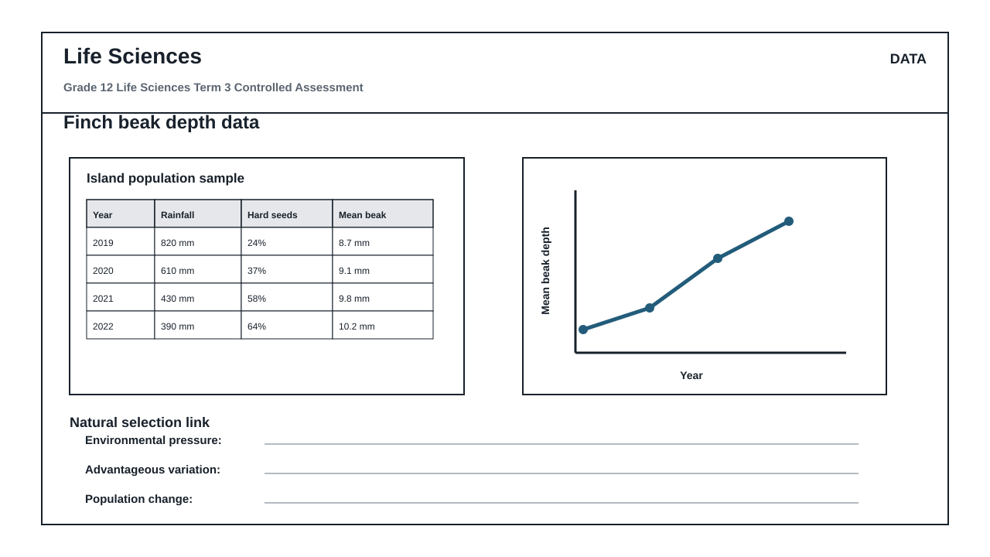
FIGURE 2: Investigation Data And Method Sheet
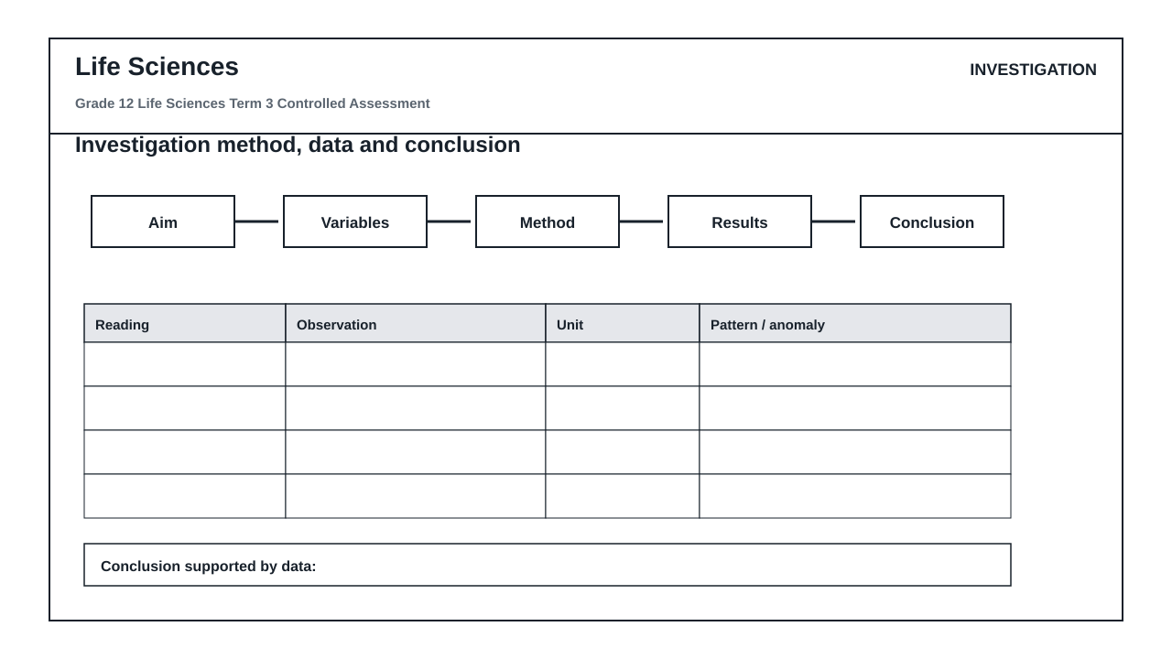
FIGURE 3: Life Sciences Hominin Skull Diagram
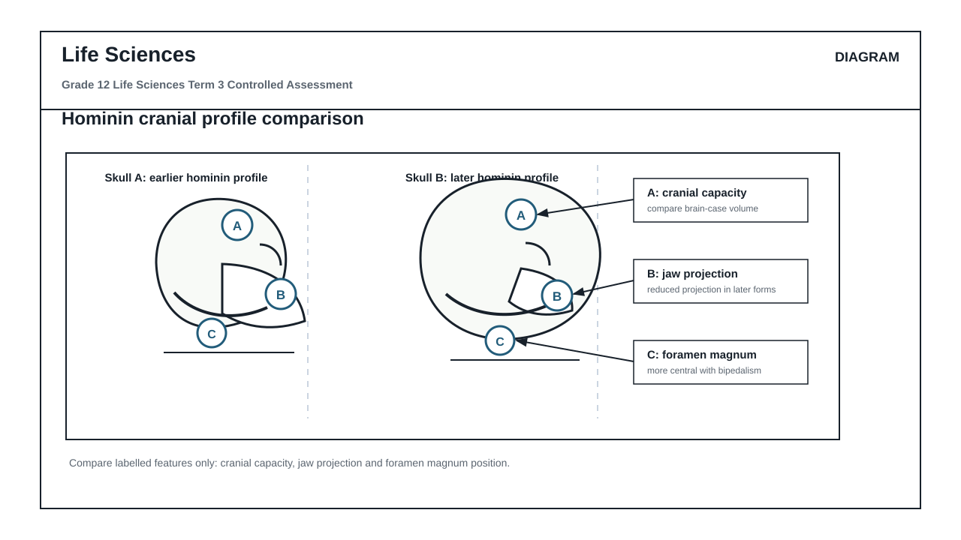

QUESTIONS

QUESTION 1: SECTION A: NATURAL SELECTION AND ENVIRONMENTAL PRESSURES
Instructions: Answer all questions in this section. Refer to Figure 1 which shows data collected on a population of finches on an island over a four-year period.
Stimulus: Figure 1: Finch beak depth data table and graph.
- 2019: rainfall 820 mm, hard seeds 24%, mean beak depth 8.7 mm
- 2020: rainfall 610 mm, hard seeds 37%, mean beak depth 9.1 mm
- 2021: rainfall 430 mm, hard seeds 58%, mean beak depth 9.8 mm
- 2022: rainfall 390 mm, hard seeds 64%, mean beak depth 10.2 mm
1.1. Calculate the percentage change in the mean beak depth of the finch population from 2019 to 2022. Show all working in your workspace. (4)

1.2. Describe the trend in rainfall and the availability of hard seeds from 2019 to 2022 as shown in Figure 1. (4)

1.3. Explain how the change in rainfall acts as a selection pressure that links to the availability of hard seeds. (6)

1.4. Use Darwin's theory of natural selection to explain why a larger mean beak depth became more common in this finch population by 2022. (8)

1.5. State THREE environmental factors, other than rainfall, that could act as selection pressures in a natural population. (3)

QUESTION 2: SECTION B: SCIENTIFIC INVESTIGATION DESIGN
Instructions: Answer all questions in this section. Refer to Figure 2, which outlines an investigation method and data sheet designed to model natural selection using different tools to collect seeds.
Stimulus: Figure 2: Investigation method and data sheet.
- Aim: To investigate the efficiency of different tools (forceps, spoon, clothes peg) in collecting soft sunflower seeds versus hard beans.
- Method: 50 seeds of each type are placed in a tray. A learner has 30 seconds to collect as many seeds as possible using one of the tools. The procedure is repeated 3 times for each tool.
- Recorded observations: The clothes peg collected an average of 42 hard beans, while the forceps collected an average of 5 hard beans.
2.1. Formulate a suitable hypothesis for this investigation based on the tools and seed types described in Figure 2. (3)

2.2. Identify the independent and dependent variables in this investigation. (4)

2.3. State TWO variables that must be controlled (kept constant) during this investigation to ensure a fair test. (4)

2.4. Explain how the reliability of the results was ensured in this investigation. (3)

2.5. Critique the validity of using artificial tools (forceps, spoon, clothes peg) to model natural selection in finch populations. State ONE strength and ONE limitation of this model. (4)

2.6. Based on the recorded observations in Figure 2, write a scientifically sound conclusion for this investigation. (4)

2.7. Suggest ONE way the learners could improve the validity of their experimental setup. (3)

QUESTION 3: SECTION C: HUMAN EVOLUTION EVIDENCE AND INTERPRETATION
Instructions: Answer all questions in this section. Refer to Figure 3, which shows a comparison of two hominin skulls.
Stimulus: Figure 3: Hominin skull comparison diagram.
- Skull A represents an earlier hominin profile.
- Skull B represents a later hominin profile.
- Label A indicates cranial capacity.
- Label B indicates jaw projection.
- Label C indicates foramen magnum position.
3.1. Identify the anatomical features indicated by Labels A, B, and C in Figure 3. (3)

3.2. Compare Skull A and Skull B with respect to Label A (cranial capacity) and Label B (jaw projection). Tabulate your comparison. (5)

3.3. Explain the evolutionary significance of the change in cranial capacity (Label A) from Skull A to Skull B. (4)

3.4. Describe the difference in the position of the foramen magnum (Label C) between Skull A and Skull B, and explain how this provides evidence for bipedalism. (6)

3.5. Explain how a change in diet from tough, raw food to cooked, softer food could have led to the evolutionary changes observed in jaw projection (Label B) and dentition. (7)

