LIFE SCIENCES
GRADE 12 LIFE SCIENCES TERM 3 CONTROLLED ASSESSMENT

SUBJECT | LIFE SCIENCES
GRADE | 12
ASSESSMENT TASK | GRADE 12 LIFE SCIENCES TERM 3 CONTROLLED ASSESSMENT
MARKS | 75
TIME | 1.5 hours

Educator approval required before classroom use.

INSTRUCTIONS AND INFORMATION
1. Read all instructions carefully.
2. Answer all questions or complete all activities as instructed.
3. Show all working where calculations, planning, diagrams or explanations are required.
4. Use the space provided by the educator, answer booklet or learner task book.
5. Write neatly and clearly.

VISUAL MATERIAL
FIGURE 1: Finch Beak Data Table And Graph
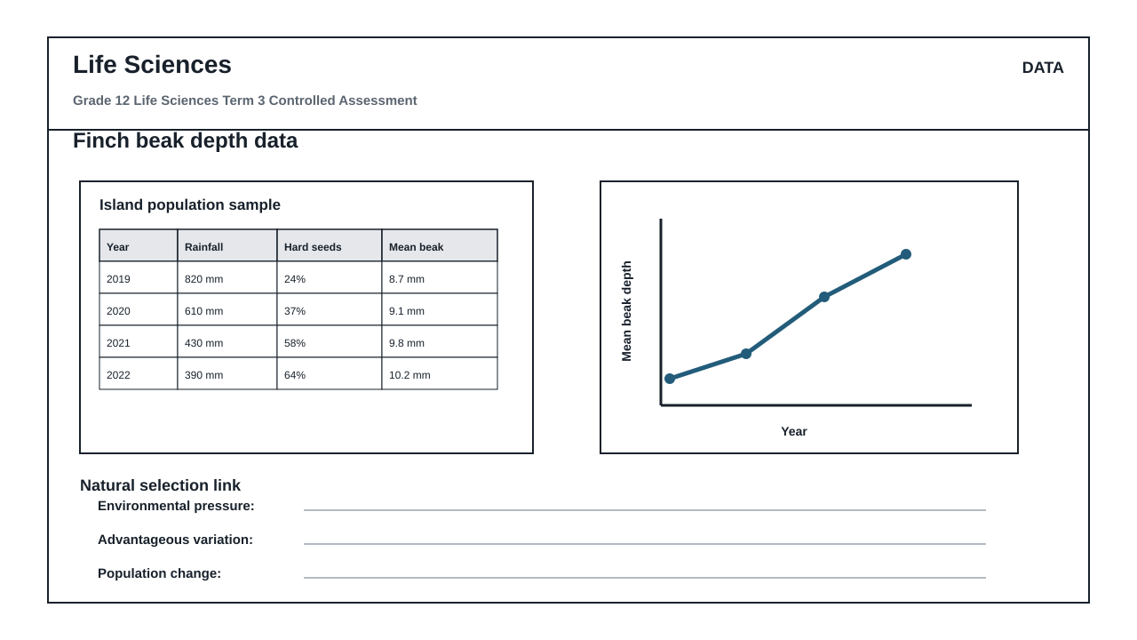
FIGURE 2: Investigation Data And Method Sheet
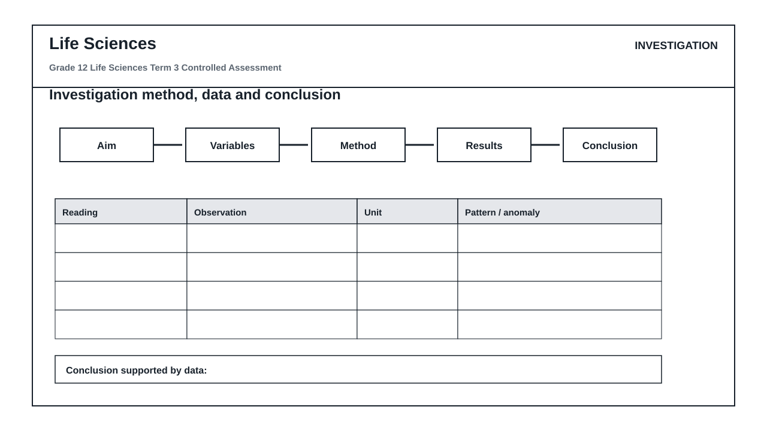
FIGURE 3: Life Sciences Hominin Skull Diagram
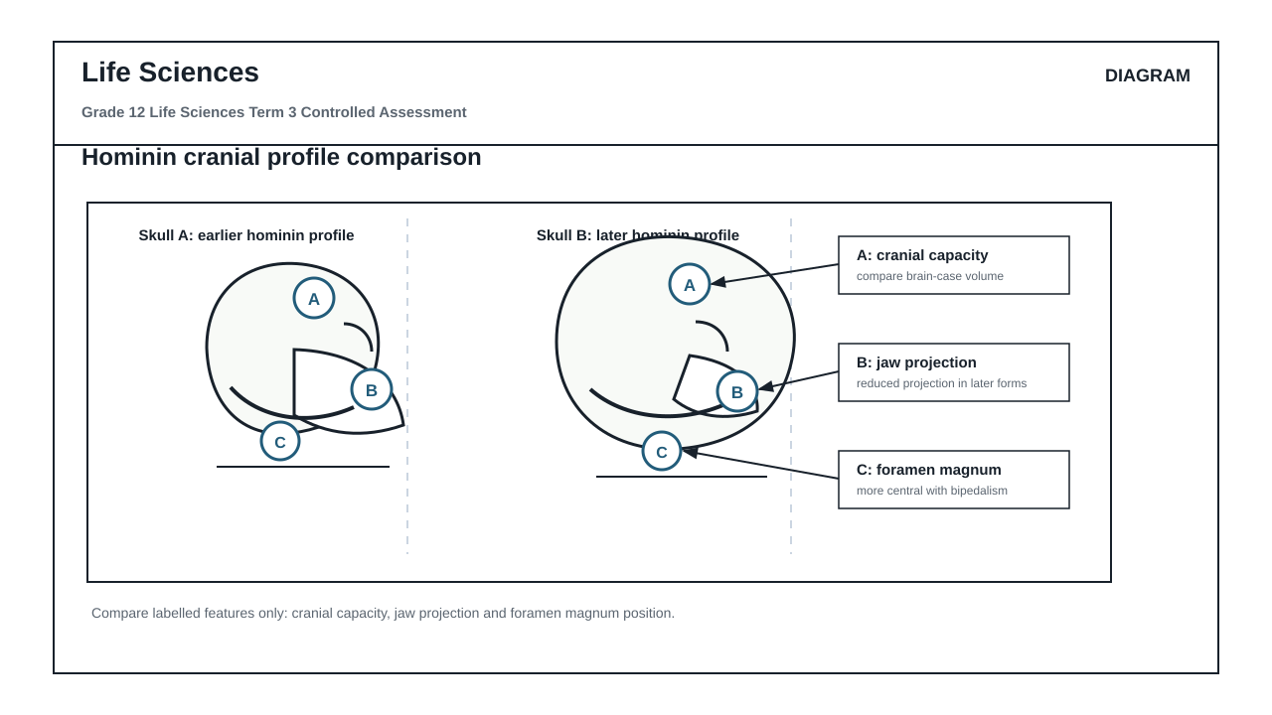

QUESTIONS

QUESTION 1: SECTION A: NATURAL SELECTION AND POPULATION DYNAMICS (FIGURE 1)
Instructions: Answer all questions in this section. Refer to Figure 1, which displays finch beak depth data and environmental factors collected from 2019 to 2022.
Stimulus: Figure 1: Finch beak depth data table and graph.
- 2019: rainfall 820 mm, hard seeds 24%, mean beak depth 8.7 mm
- 2020: rainfall 610 mm, hard seeds 37%, mean beak depth 9.1 mm
- 2021: rainfall 430 mm, hard seeds 58%, mean beak depth 9.8 mm
- 2022: rainfall 390 mm, hard seeds 64%, mean beak depth 10.2 mm
1.1. Calculate the total change in the mean beak depth of the finch population from 2019 to 2022. Show all working. (3)

1.2. Describe the trend in rainfall and the availability of hard seeds from 2019 to 2022 as shown in Figure 1. (4)

1.3. Explain how the change in rainfall from 2019 to 2022 acted as a selection pressure on the finch population. (6)

1.4. Using Darwin's theory of evolution by natural selection, explain why a larger mean beak depth became more common in this population by 2022. (8)

1.5. Predict the effect on the mean beak depth of the finch population if the rainfall in 2023 increased significantly to 900 mm. Explain your prediction. (4)

QUESTION 2: SECTION B: SCIENTIFIC INVESTIGATION DESIGN (FIGURE 2)
Instructions: Answer all questions in this section. Refer to Figure 2, which outlines the investigation method and data sheet used to simulate natural selection.
Stimulus: Figure 2: Investigation method and data sheet. The investigation simulates how different beak shapes (represented by different tools: tweezers, forceps, and spoons) collect seeds of varying hardness. The data sheet records the number of seeds collected by each tool type over three timed trials.
2.1. Formulate a suitable aim for this scientific investigation based on the context of natural selection. (3)

2.2. Identify the independent and dependent variables in this investigation. (4)

2.3. State three variables that must be controlled (kept constant) during this simulation to ensure a fair test. (3)

2.4. Explain the difference between the reliability and the validity of this investigation. (4)

2.5. Critique the quality of the method provided in Figure 2. Identify two potential design flaws and suggest how to improve each flaw to increase validity. (6)

2.6. Formulate a suitable conclusion for this investigation based on the recorded observations of tool efficiency. (5)

QUESTION 3: SECTION C: HUMAN EVOLUTION EVIDENCE AND INTERPRETATION (FIGURE 3)
Instructions: Answer all questions in this section. Refer to Figure 3, which illustrates a hominin skull comparison diagram.
Stimulus: Figure 3: Hominin skull comparison diagram.
- Skull A represents an earlier hominin profile.
- Skull B represents a later hominin profile.
- Label A indicates cranial capacity.
- Label B indicates jaw projection.
- Label C indicates foramen magnum position.
3.1. Identify the anatomical features or structures represented by labels A, B, and C in Figure 3. (3)

3.2. Draw a table to compare three anatomical differences between Skull A (earlier hominin) and Skull B (later hominin) using only the features indicated by labels A, B, and C. (7)

3.3. Explain the significance of the change in the position of label C (foramen magnum) in relation to the locomotion of the hominins. (6)

3.4. Explain how the change in cranial capacity (label A) from Skull A to Skull B correlates with cognitive development and tool use in human evolution. (5)

3.5. Describe how the change in jaw projection (label B) relates to a change in diet from earlier hominins to modern humans. (4)

