LIFE SCIENCES
GRADE 12 LIFE SCIENCES TERM 3 CONTROLLED ASSESSMENT

SUBJECT | LIFE SCIENCES
GRADE | 12
ASSESSMENT TASK | GRADE 12 LIFE SCIENCES TERM 3 CONTROLLED ASSESSMENT
MARKS | 75
TIME | 1.5 hours

Educator approval required before classroom use.

INSTRUCTIONS AND INFORMATION
1. Read all instructions carefully.
2. Answer all questions or complete all activities as instructed.
3. Show all working where calculations, planning, diagrams or explanations are required.
4. Use the space provided by the educator, answer booklet or learner task book.
5. Write neatly and clearly.

VISUAL MATERIAL
FIGURE 1: Finch Beak Data Table And Graph
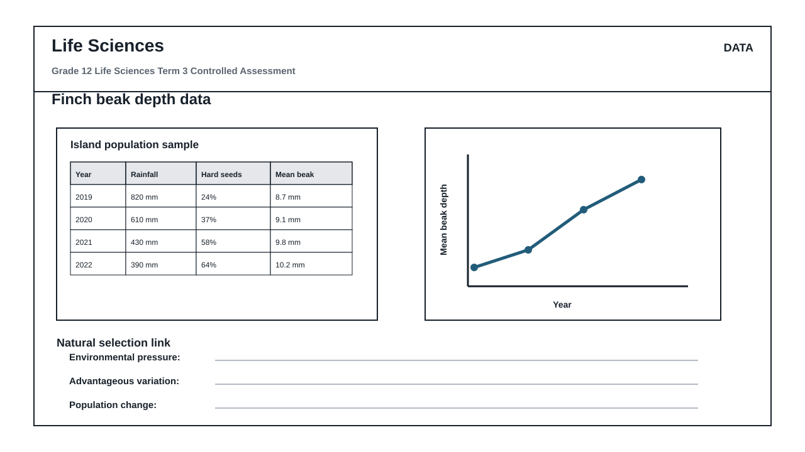
FIGURE 2: Investigation Data And Method Sheet
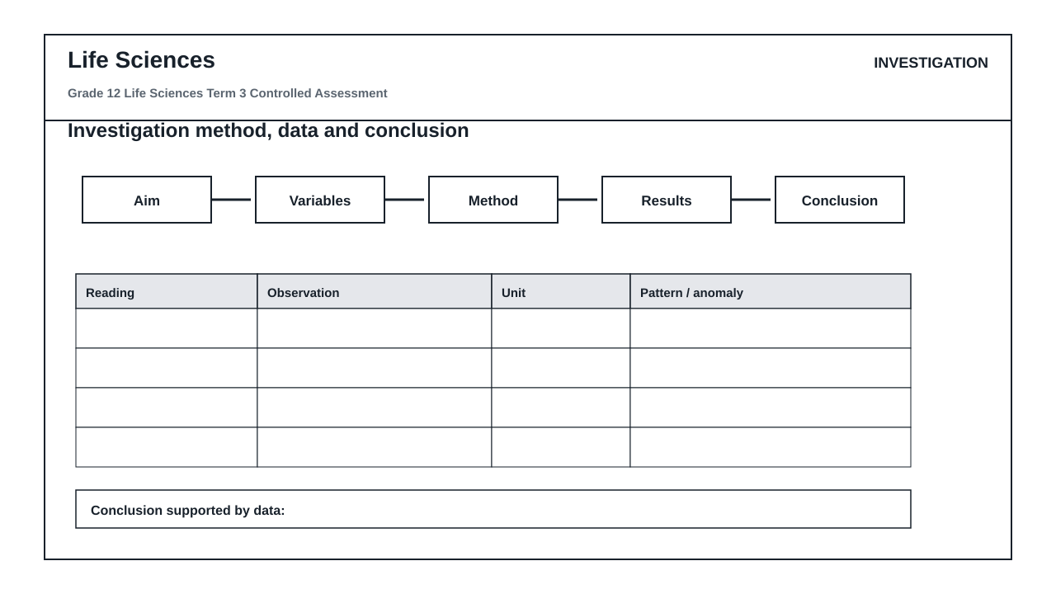
FIGURE 3: Life Sciences Hominin Skull Diagram
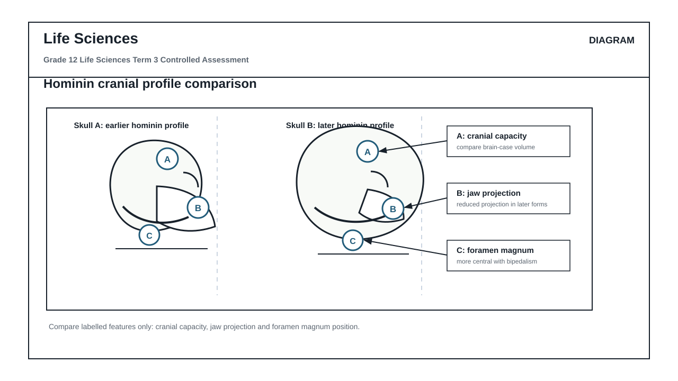

QUESTIONS

QUESTION 1: SECTION A: NATURAL SELECTION AND POPULATION DYNAMICS (FIGURE 1)
Instructions: Answer all questions in this section. Refer to Figure 1, which displays finch beak depth data and environmental factors collected from 2019 to 2022.
Stimulus: Figure 1: Finch beak depth data table and graph.
- 2019: rainfall 820 mm, hard seeds 24%, mean beak depth 8.7 mm
- 2020: rainfall 610 mm, hard seeds 37%, mean beak depth 9.1 mm
- 2021: rainfall 430 mm, hard seeds 58%, mean beak depth 9.8 mm
- 2022: rainfall 390 mm, hard seeds 64%, mean beak depth 10.2 mm
1.1. Calculate the total change in the mean beak depth of the finch population from 2019 to 2022. Show all working. (3)

1.2. Describe the trend in rainfall and the availability of hard seeds from 2019 to 2022 as shown in Figure 1. (4)

1.3. Explain how the change in rainfall from 2019 to 2022 acted as a selection pressure on the finch population. (6)

1.4. Using Darwin's theory of evolution by natural selection, explain why a larger mean beak depth became more common in this population by 2022. (8)

1.5. Predict the effect on the mean beak depth of the finch population if the rainfall in 2023 increased significantly to 900 mm. Explain your prediction. (4)

QUESTION 2: SECTION B: SCIENTIFIC INVESTIGATION DESIGN (FIGURE 2)
Instructions: Answer all questions in this section. Refer to Figure 2, which outlines the investigation method and data sheet used to simulate natural selection.
Stimulus: Figure 2: Investigation method and data sheet. The investigation simulates how different beak shapes (represented by different tools: tweezers, forceps, and spoons) collect seeds of varying hardness. The data sheet records the number of seeds collected by each tool type over three timed trials.
2.1. Formulate a suitable aim for this scientific investigation based on the context of natural selection. (3)

2.2. Identify the independent and dependent variables in this investigation. (4)

2.3. State three variables that must be controlled (kept constant) during this simulation to ensure a fair test. (3)

2.4. Explain the difference between the reliability and the validity of this investigation. (4)

2.5. Critique the quality of the method provided in Figure 2. Identify two potential design flaws and suggest how to improve each flaw to increase validity. (6)

2.6. Formulate a suitable conclusion for this investigation based on the recorded observations of tool efficiency. (5)

QUESTION 3: SECTION C: HUMAN EVOLUTION EVIDENCE AND INTERPRETATION (FIGURE 3)
Instructions: Answer all questions in this section. Refer to Figure 3, which illustrates a hominin skull comparison diagram.
Stimulus: Figure 3: Hominin skull comparison diagram.
- Skull A represents an earlier hominin profile.
- Skull B represents a later hominin profile.
- Label A indicates cranial capacity.
- Label B indicates jaw projection.
- Label C indicates foramen magnum position.
3.1. Identify the anatomical features or structures represented by labels A, B, and C in Figure 3. (3)

3.2. Draw a table to compare three anatomical differences between Skull A (earlier hominin) and Skull B (later hominin) using only the features indicated by labels A, B, and C. (7)

3.3. Explain the significance of the change in the position of label C (foramen magnum) in relation to the locomotion of the hominins. (6)

3.4. Explain how the change in cranial capacity (label A) from Skull A to Skull B correlates with cognitive development and tool use in human evolution. (5)

3.5. Describe how the change in jaw projection (label B) relates to a change in diet from earlier hominins to modern humans. (4)

MARKING GUIDELINE

TASK 1: SECTION A: NATURAL SELECTION AND POPULATION DYNAMICS (FIGURE 1)
1.1. Calculate the total change in the mean beak depth of the finch population from 2019 to 2022. Show all working. (3)
- 10.2 mm - 8.7 mm (1 mark for correct values from table)
- = 1.5 (1 mark for correct calculation)
- mm (1 mark for correct unit)
1.2. Describe the trend in rainfall and the availability of hard seeds from 2019 to 2022 as shown in Figure 1. (4)
- Rainfall decreased consistently over the four-year period from 820 mm to 390 mm. (2 marks)
- The percentage of hard seeds increased consistently over the same period from 24% to 64%. (2 marks)
1.3. Explain how the change in rainfall from 2019 to 2022 acted as a selection pressure on the finch population. (6)
- The decrease in rainfall (from 820 mm to 390 mm) led to a decrease in soft seed availability. (2 marks)
- This forced finches to rely on hard seeds, which increased from 24% to 64%. (2 marks)
- Finches with smaller, shallower beaks could not crack the hard seeds and faced starvation, while those with larger beak depths could crack them and survive. (2 marks)
1.4. Using Darwin's theory of evolution by natural selection, explain why a larger mean beak depth became more common in this population by 2022. (8)
- There is variation in beak depth within the finch population; some have larger beak depths, and some have smaller beak depths. (2 marks)
- The environmental change (drought/decrease in rainfall) acted as a selection pressure. (1 mark)
- Finches with larger beak depths were better adapted to crack and feed on the abundant hard seeds. (2 marks)
- These adapted finches had a higher chance of survival (survival of the fittest). (1 mark)
- They reproduced and passed on the favorable allele/gene for larger beak depth to their offspring. (1 mark)
- Over generations, the frequency of the allele for larger beak depth increased, making it more common in the population by 2022. (1 mark)
1.5. Predict the effect on the mean beak depth of the finch population if the rainfall in 2023 increased significantly to 900 mm. Explain your prediction. (4)
- Prediction: The mean beak depth will likely decrease over subsequent generations. (1 mark)
- Explanation: Increased rainfall will lead to an abundance of soft seeds. (1 mark)
- Finches with smaller beak depths will no longer be selected against as food is plentiful and easy to access. (1 mark)
- The selection pressure favoring large beaks is reduced, allowing smaller-beaked finches to survive and reproduce equally. (1 mark)

TASK 2: SECTION B: SCIENTIFIC INVESTIGATION DESIGN (FIGURE 2)
2.1. Formulate a suitable aim for this scientific investigation based on the context of natural selection. (3)
- To investigate the effect of different tool shapes (representing beak variation) on the efficiency of collecting seeds of varying hardness. (3 marks)
- Accept: To determine which beak shape (tool) is best adapted to collect hard seeds. (3 marks)
2.2. Identify the independent and dependent variables in this investigation. (4)
- Independent variable: The shape/type of the tool (representing beak variation). (2 marks)
- Dependent variable: The number of seeds collected / feeding efficiency. (2 marks)
2.3. State three variables that must be controlled (kept constant) during this simulation to ensure a fair test. (3)
- The time allowed for seed collection in each trial. (1 mark)
- The total starting number/mass of seeds available in each trial. (1 mark)
- The size/type of the container from which seeds are collected. (1 mark)
- Accept: The person operating the tools (to control force/speed). (1 mark)
2.4. Explain the difference between the reliability and the validity of this investigation. (4)
- Reliability refers to the consistency of the results, which is achieved by repeating the trials (three trials) and calculating an average. (2 marks)
- Validity refers to whether the investigation successfully tests what it designs to test, which is achieved by controlling all variables except the independent variable. (2 marks)
2.5. Critique the quality of the method provided in Figure 2. Identify two potential design flaws and suggest how to improve each flaw to increase validity. (6)
- Flaw 1: Different learners might operate different tools, introducing variation in human speed and dexterity. (2 marks)
- Improvement 1: Have the same learner operate all tools, or train operators to use uniform force and speed. (1 mark)
- Flaw 2: The seeds might be placed in different positions or containers for each tool trial. (2 marks)
- Improvement 2: Ensure the exact same container and seed distribution pattern are used for every trial. (1 mark)
2.6. Formulate a suitable conclusion for this investigation based on the recorded observations of tool efficiency. (5)
- The tool shape (beak type) significantly affects the number of seeds collected. (2 marks)
- Specific tools (e.g., tweezers/forceps) are highly efficient at collecting specific seed types compared to others. (2 marks)
- This supports the conclusion that anatomical variation determines survival efficiency under specific environmental conditions. (1 mark)

TASK 3: SECTION C: HUMAN EVOLUTION EVIDENCE AND INTERPRETATION (FIGURE 3)
3.1. Identify the anatomical features or structures represented by labels A, B, and C in Figure 3. (3)
- Label A: Cranial capacity / Cranium (1 mark)
- Label B: Jaw projection / Prognathism (1 mark)
- Label C: Foramen magnum position (1 mark)
3.2. Draw a table to compare three anatomical differences between Skull A (earlier hominin) and Skull B (later hominin) using only the features indicated by labels A, B, and C. (7)
- Table structure: Correct columns, rows, and headings. (1 mark)
- Label A (Cranial capacity): Skull A has a smaller cranial capacity / brain size; Skull B has a larger cranial capacity / brain size. (2 marks)
- Label B (Jaw projection): Skull A has a more projecting jaw (prognathous); Skull B has a flatter face / less projecting jaw (non-prognathous). (2 marks)
- Label C (Foramen magnum): Skull C/A has the foramen magnum positioned further back; Skull B has the foramen magnum positioned forward/centrally at the base of the skull. (2 marks)
3.3. Explain the significance of the change in the position of label C (foramen magnum) in relation to the locomotion of the hominins. (6)
- In Skull A, the foramen magnum is positioned towards the back of the skull, indicating quadrupedal locomotion (walking on four limbs). (2 marks)
- In Skull B, the foramen magnum is positioned centrally/forward at the base of the skull. (2 marks)
- This central position allows the skull to balance vertically on top of the vertebral column, which is an adaptation for bipedalism (walking upright on two legs). (2 marks)
3.4. Explain how the change in cranial capacity (label A) from Skull A to Skull B correlates with cognitive development and tool use in human evolution. (5)
- The increase in cranial capacity from Skull A to Skull B indicates an increase in brain size. (1 mark)
- A larger brain size correlates with higher cognitive ability, intelligence, and complex processing. (2 marks)
- This cognitive development enabled later hominins to design, manufacture, and use sophisticated tools for hunting and survival. (2 marks)
3.5. Describe how the change in jaw projection (label B) relates to a change in diet from earlier hominins to modern humans. (4)
- Earlier hominins (Skull A) had a highly projecting jaw (prognathism) with large teeth to chew raw, tough, fibrous vegetation. (2 marks)
- Later hominins (Skull B) have a flatter face with smaller teeth because their diet shifted to softer, cooked food. (2 marks)

RUBRIC
Criterion | Marks | Descriptor
Section A: Natural Selection and Population Dynamics | 25 | Assessment of data interpretation, trend analysis, and application of Darwinian natural selection principles using Figure 1.
Section B: Scientific Investigation Design | 25 | Assessment of scientific method, variable identification, reliability, validity, and critique of experimental design using Figure 2.
Section C: Human Evolution Evidence and Interpretation | 25 | Assessment of comparative hominin anatomy, bipedalism adaptations, and evolutionary trends using Figure 3.

EDUCATOR REVIEW CHECKLIST
- Verify that the total marks sum to exactly 75.
- Confirm that no pelvis-related terms or other unprovided anatomical structures are assessed in Figure 3.
- Ensure the finch data values in Section A match the locked source card exactly.
- Check that the memo allows for scientifically equivalent phrasing in explanations.

