ENGLISH LANGUAGE
ENGLISH LANGUAGE GRADE 12 TERM 3 CONTROLLED ASSESSMENT PACK

SUBJECT | ENGLISH LANGUAGE
GRADE | 12
ASSESSMENT TASK | ENGLISH LANGUAGE GRADE 12 TERM 3 CONTROLLED ASSESSMENT PACK
MARKS | 50
TIME | 1 hour

Educator approval required before classroom use.

INSTRUCTIONS AND INFORMATION
1. Read each source text and question carefully.
2. Answer in the language of assessment unless instructed otherwise.
3. Use evidence from the supplied text or visual source where required.
4. Plan written responses before writing the final answer.
5. Write neatly and observe spelling, punctuation, grammar and register.

VISUAL MATERIAL
FIGURE 1: Text Response And Language Planner
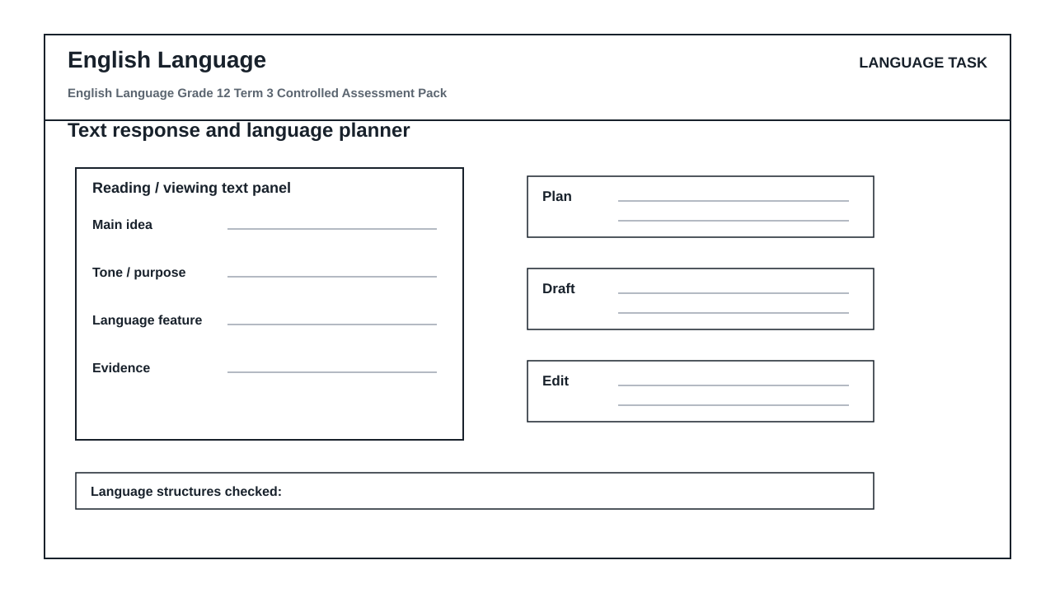

LANGUAGE ASSESSMENT TASK

SECTION 1: SECTION A: COMPREHENSION AND VISUAL LITERACY
Instructions: Read the supplied text and visual stimulus carefully before answering.
Source: Source set on integrated comprehension, summary and language structures and cartoon, advertisement or infographic analysis. The educator inserts the approved text, cartoon, advertisement or infographic.
1.1. Identify the main idea of the text and quote ONE piece of supporting evidence. (4)

1.2. Explain how tone and register shape the reader's response. (6)

1.3. Analyse how the visual text uses image, layout and wording to communicate its message. (8)

1.4. Write a 60-80 word summary of the key information. (7)

SECTION 2: SECTION B: LANGUAGE IN CONTEXT
Instructions: Use the source text for language and editing questions.
Source: Language focus: editing for grammar, diction, register and punctuation.
2.1. Edit the supplied sentence for diction, punctuation and register. (5)

2.2. Explain the function of TWO language structures used in the text. (5)

2.3. Rewrite a sentence in a more formal register without changing the meaning. (5)

SECTION 3: SECTION C: WRITING RESPONSE
Instructions: Plan and write a structured response.
Source: Writing task: formal transactional writing and controlled response planning.
3.1. Write a transactional text with suitable structure, register and purpose. (10)

LANGUAGE TASK CONDITIONS
- Use language-skills integration instead of a generic content subject exam.
- Scale text length, vocabulary, and writing load to the phase.

MARKING GUIDELINE

TASK 1: SECTION A: COMPREHENSION AND VISUAL LITERACY
1.1. Identify the main idea of the text and quote ONE piece of supporting evidence. (4)
- Main idea is accurate.
- Evidence is quoted or paraphrased from the source.
1.2. Explain how tone and register shape the reader's response. (6)
- Tone identified.
- Register discussed.
- Effect on reader explained.
1.3. Analyse how the visual text uses image, layout and wording to communicate its message. (8)
- Image/layout discussed.
- Wording discussed.
- Message explained.
1.4. Write a 60-80 word summary of the key information. (7)
- Relevant points selected.
- Own words used.
- Word limit controlled.

TASK 2: SECTION B: LANGUAGE IN CONTEXT
2.1. Edit the supplied sentence for diction, punctuation and register. (5)
- Diction improved.
- Punctuation corrected.
- Register remains appropriate.
2.2. Explain the function of TWO language structures used in the text. (5)
- Two structures identified.
- Functions explained accurately.
2.3. Rewrite a sentence in a more formal register without changing the meaning. (5)
- Meaning retained.
- Formal register consistent.

TASK 3: SECTION C: WRITING RESPONSE
3.1. Write a transactional text with suitable structure, register and purpose. (10)
- Structure suits text type.
- Register and purpose are clear.
- Content is coherent.

LANGUAGE RUBRIC
Criterion | Marks | Descriptor
Subject accuracy and terminology | 12 | Uses accurate concepts and terminology.
Evidence, data or source use | 12 | Uses supplied evidence appropriately.
Reasoning and explanation | 12 | Shows logical, grade-appropriate reasoning.
Communication and completion | 14 | Answers are clear, complete and structured.

EDUCATOR REVIEW CHECKLIST
- Confirm CAPS term and topic fit before classroom use.
- Insert or approve final source material where the pack requests educator-supplied sources.
- Check mark allocation, memo wording and learner level.
- Confirm visuals are suitable and not treated as official source material unless sourced separately.

