ENGLISH LANGUAGE
ENGLISH LANGUAGE GRADE 12 TERM 4 CONTROLLED ASSESSMENT PACK

SUBJECT | ENGLISH LANGUAGE
GRADE | 12
ASSESSMENT TASK | ENGLISH LANGUAGE GRADE 12 TERM 4 CONTROLLED ASSESSMENT PACK
MARKS | 50
TIME | 1 hour

Educator approval required before classroom use.

INSTRUCTIONS AND INFORMATION
1. Read each source text and question carefully.
2. Answer in the language of assessment unless instructed otherwise.
3. Use evidence from the supplied text or visual source where required.
4. Plan written responses before writing the final answer.
5. Write neatly and observe spelling, punctuation, grammar and register.

VISUAL MATERIAL
FIGURE 1: Text Response And Language Planner
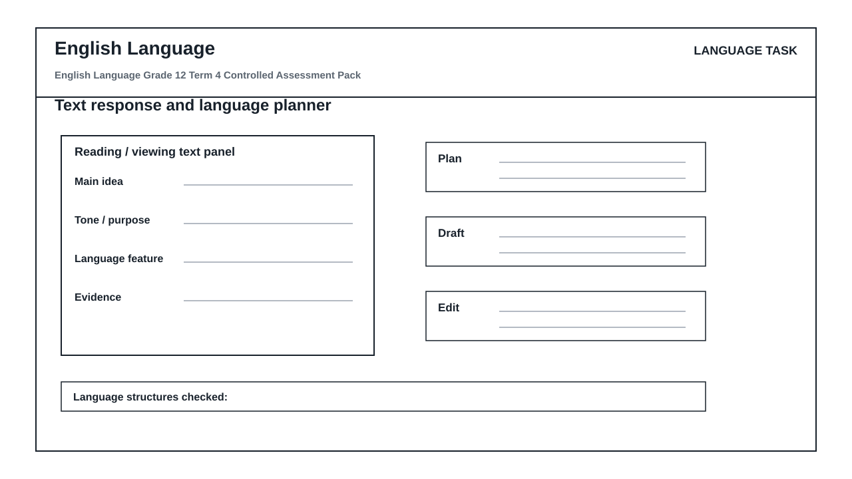

LANGUAGE ASSESSMENT TASK

SECTION 1: SECTION A: COMPREHENSION AND VISUAL LITERACY
Instructions: Read the supplied text and visual stimulus carefully before answering.
Source: Source set on final integrated language examination practice and unseen text interpretation and visual literacy synthesis. The educator inserts the approved text, cartoon, advertisement or infographic.
1.1. Identify the main idea of the text and quote ONE piece of supporting evidence. (4)

1.2. Explain how tone and register shape the reader's response. (6)

1.3. Analyse how the visual text uses image, layout and wording to communicate its message. (8)

1.4. Write a 60-80 word summary of the key information. (7)

SECTION 2: SECTION B: LANGUAGE IN CONTEXT
Instructions: Use the source text for language and editing questions.
Source: Language focus: time-managed summary, editing and evidence-based answers.
2.1. Edit the supplied sentence for diction, punctuation and register. (5)

2.2. Explain the function of TWO language structures used in the text. (5)

2.3. Rewrite a sentence in a more formal register without changing the meaning. (5)

SECTION 3: SECTION C: WRITING RESPONSE
Instructions: Plan and write a structured response.
Source: Writing task: extended writing with argument, coherence and style control.
3.1. Write a transactional text with suitable structure, register and purpose. (10)

LANGUAGE TASK CONDITIONS
- Use language-skills integration instead of a generic content subject exam.
- Scale text length, vocabulary, and writing load to the phase.

