GEOGRAPHY
GEOGRAPHY GRADE 12 TERM 2 CONTROLLED ASSESSMENT PACK

SUBJECT | GEOGRAPHY
GRADE | 12
ASSESSMENT TASK | GEOGRAPHY GRADE 12 TERM 2 CONTROLLED ASSESSMENT PACK
MARKS | 50
TIME | 1 hour

Educator approval required before classroom use.

INSTRUCTIONS AND INFORMATION
1. Read all instructions carefully.
2. Answer all questions or complete all activities as instructed.
3. Show all working where calculations, planning, diagrams or explanations are required.
4. Use the space provided by the educator, answer booklet or learner task book.
5. Write neatly and clearly.

VISUAL MATERIAL
FIGURE 1: Population Distribution Map And Density Data
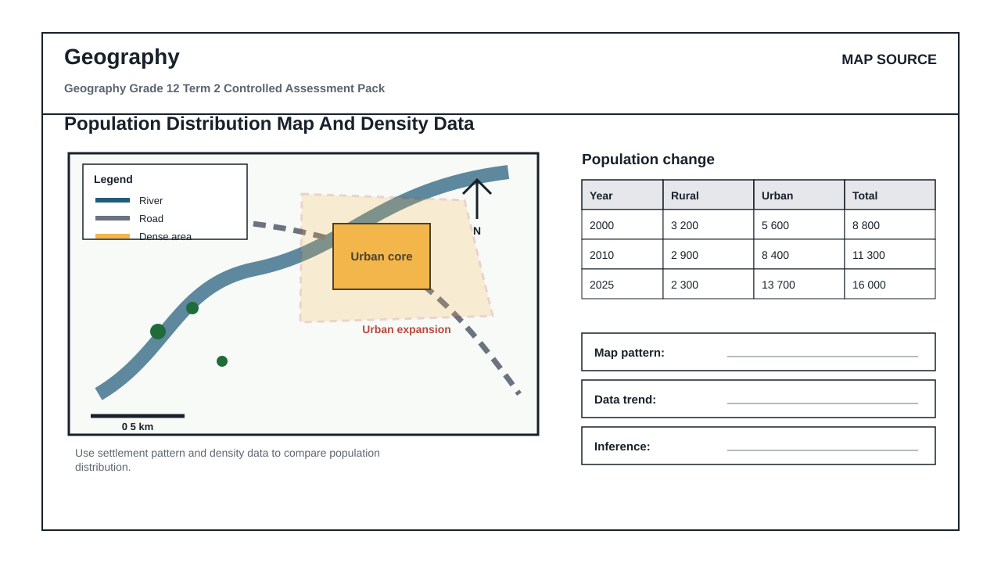

QUESTIONS

QUESTION 1: SECTION A: MAP AND SOURCE SKILLS
Instructions: Use the supplied map, photograph, diagram or graph.
Stimulus: Geography source set linked to rural and urban settlement geography.
1.1. Identify TWO visible spatial patterns or features from the source. (4)

1.2. Explain the process or relationship shown in the source. (8)

1.3. Interpret the supplied data table or graph and describe the trend. (6)

QUESTION 2: SECTION B: GEOGRAPHIC EXPLANATION
Instructions: Write structured geographical explanations.
Stimulus: Explanation focus: settlement patterns, land use, urban problems and sustainability.
2.1. Compare two places, processes or patterns using source evidence. (8)

2.2. Suggest a sustainable response to the geographic challenge. (9)

QUESTION 3: SECTION C: INTEGRATED MAPWORK OR GIS
Instructions: Apply spatial reasoning.
Stimulus: Integrated focus: structured extended response on human-environment interaction.
3.1. Complete an integrated spatial reasoning task using map/data evidence. (15)

MARKING GUIDELINE

TASK 1: SECTION A: MAP AND SOURCE SKILLS
1.1. Identify TWO visible spatial patterns or features from the source. (4)
- Two features identified.
1.2. Explain the process or relationship shown in the source. (8)
- Process explained.
- Source evidence cited.
1.3. Interpret the supplied data table or graph and describe the trend. (6)
- Trend described.
- Data cited.

TASK 2: SECTION B: GEOGRAPHIC EXPLANATION
2.1. Compare two places, processes or patterns using source evidence. (8)
- Comparison clear.
- Evidence used.
2.2. Suggest a sustainable response to the geographic challenge. (9)
- Response relevant.
- Reasoning justified.

TASK 3: SECTION C: INTEGRATED MAPWORK OR GIS
3.1. Complete an integrated spatial reasoning task using map/data evidence. (15)
- Map/data evidence used.
- Reasoning accurate.

RUBRIC
Criterion | Marks | Descriptor
Subject accuracy and terminology | 12 | Uses accurate concepts and terminology.
Evidence, data or source use | 12 | Uses supplied evidence appropriately.
Reasoning and explanation | 12 | Shows logical, grade-appropriate reasoning.
Communication and completion | 14 | Answers are clear, complete and structured.

EDUCATOR REVIEW CHECKLIST
- Confirm CAPS term and topic fit before classroom use.
- Insert or approve final source material where the pack requests educator-supplied sources.
- Check mark allocation, memo wording and learner level.
- Confirm visuals are suitable and not treated as official source material unless sourced separately.

