GEOGRAPHY
GEOGRAPHY GRADE 12 TERM 4 CONTROLLED ASSESSMENT PACK

SUBJECT | GEOGRAPHY
GRADE | 12
ASSESSMENT TASK | GEOGRAPHY GRADE 12 TERM 4 CONTROLLED ASSESSMENT PACK
MARKS | 50
TIME | 1 hour

Educator approval required before classroom use.

INSTRUCTIONS AND INFORMATION
1. Read all instructions carefully.
2. Answer all questions or complete all activities as instructed.
3. Show all working where calculations, planning, diagrams or explanations are required.
4. Use the space provided by the educator, answer booklet or learner task book.
5. Write neatly and clearly.

VISUAL MATERIAL
FIGURE 1: Topographic Map Extract And Orthophoto Cues
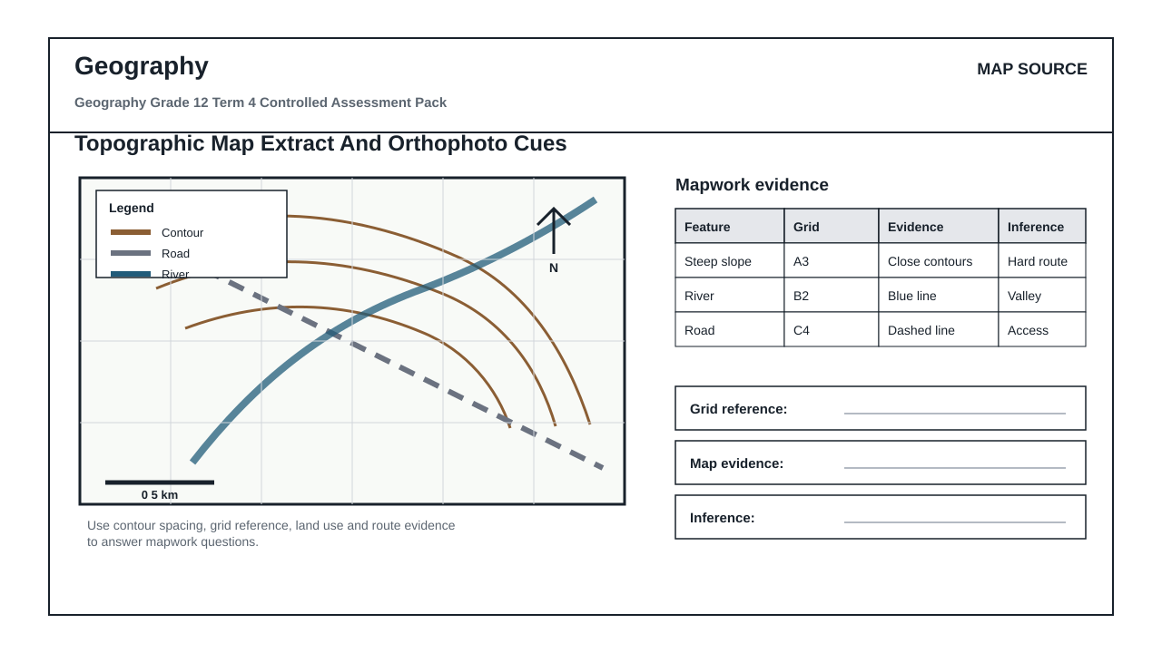

QUESTIONS

QUESTION 1: SECTION A: MAP AND SOURCE SKILLS
Instructions: Use the supplied map, photograph, diagram or graph.
Stimulus: Geography source set linked to final integrated Geography examination practice.
1.1. Identify TWO visible spatial patterns or features from the source. (4)

1.2. Explain the process or relationship shown in the source. (8)

1.3. Interpret the supplied data table or graph and describe the trend. (6)

QUESTION 2: SECTION B: GEOGRAPHIC EXPLANATION
Instructions: Write structured geographical explanations.
Stimulus: Explanation focus: climate, geomorphology, settlement, economic geography, GIS and mapwork.
2.1. Compare two places, processes or patterns using source evidence. (8)

2.2. Suggest a sustainable response to the geographic challenge. (9)

QUESTION 3: SECTION C: INTEGRATED MAPWORK OR GIS
Instructions: Apply spatial reasoning.
Stimulus: Integrated focus: extended geographical argument using spatial evidence.
3.1. Complete an integrated spatial reasoning task using map/data evidence. (15)

