HISTORY
HISTORY GRADE 12 TERM 3 CONTROLLED ASSESSMENT PACK

SUBJECT | HISTORY
GRADE | 12
ASSESSMENT TASK | HISTORY GRADE 12 TERM 3 CONTROLLED ASSESSMENT PACK
MARKS | 50
TIME | 1 hour

Educator approval required before classroom use.

INSTRUCTIONS AND INFORMATION
1. Read all instructions carefully.
2. Answer all questions or complete all activities as instructed.
3. Show all working where calculations, planning, diagrams or explanations are required.
4. Use the space provided by the educator, answer booklet or learner task book.
5. Write neatly and clearly.

VISUAL MATERIAL
FIGURE 1: Source Panel And Evidence Table
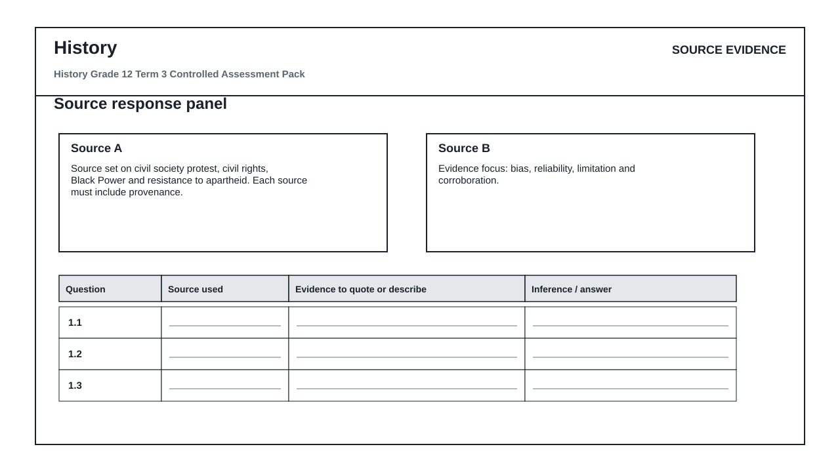
FIGURE 2: Claim Evidence Reasoning Table
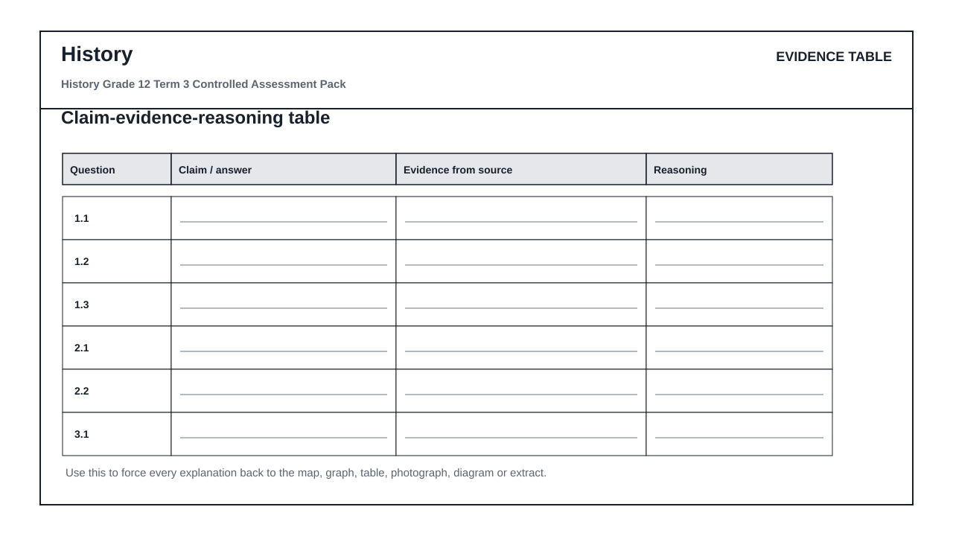

QUESTIONS

QUESTION 1: SECTION A: SOURCE-BASED QUESTIONS
Instructions: Use the supplied historical source set.
Stimulus: Source set on civil society protest, civil rights, Black Power and resistance to apartheid. Each source must include provenance.
1.1. Contextualise the source in relation to the historical topic. (4)

1.2. Explain the message or viewpoint of the source using evidence. (6)

1.3. Evaluate the usefulness or reliability of the source. (8)

QUESTION 2: SECTION B: COMPARISON AND CAUSATION
Instructions: Compare evidence and explain causation.
Stimulus: Evidence focus: bias, reliability, limitation and corroboration.
2.1. Compare two sources and explain where they agree or differ. (8)

2.2. Explain one cause and one consequence linked to the topic. (9)

QUESTION 3: SECTION C: ESSAY PARAGRAPH
Instructions: Write a concise, evidence-linked argument.
Stimulus: Essay focus: evidence-based essay on resistance movements and impact.
3.1. Write a structured historical paragraph with a clear claim, evidence and judgement. (15)

MARKING GUIDELINE

TASK 1: SECTION A: SOURCE-BASED QUESTIONS
1.1. Contextualise the source in relation to the historical topic. (4)
- Context accurate.
1.2. Explain the message or viewpoint of the source using evidence. (6)
- Viewpoint explained.
- Evidence cited.
1.3. Evaluate the usefulness or reliability of the source. (8)
- Provenance considered.
- Limitation discussed.

TASK 2: SECTION B: COMPARISON AND CAUSATION
2.1. Compare two sources and explain where they agree or differ. (8)
- Agreement/difference clear.
- Evidence from both sources.
2.2. Explain one cause and one consequence linked to the topic. (9)
- Cause explained.
- Consequence explained.

TASK 3: SECTION C: ESSAY PARAGRAPH
3.1. Write a structured historical paragraph with a clear claim, evidence and judgement. (15)
- Claim clear.
- Evidence relevant.
- Judgement sustained.

RUBRIC
Criterion | Marks | Descriptor
Subject accuracy and terminology | 12 | Uses accurate concepts and terminology.
Evidence, data or source use | 12 | Uses supplied evidence appropriately.
Reasoning and explanation | 12 | Shows logical, grade-appropriate reasoning.
Communication and completion | 14 | Answers are clear, complete and structured.

EDUCATOR REVIEW CHECKLIST
- Confirm CAPS term and topic fit before classroom use.
- Insert or approve final source material where the pack requests educator-supplied sources.
- Check mark allocation, memo wording and learner level.
- Confirm visuals are suitable and not treated as official source material unless sourced separately.

