HISTORY
HISTORY GRADE 12 TERM 4 CONTROLLED ASSESSMENT PACK

SUBJECT | HISTORY
GRADE | 12
ASSESSMENT TASK | HISTORY GRADE 12 TERM 4 CONTROLLED ASSESSMENT PACK
MARKS | 50
TIME | 1 hour

Educator approval required before classroom use.

INSTRUCTIONS AND INFORMATION
1. Read all instructions carefully.
2. Answer all questions or complete all activities as instructed.
3. Show all working where calculations, planning, diagrams or explanations are required.
4. Use the space provided by the educator, answer booklet or learner task book.
5. Write neatly and clearly.

VISUAL MATERIAL
FIGURE 1: Source Panel And Evidence Table
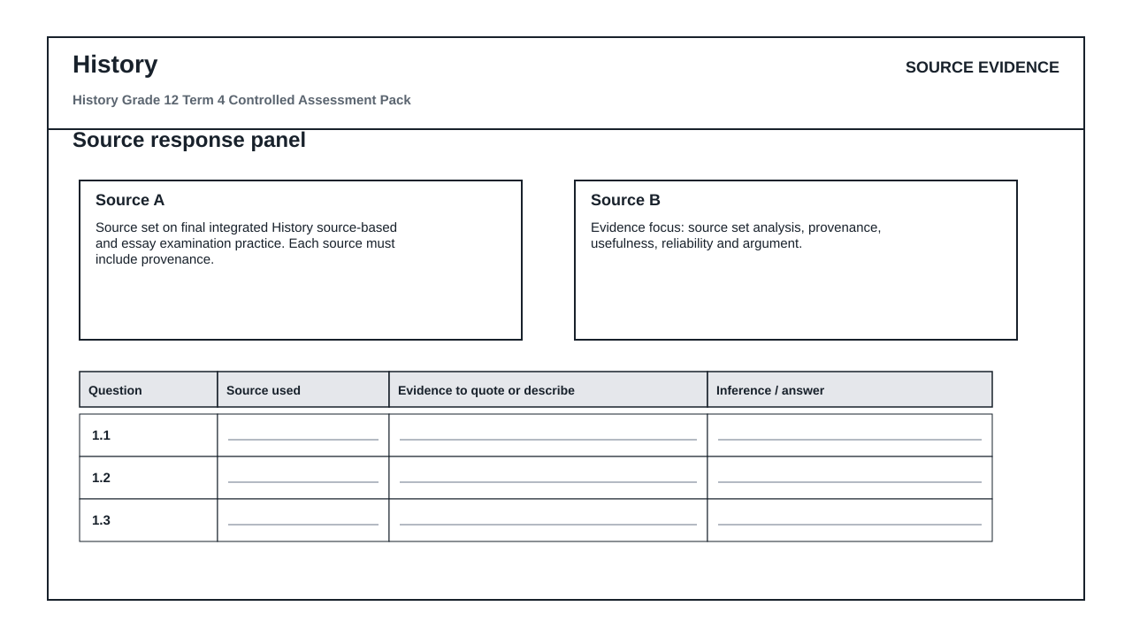
FIGURE 2: Claim Evidence Reasoning Table
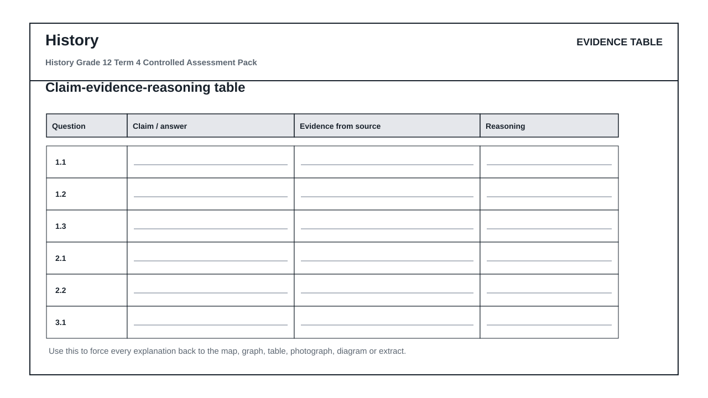

QUESTIONS

QUESTION 1: SECTION A: SOURCE-BASED QUESTIONS
Instructions: Use the supplied historical source set.
Stimulus: Source set on final integrated History source-based and essay examination practice. Each source must include provenance.
1.1. Contextualise the source in relation to the historical topic. (4)

1.2. Explain the message or viewpoint of the source using evidence. (6)

1.3. Evaluate the usefulness or reliability of the source. (8)

QUESTION 2: SECTION B: COMPARISON AND CAUSATION
Instructions: Compare evidence and explain causation.
Stimulus: Evidence focus: source set analysis, provenance, usefulness, reliability and argument.
2.1. Compare two sources and explain where they agree or differ. (8)

2.2. Explain one cause and one consequence linked to the topic. (9)

QUESTION 3: SECTION C: ESSAY PARAGRAPH
Instructions: Write a concise, evidence-linked argument.
Stimulus: Essay focus: timed essay with claim, evidence and judgement.
3.1. Write a structured historical paragraph with a clear claim, evidence and judgement. (15)

