LIFE SCIENCES
LIFE SCIENCES GRADE 12 TERM 1 CONTROLLED ASSESSMENT PACK

SUBJECT | LIFE SCIENCES
GRADE | 12
ASSESSMENT TASK | LIFE SCIENCES GRADE 12 TERM 1 CONTROLLED ASSESSMENT PACK
MARKS | 50
TIME | 1 hour

Educator approval required before classroom use.

INSTRUCTIONS AND INFORMATION
1. Read all instructions carefully.
2. Answer all questions or complete all activities as instructed.
3. Show all working where calculations, planning, diagrams or explanations are required.
4. Use the space provided by the educator, answer booklet or learner task book.
5. Write neatly and clearly.

VISUAL MATERIAL
FIGURE 1: Science Data Table And Graph Stimulus
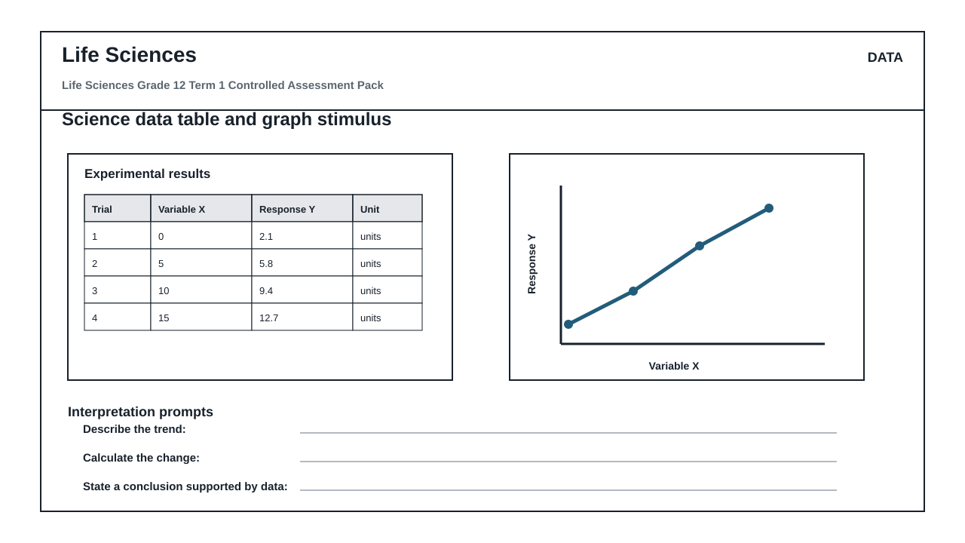
FIGURE 2: Investigation Data And Method Sheet
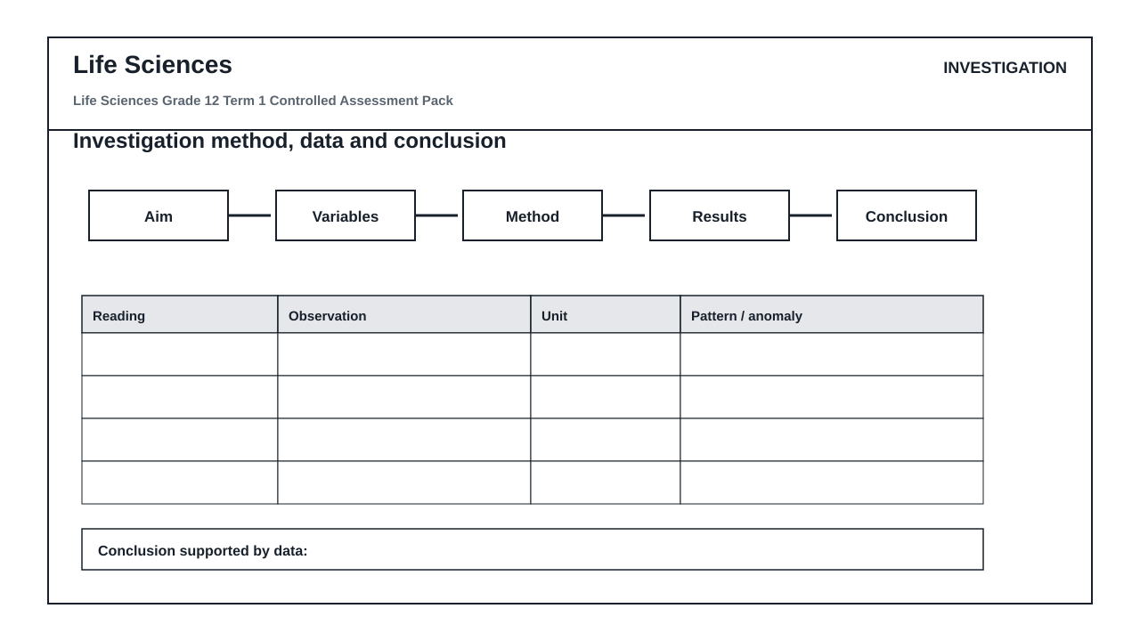
FIGURE 3: Life Sciences Labelled Diagram Stimulus
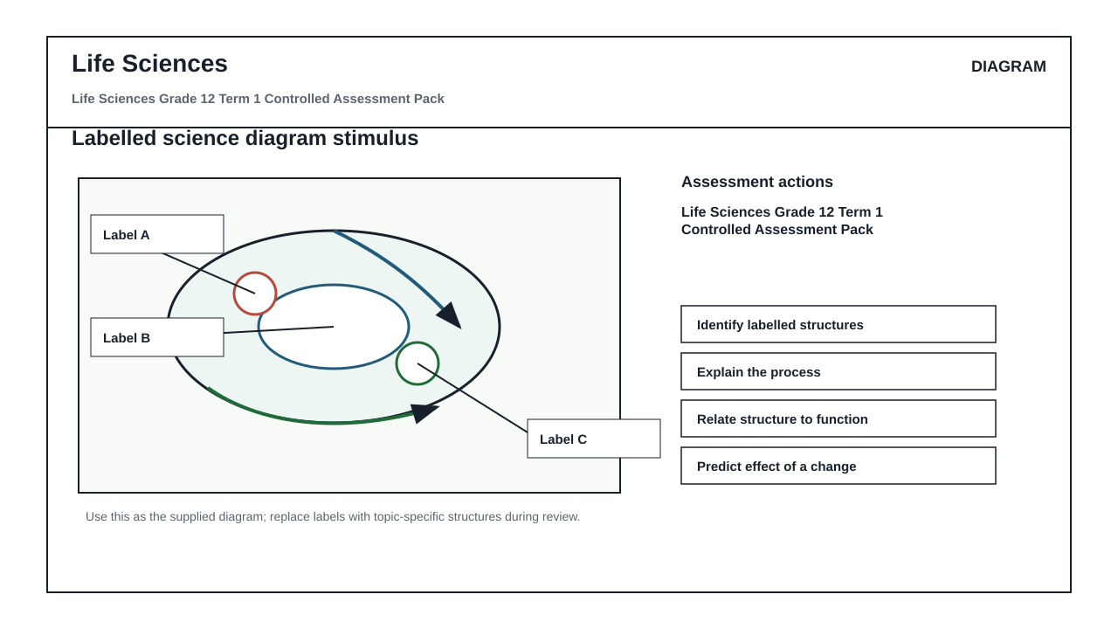

QUESTIONS

QUESTION 1: SECTION A: CONCEPTS AND DATA
Instructions: Use the supplied data, diagram or graph.
Stimulus: Data/diagram stimulus linked to DNA, meiosis, genetics and inheritance patterns.
1.1. Define one key concept from the term focus. (2)

1.2. Describe the trend or relationship shown by the supplied data. (5)

1.3. Explain the process or principle using correct terminology. (8)

1.4. Calculate or infer a result from the supplied values and show working where needed. (5)

QUESTION 2: SECTION B: INVESTIGATION DESIGN
Instructions: Critique method, variables and evidence.
Stimulus: Investigation focus: interpreting genetic crosses, diagrams and data tables.
2.1. State a suitable aim or hypothesis for the investigation. (3)

2.2. Identify independent, dependent and controlled variables. (6)

2.3. Evaluate validity and reliability and suggest one improvement. (6)

QUESTION 3: SECTION C: APPLICATION
Instructions: Use subject knowledge and supplied evidence.
Stimulus: Application focus: application of inheritance evidence to explain biological variation.
3.1. Answer an integrated explanation question using evidence from the stimulus. (15)

MARKING GUIDELINE

TASK 1: SECTION A: CONCEPTS AND DATA
1.1. Define one key concept from the term focus. (2)
- Definition scientifically accurate.
1.2. Describe the trend or relationship shown by the supplied data. (5)
- Trend described.
- Evidence cited.
1.3. Explain the process or principle using correct terminology. (8)
- Correct terms.
- Logical explanation.
1.4. Calculate or infer a result from the supplied values and show working where needed. (5)
- Working shown.
- Answer accurate.

TASK 2: SECTION B: INVESTIGATION DESIGN
2.1. State a suitable aim or hypothesis for the investigation. (3)
- Aim/hypothesis testable.
2.2. Identify independent, dependent and controlled variables. (6)
- Variables correctly classified.
2.3. Evaluate validity and reliability and suggest one improvement. (6)
- Validity/reliability explained.
- Improvement practical.

TASK 3: SECTION C: APPLICATION
3.1. Answer an integrated explanation question using evidence from the stimulus. (15)
- Evidence used.
- Explanation coherent.
- Conclusion supported.

RUBRIC
Criterion | Marks | Descriptor
Subject accuracy and terminology | 12 | Uses accurate concepts and terminology.
Evidence, data or source use | 12 | Uses supplied evidence appropriately.
Reasoning and explanation | 12 | Shows logical, grade-appropriate reasoning.
Communication and completion | 14 | Answers are clear, complete and structured.

EDUCATOR REVIEW CHECKLIST
- Confirm CAPS term and topic fit before classroom use.
- Insert or approve final source material where the pack requests educator-supplied sources.
- Check mark allocation, memo wording and learner level.
- Confirm visuals are suitable and not treated as official source material unless sourced separately.

