LIFE SCIENCES
LIFE SCIENCES GRADE 12 TERM 3 CONTROLLED ASSESSMENT PACK

SUBJECT | LIFE SCIENCES
GRADE | 12
ASSESSMENT TASK | LIFE SCIENCES GRADE 12 TERM 3 CONTROLLED ASSESSMENT PACK
MARKS | 50
TIME | 1 hour

Educator approval required before classroom use.

INSTRUCTIONS AND INFORMATION
1. Read all instructions carefully.
2. Answer all questions or complete all activities as instructed.
3. Show all working where calculations, planning, diagrams or explanations are required.
4. Use the space provided by the educator, answer booklet or learner task book.
5. Write neatly and clearly.

VISUAL MATERIAL
FIGURE 1: Science Data Table And Graph Stimulus
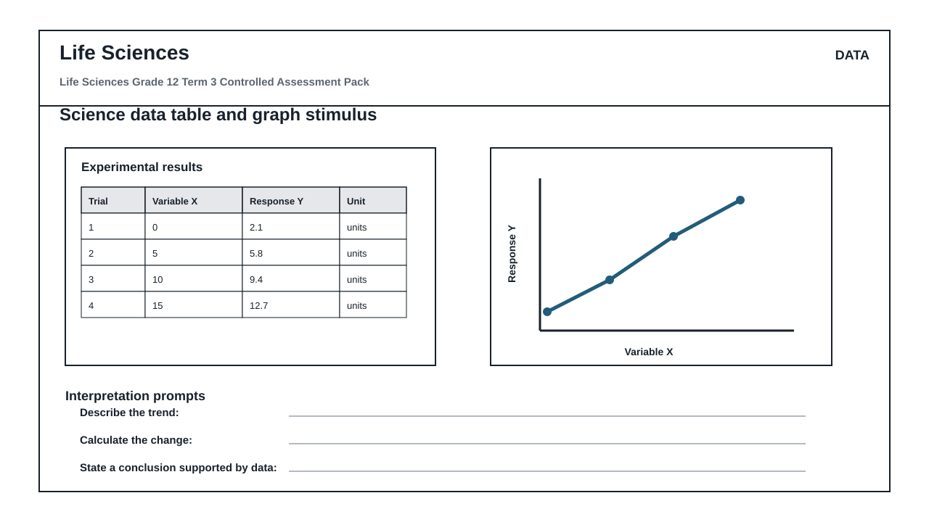
FIGURE 2: Investigation Data And Method Sheet
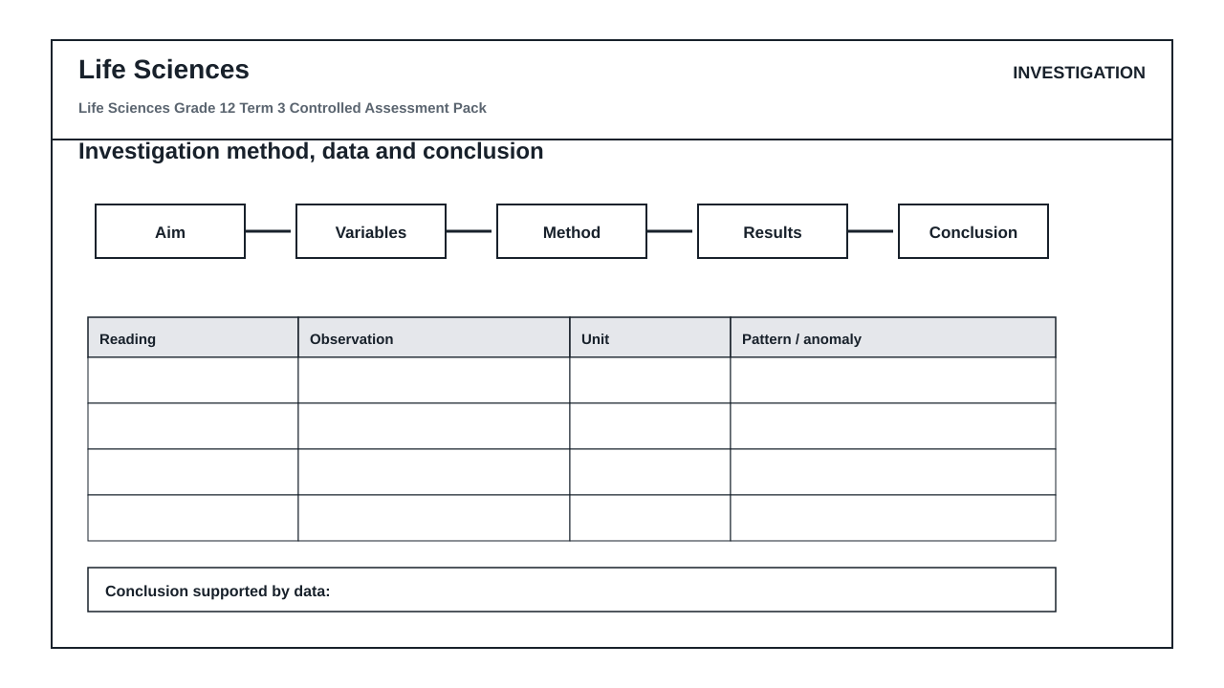
FIGURE 3: Life Sciences Labelled Diagram Stimulus
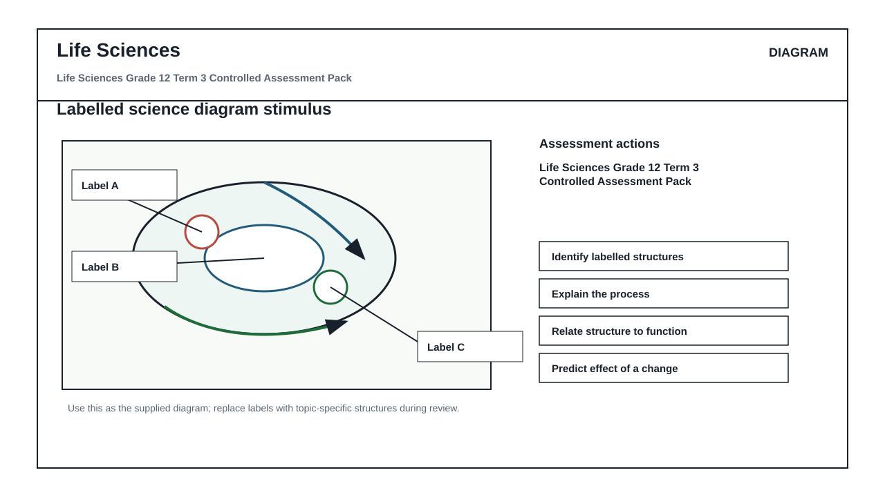

QUESTIONS

QUESTION 1: SECTION A: CONCEPTS AND DATA
Instructions: Use the supplied data, diagram or graph.
Stimulus: Data/diagram stimulus linked to Evolution by natural selection and speciation.
1.1. Define one key concept from the term focus. (2)

1.2. Describe the trend or relationship shown by the supplied data. (5)

1.3. Explain the process or principle using correct terminology. (8)

1.4. Calculate or infer a result from the supplied values and show working where needed. (5)

QUESTION 2: SECTION B: INVESTIGATION DESIGN
Instructions: Critique method, variables and evidence.
Stimulus: Investigation focus: Scientific investigation design for natural selection.
2.1. State a suitable aim or hypothesis for the investigation. (3)

2.2. Identify independent, dependent and controlled variables. (6)

2.3. Evaluate validity and reliability and suggest one improvement. (6)

QUESTION 3: SECTION C: APPLICATION
Instructions: Use subject knowledge and supplied evidence.
Stimulus: Application focus: Using data and anatomical evidence to support evolutionary explanations.
3.1. Answer an integrated explanation question using evidence from the stimulus. (15)

